**Tailoring Transition Metal Perovskite Oxides via Low-Temperature Hydrothermal Routes as Potential Candidates for Catalytic Applications**

Submitted in partial fulfillment of the requirements

of the degree of

**Doctor of Philosophy**

By

**KOTHA VISHAL**

**(Roll No. 164030003)**

Supervisor:

**Prof. Leela Srinivas Panchakarla**



Department of Chemistry

INDIAN INSTITUTE OF TECHNOLOGY BOMBAY

(2022)

## Approval Sheet

This dissertation entitled **“Tailoring Transition Metal Perovskite Oxides via Low-Temperature Hydrothermal Routes as Potential Candidates for Catalytic Applications”** by **Kotha Vishal** is approved for the degree of **Doctor of Philosophy.**

**Examiners**

\_\_\_\_\_\_\_\_\_\_\_\_\_\_\_\_\_\_\_\_\_\_\_\_

\_\_\_\_\_\_\_\_\_\_\_\_\_\_\_\_\_\_\_\_\_\_\_\_

\_\_\_\_\_\_\_\_\_\_\_\_\_\_\_\_\_\_\_\_\_\_\_\_

**Supervisor**

Prof. M. Ravikanth

**Chairman**

\_\_\_\_\_\_\_\_\_\_\_\_\_\_\_\_\_\_\_\_\_\_\_\_

**Date:** 02nd April 2022

**Place:** Mumbai, India

## Declaration

I declare that this written submission represents my ideas in my own words and where others' ideas or words have been included, I have adequately cited and referenced the original sources. I also declare that I have adhered to all principles of academic honesty and integrity and have not misrepresented or fabricated or falsified any idea/data/fact/source in my submission. I understand that any violation of the above will be cause for disciplinary action by the Institute and can also evoke penal action from the sources which have thus not been properly cited or from whom proper permission has not been taken when needed.

(Signature)

**Kotha Vishal**

(Name of the student)

**164030003**

(Roll No.)

**Date:** 8th August 2022

**Place:** IIT Bombay, Mumbai

## Copyright

© Vishal Kotha (2022)

I certify that I have made all reasonable efforts to secure copyright permissions for third-party content included in this thesis and have not knowingly added copyright content to my work without the permission.

**To**

**My Mother & Motherland**

## Research publications, Symposiums and Conferences

1. **Kotha, V.**; Karajagi, I.; Ghosh, P. C.; Panchakarla, L. S. Potassium-Substituted LaMnO3 as a Highly Active and Exceptionally Stable Electrocatalyst toward Bifunctional Oxygen Reduction and Oxygen Evolution Reactions. ACS Appl. Energy Mater. **2022**, 5 (6), 7297–7307. (\*Chapter-4, Part-1)
2. Bhavani, B.; Chanda, N.; **Kotha, V.**; Reddy, G.; Basak, P.; Pal, U.; Giribabu, L.; Prasanthkumar, S. 1D Alignment of Co(II) Metalated Porphyrin-Napthalimide Based Self-Assembled Nanowires for Photocatalytic Hydrogen Evolution. *Nanoscale* **2022**, *14* (1), 140–146.
3. Nishad, H. S.; Gupta, S. P.; **Kotha, V.**; Patil, B. M.; Chakane, S. D.; Bute, M. G.; Gosavi, S. W.; Late, D. J.; Walke, P. S. Enhanced Van-Der Waals Separation in Hydrated Tungsten Oxide Nanoplates Enables Superior Pseudocapacitive Charge Storage. *J. Alloys Compd.* **2022**, *914*, 165227.
4. **Kotha, V.**; Kumar, K.; Dayman, P.; Panchakarla, L. S. Doping with Chemically Hard Elements to Improve Photocatalytic Properties of ZnO Nanostructures. *J. Clust. Sci.* **2021**, (189), 1–8. (\*Chapter-5)
5. Sugathan, V.; Ghosh, B.; Harikesh, P. C.; **Kotha, V.**; Vashishtha, P.; Salim, T.; Yella, A.; Mathews, N. Synthesis of Bismuth Sulphoiodide Thin Films from Single Precursor Solution. *Sol. Energy* **2021**, *230*, 714–720.
6. Bera, A.; Pathak, S. S.; **Kotha, V.**; Prasad, B. L. V. Lamellar Bimetallic Thiolates: Synthesis, Characterization, and Their Utilization for the Preparation of Bimetallic Chalcogenide Nanocrystals through Mechanochemical Grinding. *Adv. Mater. Interfaces* **2021**, *8* (23), 2100898.
7. Mrinalini, M.; Suman Krishna, J. V.; Krishna, N. V.; **Kotha, V.**; Panchakarla, L. S.; Prasanthkumar, S.; Giribabu, L. Photobleaching of Triphenylamine–Phthalocyanine Entails Mixed Valence-State Triggered Self-Assembled Nanospheres. *J. Phys. Chem. C*. **2018**, *122* (34), 19946–19952.
8. **Kotha, V.**; Reddy P. L.; Maddu D.; Panchakarla, L. S. Importance of K substitution in LaMnO3 towards high-performance selective reduction of α,β-unsaturated carbonyl compounds and nitroarenes. *(Submitted to ACS Nano Letters).*
9. Nishad, H. S.; Gupta, S. P.; **Kotha, V.**; Magdum, V. V.; Gawade, V. V.; Patole, P. S.; Biradar, A. V.; Walke, P. S. Structural engineering of WO3 nanoflowers via Na doping as a suitable cathode for aqueous zinc ion battery *(Submitted to Journal of Energy Storage).*
10. **V. Kotha,** 3-minute Oral Presentation on ‘Lanthanum-based Perovskites’; In-house Symposium, Department of Chemistry, IIT-Bombay, Mumbai, India, **2019**.
11. **V. Kotha,** L. Panchakarla, Poster entitled ‘Low-Temperature Synthesis of K-substituted LaMnO3 Microcubes’; International Conference on Complex and Functional Materials (ICCFM-2018), S. N. Bose National Centre for Basic Sciences, Kolkata, India, **2018**.
12. **V. Kotha,** L. Panchakarla, Poster entitled ‘Low-Temperature Synthesis of K-substituted LaMnO3’; In-house Symposium, Department of Chemistry, IIT-Bombay, Mumbai, India, **2018**.

## Abstract

Perovskite oxides have been known for their multi-dimensional properties for decades. Among them, Lanthanum-based oxide perovskites have remained some of the most lucrative materials due to their significant properties like superconductivity, colossal magnetoresistance, and supercapacitance, exhibiting multiple utilities in multiferroic, and piezoelectric applications. However, their phase-controlled synthesis and ability to tune size and morphology for exploring properties have remained crucial questions to be addressed. To date, synthesis techniques of these materials mostly employ solid-state reaction conditions at very unconventional temperatures, with poor control of their morphology, phase, and yield. Despite their remarkable properties, the lack of a synthetic procedure to control size and morphology restricts their application in today’s advanced technologies and main stream applications (catalysis), thus forming the need of the hour. This doctoral thesis aims to establish a low-temperature, hydrothermal solution-phase synthetic approach, where reasonable control over these compounds' size, composition, phase, and morphology could be facilitated. This dissertation shows our attempts to stabilize these perovskite phases at low temperatures using a solution-based synthetic approach. To facilitate the same, four materials were chosen, viz. LaCrO3 (LCrO), LaMnO3 (LMO), LaFeO3 (LFO), and LaNiO3 (LNO). Various optimization studies conducted on these materials facilitated not only a control on the phase; but also the morphology, size, crystallinity, and effective yield. In addition, a plausible mechanism for the nucleation of these materials has also been proposed. This was subsequently extrapolated successfully to synthesizing a few more submicron-sized materials like LCrO, La1-xKxMnO3 (LKMO), and LFO, which proved that the synthetic protocol was generic and applicable to a wide diversity of similar materials. Apart from the classical hydrothermal method, which is static in nature, a modern dynamic hydrothermal method was introduced to enhance the kinetics of the formation of these Lanthanum-based Perovskite oxides (LPO) systems. Further, LKMO was synthesized in a one-dimensional fashion at low temperatures using the same chemical routes. This work was further extended to obtain truncated cubes of LKMO and double perovskites such as La2-xKxNiMnO6, La2-xKxMnCrO6, and La2-xKxCrFeO6. Finally, the catalytic activity of the LKMO microcubes synthesized in these methods was studied in an electrochemical device and reduction of organic molecules. Apart from the perovskite oxides, ZnO nanoparticles were synthesized hydrothermally by doping with chemically hard elements, showing enhanced photocatalytic activity.

Keywords

Lanthanum-Based Oxide Perovskites, Catalysis, Manganite, Low-Temperature, Hydrothermal, Mechanism, Size, Crystallinity, Phase, Degrees of Freedom, Crystal Facets, Kinetics, Heterogeneous Nucleation, Morphology, Polarity, Chemical Hardness

## Thesis Structure

Broadly, the research conducted in this doctoral thesis aims to establish a low-temperature, hydrothermal solution-phase synthetic approach for the synthesis of size-, phase-, composition- and morphology-controlled lanthanum-based oxide perovskites. This work is sectioned into the following chapters:

**Chapter-1: Introduction and Literature Review** gives an overall perspective on the importance of understanding the crystallization mechanism of lanthanum-based oxide perovskites; and how hydrothermal synthesis has been used to synthesize various binary, ternary, and quaternary metal oxides in controlled shape, composition, and phases.

**Chapter-2: Static hydrothermal synthesis: controlled nucleation and growth** talks about the conventional hydrothermal synthesis (SH-static hydrothermal) approach to generating lanthanum manganite. The key outcomes of these studies were the observations that solid-liquid diffusion governs the material formation, and the average size of the materials does not vary with time. Based on these results, it was imperative to study the factors that governed the kinetics of the reaction. We aimed to approach this by using the same- or similar- structure materials as precursor seeds, commonly known as substrate/seed-assisted synthesis. This method is well explored in synthesizing many materials such as graphene, TiO2, ZnO, GaN but has not been utilized to synthesize these bi- and tri- component systems. This clause has been explored in this chapter, and micro-and submicron cubes of LaCrO3, LaKMnO3 (LKMO), LaFeO3 have been synthesized. Another more controlled method to control the hydrothermal synthesis of LPOs is described in the next chapter.

**Chapter-3: Dynamic hydrothermal synthesis: tailoring nucleation and growth** deals with dynamic hydrothermal synthesis (facilitation of synthesis through continuous stirring) of perovskites to enhance the diffusion and simultaneous availability of the reagents. Thus, successfully synthesized LaCrO3, LaKMnO3 (LKMO), LaFeO3 phases and hollow cubes, truncated cubes, and nanorods of LKMO. Further, the electrical transport characteristics of LKMO nanorods have been discussed. A mechanism of nucleation has been proposed based on the observations. This was further extended to obtain double perovskites such as LaKNiMnO6, LaKMnCrO6, and LaKCrFeO6.

**Chapter-4: Applications: study of electrocatalytic and organocatalytic activity of LKMO microcubes** depicts, in the first part, the electrocatalytic applications of the above-synthesized LKMO microcubes in metal-air battery systems. The catalyst performed remarkably well, with improved kinetics and activity for ORR (half-wave onset potential of 0.78 mV) and OER (onset potential at 10 mA cm-2 current density is of 1.66 mV) in an alkaline environment. Additionally, as a two-electrode, this catalyst rendered the potential for use as an electrode in zinc-air batteries with unprecedented stability (no visible sign of degradation even after 1000 cycles; 100 hours). Subsequently, in the second part, the synthesized LKMO microcubes were used as organo-catalyst to evaluate catalytic efficiency in the reduction of α,β-unsaturated carbonyl compounds, and nitroarenes. The findings were compared to those obtained with La0.5Sr0.5MnO3 (LSMO) and submicron LaMnO3 (LMO), revealing that only LKMO exhibits enhanced catalytic activity against the selective reduction of α,β-unsaturated carbonyl compounds, and nitroarenes. LKMO demonstrated better catalytic conversion of 100% at 120 °C and 7 bar pressure, without any external activating agents. Systematic surface characterization demonstrated that LSMO covered microcubes with an inert SrO layer, while LKMO exposed catalytically active Mn sites on the surface. Due to its low cost, non-pyrophoric and catalytic properties, LKMO could be a possible substitute for precious metals in catalytic hydrogenation.

**Chapter-5: Doping with chemically hard elements to improve photocatalytic properties of ZnO nanostructures** illustrates simple and most abundant ZnO hydrothermally doped with divalent (Ni2+ and Sr2+) and trivalent (Cr3+ and Al3+) cations. The photocatalytic activity of undoped and doped ZnO nanostructures was tested towards the degradation of methyl orange (MO), methylene blue (MB), and congo red (CR). Al-ZnO exhibited a 91.25% removal rate compared to 40.88% for pure ZnO in MO degradation under ultra-violet (UV) radiation. The trend of photocatalytic activity of different photocatalysts (Al-ZnO > Sr-ZnO > Cr-ZnO > Ni-ZnO > ZnO) is identical to the trend of Pearson hardness values of Al3+ > Sr2+ > Cr3+ > Ni2+ > Zn2+ indicating the chemical hardness of the dopant plays a significant role in the photocatalytic dye degradation. These reactions also reveal that the dopant type affects the morphology of the ZnO nanostructures in given reaction conditions. We propose the polarity-induced mechanism to understand the changes in the morphology due to different dopants.

[**Chapter-6:**](#_FUTURE_SCOPES) **Conclusion and Future Scope** summarizes and concludes the scope of this current thesis. Describes the possible directions this thesis could open for future studies. Further, it also provides a foothold on novel discoveries that are possible through widening the horizons of this work.

## Research highlights

1. A practically safe, green, economical, and energy-efficient protocol for the low-temperature, hydrothermal solution-based synthesis of potassium substituted cubic LMO perovskite materials has been described.
2. The influence of different reaction parameters, such as KOH concentration, precursor concentration, precursor ratio, and duration, on the regulation of size, morphology, and crystallinity of the LKMO structures has been examined.
3. A mechanism for the creation of transition metal-oxide perovskites has been proposed.
4. A generic strategy that could be applied to initiate better control on phase, morphology, and nucleation in similar La-based perovskites such as LaCrO3 and LaFeO3 has been developed.
5. Submicron cubes of LaCrO3, LKMO, and LFO have been synthesized by enhancing the secondary nucleation approach.
6. A dynamic hydrothermal method aided by stirring has been introduced to LPO systems.
7. In the DH method of synthesis, a shear-induced jamming phenomenon that aids nucleation has been proposed.
8. Hollow and truncated micron size LKMO cubes were synthesized.
9. Double perovskites of manganite were synthesized.
10. The dynamic hydrothermal method was used to obtain LKMO nanorods.
11. LKMO single nanorod FETs were fabricated and their electrical properties were investigated.
12. Electrocatalytic properties of the LKMO microcubes were explored by employing them as electrocatalysts in Zin-Air batteries.
13. As an organo-catalyst, LKMO microcubes promoted selective reduction of chalcones and nitroarenes with higher activity at nominal conditions.
14. The influence of dopant chemical hardness on photocatalytic dye degradation was investigated using ZnO nanoparticles.
15. A polarity-induced morphology tuning mechanism in ZnO nanoparticles is presented.

## Acknowledgments

First and foremost, I wish to thank the first teacher of my life; my mother Kotha Kalavati; for her blessings in every endeavour that I have taken up to date. Her unparalleled support, love and care have given me the strength to overcome all obstacles and circumstances to complete all my undertakings, including this thesis work. They have guided and moulded me into what I am today, and I attribute myself wholly to her selfless sacrifices.

Secondly, I wish to thank all my teachers - Dr Panchanan Gouda, *Late* Basudev Nayak, Surya Narayan Kar, Damburudhar Panda, Ranjit Sabat, Dr. Chandra Sekhar Patro - who have supported me at different crucial stages of my life and whose guidance has been instrumental in ensuring that I learn and grow constantly. Another important factor determining the foundation of a good individual is friends – I am thankful for having been gifted with a childhood surrounded by a good set of friends - Anil Kumar Gaudo, Deepak Kumar Mishra, Satyabrata Mishra, *Late* Sitansu Muni, Sunita Tarei.

I wish to express my sincere gratitude to my PhD supervisor, *Late* Prof Leela Srinivas Panchakarla for all his support, motivation, and encouragement. His advice and guidance have been very crucial in keeping me focussed, motivated and undeterred from my work whenever I was in need. His presence has always been a strong pillar of support for me. He is my inspiration and an image of scientific temper. I thank Prof C. S. Subramanian and Prof R. Murugavel, my Research Panel Committee (RPC) members, for all their suggestions and feedback, whose inputs throughout my tenure have been priceless and most needed during my times of difficulty. I am grateful to Prof Madhu Chennabasappa, who was so kind to provide me mentorship at a crucial time when I was stranded in my PhD and guided me with great dedication, care and love. Also, I extend my gratitude to my faculty collaborators like Prof P.C. Ghosh who partnered with my work and helped me gain deeper insights into different aspects of research apart from my domain. I thank faculty members like Prof Ravikanth, Prof Anindya Datta, Prof C. M. R. Volla, Prof Rajaraman, Prof. Aswani Yella, Prof. Balasubramaniam Kavaipatti - who helped me profusely with their feedback, comments, and suggestions whenever I needed a second opinion. I thank my Masters’ professor and senior; Dr M. M. Balakrishna Rajan and Dr P. D. Pancharatna for all their support. I thank Prof Reshef Tenne and Dr Sreedhara for having helped me see my shortcomings in research writing and supported me with their valuable advice.

I wish to thank the administration of IITB, the Department of Chemistry and all its technical and non-technical staff and students for having provided me with a memorable time at IITB. I wish to thank National Centre for Photovoltaic Research and Education (NCPRE), Sophisticated Analytical Instrument Facility (SAIF), Centre for Research in Nano Technology and Science (CRNTS), Industrial Research and Consultancy Centre (IRCC), and Centre of Excellence in Nanoelectronics (CEN) of IIT Bombay for granting access to their facilities for fabrication and characterization requirements of the projects. Further, I thank all instrument operators, technicians, colleagues, and friends at different characterization labs who helped me overcome difficulties and sail through research smoothly. I especially thank Bharati ma’am and Amit Bhaiya for having taught me the operation and practical aspects of the TEM. I would like to thank all my Advanced Materials Lab group members for their continuous support and assistance. I thank my research grant MHRD-teaching assistantship which provided funding for my research.

This work would not have been possible without the help of many individuals. I want to thank the people with whom discussions at different points in my life provided me with directions to think and execute: Imran Karajagi, Vipinraj Sugathan, Basvaraj Kote, Kailasham Ramalingam, Akshay Nair, Sabari Nathan, Shreemoyee Kumar, Karuna Veeramani, Soham Sarkar, Dipak Fartade, Marimuthu Rajendiran, Vallabh Vasudevan. Further, I thank my present seniors and well-wishers – Dr. Saravanan Raju, Dr. Ravi Kumar Gupta, Dr. Abhishek Tripathi, Dr. Kanhu Nayak, Dr. Aditya Kumar Das, Dr. Soumitra K Nayak, Dr. Raghaba Sahu, Dr. Salman Khan, Nama Premsai, Dr. N Sivashankar, Dr. Mufeedah, Dr. Vishwanath Kalyani, Dr. Yuvaraj Dommaraju, Dr. Sohan Lal for their support and advice during times of need. I thank all the senior and junior members of our own as well as other research groups for their help during different stages of my PhD. I thank all my dearest friends like Sidhartha Kalahasti, Murali Sudha Krishna, Madasi Shivashankar, Ashwini Varpe, Vijay Sharma for having taken out time from their busy schedules and helped me with their suggestions and criticism whenever I required.

I thank my Father, Mr Upendra Rao Kotha, for having extended his warm support in all my activities and for helping me learn about life. He has been my role model in understanding the importance of hard work and selfless devoted service. I thank my younger brother, Kotha Sooraj, for having provided me with the mental support I have needed multiple times during my stressful days. He has been more like a friend; loving, caring, and understanding; so that I do not lose myself during my hard times.

Finally, I thank God with all my heart for having given me this life, good people around, and a scientific frame of mind.

## Table of Contents

[Approval Sheet ii](#_Toc107303041)

[Declaration iii](#_Toc107303042)

[Copyright iv](#_Toc107303043)

[Research publications, Symposiums and Conferences vi](#_Toc107303044)

[Abstract viii](#_Toc107303045)

[Thesis Structure x](#_Toc107303046)

[Research highlights xii](#_Toc107303047)

[Acknowledgments xiii](#_Toc107303048)

[Table of Contents xv](#_Toc107303049)

[List of Figures xix](#_Toc107303050)

[List of Tables xxvi](#_Toc107303051)

[Abbreviations xxvii](#_Toc107303052)

[Chapter-1: Introduction and Literature Review 1](#_Toc107303053)

[1.1 Introduction 2](#_Toc107303054)

[1.2 Background on Perovskite: 2](#_Toc107303055)

[1.2.1 Crystal structure: 2](#_Toc107303056)

[1.2.2 Origin of Crystal Distortion: 4](#_Toc107303057)

[1.2.3 Applications: 6](#_Toc107303058)

[1.2.4 Synthesis: 8](#_Toc107303059)

[1.3 Hydrothermal Synthesis: 12](#_Toc107303060)

[1.4 Thermodynamic modelling of the hydrothermal production of perovskite oxide: 13](#_Toc107303061)

[1.5 Lanthanum-based transition metal perovskite oxides (LPOs): 14](#_Toc107303062)

[Chapter-2: Static hydrothermal synthesis: controlled nucleation and growth 7](#_Toc107303063)

[2.1 Abstract 23](#_Toc107303064)

[2.2 Introduction 24](#_Toc107303065)

[2.3 Existing issues 26](#_Toc107303066)

[2.4 Objectives & Action plan 27](#_Toc107303067)

[2.5 Materials and Methods 27](#_Toc107303068)

[2.5.1 Materials 27](#_Toc107303069)

[2.5.2 Synthesis 28](#_Toc107303070)

[2.5.2.1 Preparation of LKMO microcubes: 28](#_Toc107303071)

[2.5.2.2 Separation of La(OH)3 nanorods from LKMO 28](#_Toc107303072)

[2.5.2.3 Preparation of LaCrO3 microcubes 29](#_Toc107303073)

[2.5.2.4 Preparation of LaFeO3 microcubes 29](#_Toc107303074)

[2.5.2.5 Synthesis of LKMO submicron cubes: using LKMO microcubes precursor 30](#_Toc107303075)

[2.5.2.6 Synthesis of LaCrO3 submicron cubes: using LaCrO3 microcubes precursor 30](#_Toc107303076)

[2.5.2.7 Synthesis of SrTiO3 nanoparticles 30](#_Toc107303077)

[2.5.2.8 Synthesis of LKMO submicron cubes: using STO nanoparticles as precursor 31](#_Toc107303078)

[2.5.2.9 Synthesis of LaFeO3 submicron cubes: using STO nanoparticles as a precursor 31](#_Toc107303079)

[2.5.3 Characterization 31](#_Toc107303080)

[2.6 Results and Discussion 33](#_Toc107303081)

[2.6.1 Effect of temperature 33](#_Toc107303082)

[2.6.2 Morphological and structural characterization of LKMO microcubes 34](#_Toc107303083)

[2.6.3 Effect of alkali (KOH) concentration: 39](#_Toc107303084)

[2.6.4 Effect of precursor concentration 41](#_Toc107303085)

[2.6.5 Effect of precursor ratio 43](#_Toc107303086)

[2.7 Mechanisms: 45](#_Toc107303087)

[2.7.1 Nucleation: 45](#_Toc107303088)

[2.8 Magnetic properties measurement: 50](#_Toc107303089)

[2.9 Phase transformation: 51](#_Toc107303090)

[2.10 LKMO synthesis as a generic growth strategy: 54](#_Toc107303091)

[2.11 Effect of doping: 55](#_Toc107303092)

[2.12 LKMO microcube growth 56](#_Toc107303093)

[2.13 Conclusion 58](#_Toc107303094)

[Chapter-3: Dynamic hydrothermal synthesis: tailoring nucleation and growth 35](#_Toc107303095)

[3.1 Abstract 61](#_Toc107303096)

[3.2 Introduction 61](#_Toc107303097)

[3.3 Existing issues 64](#_Toc107303098)

[3.4 Objectives & Action plan 64](#_Toc107303099)

[3.5 Materials and Methods 64](#_Toc107303100)

[3.5.1 Materials 64](#_Toc107303101)

[3.5.1.1 Reagents 64](#_Toc107303102)

[3.5.1.2 Equipment 65](#_Toc107303103)

[3.5.2 Synthesis 66](#_Toc107303104)

[3.5.2.1 Preparation of LKMO microcubes, truncated microcubes and nanorods 66](#_Toc107303105)

[3.5.2.2 Preparation of LaCrO3 and LaFeO3 microcubes 66](#_Toc107303106)

[3.5.2.3 Synthesis of La2-xKxMnBO6 (B = Cr, Fe, and Ni) double-perovskite microcubes 66](#_Toc107303107)

[3.5.2.4 Synthesis of hollow cubes of LMKO 67](#_Toc107303108)

[3.6 Results and Discussion 67](#_Toc107303109)

[3.7 Conclusion 82](#_Toc107303110)

[Chapter-4: Applications: study of electrocatalytic and organocatalytic activity of LKMO microcubes 50](#_Toc107303111)

[Part-1: Importance of K Substitution in LaMnO3 to Achieve Highly Active and Exceptionally Stable Bifunctional Electrocatalyst Towards Oxygen Reduction and Oxygen Evolution Reactions 85](#_Toc107303112)

[4.1 Abstract 85](#_Toc107303113)

[4.2 Introduction 85](#_Toc107303114)

[4.3 Materials and Methods 87](#_Toc107303115)

[4.3.1 Materials 87](#_Toc107303116)

[4.3.2 Synthesis of LKMO microcubes: 87](#_Toc107303117)

[4.3.3 Electrochemical characterization: 88](#_Toc107303118)

[4.3.4 Zinc-air battery fabrication and testing: 89](#_Toc107303119)

[4.4 Electrochemical measurements 89](#_Toc107303120)

[4.5 Conclusion: 101](#_Toc107303121)

[Part-2: Importance of K substitution in LaMnO3 towards high-performance selective reduction of α,β-unsaturated carbonyl compounds 102](#_Toc107303122)

[4.6 Abstract 102](#_Toc107303123)

[4.7 Introduction 102](#_Toc107303124)

[4.8 Materials and Methods 103](#_Toc107303125)

[4.8.1 Materials and characterization 103](#_Toc107303126)

[4.8.2 Synthesis of LSMO microcubes: 104](#_Toc107303127)

[4.8.3 Synthesis of LMO sub-microcubes: 104](#_Toc107303128)

[4.9 Physical characterization 105](#_Toc107303129)

[4.9.1 General procedure for hydrogenation 108](#_Toc107303130)

[4.10 Catalytic activity 108](#_Toc107303131)

[4.11 Conclusion 113](#_Toc107303132)

[Chapter-5: Doping with chemically hard elements to improve photocatalytic properties of ZnO nanostructures 78](#_Toc107303133)

[5.1 Abstract 115](#_Toc107303134)

[5.2 Introduction 115](#_Toc107303135)

[5.3 Existing issues 118](#_Toc107303136)

[5.4 Objectives & Action plan 118](#_Toc107303137)

[5.5 Materials and Methods 119](#_Toc107303138)

[5.5.1 Materials used 119](#_Toc107303139)

[5.5.2 Synthesis of ZnO nanoparticles 119](#_Toc107303140)

[5.5.3 Dye-degradation test 119](#_Toc107303141)

[5.5.4 Characterization 120](#_Toc107303142)

[5.6 Results and Discussion 120](#_Toc107303143)

[5.7 Conclusions 129](#_Toc107303144)

[Chapter-6: Conclusion and Future Scope 95](#_Toc107303145)

[Conclusion 131](#_Toc107303146)

[Future scope 132](#_Toc107303147)

[Appendix 97](#_Toc107303148)

[Spectral data: B](#_Toc107303149)

[Synthesis of perovskite oxides by TMSS method :- P](#_Toc107303150)

[Bibliography 1](#_Toc107303151)

## List of Figures

[**Figure 1.1** Structural representation of two different views of the AA’BO3 ideal cubic perovskite (a) A/A’-atom at the centre and (b) A/A’-atom at the corner of the cubic unit cell. 3](#_Toc107303152)

[**Figure 1.2** Schematic representation of (a) orthorhombic (LaMnO3) and (b) face-sharing hexagonal (BaNiO3) perovskite. 5](#_Toc107303153)

[**Figure 1.3** A graphical representation of degrees of freedom (D.O.F.). 17](#_Toc107303154)

[**Figure 1.4** Pictorial representation of double exchange phenomena in LCMO (a) (b).69 17](#_Toc107303155)

[**Figure 1.5** An overall graphical representation of this thesis; showing various LKMO morphologies that we have synthesised thus far, nucleation mechanism studied, catalytic applications studied. 20](#_Toc107303156)

[**Figure 2.1** (a) SEM image and (b) XRD pattern and (c) EDS mapping indicating the elemental distribution of by-products obtained at 240 °C which are La(OH)3 rods and K0.5Mn2O4.3.(H2O)0.5 sheets of birnessite-like phase. 33](#_Toc107303157)

[**Figure 2.2** (a) Typical SEM image of as-synthesized LKMO sample, (b) the size-distribution histogram with an average size of the LKMO cubes ≈11 microns, (c) SEM image of LKMO sample after separating the by-products via density-separation method, (d) SEM image of LKMO sample after separating the by-products via H2O2 treatment inset showing the supernatant containing degraded by-products, (e) XRD pattern of the LKMO microcubes obtained via hydrothermal treatment at 265 °C for 7 days with [KOH] = 18 м at 5mmol [precursor] and RLa/Mn = 1.0, (f) growth of smaller cubes on the externally added LKMO cubes as a precursor. 34](#_Toc107303158)

[**Figure 2.3** EDS elemental mapping and EDS spectrum indicating the elemental composition of the LKMO microcubes after removal of the La(OH)3 nanorods by density-based separation 35](#_Toc107303159)

[**Figure 2.4** (a) Typical TEM image of as-synthesized LKMO microcube and (b) SAED pattern along the [1 2 2] zone-axis, synthesized via hydrothermal treatment at 265 °C for 7 days with 18 м KOH at 5 mmol precursor concentration. 37](#_Toc107303160)

[**Figure 2.5** XP spectra of LKMO microcubes synthesized via hydrothermal treatment at 265 °C for 7 days with 16 м KOH at 5 mmol precursor concentration. (a)Survey spectrum, and high-resolution spectra of (b) La 3d, (c) K 2s, (d) K 2p, (e) Mn 2p, (f) Mn 3s and (g) O 1s contributions. The narrow-scan spectra were fitted into individual components (turquoise, blue, red, and pink areas) using the combination of Gaussian and Lorentzian algorithm with Shirley background algorithm. 38](#_Toc107303161)

[**Figure 2.6**(a-l) SEM images of the LKMO samples synthesized via hydrothermal process at 265 °C for 7days ([La,Mn]=5.0M), (RLa/Mn=1) with varying KOH concentrations: (a) 0 mol/L (K0), (b) 2 mol/L (K2), (c) 4 mol/L (K4), (d) 5 mol/L (K5), (e) 6 mol/L (K6), (f) 7 mol/L (K7), (g) 8 mol/L (K8), (h) 9 mol/L (K9), (i) 12 mol/L (K12), (j) 16 mol/L (K16), (k) 18 mol/L (K18P5), and (l) 21 mol/L (K21). 40](#_Toc107303162)

[**Figure 2.7** XRD patterns of the LKMO samples synthesized via hydrothermal process at 265 °C for 7days ([La,Mn]=5.0M), (RLa/Mn=1) with varying KOH concentrations: (a) 0 mol/L (K0), (b) 2 mol/L (K2), (c) 4 mol/L (K4), (d) 5 mol/L (K5), (e) 6 mol/L (K6), (f) 7 mol/L (K7), (g) 8 mol/L (K8), (h) 9 mol/L (K9), (i) 12 mol/L (K12), (j) 16 mol/L (K16), (k) 18 mol/L (K18P5), and (l) 21 mol/L (K21). 40](#_Toc107303163)

[**Figure 2.8** a-c SEM images of the LKMO samples synthesized via hydrothermal process at 265 ⁰C for 7days (RLa/Mn = 1.0) at 12 м KOH, with various [La,Mn] : (a) 1 (K12P1), (b) 5 (K12P2.5), (c) 8 (K12P5), and the (d & e) XRD pattern of K12P1, K12P2.5, & K12P5. 41](#_Toc107303164)

[**Figure 2.9** (a-c) SEM images of the LKMO samples synthesized via hydrothermal process at 265 ⁰C for 7days (RLa/Mn = 1.0) at 18 м KOH, with various [La, Mn]: (a) P1, (b) P5, (c) P8, and the (d) XRD patterns of P1, P5, & P8. 42](#_Toc107303165)

[**Figure 2.10** SEM images of the LKMO samples hydrothermal synthesized at 265 ⁰C (RLa/Mn = 1.0), with various [La, Mn], reaction time & KOH concentrations: (a) (P1T3), (b) (P2.5T3), (c) (K9P5T2), (d) (K9P8T2), and Overall and 32°-33° focused (e) XRD pattern of P1T3, P2.5T3, & (f) XRD pattern of K9P5T2, K9P8T2. 43](#_Toc107303166)

[**Figure 2.11** a and b SEM images of the LKMO samples synthesized via hydrothermal process at 265 °C for 7days ([La,Mn]=1.0M) & 18 м KOH with various RLa/Mn 1 (P1) and (b) 0.67 (P1R0.67), and (c) Typical XRD patterns at around 2θ = 32°–34°. 43](#_Toc107303167)

[**Figure 2.12** a,b SEM images of the LKMO samples synthesized via hydrothermal process at 265 °C for 7days ([La,Mn]=1.0M) & 12 м KOH with various RLa/Mn: 1 (K12P1) and (b) 0.67 (K12P1R0.67) (c) Typical XRD patterns at around 2θ = 32°–34°. 44](#_Toc107303168)

[**Figure 2.13** Atomic% analysis of La and K in LKMO at different KOH concentration (12 м & 18 м), precursor ratio (1:1, 1:1.5, & 1.5:1), and reaction time (2d & 7d) conditions from several EDS points. 44](#_Toc107303169)

[**Figure 2.14** a-g SEM images of the LKMO samples synthesized via hydrothermal process at 265 ⁰C, 18 м KOH, ([La,Mn]=1.0M), (RLa/Mn=1) with varying reaction time: (a) 1day (T1), (b) 2days (T2), (c) 3days (T3), (d) 4days (T4), (e) 5days (T5), (f) 6days (T6), (g) 7days (T7), and (h) XRD pattern of as-synthesized LKMO sample with time variation. 46](#_Toc107303170)

[**Figure 2.15** SEM image of (a) LaCrO3 and (b) LaFeO3 microcubes synthesized hydrothermally, (c) XRD pattern of LCrO and LFO microcubes after density-gradient separation of byproducts. 47](#_Toc107303171)

[**Figure 2.16** SEM image of (a) as-synthesized LaCrO3 submicron cubes by secondary nucleation by adding pre-synthesized microcubes of the same, inset showing even smaller cubes of LCrO, (b & c) density-gradient separated LaCrO3 submicron cubes synthesized hydrothermally, (d) LaKMnO3 synthesized by using the STO nanoparticles (e) LFO submicron cubes synthesized by using the STO nanoparticles; inset showing the lower magnification of the same, and (g) XRD patterns of LaCrO3, LKMO-STO, and LFO-STO submicron cubes 48](#_Toc107303172)

[**Figure 2.17** EDS and mapping of density-separated (a) LaCrO3 and (b) LaFeO3 microcubes indicating the elemental composition and distribution 49](#_Toc107303173)

[**Figure 2.18** EDS spectrum and mapping of density-separated (a) LaCrO3 and (b) LaKMnO3 submicron cubes indicating the elemental composition and distribution 49](#_Toc107303174)

[**Figure 2.19** Temperature-dependent magnetization of LKMO samples (a) 12 м KOH & (c) 18 м KOH obtained at 300 Oe. The inset shows the first-order derivative of the respective zero-field cooling magnetization with respect to temperature. (b) & (d) are the field-dependent magnetization of LKMO samples synthesized at 12 м and 18 м KOH, respectively, at different temperatures varying from 2K to 300K. 50](#_Toc107303175)

[**Figure 2.20** Rietveld refinement of (a) 18 м-LKMO, (b) 12 м-LKMO\*, (c) LMO, and (d) annealed 12 м-LKMO; indicating the observed (Yobs), calculated (Ycal), and difference (Yobs-Ycal). (\*Neutron diffraction (ND) will provide accurate refinement of both as-prepared and annealed 12 м LKMO.) 52](#_Toc107303176)

[**Figure 2.21** SEM micrographs of (a) MSS-synthesized LMO nanoparticles, (b) 900 °C annealed 12 м-LKMO microcubes, (c) as-synthesized 12 м-LKMO microcubes, (d) as-synthesized 18 м-LKMO microcubes, and (e) XRD patterns of LMO, 18 м, 12 м, and annealed 12 м LKMO. 52](#_Toc107303177)

[**Figure 2.22** EDS elemental quantification of (a) 18 м and (b) 12 м LKMO microcubes after annealed at 900 °C. 53](#_Toc107303178)

[**Figure 2.23** Magnetization-Temperature curves (ZFC, FCC, FCW) of annealed 12 м LKMO microcube sample, with the first-derivative of ZFC indicating the Tc shown in the inset. 54](#_Toc107303179)

[**Figure 2.24** (a) MT and (b) MH studies of LaCrO3 microcubes at 100 Oe field and 5K, 180K and 300K temperatures, respectively. 55](#_Toc107303180)

[**Figure 3.1** Schematic representation; cross-sectional view of static vs dynamic hydrothermal autoclave where red, blue, and gold coloured spheres are reagent ions, magnetic bead is shown in black color. The grey lines indicate that the ionic movement is very much localized for static case. Whereas it is comprehensive for dynamic case. 62](#_Toc107303181)

[**Figure 3.2** The setup for the dynamic hydrothermal synthesis of LKMO microcubes 65](#_Toc107303182)

[**Figure 3.3** Comparison of SEM micrographs of LKMO microcubes obtained by static and dynamic hydrothermal at 1 and 7 days. 68](#_Toc107303183)

[**Figure 3.4** Schematic representation of formation of LKMO in DH; SEM micrograph showing formation of (a) smaller cubes from bigger cubes, (b) dissolution of La(OH)3 rods forming groves. 69](#_Toc107303184)

[**Figure 3.5** (Left side) Different stages of crystal formation146 and Internal organisation of ions in crystal nucleation147 (right side) 70](#_Toc107303185)

[**Figure 3.6** Schematic representation of the shear jamming situation proposed in DH. 71](#_Toc107303186)

[**Figure 3.7** SEM images of (a) LaCrO3 and (b) LaFeO3 sample synthesized by dynamic hydrothermal method and (c) corresponding XRD patterns. 73](#_Toc107303187)

[**Figure 3.8** SEM micrographs and EDS spectrum-mapping of LKMO hollow cubes. 74](#_Toc107303188)

[**Figure 3.9** SEM images of high-index {111} truncated LKMO microcubes obtained by DH method. 74](#_Toc107303189)

[**Figure 3.10** (a) SEM micrographs indicating the {111} faceted LKMNO microcubes, (b) XRD pattern, (c) EDS mapping, and (d)EDS spectrum of LKMNO. 75](#_Toc107303190)

[**Figure 3.11** EDS mapping of (a) LKMCrO and (b) LKMFO double perovskites. 76](#_Toc107303191)

[**Figure 3.12** SEM micrographs of LKMO nanorods obtained in DH at 12 м KOH. 77](#_Toc107303192)

[**Figure 3.13** (a) TEM image of LKMO nanorod, (b) HRTEM image showing the lattice fringes where 1 and 2 are IFFT images showing the lattice d-spacing and corresponding hkl plane. 77](#_Toc107303193)

[**Figure 3.14** (a) Indexed SAED along [1 0 0] zone axis, (b) STEM-BF, (c) STEM-HAADF image of LKMO nanorod, and (d) IFFT of bright field STEM image showing a model overlay of the La and Mn columns of the LKMO nanorod in the magnified red rectangle. 78](#_Toc107303194)

[**Figure 3.15** (a) STEM image, (b) EDS mapping, (c) Line mapping along the length of LKMO nanorod, and (d) Second line mapping case of LKMO nanorod for K%. 79](#_Toc107303195)

[**Figure 3.16** (a) SEM image of two probe IV devices of LKMO single nanorod, (b) enlarged representatively, (c) 2-terminal IV or drain current and absolute values, and (d) variation of drain current w.r.t. the drain voltage, inset showing comparison of theoretical and experimental fitting for Schottky model shown by S. Acharya. (2018).151 81](#_Toc107303196)

[**Figure 4.1** Left side depicts the hydrothermal synthesis of LKMO microcubes, and the right side shows the drop in JT-distortion with potassium substitution 88](#_Toc107303197)

[**Figure 4.2** Cyclic voltammogram of LKMO at N2 and O2 saturated 0.1 м KOH electrolyte. 90](#_Toc107303198)

[**Figure 4.3** (a) ORR polarization curves of LMO, LSMO, LKMO, and Pt/C (20% ) catalyst in 0.1 м KOH oxygen saturated at 1600rpm (b) Tafel slope plots for ORR (c) OER polarization curves of LMO, LSMO, LKMO and IrO2 at 1600rpm. (d) Tafel slopes plots for OER. 91](#_Toc107303199)

[**Figure 4.4** (a) LSV curve in the range of potential from 0.2 to 2 V, ∆E( Ej = 10– E1/2) is a measure of OER and ORR bifunctionality. (b) Bifunctionality measurement from LSV for OER and ORR potential to achieve a current density of 10 mA cm-2 and 3 mA cm-2, respectively. (c) Polarization curves for charge-discharge of zinc-air battery. (d) Power density curve for LKMO, LSMO, LMO, and Pt/C (20% ) as electrocatalyst at air electrode of zinc-air battery. 92](#_Toc107303200)

[**Figure 4.5** Chronoamperometric response of LMO, LSMO, LKMO, and IrO2 at 1.5 V vs. RHE 93](#_Toc107303201)

[**Figure 4.6** Schematic illustration of the working of the Zinc-air battery. 96](#_Toc107303202)

[**Figure 4.7** (a) Charge-discharge curve for zinc-air battery with LKMO electrocatalyst. (b) Specific discharge capacity of the battery at 15 mA cm-2 current density with LKMO catalyst (c) Cycling of battery with LKMO at 5 mA cm-2  (d) Discharging of battery with various current densities starting from 5 mA cm-2 to 100 mA cm-2. (e) Charging of battery with different current densities starting from 5 mA cm-2 to 100 mA cm-2. 97](#_Toc107303203)

[**Figure 4.8** SEM micrographs **(a)** before, **(b)** after cycling, **(c)** XRD pattern of the catalyst before and after cycling, and **(d)** EDS spectrum-quantification of LKMO after cycling. 100](#_Toc107303204)

[**Figure 4.9** SEM images of (a) LMO submicron cubes synthesized by molten salt, (b) LKMO particles synthesized hydrothermally, (c) LSMO microcubes synthesized hydrothermally, and (d) powder XRD pattern of all the three systems. 105](#_Toc107303205)

[**Figure 4.10** EDS elemental mapping and EDS spectrum of the LKMO microcubes after removal of the La(OH)3 nanorods by density-based separation. 106](#_Toc107303206)

[**Figure 4.11** EDS elemental mapping and EDS spectrum of the LMO submicron-cubes. The SEM micrograph entirely accords to the images of the EDS mapping of La, Mn and O atoms. All the atoms are homogeneously dispersed on the microcubes. 107](#_Toc107303207)

[**Figure 4.12** EDS elemental mapping and EDS spectrum of the LSMO particles.The SEM micrograph entirely accords to the images of the EDS mapping of La, Sr, Mn and O atoms. 107](#_Toc107303208)

[**Figure 4.13** XPS survey scan of LMO, LSMO, and LKMO samples and their high-resolution scans for the peaks Mn 2p, O 1s, and C 1s; insets show K 2p (LKMO) and Sr 3d (LSMO)). 109](#_Toc107303209)

[**Figure 4.14** Plot describing the recyclability of the LKMO catalyst. 113](#_Toc107303210)

[**Figure 5.1** The molecular structures of the dyes used for the photocatalytic activity of pure and doped ZnO nanostructures 118](#_Toc107303211)

[**Figure 5.2** XRD patterns of undoped as well as Sr2+, Cr3+, Al3+, and Ni2+ doped ZnO nanostructure 120](#_Toc107303212)

[**Figure 5.3** FE-SEM images of undoped as well as Sr2+, Ni2+, Cr3+, and Al3+ doped ZnO nanostructures. The scale bars of the respective images indicate 1µm 121](#_Toc107303213)

[**Figure 5.4** (a) Schematic of wurtzite structure, (b) schematic of polarity-cloud dispersion by doping (increasing intensity of the red color indicates an increase in polarity) 122](#_Toc107303214)

[**Figure 5.5** Absorption spectra of the pure and doped ZnO nanostructures 124](#_Toc107303215)

[**Figure 5.6** Changes in absorption spectra of MO with and without photocatalyst after 60 minutes (a) under UV-light irradiation and (b) under visible-light irradiation. (c) Optical images of MO-degradation with and without photocatalyst under UV-light 125](#_Toc107303216)

[**Figure 5.7** The change of normalized concentration with the exposure time for the photocatalytic degradation of MO with and without catalyst (a) under UV-light irradiation and (b) under visible-light irradiation 126](#_Toc107303217)

[**Figure 5.8** (a) Absorption plots of MO dye degradation at different time intervals under UV light, in the presence and absence of photocatalyst. (b) Optical images of MO dye degradation at (0 mins, 30 mins, and 60 mins) under UV light, in the presence and absence of photocatalyst 127](#_Toc107303218)

[**Figure 5.9** (a) and (b) are the absorption spectrum of MB and CR with and without photocatalyst treated under UV-light for 60 mins, respectively. (c) and (d) are the optical images of MB and CR degradation with and without catalyst under UV-light with time, respectively 128](#_Toc107303219)

[**Figure 0.1** (a) SEM image and (b) XRD pattern of SrTiO3 nanoparticles. A](#_Toc107303220)

[**Figure 0.2** Top and lateral view of atomic arrangement along face [1 0 0], edge [1 1 0], and corner [1 1 1] of LKMO (R3c-167) microcube. A](#_Toc107303221)

[**Figure 0.3** XRD and SEM of LMO, LFO, LCoO, LNO, & LAO obtained from TMSS Q](#_Toc107303222)

## List of Tables

[**Table 2.1** The details of the various experiments carried out to estimate the effect of various parameters; viz. K (mineralizer (KOH) concentration in M(mol/L)), P (precursor (La, Mn) concentration in mM), R (precursor ratio RLa/Mn,) and T (time taken for the reaction in days) at 265 ⁰C. The base value *K=18 м, P=5M, R=1 & T=7days* is the best-optimized values that correspond to the master entry in this table 36](#_Toc107303223)

[**Table 4.1.** The onset potentials of different catalysts are tabulated here. 94](#_Toc107303224)

[**Table 4.2**. The stability of different perovskite catalysts is listed here. 98](#_Toc107303225)

[**Table 4.3** Binding energy (B.E.) and relative concentration of Mn3+, Mn4+, and oxygen species from the deconvolution of Mn 2p and O 1s XPS peaks of LMO, LSMO, LKMO. 110](#_Toc107303226)

[**Table 4.4** Optimization of LKMO for hydrogenation of α,β-unsaturated carbonyl compounds.a 110](#_Toc107303227)

[**Table 4.5** Substrate scope of the LKMO for hydrogenation of α,β-unsaturated carbonyl compounds. 111](#_Toc107303228)

[**Table 4.6** Catalytic hydrogenation of nitroarenes to corresponding amines. 112](#_Toc107303229)

[**Table 5.1** Some of the relevant photocatalytic dye degradation of doped-ZnO nanostructures reported in the literature 122](#_Toc107303230)

## Abbreviations

|  |  |
| --- | --- |
| **LPO** | Lanthanum-based Perovskite Oxide |
| **SH** | Static Hydrothermal |
| **DH** | Dynamic Hydrothermal |
| **TMSS** | Topochemical Molten Salt Synthesis |
| **LKMO** | Lanthanum-Potassium-Manganese-Oxygen |
| **STO** | Strontium Titanate |
| **La(OH)3** | Lanthanum Hydroxide |
| **LCrO** | Lanthanum Chromate |
| **LFO** | Lanthanum Ferrite |
| **LNO** | Lanthanum Nickelate |
| **SEM** | Scanning Electron Microscopy/Secondary Electron Microscopy |
| **TEM** | Transmission Electron Microscopy |
| **HRTEM** | High Resolution Transmission Electron Microscopy |
| **SAED** | Selected Area Electron Diffraction |
| **IFFT** | Inverse Fast Fourier Transformation |
| **HAADF** | High Angle Annular Dark Field |
| **STEM** | Scanning Tunnelling Electron Microscopy |
| **XRD** | X-ray Powder Diffraction |
| **ND** | Neutron Diffraction |
| **MCE** | Magnetocaloric effect |
| **EDS/EDAX** | Energy Dispersive Spectroscopy/Energy Dispersive X-ray Analysis |
| **eBL** | Electron Beam Lithography |
| **VSM** | Vibrating Sample Magnetometer |
| **PPMS** | Physical Property Measurement System |
| **LSV** | Linear Sweep Voltammetry |
| **CV** | Cyclic Voltammetry |
| **BET** | Braunneur Emmet Teller |
| **XPS/ESCA** | X-ray Photoelectron Spectroscopy/Electron Spectroscopy for Chemical Analysis |
| **UPS** | Ultraviolet Photoelectron Spectroscopy |

# Introduction and Literature Review

**Introduction and Literature Review**

## Introduction

Materials science played an essential role in the evolution of humans by forming a pivotal role in today's technological advances. The discovery of graphene ushered in a similar revolution for which new materials with multidimensional properties were required. For the synthesis of novel materials, new synthetic techniques must be developed. This is where a materials chemist's knowledge comes in handy. We need these chemists' unique vision to develop new synthetic techniques and improve existing ones.

## Background on Perovskite:

### Crystal structure:

Perovskite is one of the structural materials which has received tremendous attention for wide-ranging properties because of its flexible crystal structure. The word ‘perovskite’ was coined after Russian mineralogist Lev Aleksevich Perovskite in the 1840s.1 It has a generic ABO3 structure which can accommodate around 90% of the metals from the periodic table. The beauty of this is that it provides the flexibility for the metal ions to move around within the framework. The A and B cationic sites can be easily substituted because of which one can easily tune these materials' physical and chemical properties. Generally, the A-site cation is larger than the B-site cation, having 12-fold cuboctahedral coordination (**Figure 1.1**(a)). In addition to the simple atomic structure, the ideal cubic cell unit could have a specific cation distribution. The A cations are at the cube's corners, while the B cation is in the center and is coordinated with six anions in the cubic unit cell's face-centered positions (**Figure 1.1**(b)). In most cases, transition metal ion takes up the B-site, whereas lanthanides, alkali, and alkaline earth metals suit the A-site. Because of the partially filled d-orbitals, the B-site cations possess the flexibility to change their oxidation states by accepting or donating electrons.

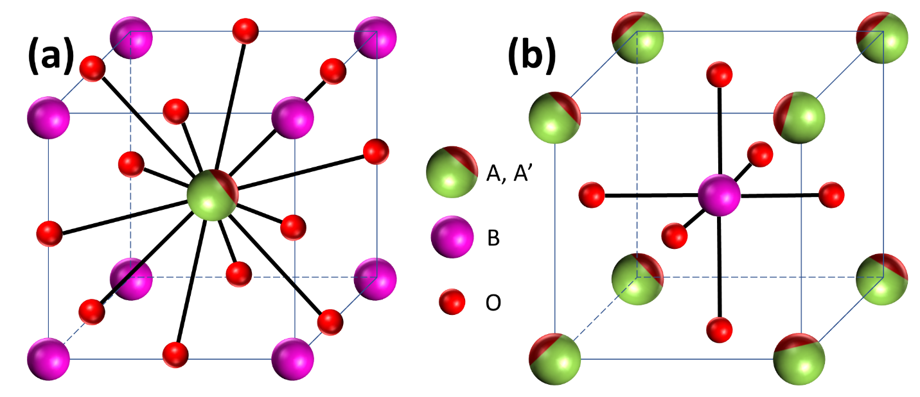

**Figure 1.1** Structural representation of two different views of the AA’BO3 ideal cubic perovskite (a) A/A’-atom at the centre and (b) A/A’-atom at the corner of the cubic unit cell.

In 1920, Goldsmith proposed some important features that relate the crystalline structure to chemical composition parameters as a result of his early exploration of the perovskite crystalline structure.1,2 The tolerance factor was one of the most fundamental ideas offered. The tolerance factor is a method that is commonly used to forecast the structural organisation and stability of a specific perovskite composition, both chemically and physically. This aspect is considered before deciding on the best processing approach for perovskite preparation.

Because strontium titanate oxide exhibits the atomic packing seen in **Figure 1.1**(**b**), SrTiO3 (STO) has the idealised cubic (fcc) structure. The atomic distribution of an ideal cubic structure is as follows, in conformity with the Wyckoff positions:

‘A’ cations are at 0.5, 0.5, 0.5 in XYZ coordinate system (**Figure 1.1**(**b**)), while

‘B’ cation is at 0, 0, 0 (**Figure 1.1**(**b**)), and

‘O’ anions are situated at 0.5, 0, 0; 0, 0.5, 0; and 0, 0, 0.5.

STO's idealised cubic structure has been altered in numerous ways. One of them is cation deficit at the A-site, which results in a ReO3 type structure.2 When this is followed by an octahedral rotation, another structural distortion leading to hcp type RhF3 occurs. Aside from vacancies and tilts, minor atomic displacements from their ideal location also vary the final symmetry by a few tenths of an angstrom, resulting in significantly varied final symmetry across various materials. Because of the pure flexibility of its crystal structure, all of these different types of distortions may indeed be accommodated in a perovskite structure.1–3 Aside from the geometrical features, the electrical structure introduces a particular distortion known as the Jahn-Teller phenomenon.

### Origin of Crystal Distortion:

The structural distortions on perovskite structure are caused by variances in ionic radii, as established by Goldschimidt's pioneering study.1–3 The equation 1 is presented that geometrically connects the ionic radii (rA, rB, and rO) for the perfect cubic cell with the lattice parameter a0. Where, rA is the average ionic radii of A-site cations, rB is the average ionic radii of B-site cations and rO is the average ionic radii of oxygen atoms.

$a_{0}= \sqrt{2}\left(r_{A}+r_{O}\right)=2\left(r_{B}+r_{O}\right)$… … … … … … … … … … … … (1)

The equation involving the unit cell length ratio is known as the Goldschmidt's tolerance factor **t**, and it is used to measure the amount of distortion obtained by a certain perovskite-structured molecule. Fundamentally, it accounts the ionic radii of the constituent atoms that meet the chemical stoichiometry and promotes pure ionic bonding between them; the mathematical expression for t is provided in Eq (2).

$t=\frac{\left(r_{A}+r_{O}\right)}{√2\left(r_{B}+r_{O}\right)}$… … … … … … … … … … … … … … … … … … (2)

According to the above Eq. (2), an ideal perovskite cubic structure has a "t" value of one, which can be determined for SrTiO3 with ionic radii of 1.44, 0.605, and 1.40. When the A ionic radius is somewhat smaller, the value of t is less than one, and the octahedral unit [BO6] physically tilts forward to occupy the extra space. According to Eq. (2), the optimal value of grade of tolerance (t) to achieve cubic structure in perovskite compounds lies between 0.89 and 1.2–4

Among the existing, orthorhombic structured perovskites is most abundant and hugely explored for its diverse chemistry. This orthorhombic distortion arises because of the tilting of BO6 octahedra in the formation stage itself. But noticing it is challenging because of the temperature raise which dilutes the tilt angle.5 Typically, an orthorhombic structure has unit cell twice in size that of cubic structure (**Figure 1.2**(**a**)). LMO like orthorhombic perovskites (where L = rare earth metals and M = 3d transition metal) shows high intrinsic distortion when their L3+ ionic size is nearly 1.11 Å. This can be reduced by increasing the average A-site ionic size to above 1.11 Å. Till date LTiO3, LVO3, LMnO3, LFeO3, and LNiO3 orthorhombic perovskites are exhaustively studied by the crystallographers. Along with the structural factors, cooperative Jahn-Teller effect on the cation orbital ordering also studied.6

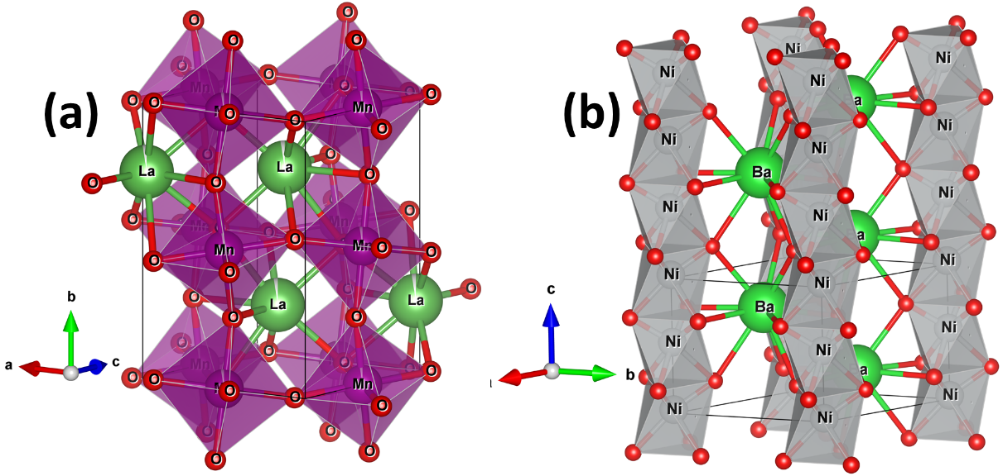

**Figure 1.2** Schematic representation of (a) orthorhombic (LaMnO3) and (b) face-sharing hexagonal (BaNiO3) perovskite.

Another popularly studied systems are hexagonal structured perovskites. These compounds have tolerance factor, t > 1. This distortion takes place when one of the cations among A or B site becomes extremely large or small. Because of which the cubic structure distorts forming hexagonal as shown in **Figure 1.2**(**b**). This structure is formed by closely packed layers of face sharing octahedra units. The stability of this is poor compared to the one which is formed by corner-sharing octahedra. But, some overcome this constraint by endorsing B-B bonding between BO6 octahedra which is strong enough to endure the metal-metal repulsion.1 Because of these stability constraints, hexagonal perovskites are uncommon. BaNiO3 is an example of hexagonal perovskite which has P63/mm space group. **Figure 1.2**(**b**) depicts a representative hexagonal perovskite unit cell structure. Here, the chains of face-sharing BO6 octahedra are provided, oriented along the c-axis. Multiple structures can be obtained by further distortion as observed in cubic systems.

In this case, deformation does not have significant effect on the unit cell, whereas in a typical cubic cell any small amount of deformation leads to transformation into rhombohedral symmetry. As a result, the unit cell is likely to include at least one or two rhombohedral polyhedral units with angles of 60° or 90°. The anions, on the other hand, are displaced, resulting in the development of a huge unit cell with a 60° angle.

BaTiO3 is a widely known tetragonal-structured perovskite exhibits a stable ferroelectric nature at ambient temperature. The TiO6 octahedra in this structure are somewhat deformed (four Ti-O bond at 2.0 Å, one at 1.86 Å, and a longer one at 2.17 Å). At 2.80 Å, four oxygen atoms are in cooperation with the barium atom, four at 2.88 Å, and four more at 2.83 Å. Other tetragonal perovskites (PbHfO3, SrPbO3, SrZrO3, AgTaO3, and others) have single-molecular cells and are isotypic with BaTiO3. However, at high temperatures, majority of these materials exhibit tetragonal structure, making crystallographic investigations challenging. In general, a large number of perovskite-like materials undergo polymorphic changes. Some of these are significant in terms of physical features and uses. BaTiO3 and KNbO3 exhibit this kind of transformation from Rhombohedral to Orthorhombic to Tetragonal to Cubic under elevated temperatures.

Ferroelectric characteristics are found in low-temperature crystalline materials (cubic, tetragonal, and orthorhombic). In nature, all phase transitions are reversible, and all polymorphic forms contain a pseudo-cubic unit cell with a0 ~ 4Å. As a result, the polymorphism variation in the perovskite structure has an even greater influence on the crystal chemistry of this class of materials.4–6

### Applications:

Since the discovery of the usefulness of perovskites materials over five decades ago, hundreds of research papers have been published explaining the physical and chemical characteristics of perovskites. These investigations have offered useful information about the principles of the chemical and physical components that contribute to structural aberrations in ABO3 materials. The previous research also shows that there are still surprises in store for this specific set of compounds, particularly the perovskites with low tolerance factors, such as those shown in the phase stability diagram FeTiO3-LiNbO3-Pnma.7 A large number of elements in the periodic table are most likely found at A or B unit cell locations. This fact opens up a vast array of compounds with structural similarities and a wide range of characteristics. All of these functionalities are triggered by the existence of multiple degrees of freedom (**Figure 1.3**) in these materials, such as charge, spin, orbital, and lattice, and the coupling between them leads to exotic magnetism, superconductivity, and electricity.8 Colossal magnetoresistance,9–13 ferromagnetism (Sr2FeRuO6), Ferroelectricity (BaTiO3), weak ferromagnetism (LaFeO3), superconductivity (Ba0.6K0.4BiO3),14 and high thermal conductivity (LaCoO3) are among the most notable features. Insulating to metallic transitions are of particular interest in the design of devices for thermistor applications (LaCoO3), fluorescence is applicable for laser devices (LaAlO3:Nd), and transport properties have piqued the interest of researchers working on the development of high-temperature thermoelectric power devices (La2CuO4).1,5,7,9–15

These materials have been studied for potential application in the preparation of solid electrolytes. Because of their superior performance, barium cerate (BaCeO3) and barium zirconate (BaZrO3) have been utilized in a variety of electrochemical devices. A solid electrolyte serves three important functions: (1) separates the anode from the cathode in the electrochemical cell (oxidizing and reducing sides), (2) if required, functions as an electronic insulator, enhancing the flow of electric current through an external circuit, and (3) it has a high ionic conduction coefficient, which is required to control the flow of electric current in the external circuit.16 Similarly, proton-conducting ceramics applications are classified based on two basic functions: (1) ability to produce electromotive force EMF upon the application of chemical potential and (2) ability to enhance electrochemical ion transport (oxygen or hydrogen) with an external power source. The use of an electrolyte which conducts cations mainly protons upon application of chemical potential finds a potential application in a device that can generate electrical energy.17,18 This electrochemical notion sparked the development of solid oxide fuel cell (SOFC) power sources. The SOFC is a type of energy conversion device that creates electricity through an electrochemical process that occurs at temperatures exceeding 800 °C. The mechanism to create electricity is the chemical reaction that occurs between the fuel (methane, hydrogen, natural gas) and the oxidizing agent (oxygen from air).16,17 The electrodes are the primary components accountable for the redox reaction in this specific electrochemical converter device; ion transport occurs in all cell parts (solid electrolyte and electrodes). In contrast to rechargeable battery systems, the SOFC does not need to be recharged and simply has to be continually supplied with a specific fuel to generate power.16–21

Some perovskites have been used in a variety of applications, including photocatalytic processes. Various titanates and cobaltites were used to conduct considerable research on photocatalytic oxidation. In contrast to the easily reducible LaCoO3, titanates (SrTiO3 and BaTiO3) were shown to have a high photocatalytic action. Because certain rare earth elements (Nd3+ or Sm3+) are inserted in the A site of the structure, perovskite materials have showed remarkable performance as hosts in laser systems. These are some of the primary components used in the manufacture of laser ion devices. Furthermore, certain perovskite oxides are highly resistive to electric field, making them ideal for the manufacture of dielectric materials that are poor electrical conductors and are commonly utilized for electrical insulation in power systems. Furthermore, these materials can be employed for energy storage, such as in capacitors. Typical conductor and semiconductor oxides include either B-ions with a net charge less than that of the stable B4+, or B-ions with two distinct net charges. Materials such as LaVO3, LaTiO3, and SrMoO3 have been identified as excellent conductors or semiconductors. Sound generation, mechanical actuation as in piezoelectric materials as a result of dimensional change under a voltage source, transducers as in condensers, piezoelectric recorders, temperature detection as in pyroelectrics, and liquid crystals used in alphanumeric displays are all examples of dielectric perovskites' diverse applications.

Oxygen sensors are also made using perovskite oxide materials. The mechanism at work in these sensors is electrical conductivity in nature, which increases oxygen adsorption in the crystalline structure. The electrical conductivity of ABO3 is related to the partial pressure of oxygen and the concentration of oxygen vacancies. SrTiO3 is a compound with a high sensitivity to oxygen motion. SrSnO3 is also a potential material for combustion monitoring sensors. Understanding the link between the composition of materials and crystalline structure is required for the creation of functional materials.16–22

### Synthesis:

The synthesis of perovskite oxide has received a lot of attention as design of variety of technological features and its development plays a critical role in attaining materials for diverse applications with unique physical morphology. Thin films, porous solids, and monodispersed powders of nanometric size are some of the recent breakthroughs. Furthermore, the desire for certain structural ordering displaying chains that improve unidirectional characteristics has encouraged several research groups to seek the fabrication of novel perovskite oxides with specified compositions.23,24 During the early 1940s, the standard solid-state reaction process (ceramic method) was widely utilized to generate perovskite oxide powders. For the fabrication of single crystals of different perovskite oxides, a comparable approach, the flux method, which is likewise based on solid-state reactivity, has been used.24 Both techniques are sufficient for the synthesis of oxide compounds because they allow for the simple achievement of the required conditions owing to the reaction taking place in an air environment and at ambient pressure.25 Homogeneous grinding and mixing are common processes in solid-state reaction techniques. The most often used solid reactants are oxygen and carbonate. These are blended in stoichiometric proportions prior to the application of a heat treatment at high temperatures (1000 °C) for extended periods of time (several hours or days). Grinding and heating cycles are repeated until the required pure phase is obtained. There is some uncertainty about the universal method's utility and ease of use, although meeting the prerequisites for atomic diffusion might be difficult. As a result, high temperatures are required to speed atomic diffusion and avoid the creation of metastable phases. However, this has the drawback of increasing the volatility of reactants such as lead oxide (in the case of Pb2+ compounds such as PbTiO3). Furthermore, the necessity to regrind the materials numerous times necessitates a significant amount of energy and time, as these factors have a considerable effect on obtaining the necessary product performance.23–25

The solid-state metathesis (SSM) reaction technique has recently emerged as an effective processing strategy for the synthesis of a diverse variety of non-oxide materials. The procedure that takes place under thermodynamic equilibrium conditions is more efficient than the traditional solid-state reaction approach.23,26 The SSM reaction technique is a version of the SHS process in which chemical reactions occur at a quick pace. In a typical SSM reaction, an ionic exchange occurs between the reactants, resulting in thermodynamically stable perovskites. A substantial enthalpy shift happens along with the reaction, and high adiabatic reaction temperatures are attained. The solid-state metathesis process is carried out using alkaline precursors such as chalcogenide, silicide, or boride; the salt is then reacted with a metal halide in accordance with the general reaction as shown below.

PaQb + RXa → QXb + aPX … … … … … … … … … … … … … … … (3)

where P = Li, Na, K, Mg, Ca, Sr, or Ba;

Q = B, Si, N, P, As, Sb, Bi, O, S, Se, or Te;

R = transition group, principal group or actinide metal, and

X = halogen.

One of the primary limitations of the techniques discussed above in terms of energy expenditure is the efficacy of transferring the heat necessary to achieve the chemical reactions under solid-state conditions. "Microwave irradiation" is one of the new processing approaches that has solved this problem. Heating is directly delivered to the solid reactants during microwave processing settings because it results from a molecular interaction between the electromagnetic field and some of the components forming the solid. This interaction changes according to parameters such as the dielectric and magnetic characteristics of the solid reactants, frequency and microwave power production, microwave permeability, and material size and density.25 In compared to the traditional and SSM approaches, microwave heating enhances reaction kinetics by 10 to 1,000 times, leading in considerable variations in the crystalline structure and characteristics of the reaction products generated. Microwave processing has recently been extensively studied in the production of several perovskite-structured materials. The processing procedures for several single-phase perovskite materials synthesized using microwave irradiation can be found in reference25.

Chemists working in material research are continuously looking for innovative ways to process materials that use less energy and are more ecologically friendly. The innovative approaches are extremely useful, allowing us to synthesis perovskite oxides under much gentler circumstances than the traditional solid-state procedure.27–29 Non-traditional ceramic materials, such as soft chemistry approaches, have a more homogenous distribution of ingredients, are purer, and may be created with a broad range of partial dopant replacements and forms (i.e. coatings and fibers) that are not truly attainable by normal procedures.30 Soft chemical processing techniques also enable the creation of bulk monoliths without the usage of intermediary powders, which is accomplished by supercritical drying a precursor gel.30

Coprecipitation and sol–gel methods have evolved as processing options for ceramic powders, including certain perovskite compounds, since the early 1960s. Certain innovative characteristics of these approaches are linked with the control of physical parameters such as size, aggregation state, and purity of the generated molecules. The operation of these technologies is based on concepts related to the mechanism of colloidal formation in aqueous fluids at extremely low temperatures. The beginning chemical reagents, i.e. salt solutions containing specified cation species, undergo chemical treatments at mild temperatures (100 °C) to generate stable colloid dispersions, or sols, when combined with an acid or basic solution in the aqueous "sol–gel" procedure. The particle size of the sols ranges from 1 nm to 1 um. The sols can be made from highly hydrolysable salt reagents such as ZrCl4 or TiCl4, i.e. zirconate or titanate in the case of perovskite. The crystallization stage in "sol–gel" processing occurs at substantially lower calcination temperatures than those involved with the creation of the identical crystalline phase by the solid-state method. A preliminary dehydration stage is performed before to this procedure to separate the gel from the sol.30,31 Over the last three decades, enormous efforts have been made to discover novel alternative soft chemistry methods that allow us to lower the sol–gel crystallization temperature and manage the stoichiometry of the reaction products. One of the recently suggested processing techniques includes reacting a hydroxide reagent precursor, either NaOH or KOH, with Nb(OH)5 xH2O. The dissolving of Nb2O5 in an HF solution was the first step in preparing the niobium precursor. The hydroxide powder combination, which contained stoichiometric proportions of the precursor reagents (sources of K and Nb), was heat-treated in air for 6 hours at temperatures ranging from 200 to 700 °C. The orthorhombic KNbO3 perovskite phase was formed at 700 °C without the generation of any by-products, whereas the NaNbO3 particles were created at temperatures as low as 500 °C.31

Approaches based on the synthesis of polymer precursors with organic solvent solutions, such as the Pechini technique and its alternative process polymerized complex method (PC). A chemical interaction between appropriate organometallic precursors and the liquid solvent results in the formation of a polymer comprising the cation precursors of the perovskite molecule. The polymer precursor is created by a low-temperature (200–400 °C) treatment that results in the compositional homogeneity of the components assigned to the polymer structure.32–34 Typically, amorphous polymer precursors are calcined to facilitate crystallization of the stable KNbO332,33 and BaTiO334 ceramic phases. Furthermore, polymer precursors can be engineered in terms of components and composition to increase their combustion performance. A combustion approach has been developed based on this idea. As a novel soft chemical pathway, a combustion process has been developed based on this idea. This technology is useful in industry since it allows for the processing of huge batches of powder. Furthermore, the creation of nanocrystalline oxide ceramics powders occurs in a relatively short period at a lower calcination temperature. The particles generated have the maximum degree of purity as well as properties such as narrow particle size distribution and a greater surface area, which improves sintering ability.33,34 The exothermic breakdown of a fuel-oxidant precursor is the basis for the combustion process. The reaction favors the development of a fine monodispersed powder with a perovskite structure, or a partly degraded precursor with significant carbon traces. The final outcomes are determined by the precursor and the fuel-to-oxidant ratio utilized to perform the combustion. During the decomposition, the organic component breakdown allows for a quick increase in temperature paired with gas generation, resulting in particle coalescence and short diffusion paths. As a result, a foamed porous aggregate formed by agglomerated pure-phase nanoparticles may be generated at low temperatures.33,34

To generate perovskite oxides, several processing approaches involving non-equilibrium reaction conditions are also of industrial relevance. The glycothermal method is a unique process that involves crystallization of oxide particles, such as KNbO3, and is carried out at supercritical pressures, depending on the organic solvent used. The organic solvent capacity at supercritical circumstances is similar to that of conventional polar liquids, but it has greater transport capabilities (diffusivity, viscosity, and thermal conductivity, among others).35 In terms of repeatability and environmental concerns, this technology is dependable. However, the expensive cost of organometallic reagent precursors and the limited kinds of organic solvents are some drawbacks of this approach. Hydrothermal processing, a comparable technology that uses just water as the solvent, has been widely employed for more than three decades to produce a wide range of perovskite materials. In the mid-twentieth century, this method was investigated in the engineering disciplines of crystal formation and metal leaching. Until now, hydrothermal technology has extensively covered a variety of multidisciplinary domains of materials science. Hydrothermal media have lately been used in the field of solid-state chemistry to prepare a wide range of ceramic compounds. Because of the influence of a combination of factors, such as solvent media, temperature, and pressure, on the ionic reaction equilibrium, this method provides an efficient reaction environment for synthesizing perovskite powders. The traditional hydrothermal (CH) technique is an effective approach for enhancing the crystallization of micro/nanometric morphology regulated and crystal growth-oriented particles. Furthermore, this approach is dependent on the solubility of inorganic salts in water under varying temperature and pressure circumstances. The vapor pressure is another important component that has a significant impact on boosting the heterogeneous reactions in this process.

## Hydrothermal Synthesis:

The term "hydrothermal" is derived from the etymological root of the Greek word "hydrous," which means "water," and "thermal," which means "heat." The word "hydrothermal" derives from geology. Sir Roderick Murchinson, a Scottish geologist, presented this name to the Scientific Society in the mid-eighteenth century. In practical terms, he stated that the development of mineral species on Earth's crust is caused by the reaction of water subjected to high temperatures and pressures. Another acceptable technical definition by the Scientific Society refers to the word "hydrothermal" as any heterogeneous chemical reaction that occurs in the presence of a solvent medium. At temperatures over 25 °C and pressures above 0.1 MPa, the reactions take place inside a hermetically sealed vessel system. It makes no difference whether the solvent is aqueous or non-aqueous under hydrothermal conditions. Under hydrothermal circumstances, the crystallization of solid phases occurs at autogenous pressure, which is produced by the saturated vapor pressure of the fluid at the prescribed temperature and composition of the hydrothermal solution. In this regard, gentle operating conditions, such as temperatures of treatment below 350 °C and pressures less than 50 MPa, are favored in industrial and commercial processing.36,37 The autoclave vessel's lining material strength is the processing characteristic that facilitates the shift from moderate to severe reaction conditions during a hydrothermal treatment. The liner material may corrode quickly under harsh treatment conditions in highly concentrated acidic or basic solutions. Progress in experimental work study in this field of examination has allowed for a better knowledge of how chemical reactions created in hydrothermal fluids behave. Several oxide and non-oxide materials were crystallized with proper adjustment of the experimental conditions during the hydrothermal treatment (T 200 °C and P 1.5 MPa). Recent scientific and technical advances have made hydrothermal synthesis more cost-effective. One example is the synthesis of ceramic particles, which may be done in a single step by combining sophisticated pressure reactor technology with processing approaches described for a variety of inorganic substances.38

## Thermodynamic modelling of the hydrothermal production of perovskite oxide:

The major preoccupation of the chemical community in the early 1990s was the development of monodispersed perovskite oxide tiny particles with regulated shape. Hydrothermal processing is one chemical approach that offers a suitable environment for the manufacture of a large range of ceramic materials. Hydrothermal reaction enables dynamic interaction of dissolved species of various elements by tuning processing parameters such as solvent, temperature and pressure which impact mobility and interaction ability of solvated ions. The reactions lead to the formation of crystalline oxide of single or multicomponent phases. The wide range of precursor chemical reactants (such as water, soluble salts, hydroxides, and oxides, among others) enables the preparation of solvents suitable for use as hydrothermal media. This processing parameter encourages a wide range of reaction paths in order to crystallize a solid in a specific hydrothermal reaction system. In general, phase-pure perovskite oxides with precise stoichiometry, particle size, and shape may be hydrothermally generated in a single step using low-cost chemicals at temperatures and pressures five times lower than those required for standard processing procedures.

Previously, the practical basics were developed from the experience gathered over the previous five decades. To fully exploit the novelty of hydrothermal technology for the processing of inorganic compounds, some critical key processing factors must be considered, such as the selection of a suitable precursor system (highly reactive and cost-effective) required for the optimization of the chemical equilibrium that enhances the crystallization of the desired phase. The success of the chosen experimental strategy may be assessed by adjusting the chemical precursor concentrations and mixing ratios, the pH of the hydrothermal media, the temperature, and the pressure level.39,40 Because of the multiple factors involved, this method is relatively difficult and time-consuming. As a result, since the early 1990s, a technique based on thermodynamic modelling to mimic hydrothermal reactions has been developed to estimate the efficacy of the precursor hydrothermal system.41 To simulate the chemical processes, OLI Systems Inc. (USA) created an algorithm that includes the thermodynamic foundation. The model can generate thermochemical data for a wide range of perovskite compounds with excellent consistency and precision, including single-phase BaTiO3, SrTiO3, CaTiO3, PbTiO3, SrZrO3, and certain chosen solid solutions of Ba1–xSrxTiO3 and PbZr1–xTixO3.42–50 Furthermore, these investigations have yielded useful information about the behavior of solutions under varying pressure and temperature circumstances. Solubility, stability, and yield product quantity, as well as reaction processes, are among the most studied properties under hydrothermal settings.

## Lanthanum-based transition metal perovskite oxides (LPOs):

Much research has been done in recent years to synthesize perovskite-type LaCrO3 and LaMnO3 (LCrO and LMO) under moderate hydrothermal conditions. Several studies have been published on the synthesis of nanoparticles under hydrothermal conditions. Zheng et al. investigated the effect of solvent alkalinity using KOH concentrations ranging from 2 to 16 M.51 Another parameter studied in this study was the molar ratio of KOH/Cr = 10–80, and the hydrothermal treatments were carried out at 260 °C for 7 days. When the chosen B-cation exhibits amphoteric behavior, as in the case of Cr3+, the authors discovered that a highly concentrated alkaline solvent is necessary. As a result, 8 м of KOH was required in the reaction media to produce pure LCrO.

Hydrothermally, a number of solid solutions with perovskite-type structures have been produced. The orthorhombic structured La1–xSrxCrO3 (LSCrO) synthesis was carried out at an early stage employing several reaction media to prepare the co-precipitated gel precursor. Triton as non-ionic surfactant and NH4OH as co-precipitation medium were used to make perovskite LSCrO powders; the pH of the beginning aqueous media was 8. The common ion effect induced by the metal precursor, as well as the steric barrier caused by the presence of surfactant micelles, influenced the reaction rate associated with this procedure.52 The dissolution–crystallization method was also used to synthesize LSCrO fine particles in a medium with a NaOH concentration of 0.5 M. Even at the concentration chosen, the solvent promotes homogenous nucleation, resulting in the creation of scattered particles. The hydrothermal solvent chemically interacts with the solid species in the vessel, resulting in solid dissolution and ionic saturation of the aqueous solvent medium. As a result, the LCrO and LSCrO powders precipitate spontaneously.53 These powders were also synthesized in a KOH solution reaction media. The KOH solution was combined in two phases in this technique. KOH was first combined with CrCl3 to form Cr(OH)3, and then used to modify the alkalinity of the reaction medium after the sources of Sr and La were added. Furthermore, because Cr3+ is an amphoteric element, a greater alkalinity is required for the manufacture of LSCrO. In fact, the optimal alkalinity range for crystallization of LSCrO solid solutions is 5 to 8 M.54 The production of rare-earth and yttrium orthochromite perovskites followed a similar chemical route. Because a rare earth element partially replaces one of the key elements in the perovskite structure, a strong alkaline solution (i.e. 10–12 м KOH) must be employed as a precursor solvent.55

Under hydrothermal circumstances, several forms of lanthanum manganite solid solutions have been produced. LBM nanowires (La0.5Ba0.5MnO3) with a cubic perovskite structure were synthesized at 270 °C for 25 hours with a net [OH–] = 10 м using La(NO3)3, Ba(OH)2, KMnO4, and MnCl4 as precursors.56 Similarly, a solid solution with orthorhombic structure was obtained under comparable circumstances of synthesis of LCM (La0.5Ca0.5MnO3). The reaction related with the examined hydrothermal processing is as follows57:

(3KMnO4 *aq* + 7MnCl2 *aq*) + (5La(NO3)3 *aq* + 5Ca(NO3)2 *aq*) + 36KOH *aq* → 10La0.5Ca0.5MnO3 s + 18H2O *aq* + 25KNO3 *aq* + 14KCl *aq* … … … … … … … … … 4

Perovskite LSMO (La1-xSrxMnO3+δ) were recently produced at 150 °C for 20 hours by increasing the suspension (hydrothermal medium) pH to 9 using an ammonia solution. Based on the findings of exploratory runs, a systematic investigation was carried out with the goal of obtaining the appropriate chemical compositions of manganite solid solutions.58 The manufacture of this specific perovskite chemical is facilitated by a method of dendritic nucleation. This fact was proven using crystalline phase evolution investigations of the reaction product generated after each treatment, which was carried out in a 4 м NaOH hydrothermal medium. At temperatures below 220 °C, the SLM solid solution with hexagonal perovskite structure and particle shape of hexagonal platelets was created. The mechanism of embryo nucleation, on the other hand, differs when the reaction temperature is 240 °C. Near this temperature, the LSMO particles were created by epitaxial nucleation, which occurs preferentially at the hexagonal platelet's edges. As a result, under the hydrothermal conditions studied, the formation of "tree-like" LCM dendrites is favored.59 Spooren et al. examined the synthesis of LCMO, LSMO, and LBMO solid solutions using a KOH reaction medium in recent years; the use of alternative solvents was also researched.60 However, the generation of reaction by-products was not prevented in any of the novel solvents studied. The hydrothermal synthesis of LBMO, LSMO, and LCMO in KOH solvent solution was accomplished for various molar compositional ratios of:

Mn2+:MnO42-:(Ba2+/Sr2+):La3+:KOH:H2O **~** 7:3:5:5:1250:3256 at 240 °C for 24 h

Mn2+:MnO42-:Ca2+:La3+:KOH:H2O ~ 7:3:5:5:1250:3256 at 270 °C for 24 h

Several authors are now engaged in the investigation of perovskite solid solutions.61,62 The research was aimed at developing a facile synthesis approach for LCSMO (La1–xCaxSrxMnO3) solid solutions with orthorhombic structure and cuboidal shape. For 72 hours, the synthesis was carried out at 240 °C. The traditional hydrothermal and microwave-assisted hydrothermal methods were used to produce perovskite LAMO (La1–xAgxMnO3) using a reaction medium saturated with NH4OH solution to adjust the solution pH to 8.5.63 In addition, orthorhombic perovskite manganates YCMO (YMnO3 and Y1–xCaxMnO3, x = 0.07, 0.55, 0.65) were synthesised in a single step using a moderate hydrothermal synthesis. To stabilize the single phase of YCMO, the optimal concentration of the alkaline solvent medium used to perform the hydrothermal crystallization was 23 M.64 The pH of the solvent solution is an important factor in the crystallization of PSMO and NSMO manganites.

The optimal KOH molar concentration for achieving equilibrium between dissolution crystallization events is between 5.0 and 10 M. As a result, solid solutions PSMO (Pr0.5Sr0.5MnO3), NSMO (Nd0.5Sr0.5MnO3), and alkali-earth manganese oxides such as 4H-SrMnO3 and 2H-BaMnO3 were synthesized using KOH at the above-mentioned concentrations.65 In the case of perovskite RMnO3 (R = Dy, Ho, La, Pr, Nd, Tb, and Bi), the high alkalinity of the solutions is a frequent characteristic of the mild hydrothermal synthesis. This high alkalinity creates a crucial condition that has a significant impact on the crystallization and composition of the RMnO3 product during the hydrothermal synthesis.66,67 The high alkalinity of the reaction solution is also an ideal condition that effects the crystallization of perovskite manganites significantly. Thus, to maintain the essential alkalinity for the hydrothermal process, a strong solvent such as KOH must be used.68

**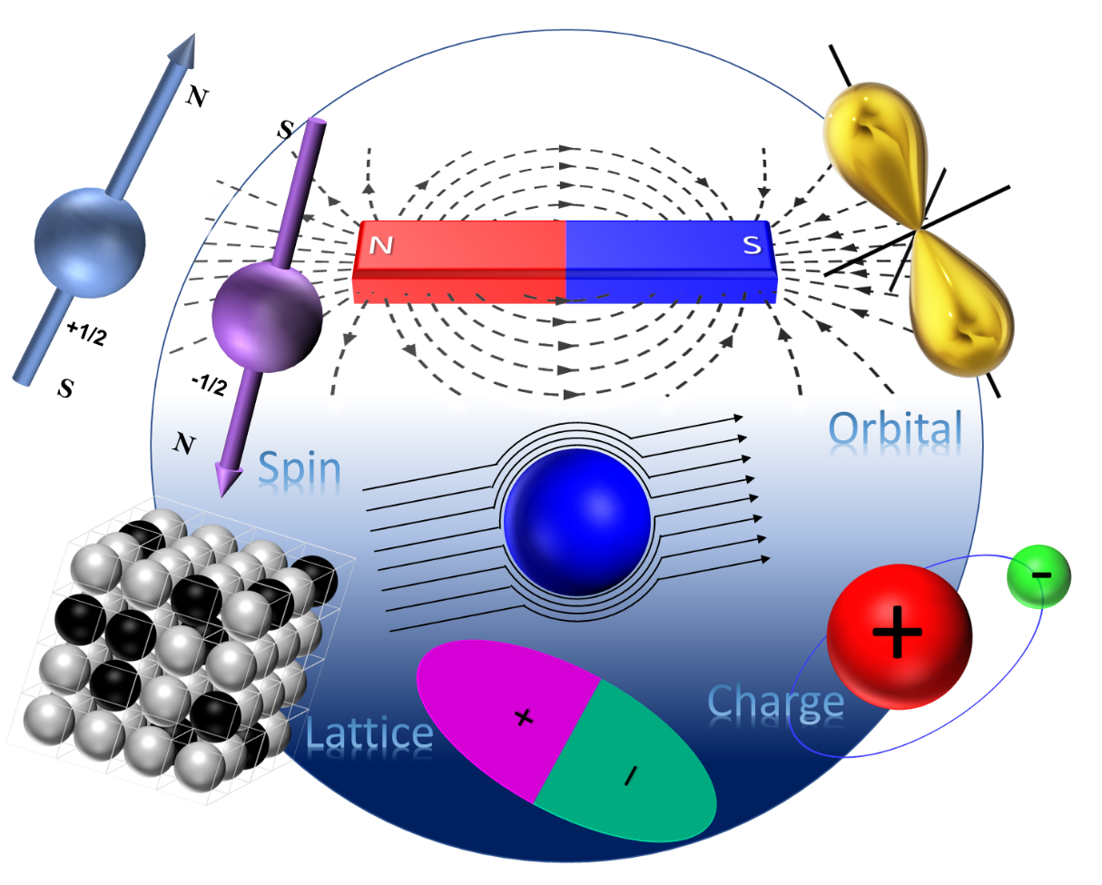**

**Figure 1.3** A graphical representation of degrees of freedom (D.O.F.).

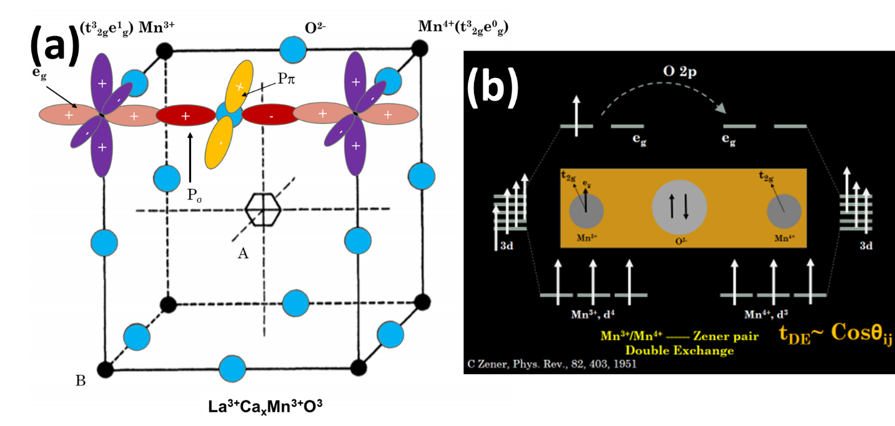

**Figure 1.4** Pictorial representation of double exchange phenomena in LCMO (a) (b).69

In these perovskite manganites, the Mn+3/Mn+4 ratio leads to the transition from an insulator to a metallic property (IMT) and further to the magnetic phase transition of the material at temperatures above ambient.70 Instead of divalent alkaline earth metals, substituting half of the La+3 with monovalent alkali metal ions in these rare earth manganites has the potential to achieve equal amount of hole doping; since the hole density becomes twice that of divalent ion doping for a similar amount of monovalent dopant used.71 As well increases the exchange integral, θij allowing for double exchange and a more ferromagnetic material (**Figure 1.4**). However, the synthesis of such monovalent alkali ion-doped materials raised huge practical concerns due to their high rate of evaporation.72 This resulted in very poor control being exerted on the composition of the final product. This further paved the way for the use of alkali halide fluxes for controlled crystal growth and was tested in (LaX)MnO3 type materials where X could be appropriate monovalent alkali ions such as Na or K.73 This use of fluxes enhanced the rate of diffusion in these solid-state reactions, thus facilitating the crystallization of the final product at comparatively lower reaction temperatures of 700 °C – 900 °C. The perovskites synthesized by this technique; namely. LaNaMnO3 and LaKMnO3 showed a ferromagnetic transition Tc above ambient temperature.(74)

Knowledge of crystal growth mechanisms and how different reaction parameters affect their morphology is important to effectively synthesize the material with its desired properties for the desired activity.75 This has been the reason why there have been countless attempts by researchers around the world to effectively synthesize materials with a morphology that exhibits a corresponding activity. Solid-phase chemistry has largely dominated the synthesis of these transition-metal perovskite materials to date because of their simplicity, feasibility, and convenience.76 The traditional mode of synthesis of these wondrous materials has been solid-state chemistry at reaction temperatures ranging from 600 °C to 1,000 °C.(71,77–79) However, precise control of the local stoichiometry in low-dimensional ternary or quaternary component systems such as these lanthanum-based materials is very difficult at high temperatures.77

Surprisingly, very limited attention has been paid in understanding the mechanism of formation of these wondrous CMR materials such as lanthanum-based oxide perovskites such as LaKMnO3 (LKMO). On the other hand, the high reaction temperatures involved could probably have been the reason why it has hitherto been difficult to achieve different morphologies such as cube, rod, wire, and truncated shapes in these lanthanum-based transition metal perovskite materials. Furthermore, there are no satisfactory explanations for how the different reaction parameters affect the nucleation process or the resulting size and morphology of the materials.(75)

Solution-phase synthesis has been largely overlooked, particularly in the domain of synthesis of these types of nanomaterials. With the ability to better control nucleation and morphology even at high reaction temperatures, solution-phase chemistry is an extremely lucrative option for the controlled synthesis of nanomaterials, where controlling the size and morphology is crucial to exhibit the desired magnetic and electrical properties. Lanthanum transition metal-based perovskites, LnTmO3 or LnATmO3 alkaline earth metal doped/substituted materials (Ln=La; Tm=Cr, Mn, Fe, Co, Ni & Al; A=Na, K, Ba, Sr) have not been explored by solution-based chemistry. In complex systems such as these involving more than two components, simple kinetic products with AO or BO phases dominate as well as the desired complex thermodynamically stable products with ABO3 structures; within the same given reaction time.(80) In such scenarios, more important and desirable than reaction time or feasibility is the precise control of the nucleation step; so that the synthesis is better channelled. Solution chemistry offers this precise control and fidelity in synthesis than any other synthesis chemistry has shown to be inadequate.

Hydrothermal treatment has been a widely used technique for performing solution-phase synthesis since times immemorial.(81) This is because of the advantages it offers such as: a small reaction volume, access to high temperature and pressure conditions in a safe manner, and the option that comes closest to scalability. In addition, the process is generally safe, environmentally friendly, energy efficient, and inexpensive.

The aim of this current work was to address the crystal phase transitions through synthetic techniques that have not yet been explored and reported at lower temperatures to the best of our knowledge; and to investigate how different reaction parameters affect the morphology of these materials. LaKMnO3 perovskite oxide microcubes with excellent ferromagnetic and electrical properties were successfully synthesised, characterised, and applied using a viable, safe, energy-efficient, environmentally friendly, low-cost, low-temperature solution-phase hydrothermal synthesis. In addition, it has been thoroughly studied how various reaction parameters such as alkali concentration (KOH), precursor concentration (La), precursor metal ratios (La/Mn), and reaction time play important roles in determining the size, morphology, and nucleation processes of the formation of these materials. A plausible mechanism of formation of this LKMO phase has been proposed, along with a clear elucidation of how altering the mechanism of nucleation from homogeneous to heterogeneous can help in achieving morphological control over the nature of materials synthesized. Interestingly, it was also proven that this strategy is generic and could be applied to the controlled synthesis of other similar perovskite materials such as LaCrO3 and LaFeO3.

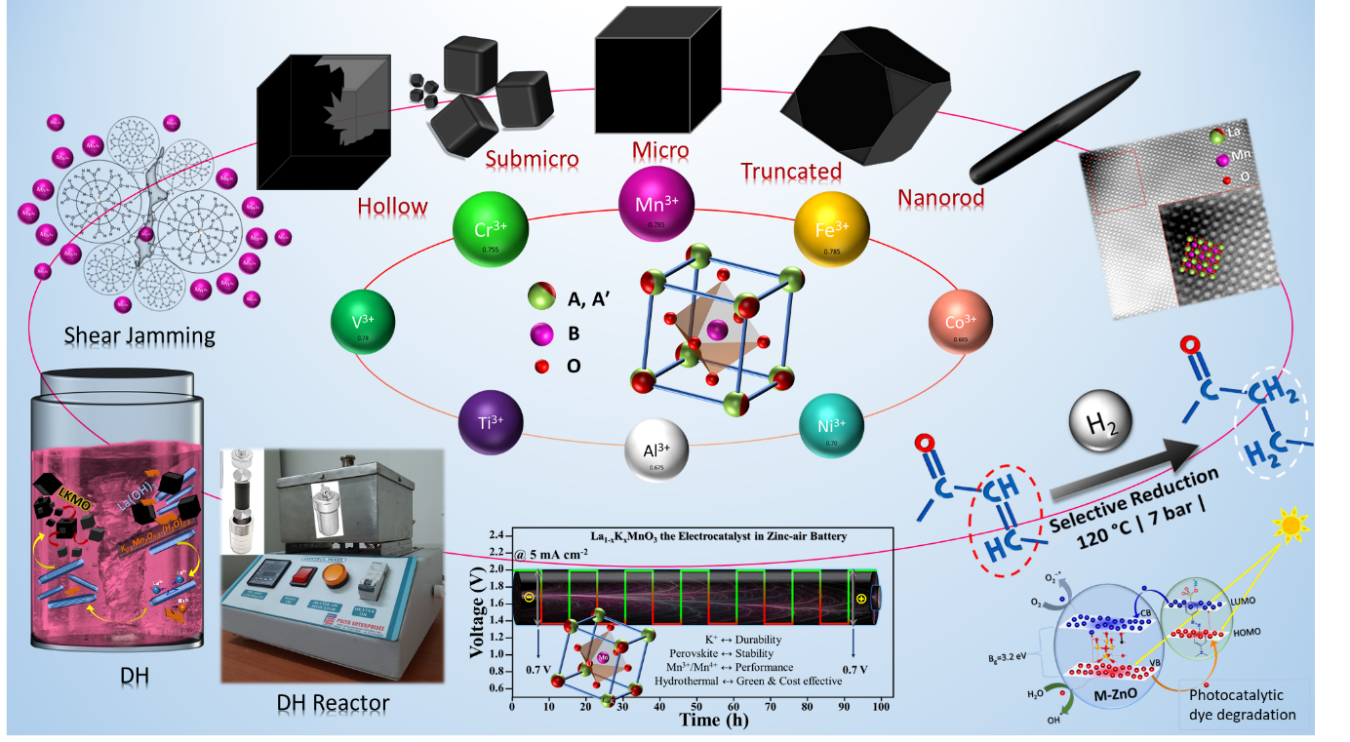

**Figure 1.5** An overall graphical representation of this thesis; showing various LKMO morphologies that we have synthesised thus far, nucleation mechanism studied, catalytic applications studied.

Aside from using a precursor for secondary nucleation or heterogeneous nucleation, in-situ stirring proves to improve the kinetics over normal static hydrothermal processes. This is known as the dynamic hydrothermal (DH) process. The DH method has shown several improvements, including improved kinetics, lower reaction temperatures, new morphologies, and controlled sizes, and it also allows us to understand the effect of stirring on nucleation. Truncated cubes and one-dimensional structures such as nanorods could be synthesized using this DH method, which could be useful for catalysis and for the transport studies. In addition, the DH method was successful in synthesising double perovskites such as La2-xKxBMnO3 (B = Cr, Fe, Ni). Because of the presence of two transition metals, which are responsible for the overall chemical property of the catalyst, these have demonstrated improved catalytic activity. This is because the 3d orbital of the B-site transition metals dominates the valance band and conduction band of perovskite materials. The lack of theoretical/thermodynamic models for lanthanum-based ternary systems is a challenge in this field. With many advancements, solution-based synthesis has proven to be a viable controlled method of synthesis. The LKMO microcubes produced have demonstrated high stability and bifunctional electrocatalytic activity. Also demonstrated improved activity and selectivity in the reduction of pharmaceutically important organic molecules. With controlled synthesis, a pseudo-cubic phase LKMO material with enhanced magnetic properties was obtained, which would have been difficult to obtain under normal conditions. This high-symmetry phase has the potential to exhibit a strong magnetocaloric effect, MCE. In their two-probe device IV-characteristics, the LKMO nanorods demonstrated Poole-Frenkel type defect/trap assisted electrical conductivity.

The LKMO microcubes electrocatalytic activity has been discussed in zinc-air battery. Also, the catalytic reduction of organic molecules has been discussed. Apart from the perovskite oxides hydrothermal synthesis could synthesize photocatalytically ZnO nanoparticles doped with chemically hard elements.

Finally, all of these materials have been tested and proven to have excellent electrical and magnetic properties. This low temperature solution-phase hydrothermal synthesis opens up enormous possibilities for the preparation of a wide range of complex systems with precise control over nucleation, phase, size, crystallinity, and morphology; this, in turn, broadens the horizons for studying one-dimensional surfaces and interfaces to reveal unique physical, electrical, mechanical, and electrochemical properties.

# Static hydrothermal synthesis: controlled nucleation and growth

**Static hydrothermal synthesis: controlled nucleation and growth**

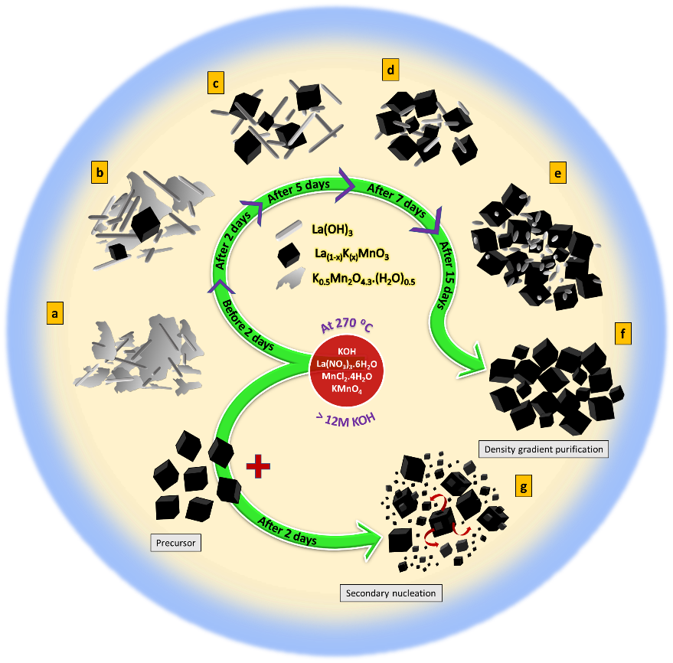

This chapter describes the impact of static hydrothermal synthesis on obtaining different phases (LaCrO3, LKMO, and LFO) and morphologies (micro, nano, cubes) of lanthanum-based oxide perovskites.

## Abstract

Lanthanum-based perovskite oxides (LPOs) with desired facets and small sizes hold great promise for a wide range of heterogeneous catalytic applications. They are frequently formed in basic hydrothermal conditions. The synthesis typically yields several micron-sized crystals, with a total reaction time ranging from 5 to 14 days. The nucleation and growth of LPOs are poorly understood, both experimentally and theoretically. In this study, we report on the synthesis of La1-xKxMnO3 (LKMO) using a low-temperature (265 °C) hydrothermal technique and investigate the growth mechanism. When reaction parameters (reaction temperature, KOH concentration, precursor amount, and time) are optimised, selectively faceted microcubes with sizes ranging from 3 to 30 microns are produced. The nucleation of LKMO is affected by both the reaction temperature and the KOH concentration. The nucleation of LKMO is affected by both the reaction temperature and the KOH concentration. The amount of K+ incorporation in LMO changes as the KOH concentration in the reaction changes, as do the crystal structure and magnetic properties. The reaction produces K0.5Mn2O4.3.(H2O)0.5 at a lower KOH concentration (8 M). The above phase dissolves as the KOH concentration increases, while La(OH)3 crystallises. The inverse relationship between the solubility of the byproducts La(OH)3 and K0.5Mn2O4.3.(H2O)0.5 during the reaction limits the simultaneous availability of La and Mn ions in the solutions for burst nucleation. The current study demonstrates that the crystallization neither follows the classical LaMer model (nucleation followed by diffusion-controlled growth) nor two-step Watzky and Finke model (nucleation and growth are temporally overlapped). We propose a mechanism called temporally separated crystallization (nucleation and growth), in which the nucleation and growth of each (set of) crystal/s formed in the reaction are temporally separated. Time-dependent studies indicate that the reaction goes through a prolonged primary nucleation step, followed by rapid crystal growth and secondary nucleation. Furthermore, the addition of the pre-synthesized cubes promoted secondary/heterogeneous nucleation, reducing the overall reaction time from 7 days to 2 days and yielding submicron cubes. The hydrothermal synthesis is extended further to yield microcubes and submicron cubes (25-450 nm) of LaCrO3 and (≈180 nm) LaFeO3. The current method could aid in the synthesis of nanocrystals of other lanthanum-based perovskite oxides and the investigation of their size and facet-dependent properties.

## Introduction

Lanthanum-based transition metal perovskite oxides (LPOs) have remained an extremely important category of materials due to their significant properties such as superconductivity82 (SC), colossal magnetoresistance83,84 (CMR), catalysis85–89, supercapacitance,90,91 and electrode for solid oxide fuel cells92,93. Their unique inherent phenomena such as charge, spin, and characteristic orbital ordering have compelled the recent past to witness a tremendous surge in the research of doped lanthanum-manganese oxide-based (LMO) perovskite materials.94 The structural stability of perovskites with respect to the oxidation state of the metal, substitution with other elements, and oxygen non-stoichiometry are unrivalled. In the ABO3 structure, the transition metal site (B) is usually catalytically active. The catalytic ability of perovskites includes oxidation, reduction, redox, combustion, eliminating volatile organic compounds, to name a few.85 Perovskites with desired planes exposed are also considered as substitutes for noble metals for heterogeneous catalysis.95,96 However, the use of perovskites to its full potential in catalytic reactions is limited due to the inability to make them in low-dimensions with desired facets exposed.75

The conventional way of synthesizing perovskite oxides has been either through solid-state chemistry employing high reaction temperatures (> 800 °C) with several intermediate grindings71,77–79 or through flux-based methods using alkali halides/hydroxides.74,97–100 However, controlling the size, morphology, and uniformity of the crystals with smooth atomic surfaces is difficult through high-temperature methods, where nucleation is faster than growth. Solution-based methods are more energy-efficient and known to have better control over nucleation and growth as well as over morphology.101,102 Atomic flat surfaces can be achieved in solution-based synthesis, which is a result of slow nucleation compared to growth.101 It also offers control over doping and substitution of perovskites oxides.102

The hydrothermal methods have been applied to synthesize various ceramic oxides in the last two decades. This technique is energy-efficient and allows reactions at high concentrations of acids and bases.38,102,103 The ionic mobility in this technique is controlled by the dynamic interaction of various parameters such as type of solvent, temperature, and pressure.103 Hydrothermal method is the only solution-based method that has been shown some success to synthesize lanthanum-based perovskite oxides (LPOs).81 This technique has been used for the synthesis of divalent cations (such as Ba104,105, Sr106–109, and Ca106) substituted LMO and also shown the morphology tuning. However, this technique could not be extended to the monovalent substituted LMO or other LnTmO3 perovskites or their substituted analogise where Ln=lanthanides; Tm=Cr, Mn, Fe, Co, Ni & Al. Hydrothermal synthesis of LnCrO3 (Ln=La, Pr, Nd, Sm, Er, Tm, Yb, Lu), LaFeO3 usually produces several (1-30) micron-sized crystals with a reaction duration of 3-14 days.110–113 Thus, the synthesis inhabits to use size and facet dependent catalytic properties of LnTmO3. Hence, use of these materials in polarity dependent activities including facet dependent functional electronic components, spatial parting of photogenerated electrons and holes, gas sensors and photocatalysts are limited.75 Moreover, there has been no satisfactory explanation on how the different reaction parameters affect the nucleation process or no thermodynamic models that could predict the crystal growth kinetics103. Further, the inability to identify temporal size evolutions in the growth stage suggest that the nucleation of LaTmO3 in hydrothermal conditions does not follow the classical LaMer model114,115, which indicates burst nucleation trailed by diffusion-controlled growth of surviving nuclei. Employing high concentration of bases for crystallizing LaTmO3 could corrode the reaction vessel; thus, it is also essential to develop hydrothermal synthesis technique below 280 °C so that Teflon can be used as a reaction vessel. Therefore, there is a need to understand these systems' nucleation and growth to synthesize small crystals under mild conditions further.

The recent past has compelled to witness a tremendous surge in the research of doped lanthanum-manganese oxide-based (LMO) perovskite materials for their unique inherent degrees of freedom.94 The divalent doping changes the oxidation state of manganese from Mn+3 to Mn+4. The appropriate Mn+3/Mn+4 ratio leads to an insulator to metallic transition (IMT) and simultaneously to the ferromagnetic transition below a transition temperature.70 On the other hand, substituting monovalent alkali metal such as Na+ or K+ at the La+3 cites in LaMnO3 generates two equivalent of hole doping per unit formula.71 It has been believed that during the synthesis of manganite, the K+ is weakly attached to the surface of MnO6 octahedra, which is replaced by the La3+ in the subsequent growth of another unit cell on the surface.116 We have realized something different is happening. As per the literature, there are plenty of reports concerning the Mn3+/Mn4+ mixed-valence, cation vacancies, or oxygen hyper-stoichiometry such as intrinsic complexity in lanthanum manganites.117 Thus, to stabilize the perovskite phase of lanthanum manganite at low temperatures, the presence of K+ is helping, leading to the incorporation of it in the A-site.

In this work, we have synthesized a relatively large cation, K+, substituted LaMnO3 microcubes through a low-temperature hydrothermal synthesis. We systematically explored different reaction conditions (including temperature, alkali (KOH) concentration, precursor (La) concentration, precursor metal ratios (La/Mn), and reaction time) to understand the nucleation and growth of lanthanum-based perovskite oxides by taking LKMO as a model system. The plausible mechanism of formation of this LKMO phase has been proposed. We have extended this method to synthesize LaCrO3 and LaFeO3 microcubes. We have observed a decrease in average particles size with increasing reaction duration, revealing the domination of secondary nucleation at extended times. Which suggest that crystallization of these systems does not follow existing nucleation and growth models (classical LaMer model or Watzky and Finke model) completely. The formation of side products (La(OH)3 and K0.5Mn2O4.3.(H2O)0.5) during the reaction limit simultaneous availability of La and Mn ions in the solutions for burst nucleation. We propose a plausible step-wise crystallization mechanism, where different crystallization events are temporally separated. Secondary or heterogeneous nucleation has already been thoroughly explored to decrease the kinetic barrier of the nucleation process.102 Still, this phenomenon has not been extended to lanthanum-based perovskite oxides. Thus, adding pre-synthesized cubes of the same materials or SrTiO3 nanoparticles at the beginning of reactions is explored to understand the effect of secondary/heterogeneous nucleation on particles sizes of the end product. We have observed, the formation of well faceted submicron crystals of LaKMnO3, LaCrO3, LaFeO3 and decreased overall reaction time from 7 to 2 days. Further, we have also studied the magnetic and electrical properties of LKMO microcubes obtained at two different KOH concentrations. The phase analysis revels that this method of synthesis is a more controlled one to obtain higher symmetry (pseudo cubic) manganite.

## Existing issues

No thermodynamic models are available to study the thermodynamics and kinetics of lanthanum-based ternary systems. As a result, there is a scarcity of information about these systems.

Because much of their synthesis was application-oriented and required enormous activation energies, solid-state synthesis methods were preferred till date.

Without the knowledge to control crystallisation, it is impossible to probe size, shape, and facet dependent properties.

## Objectives & Action plan

1. Obtaining the perovskite phase for lanthanum manganite, chromite, and ferrite using the static hydrothermal (SH) method.
2. To accomplish this, we must optimise the mineralizer (KOH) concentration.
3. The concentration and ratio of the precursors must be optimized.
4. Reaction time, temperature, and knowledge of stirring and sonication times are required.
5. Reduce the size of the single-crystal microcubes of these materials to submicron levels.
6. This necessitates understanding of the nucleation and growth processes of these materials.
7. It is necessary to closely monitor the reaction process as the reaction parameters change.
8. We have devised some techniques to overcome the existing barriers resulting from the above knowledge.
9. Fine-tune the reaction conditions further to mold the morphology of these materials and obtain nanorods.
10. Use of surfactants to control the morphology in the nucleation.
11. Using seeds to direct the crystallization into anisotropic growth.

## Materials and Methods

### Materials

All metal salts used in the experiments, viz. La(NO3)3.6H2O, MnCl2.4H2O, Cr(NO3)3.9H2O, Fe(NO3)3.6H2O, Sr(NO3)2.4H2O, Ti (OC3H7)4 (TtiP) were purchased from Merck (AR 99%) and employed as such in the experiments performed. Potassium salts KMnO4 and K2Cr2O7 were purchased from Merck (AR 99%) and used as such. KOH was purchased from Merck (AR 99%) and used as such. Ethanol (Emparta, Merck, ACS) and Milli-Q water were used for the post-reaction workup. No other purification was performed on any of the chemicals. While weighing, hygroscopic materials (La(NO3)3.6H2O) and pyrophoric chemicals (KMnO4) were handled with care to ensure minimal exposure to the atmosphere. All of the hydrothermal reactions described in this chapter were carried out in a 25 ml Teflon autoclave container.

### Synthesis

#### Preparation of LKMO microcubes:

The perovskite La1-xKxMnO3 (LKMO) microcubes were synthesized using a low-temperature hydrothermal method, which is similar to the approach adopted in the literature.106,108,118 In a typical synthesis, La(NO3)3.6H2O, MnCl2.H2O, and KMnO4 are taken into a beaker containing 2-5 ml of Milli Q water in a molar ratio of 1:0.7:0.3 (under variation of the equivalents from 1 to 8 millimoles). These reagents are dissolved in water by stirring until a homogenous solution is formed. The above solution is transferred into a 25 ml Teflon-based autoclave. Subsequently, 10 ml aqueous KOH is added into the reaction mixture such that the resultant final concentration of KOH varies from 9 to 18 м and is allowed to undergo stirring for 20-24 hours. The hydrothermal reaction is performed by heating the autoclave at 265 °C under autogenous pressure for different periods of time ranging from 20 hours to 15 days (**Table 2.1**). After completion of the reaction, the supernatant is decanted, and the resultant solid precipitate is washed thoroughly with MilliQ water and ethanol until the pH is found neutral. The product is dried at 70 °C for 12h. The reaction yields LKMO microcubes as a major product and La(OH)3 nanorods as a minor product. These lighter minor products have been separated from the heavier product in the workup process itself by using the concept of density gradiation.

#### Separation of La(OH)3 nanorods from LKMO

The La(OH)3 rods (a byproduct of the above reaction) were separated by either of the two following methods:

##### Treatment with oxidant

The as-synthesized compound containing LKMO microcubes and La(OH)3 nanorods (80 mg) is transferred into a 25 ml Teflon autoclave having 15 ml H2O2 solution (30% w/v) under stirring. After allowing the mixture to stir overnight, it was subjected to hydrothermal treatment at 180 °C for 12 hours to dissolve the La(OH)3 nanorods. The resultant precipitate was washed several times with water to eliminate the excess oxidant and other unreacted materials and dried at 70 °C in ambient conditions.

##### Density-based separation of La(OH)3 nanorods from the LKMO microcubes

The difference in densities was used to separate the LKMO microcubes from the La(OH)3 rods. 100 mg of as-prepared solid powder (containing a mixture of LKMO microcubes and La(OH)3 rods) is sonicated for a few minutes before letting it settle naturally for 5 minutes. The heavier LKMO microcubes sank to the bottom, leaving the relatively lighter La(OH)3 rods. The greyish-white supernatant formed by these rods was decanted from the heavy solid precipitate containing LKMO microcubes. This procedure was repeated until a clear transparent supernatant was obtained, indicating that La(OH)3 rods had been completely separated from the LKMO microcubes. This was then dispersed in ethanol to separate any remaining La(OH)3 rods and kept for drying. This separation's obtained phase purity was then tested using PXRD and SEM characterizations. Compared to the above H2O2 method (**Figure 2.2**(**c)**), this density-based separation (**Figure 2.2**(**b)**) method is much safer and easier.

#### Preparation of LaCrO3 microcubes

In a similar hydrothermal condition, we have also synthesized LaCrO3 microcubes starting from La(NO3)3.6H2O, Cr(NO3)3.9H2O, and K2Cr2O7 are taken in a molar ratio of 0.5:0.7:0.3 (of 1 millimoles equivalent). A precaution that was taken particularly to prevent Chromium from getting oxidized in the atmospheric air; was to ensure as little stirring as possible, thus preventing too much subjection to the atmosphere. An aqueous KOH solution was added into the above mixture under stirring until the resultant final concentration of solution reached 9 м. This was finally hydrothermally treated at 265 °C for 5 days. After completion of the reaction, the supernatant is decanted, and the resultant solid precipitate is washed thoroughly with MilliQ water and ethanol until the pH is found neutral. The product is dried 70 °C for 12h. The reaction yields LaCrO3 microcubes as the major product.

#### Preparation of LaFeO3 microcubes

In a similar hydrothermal condition, we have also synthesized LaFeO3 microcubes starting from La(NO3)3.6H2O and Fe(NO3)3.9H2O are taken in a molar ratio of 1:1 (of 1 millimoles equivalent) into a 25 ml Teflon container. An aqueous KOH solution was added into the above mixture under stirring until the resultant final concentration of solution reached 12 м. This was finally hydrothermally treated at 265 °C for 5 days. After completion of the reaction, the supernatant is decanted, and the resultant solid precipitate is washed thoroughly with MilliQ water and ethanol until the pH is found neutral. The product is dried 70 °C for 12h. The reaction yields LaFeO3 microcubes as the major product.

#### Synthesis of LKMO submicron cubes: using LKMO microcubes precursor

At first, 20mg of the LKMO microcubes was taken into a 25ml Teflon-based autoclave containing 2-3 ml Milli Q water. Into this La(NO3)3.6H2O, MnCl2.H2O, and KMnO4 are taken in a molar ratio of 1:0.7:0.3 (of 5 millimoles equivalent) and stirred until a homogenous solution formed. This reaction mixture was then subjected to the addition of aqueous KOH until the resultant final concentration of solution reached 18 м and then allowed to stir for 24 hours. This was then hydrothermally treated at 265 °C for 2 days. After completion of the reaction, the supernatant is decanted, and the resultant solid precipitate is washed thoroughly with MilliQ water and ethanol until the pH is found neutral. The product is dried 70 °C for 12h.

#### Synthesis of LaCrO3 submicron cubes: using LaCrO3 microcubes precursor

Initially, 20-30mg of thoroughly cleaned LaCrO3 microcubes, which were synthesized in the first batch, were taken into a clean 25ml Teflon container. Into which 2-3ml Milli Q water was added and sonicated for 20-30 mins for nice dispersion. Into this La(NO3)3.6H2O, Cr(NO3)3.9H2O, and K2Cr2O7 are taken in a molar ratio of 0.5:0.7:0.3 (of 1 millimoles equivalent) and stirred for 10 mins. Then KOH was added into the above mixture under stirring until the resultant final concentration of solution reached 18 м. This was hydrothermally treated at 265 °C for 2-7 days. The obtained product was multiply washed with Milli Q water until the pH became neutral. Finally, one round of workup was done with ethanol and kept for drying at 70 °C overnight.

#### Synthesis of SrTiO3 nanoparticles

By means of solvothermal reaction, we have synthesized STO nanoparticles using three different molar ratios of Ti ions in Ti (OC3H7)4 and Sr ions in Sr(NO3)2 as starting materials. The Sr/Ti atomic ratios were taken as 1:1, 1:1.5, and 1.5:1. After dissolving 1.47.9 µL of Ti(OC3H7)4 in 5 mL of 2-propanol, 105.7 mg Sr(NO3)2 and 5 mL of 2 м KOH aqueous solution were slowly added while stirring. Then this solution was transferred into an autoclave. Then in another autoclave, we had varied the amount of Sr(NO3)2, which is 221.84 µL, except that every other thing was the same as the previous one. Thirdly, we had changed the quantity of Ti(OC3H7)4 to 158.58 µL while keeping others as same. Then all the three autoclaves were kept under oven at 200 ⁰C for 15 h.119 After cooling, and the samples were centrifuged, washed with Milli-Q water repeatedly until the pH came down to neutral, and then dried in an oven at 60 ⁰C overnight.

#### Synthesis of LKMO submicron cubes: using STO nanoparticles as precursor

20mg of the thoroughly washed STO nanoparticles sample was taken into a 25ml Teflon-based autoclave containing 2-3 ml Milli Q water. Into this La(NO3)3.6H2O, MnCl2.H2O, and KMnO4 are taken in a molar ratio of 1:0.7:0.3 (of 5 millimoles equivalent). This solution was stirred and sonicated until a homogenous solution formed. This reaction mixture was then subjected to the addition of aqueous KOH until the resultant final concentration of solution reached 18 м and then allowed to stir for 24 hours. This was then hydrothermally treated at 265 °C for 2 days. After completion of the reaction, the supernatant is decanted, and the resultant solid precipitate is washed thoroughly with MilliQ water and ethanol until the pH is found neutral. The product is dried 70 °C for 12h.

#### Synthesis of LaFeO3 submicron cubes: using STO nanoparticles as a precursor

Initially, 20-30mg of thoroughly cleaned STO nanoparticles were taken into a clean 25ml Teflon container. Into which 2-3ml Milli Q water was added and sonicated for 20-30 mins for nice dispersion. Into this La(NO3)3.6H2O, Fe(NO3)3.9H2O are taken in a molar ratio of 1:1 (of 1 millimoles equivalent) and stirred for 10 mins. Then KOH was added into the above mixture under stirring until the resultant final concentration of solution reached 12 м. This was finally hydrothermally treated at 265 °C for 2 days. After completion of the reaction, the supernatant is decanted, and the resultant solid precipitate is washed thoroughly with MilliQ water and ethanol until the pH is found neutral. The product is dried 70 °C for 12h. The reaction yields LaFeO3 microcubes as the major product.

### Characterization

Components present in the synthesized materials were characterized through Powder X-ray Diffraction (PXRD) using a Panalytical Empyrean diffractometer system with CuKα (λ=1.5418 Å) with large beta-filter Nickel to filter the Kβ lines. Samples for the XRD analysis were prepared by packing onto the depression of a quartz slide. Morphology of the materials was studied through Field Emission Scanning Electron Microscopy (FESEM, *Carl Zeiss*). Elemental composition and distribution in the materials were studied by Energy Dispersive Spectroscopy (EDS) mapping. The sample for SEM and EDS analysis was prepared by taking less than 1 mg of the powder product, crushing mildly to ensure the absence of lumps, and sticking it to carbon tape on the SEM sample stub. Further, nitrogen was blown on the surface to ensure that no loose powders got into the polepiece; imaged and analyzed without coating. Magnetoresistance and resistivity of the synthesized materials were studied by the 4-probe resistivity measurement method. Around 2.5 g of the pure LKMO microcubes sample was compressed into a pellet through the hot press method at 800 °C. Piezoelectric response of the synthesized materials was tested on the Asylum/Oxford MFP3D origin Atomic Force Microscopy (AFM) machine in Piezo Force Microscopy (PFM) contact mode. The individual sample cubes were mounted onto an elastomeric matrix for a better hold for an unwavering and firm contact of the former with the PFM tip. The piezoelectric response of the synthesized materials was measured by applying DC bias in the range of -5V to +5V; and measuring triplicates on five different locations on each cube on a 5 µm X 5 µm area. Temperature-dependent magnetization of the peroxide-washed sample of LKMO was measured using the Quantum Design, USA PPMS Vibrating Sample Magnetometer (VSM) at 300 Oe with field and zero-field cooling (FC and ZFC). For qualitative and quantitative elemental information X-ray photoelectron spectroscopy (XPS) was carried out using Kratos Analytical, UK (AXIS Supra). Monochromatic Al K-alpha of 75 W was used as the x-ray source. The survey and high-resolution scans were done at 160 eV and 20 eV pass energy with ≈2 eV and ≈0.5 eV resolution, respectively. Charge corrections were performed with respect to the C 1s peak at 284.8 eV. Ultraviolet Photoelectron Spectroscopy (UPS) was done using the same above AXIS Supra, Kratos Analytical, UK facility. TEM, HRTEM, ED, and STEM\_EDS characterizations are performed with a FEI Tecnai G2, F30 microscope operating at 300 kV (resolution: point 2 Å and line 1 Å) equipped with a EDAX Octane ELITE T70, BF/DF STEM-HAADF detector. For TEM analysis the powder samples dispersed in a 1 ml Eppendorf tube using iPA solvent and ultrasonically dispersed for 0.5 to 1 hr. The fine dispersed TEM sample looks transparent. One to two drops of this dispersion deposited on the dark side of a carbon coated copper grid balanced in specialized swiss self-closing antimagnetic SS tweezer under IR-lamp.

## Results and Discussion

### Effect of temperature

The hydrothermal synthesis to make perovskite oxides in the literature adopted temperatures between 100 °C to 374 °C.(80) However, the reactions carried out in this work at temperatures below 240 °C yielded only La(OH)3 nanorods and K0.5Mn2O4.3.(H2O)0.5 sheets of birnessite-such as phase. The formation of the birnessite-such as phase was also observed in the literature.(60) The formation of the LKMO phase is observed only when the reaction temperature is above 260 °C.

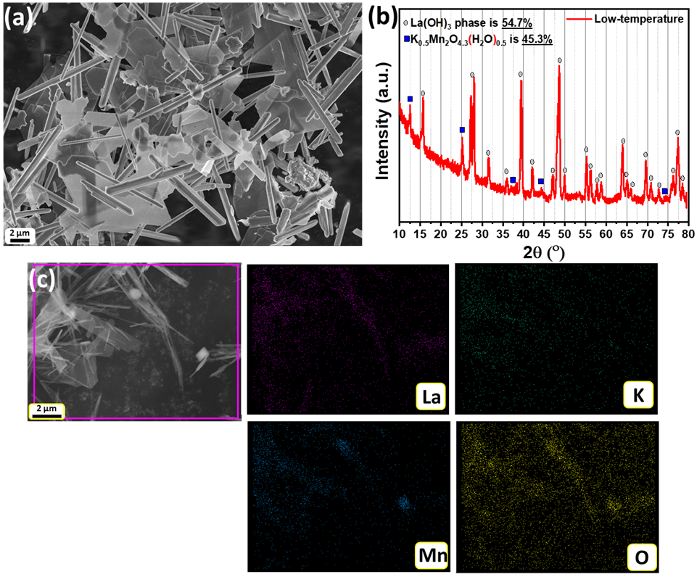

**Figure 2.1** (a) SEM image and (b) XRD pattern and (c) EDS mapping indicating the elemental distribution of by-products obtained at 240 °C which are La(OH)3 rods and K0.5Mn2O4.3.(H2O)0.5 sheets of birnessite-like phase.

**Figure 2.1** shows the SEM images of the different products other than that indicative of the LKMO phase obtained. Hence, following this observation, all the hydrothermal syntheses carried out further in this work (**Table 2.1**) were at a fixed temperature of 265 °C. The reaction temperature close to the hydrothermal reactor is also monitored by an external thermometer, and this temperature varies between 264-266 °C during the reaction.

### Morphological and structural characterization of LKMO microcubes

The SEM image is shown in **Figure 2.2**(**a)** of as-synthesized LKMO microcubes. The sizes of LKMO microcubes range from 2.0 to 23.0 µm with an average size of 11.0 µm. Size distribution of the cubes is presented as a histogram in **Figure 2.2**(**d)**. (By tuning the reaction conditions, we can vary the size of the cubes from 0.5 to 30 µm.) The above reaction also yields La(OH)3 nanorods along with LKMO microcubes, as can be seen from **Figure 2.2**(**a)**.

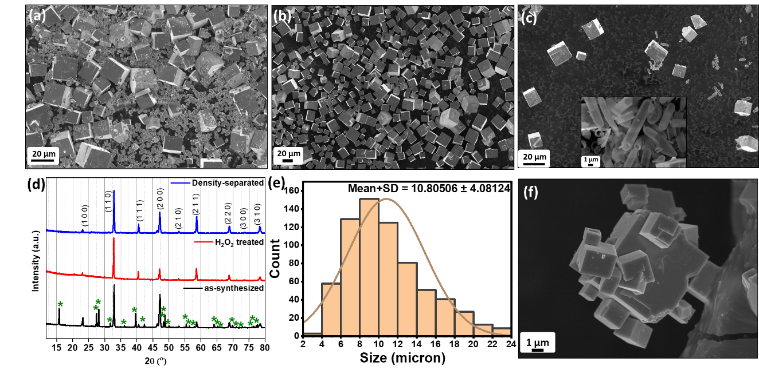

**Figure 2.2** (a) Typical SEM image of as-synthesized LKMO sample, (b) the size-distribution histogram with an average size of the LKMO cubes ≈11 microns, (c) SEM image of LKMO sample after separating the by-products via density-separation method, (d) SEM image of LKMO sample after separating the by-products via H2O2 treatment inset showing the supernatant containing degraded by-products, (e) XRD pattern of the LKMO microcubes obtained via hydrothermal treatment at 265 °C for 7 days with [KOH] = 18 м at 5mmol [precursor] and RLa/Mn = 1.0, (f) growth of smaller cubes on the externally added LKMO cubes as a precursor.

Post-synthesis separation of the La(OH)3 nanorods from the LKMO microcubes is achieved by density-based separation as well as by H2O2 treatment. **Figure 2.2**(**b** and **d)** show SEM images of LKMO microcubes after efficient removal of La(OH)3  nanorods using density-based separation and H2O2 treatment, respectively. Powder XRD analysis of the as-prepared samples reveals the formation of crystalline LKMO and La(OH)3 phases (**Figure 2.2**(**d)**). XRD patterns recorded after the separation techniques indicated the absence of La(OH)3 phase (**Figure 2.2**(**d)**). As shown in, it is clear that the obtained LKMO shows rhombohedral R-3cH crystal structure; the prominent XRD peaks at 33.12°, 40.77°, 47.4°, and 58.87° can be assigned to the (110), (111), (200), and (211) facets of the standard LKMO crystal, respectively. Among the two separation techniques, the density-based technique is easy to implement and effectively separates La(OH)3 nanorods from LKMO microcubes, which is evident from both the SEM image (**Figure 2.2**(**b)**) and XRD patterns (**Figure 2.2**(**d)**).

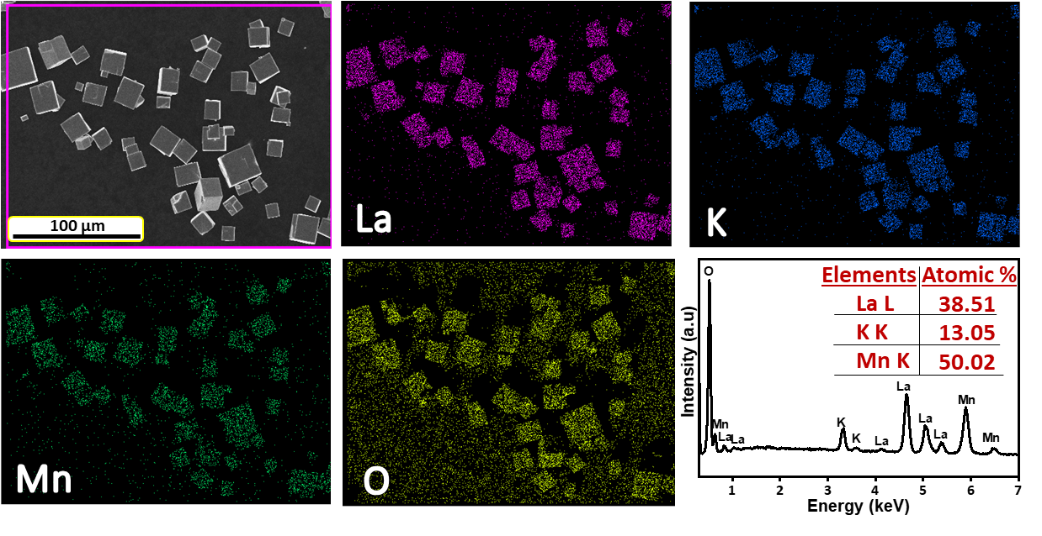

**Figure 2.3** EDS elemental mapping and EDS spectrum indicating the elemental composition of the LKMO microcubes after removal of the La(OH)3 nanorods by density-based separation

The SEM micrograph entirely accords to the images of the EDS mapping (**Figure 2.3**) of La, K, Mn, and O atoms. All the atoms are homogeneously dispersed on the microcubes. The semi-quantitative EDS analysis (**Figure 2.13**) on microcubes shows the ratio of La:K:Mn as 0.77:0.26:1.0. The stoichiometry of the microcubes obtained in these experiments is calculated based on their individual atomic percentages. As there can be some trace K+ from the KOH left out on the surface of the cube thus we considered Mn as 100% stoichiometry and the difference between Mn% and the La% as the K% in the respective samples. The excess presence of oxygen in the data could be attributed to external atmospheric sources. The yield and amount of K+ substitution in the microcubes were found to be variant depending on the reaction conditions (described below). Though K+ is known to loosely bind the lattice because of phase stabilization at low temperatures, it’s incorporated here for the phase to form.

The initial experiments have produced LKMO microcubes with only a limited yield. The yield is improved by optimizing the reaction condition such as reaction temperature, KOH concentration, precursor concentration, precursor ratio, and reaction time. The experimental **Table 2.1** portrays a compilation of all the reaction parameters investigated along with a summary of their resultant yield and morphological data.

**Table 2.1** The details of the various experiments carried out to estimate the effect of various parameters; viz. K (mineralizer (KOH) concentration in M(mol/L)), P (precursor (La, Mn) concentration in mM), R (precursor ratio RLa/Mn,) and T (time taken for the reaction in days) at 265 ⁰C. The base value *K=18 м, P=5M, R=1 & T=7days* is the best-optimized values that correspond to the master entry in this table

|  |  |  |  |  |  |  |  |  |  |
| --- | --- | --- | --- | --- | --- | --- | --- | --- | --- |
| **Sample** | **[KOH]**  **(mol/L)** | **[Precursor]**  **in M**  **(mol/L)** | **RLa/Mn** | **Time**  **in days** | **XRD** | **SEM** | | | |
| **LKMO** | | **La(OH)3** | |
| **Phase %** | **Cube size (µm)** | **Length (µm)** | **Dia (µm)** | **Rod Aspect Ratio** |
| K0 | 0 | 5 | 1 | 7 | --- | --- | --- | --- | --- |
| K2 | 2 | 5 | 1 | 7 | --- | --- | --- | --- | --- |
| K5 | 5 | 5 | 1 | 7 | --- | --- | 1.94 | 0.32 | 5.27 |
| K7 | 7 | 5 | 1 | 7 | 7.2 | 0.68 | 1.65 | 0.45 | 3.50 |
| K8 | 8 | 5 | 1 | 7 | 13.1 | 5.5 | 1.83 | 0.57 | 3.25 |
| K9 | 9 | 5 | 1 | 7 | 26 | 7.87 | 2.07 | 0.83 | 2.91 |
| K12 | 12 | 5 | 1 | 7 | 64.1\* | 9.98 | 4.66 | 0.62 | 6.93 |
| K16 | 16 | 5 | 1 | 7 | 31.8 | 11.00 | 2.49 | 1.62 | 1.44 |
| **K18P5** | **18** | **5** | **1** | **7** | 99.8 | 28.96 | 2.17 | 1.25 | 1.65 |
| P8 | 18 | 8 | 1 | 7 | 93.4 | 14.81 | 2.15 | 1.08 | 1.87 |
| P1 | 18 | 1 | 1 | 7 | 62 | 4.76 | 6.07 | 1.37 | 4.50 |
| P1R0.67 | 18 | 1 | 0.67 | 7 | 79 | 12.81 | --- | --- | --- |
| T1 | 18 | 1 | 1 | 1 | 48.9\* | 1.60 | 3.94 | 0.98 | 3.99 |
| T2 | 18 | 1 | 1 | 2 | 50.4 | 4.63 | 5.47 | 1.49 | 4.14 |
| T3 | 18 | 1 | 1 | 3 | 54.3 | 4.80 | 5.77 | 1.01 | 6.16 |
| T4 | 18 | 1 | 1 | 4 | 69.9\* | 5.01 | 4.29 | 0.96 | 4.62 |
| T5 | 18 | 1 | 1 | 5 | 74.5\* | 5.30 | 4.92 | 1.17 | 4.21 |
| T6 | 18 | 1 | 1 | 6 | 100\*\* | 5.31 | 7.67 | 1.14 | 6.81 |

**Figure 2.4(a)** is the TEM image of an LKMO microcube, which exhibits the rhombohedral symmetry identified from selected area electron diffraction (SAED) shown in **Figure 2.4(b)**. Based on these findings, it is possible to conclude that the hydrothermal method used in this study produces a more crystalline LKMO phase than the solid-state method used in the literature.120

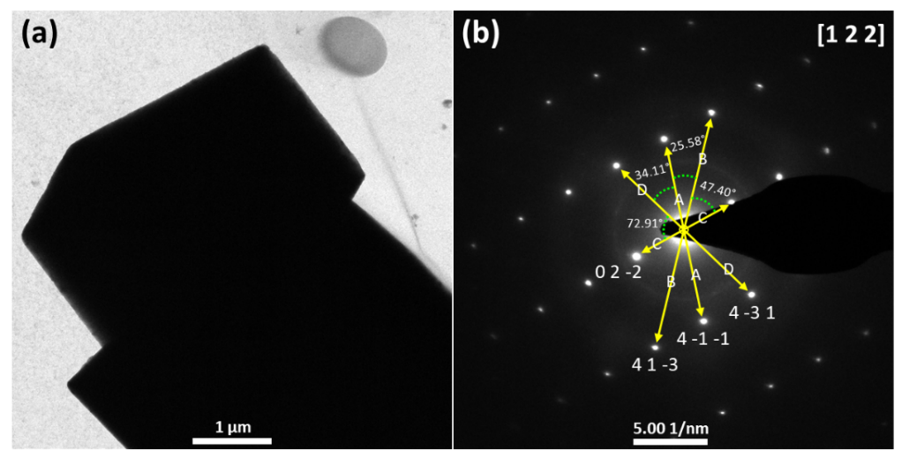

**Figure 2.4** (a) Typical TEM image of as-synthesized LKMO microcube and (b) SAED pattern along the [1 2 2] zone-axis, synthesized via hydrothermal treatment at 265 °C for 7 days with 18 м KOH at 5 mmol precursor concentration.

X-ray photoelectron spectroscopy (XPS) was carried out to investigate the chemical state of hydrothermally synthesized LKMO microcubes, as shown in **Figure 2.5**. The survey spectrum (**Figure 2.5(a)**) represents the presence of La, K, Mn, and O elements. **Figure 2.5(b)** shows the La 3d high-resolution spectrum with peak deconvolutions into core and satellite peaks. The corresponding binding energies (BE) are in good agreement with the reported values.121,122 Both the spin-orbit split 3d5/2 at 833.61 eV and 3d3/2 at 850.31 eV levels exhibit roughly comparable intensity double-peak structures.

The spin-orbit splitting between La 3d5/2 and La 3d3/2 is 16.7 eV. The additional multiplet split of the individual peak is due to electron transfer from the O valence band to the empty La 4f orbital.123,124 These shake-up satellite peaks are observed at 836 eV and 838 eV for La 3d5/2; 852.29 eV and 854.85 eV for La 3d3/2 respectively. The peak at 847.88 eV is known to be the Auger peak.121 The presence of K can be confirmed from the K 2s peak at 376.6 eV, as illustrated in **Figure 2.5(c)**.125,126 Besides, the peaks at 293.57 eV and 295.51 eV can be attributed to K 2p3/2 and 2p1/2 core levels of the K 2p spectrum shown in **Figure 2.5(d)** indicates the existence of potassium in the perovskite lattice.

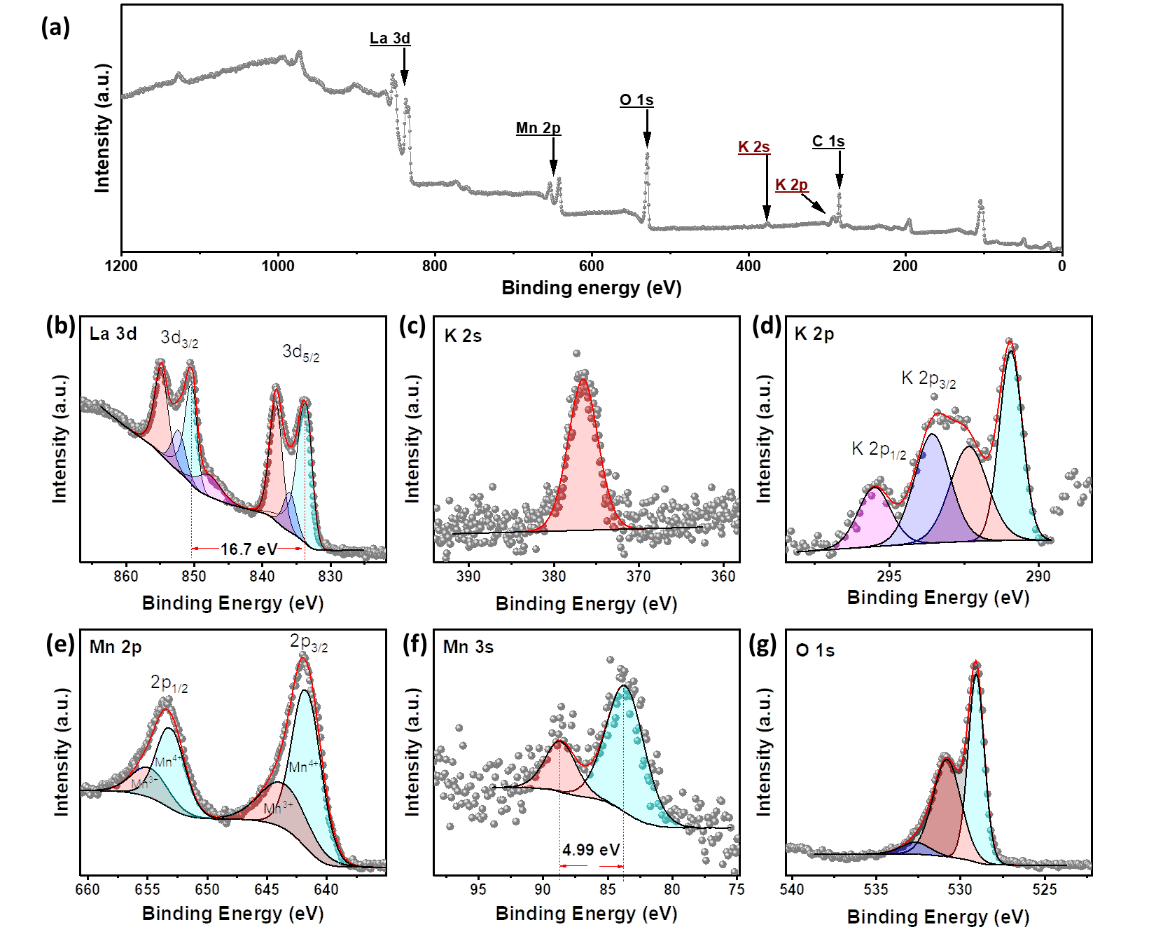

**Figure 2.5** XP spectra of LKMO microcubes synthesized via hydrothermal treatment at 265 °C for 7 days with 16 м KOH at 5 mmol precursor concentration. (a)Survey spectrum, and high-resolution spectra of (b) La 3d, (c) K 2s, (d) K 2p, (e) Mn 2p, (f) Mn 3s and (g) O 1s contributions. The narrow-scan spectra were fitted into individual components (turquoise, blue, red, and pink areas) using the combination of Gaussian and Lorentzian algorithm with Shirley background algorithm.

Mn 2p core-level spectrum (**Figure 2.5(e)**) shows spin-orbit split 2p3/2 and 2p1/2 peaks centered around 641.89 eV and 653.39 eV. Mn 2p3/2 exhibits two components with maxima at 641.64 eV and 643.51 eV indicating Mn3+ and Mn4+ respectively, and Mn 2p1/2 exhibits two components with maxima at 653.04 eV and 654.79 eV corresponding to Mn3+ and Mn4+ respectively (as shown in **Figure 2.5(e)**). From the area of the components of Mn 2p3/2, the amount of Mn3+ is around 68%, and Mn4+ is 32%. For accurate quantification of Mn average valence, the use of multiplet splitting values of the Mn 3s is preferential.127 Mn 3s core level exhibits exchange split due to the interaction of 3s hole (generated in the X-ray photoelectron emission) and 3d electrons of the Mn.128 In **Figure 2.5(f)**, we see splitting of Mn 3s into 83.64 eV and 88.63 eV peaks having 4.99 eV separation. This indicates that the formal oxidation state of Mn is +3.5 as per ref.129 Because Mn4+ has a higher oxidation capacity than Mn3+, the increased Mn4+ concentration facilitates the disproportionation reaction of intermediate HO2¯ to generate a four-electron route, boosting ORR stability. Electrocatalytic activity is relevant to the surface oxygen species in addition to the B-site metal species and valence state of the perovskite oxides. The O 1s high-resolution spectrum was deconvoluted into three components using Shirley-type background shape, as can be seen from **Figure 2.5(g)**. The 529.1 eV component belongs to the lattice oxide resembling the B.E. of Mn-O bonding. The adjacent higher B.E. 530.8 eV component can be correlated with the La/K-O bonding. As the earlier lower B.E. component is intense than the later component, signifying the surface of the material/electrocatalyst is of Mn-O bonding environment.128,130 The third higher B.E. component could be ascribed to surface/defect-related oxygen or surface hydration.

### Effect of alkali (KOH) concentration:

The concentration of KOH employed in the synthesis played a major role in the formation of different phases-morphologies-topology of LKMO. At concentrations (< 4 M), the reaction yielded only agglomerated particles of manganese oxide **Figure 2.6**(**a** and **b**). Between 4-7 м concentrations of KOH, reaction yielded LaMn2O5 and La(OH)3 nanorods (SEM images in **Figure 2.6**(**c-f)** and XRD profile in **Figure 2.7**(**c-f)**. Further, as the KOH concentration increased up to 8-9 M, the commencement of the formation of the LKMO phase was observed (in 7 days) (**Figure 2.6**(**e & f)**). However, the yield of the LKMO phase is small in comparison with that of La(OH)3 even after 7 days. At this concentration, LaMn2O5 is not observed in the reaction product. The yield of the LKMO phase was found to be higher in the range of 12-18 м KOH concentration (see **Figure 2.6**(**i-k)**). The overall yield of the LKMO phase after 7 days was 80 %. The yield and crystallinity from the SEM and XRD show 18 м is better compared to the rest of the lower KOH concentrations. The 12 м shows drastic difference in surface morphology and the phase which can be seen from the SEM and XRD. Increasing KOH concentration beyond 18 м decreased the yield of the LKMO phase (see **Figure 2.6**(**l**)). The above observations indicate that with increasing concentrations of KOH, the availability of Mn ions increases in the solution, whereas La ions decrease (formation of crystalline La(OH)3 is favourable). Thus, nucleation and dissolution of La(OH)3 at higher concentrations of KOH is the rate-limiting step for the effective synthesis of LKMO.

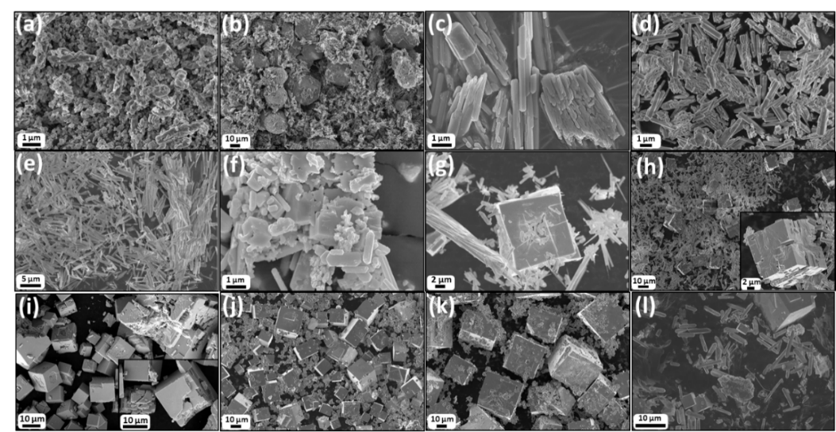

**Figure 2.6**(a-l) SEM images of the LKMO samples synthesized via hydrothermal process at 265 °C for 7days ([La,Mn]=5.0M), (RLa/Mn=1) with varying KOH concentrations: (a) 0 mol/L (K0), (b) 2 mol/L (K2), (c) 4 mol/L (K4), (d) 5 mol/L (K5), (e) 6 mol/L (K6), (f) 7 mol/L (K7), (g) 8 mol/L (K8), (h) 9 mol/L (K9), (i) 12 mol/L (K12), (j) 16 mol/L (K16), (k) 18 mol/L (K18P5), and (l) 21 mol/L (K21).



**Figure 2.7** XRD patterns of the LKMO samples synthesized via hydrothermal process at 265 °C for 7days ([La,Mn]=5.0M), (RLa/Mn=1) with varying KOH concentrations: (a) 0 mol/L (K0), (b) 2 mol/L (K2), (c) 4 mol/L (K4), (d) 5 mol/L (K5), (e) 6 mol/L (K6), (f) 7 mol/L (K7), (g) 8 mol/L (K8), (h) 9 mol/L (K9), (i) 12 mol/L (K12), (j) 16 mol/L (K16), (k) 18 mol/L (K18P5), and (l) 21 mol/L (K21).

The concentration of KOH also affects the potassium incorporation inside the LMO as well as the phase and morphology of the LKMO cubes. EDS analysis on microcubes obtained at 12 м KOH (**Figure 2.13**) shows the ratio of La:K:Mn is ≈0.91:0.21:1.0. The LKMO adopted a tetragonal structure (**Figure 2.8**(**d)**). The microcubes have shown porous in nature at the center of the cube. At 18 м KOH, the ratio of La:K:Mn in microcubes is ≈0.77:0.26:1.0 (**Figure 2.13**). At this concentration, LKMO adopted a rhombohedral structure. The XRD patterns show merging of the (110) and (104) planes (corresponding to rhombohedral structure) into one leading to a more cubic structure (**Figure 2.7**(**k)**). The crystallinity of microcubes is improved both in XRD patterns as well as in SEM images. SEM images show a solid core with no porous nature. The two phases have shown different magnetic properties, as described later in the [**section 2.8**](#_Magnetic_properties_measurement:).

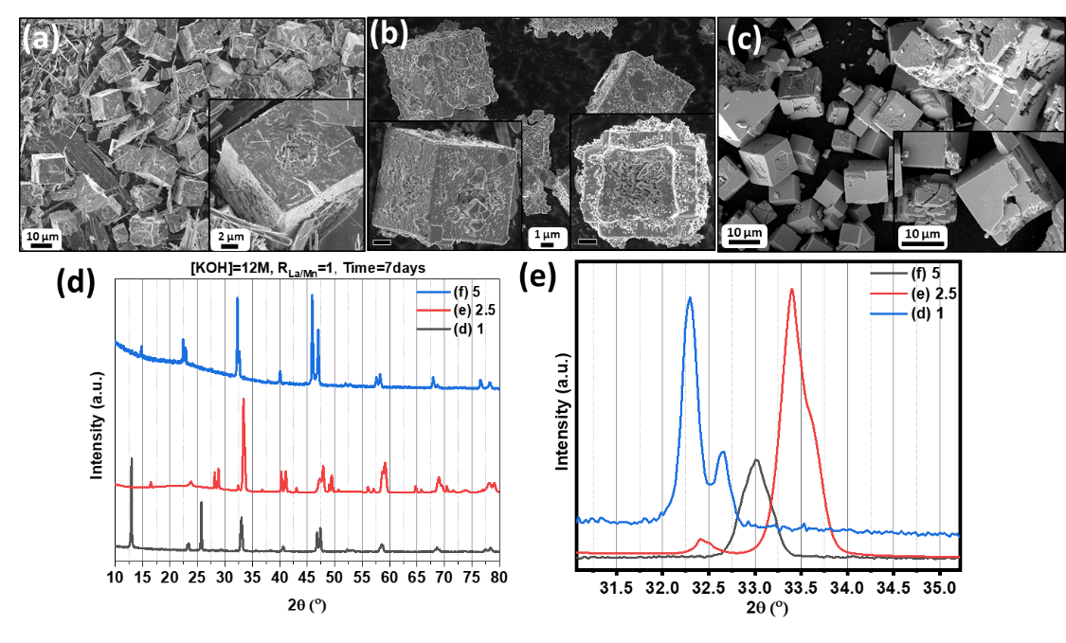

**Figure 2.8** a-c SEM images of the LKMO samples synthesized via hydrothermal process at 265 ⁰C for 7days (RLa/Mn = 1.0) at 12 м KOH, with various [La,Mn] : (a) 1 (K12P1), (b) 5 (K12P2.5), (c) 8 (K12P5), and the (d & e) XRD pattern of K12P1, K12P2.5, & K12P5.

### **Effect of precursor concentration**

Reaction kinetics generally increases with an increase in the concentration of the reagents in a reaction. Hence, keeping all the other parameters constant (at 18 м KOH), the reaction is conducted at three different precursor concentrations (1 mmol, 5 mmol, and 8 mmol) in order to study its effect on the reaction time (Table 1; P1, K18P5 & P8). The reaction yielded La(OH)3 nanorods and K0.5Mn2O4.3.(H2O)0.5 nanosheets after 1 day. When the reaction is conducted for 7 days, the yield of the phase and size of the LKMO microcubes (more than 90% yield and average size: 29 microns) are improved.

SEM images and XRD profiles of the products are depicted in **Figure 2.9**. Where we can see the length and diameter of La(OH)3 rods produced at 8 mmol decreased after 7 days compared to 1 mmol.

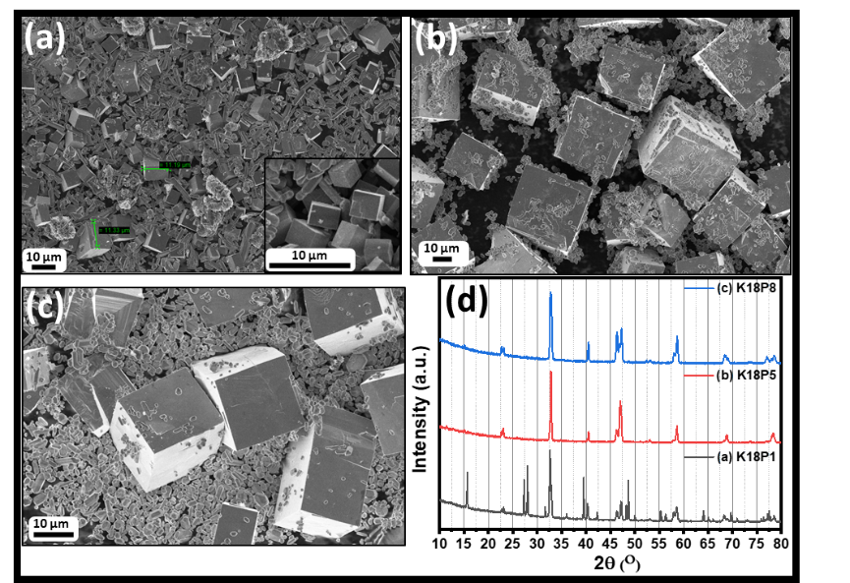

**Figure 2.9** (a-c) SEM images of the LKMO samples synthesized via hydrothermal process at 265 ⁰C for 7days (RLa/Mn = 1.0) at 18 м KOH, with various [La, Mn]: (a) P1, (b) P5, (c) P8, and the (d) XRD patterns of P1, P5, & P8.

From **Figure 2.10**, we see the cubes are growing, consuming the rods as the length of the rods is decreasing with the size of the cubes. Even at 9 м KOH, better cubes can be obtained by increasing the precursor concentration to 8mmol. This shows the importance of the precursor concentration. Even though the KOH is not sufficiently present, but higher precursor concentration allows the LKMO phase to form.

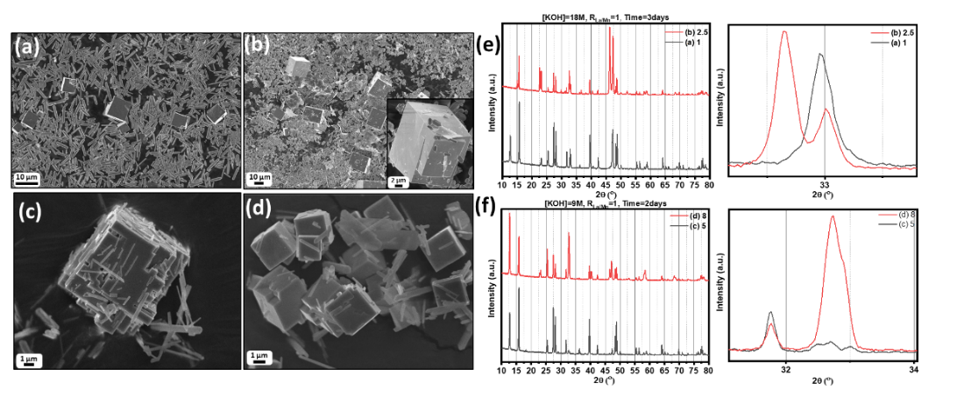

**Figure 2.10** SEM images of the LKMO samples hydrothermal synthesized at 265 ⁰C (RLa/Mn = 1.0), with various [La, Mn], reaction time & KOH concentrations: (a) (P1T3), (b) (P2.5T3), (c) (K9P5T2), (d) (K9P8T2), and Overall and 32°-33° focused (e) XRD pattern of P1T3, P2.5T3, & (f) XRD pattern of K9P5T2, K9P8T2.

From **Figure 2.8**(**a-c)**, at 12 м KOH, we see the cubes forming are hollow, and this hollowness again can be seen of different structures, which are dependent on the precursor concentration. In 5 mmol case, the holes are deep, but at 1mmol case, they are on the surface looking and amorphous in appearance. The hollowness of the forming LKMO cubes, from 1mmol to 2.5 mmol and 5 mmol at KOH of 12 м, we see the cracks are different, and the surface is getting smoother. Whereas at the higher-end above 12 м (**Figure 2.9**) the cubes are more solid.

### **Effect of precursor ratio**

The molar ratio of the precursor (La:Mn) played a pivotal role in the formation of the LKMO phase. The amount of K+ incorporation is also affected by this ratio. At La: Mn is 1:1, the XRD pattern in **Figure 2.11**(**c)** of 18KP1 shows the difference between (110) and (104) indicative of lower symmetry (having La:K:Mn as 0.97:0.03:1).

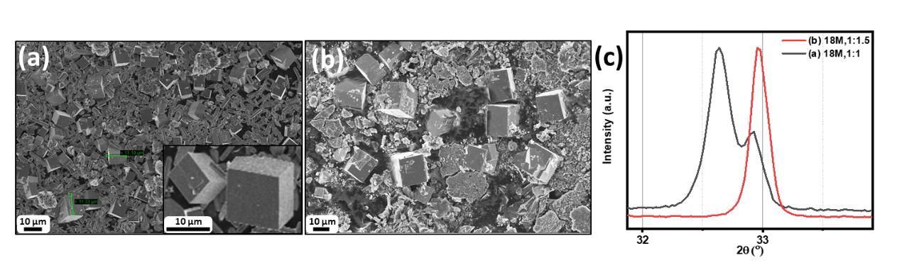

**Figure 2.11** a and b SEM images of the LKMO samples synthesized via hydrothermal process at 265 °C for 7days ([La,Mn]=1.0M) & 18 м KOH with various RLa/Mn 1 (P1) and (b) 0.67 (P1R0.67), and (c) Typical XRD patterns at around 2θ = 32°–34°.

These two peaks merge as K+ is more in the crystal. When La:Mn changes from 1:1 to 1:1.5 [(**Table 2.1**; entries P1 & P1R0.67) is depicted in **Figure 2.11** & **Figure 2.12**.], the amount of K+ inside the LKMO increased to 18% leading to the reduction of cooperative Jahn-Teller distortion in LMO. Thus, the crystal adopts higher symmetry. A similar observation is also reported in the literature in the flux method synthesis. (131) As 18 м is more favourable for the LKMO cubes formation thus the 1:1.5 has bigger cubes ≈3 times more than the 1:1. Indicating faster growth and also quick nucleation leading to more yield.

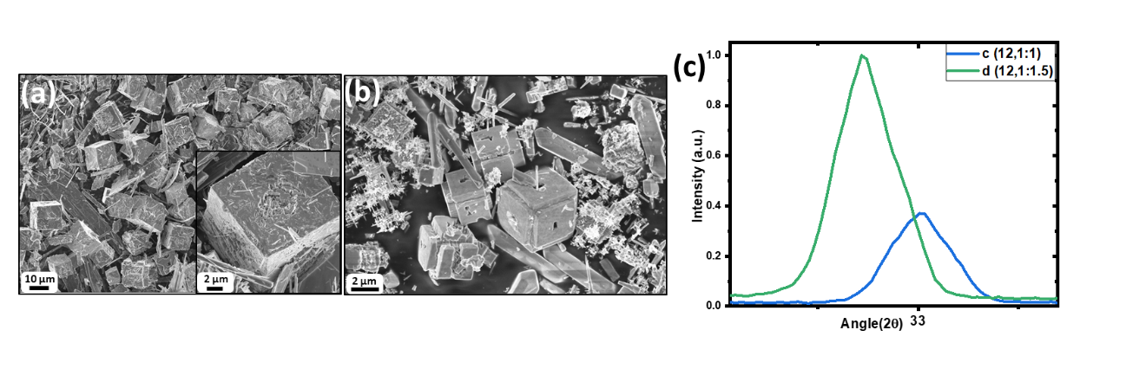

**Figure 2.12** a,b SEM images of the LKMO samples synthesized via hydrothermal process at 265 °C for 7days ([La,Mn]=1.0M) & 12 м KOH with various RLa/Mn: 1 (K12P1) and (b) 0.67 (K12P1R0.67) (c) Typical XRD patterns at around 2θ = 32°–34°.

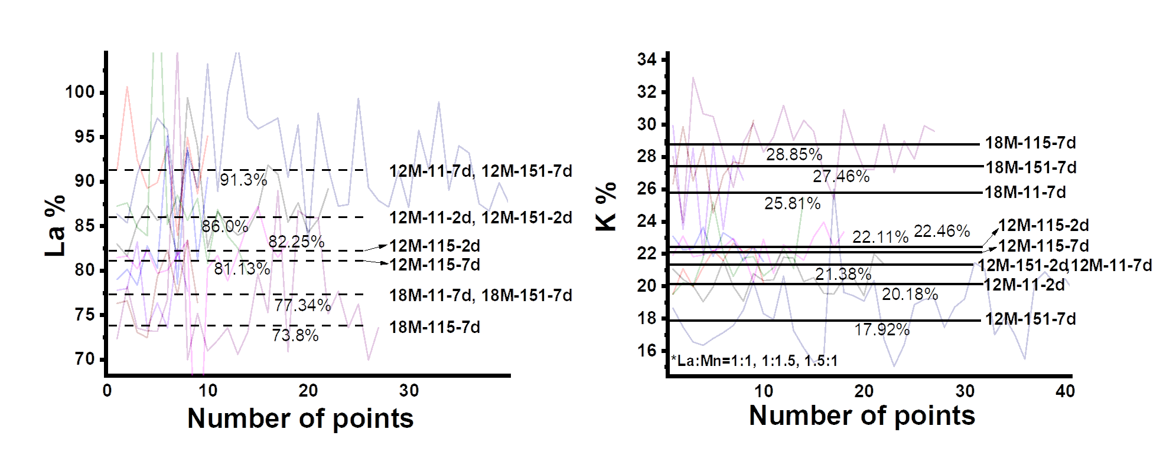

**Figure 2.13** Atomic% analysis of La and K in LKMO at different KOH concentration (12 м & 18 м), precursor ratio (1:1, 1:1.5, & 1.5:1), and reaction time (2d & 7d) conditions from several EDS points.

## Mechanisms:

### Nucleation:

Under hydrothermal conditions, nucleation rate and subsequent particle growth depend on relative supersaturation, which is influenced by processing parameters such as the concentration of the precursor feedstock, mixing and temperature. Thus, adjusting these synthesis conditions effects the final size distribution of particles. However, synthesizing complex oxides such as ABO3 through hydrothermal route; especially when lanthanides are involved; suffers from simultaneous side reactions such as the formation of oxides and hydroxides of individual elements (A(OH)x/AOy and BOz) because of the stronger interaction with oxygen. Thus, the choice of mineralizers, their concentrations and temperature play a major role to obtain single-phase perovskites oxides.

In our hydrothermal synthesis, base concentration, precursor amount, temperature, and time played an important role in LKMO synthesis. Crystallization of La1-xKxMnO3 instead of LaMnO3 in the hydrothermal conditions could be a result of difficulty in crystallizing Jahn-Teller active LaMnO3. The incorporating potassium decrease cooperative Jahn-Teller distortion and helping in nucleation. In the synthesis procedure of LKMO, although LKMO is a stable thermodynamic phase, kinetics products are dominated under basic hydrothermal conditions. At low pH ([KOH] < 8M), LaMn2O5 phase is dominated in the reaction, as seen from **Figure 2.6**(**d)**, while above 8M [KOH] LaMn2O5 phase is dissolved in the reaction, but La is precipitated as La(OH)3 rods, as seen from **Figure 2.6**(**h)**. The inverse solubility relation of Mn and La by-products with pH leads to difficulty in crystallizing the LKMO phase. With increasing pH at elevated temperatures, the solubility of La(OH)3 is slightly improved and leads to the formation of the LKMO phase. However, nucleation is very slow as we have observed crystallization has been observed only after one day (at [KOH] 18 м at 265 °C). The size of the crystals is on an average of 5 microns (sizes range from 2-9 microns). With increasing time from 1 to 7 days, we have observed the formation of new nuclei (the number of LKMO cubes are increased) and increased dissolution of La(OH)3 nanorods (length of La(OH)3 rods are decreased). This can be seen from **Figure 2.14**. We have not observed smaller cubes that are below 1 micron in this process, rather observed only increasing in the number of cubes with time.

The above observation, temporally separated crystallization, differs from the classical nucleation and growth model, where nucleation happens in a single step and follows diffusion-controlled crystal growth. In this case, a number of nuclei are the same during the process, but size increases with time. Accordingly, one should observe the size evolution of particles with time. Alternatively, Watzky and Finke developed a model to explain the temporal overlap of nucleation and growth.115,132 According to this model, nucleation is a slow continuous process (slow nucleation is a consequence of reaction limited) and growth is a fast-autocatalytic process. Accordingly, to this, within a given reaction process, nucleation and growth are predominantly overlapped events. This model has explained the kinetics of different nanoparticles.132–135

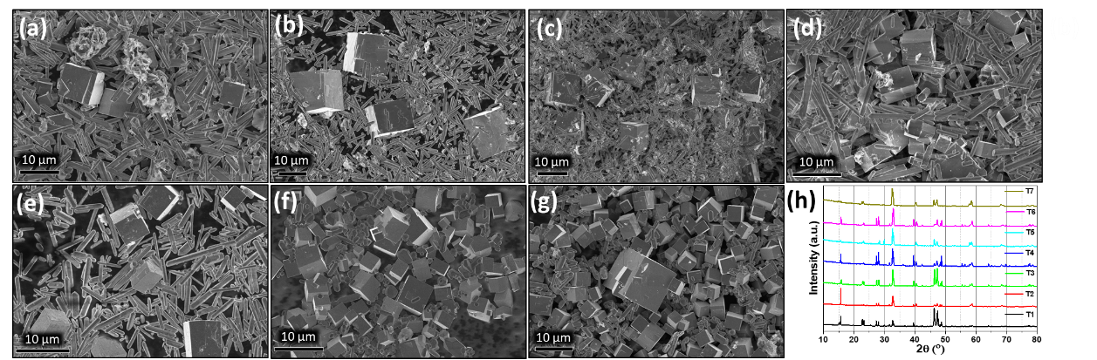

**Figure 2.14** a-g SEM images of the LKMO samples synthesized via hydrothermal process at 265 ⁰C, 18 м KOH, ([La,Mn]=1.0M), (RLa/Mn=1) with varying reaction time: (a) 1day (T1), (b) 2days (T2), (c) 3days (T3), (d) 4days (T4), (e) 5days (T5), (f) 6days (T6), (g) 7days (T7), and (h) XRD pattern of as-synthesized LKMO sample with time variation.

However, this model does not explain the temporally separated crystallization events observed in the present case, where different events of crystallization (nucleation and growth) have minimal overlap.

In our case, a high concentration of Mn in the solution (in the dissolved state) and low solubility of La(OH)3 leads to unavailability of both the cations simultaneously at one place, thus making it difficult in achieving supersaturation. For nucleation to happen, there is a need for a relative difference in the level of supersaturation; which could be either homogeneous globally or heterogeneous locally. However, the finite probability of local supersaturation leads to slow nucleation. The freshly formed nuclei have high surface energy; thus, they might dissolve back into the solution leading to difficulty in observing the nucleation at shorter durations. But, when the size of crystals crosses the critical nuclear size, the crystal grows with high rates (consuming already dissolved La and Mn) to decrease the surface energy, leading to the formation of 2 to 9 micron cubes. At this stage, the availability of dissolved La and Mn in the solution helps for the growth of already formed nuclei than the initiation of another nucleation step (as nucleation is a slow process than the growth). Now the solution is undersaturated, and rate of dissolution of La(OH)3 rods are higher than LKMO cubes (at micron size crystals) thus leading to the continuous dissolution of La(OH)3 rods into the solution. Freshly dissolved La(OH)3 can create the condition for another local supersaturation and leads to another nucleation step, thus increase the number of cubes (nuclei) with time. The already formed LKMO cubes slowly increase their size during the reaction, but the growth of newly formed small crystals is faster. This temporally separated nucleation and growth of each (set of) crystal(s) formed in the reaction could be a possible reason for not observing lanthanum-based perovskite oxides at nanosizes.

Similar conditions have been used to synthesize LaCrO3 and LaFeO3 in the usual hydrothermal conditions. In both cases, we got microcubes, as can be seen from **Figure 2.16**(**a)** and **Figure 2.16**(**e)**, respectively. The elemental distribution for the same can be seen from the EDS mapping in **Figure 2.17**(**a)** and **Figure 2.17**(**b)**, respectively. In the literature, it has been reported that similar conditions have been used to get chromite and ferrite where the particles sizes are above 1 microns.110,112,113,136 Synthesizing them at low dimensions (sizes less than 1-micron) is found to be challenging.

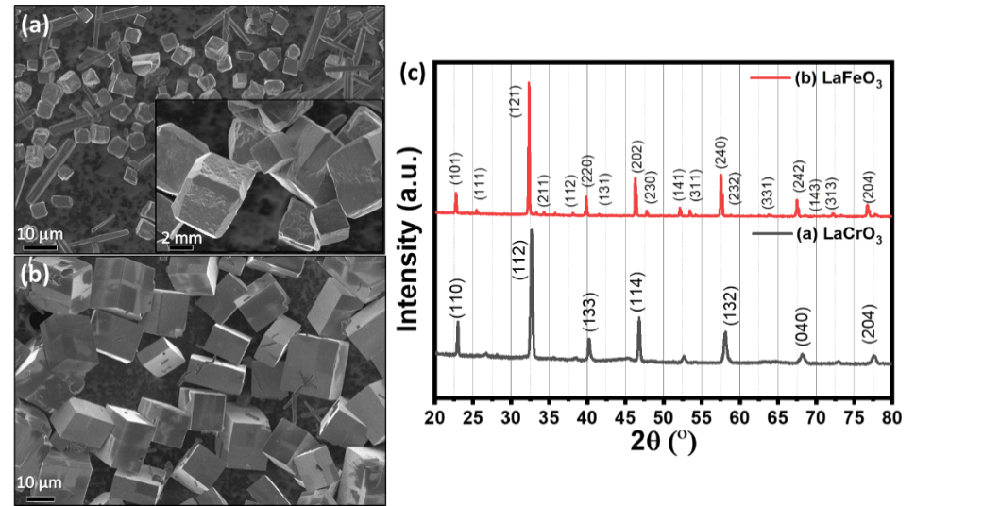

**Figure 2.15** SEM image of (a) LaCrO3 and (b) LaFeO3 microcubes synthesized hydrothermally, (c) XRD pattern of LCrO and LFO microcubes after density-gradient separation of byproducts.

As the above experiments reveal the domination of secondary nucleation at extended times, we have attempted to synthesize perovskites in the presence of pre-synthesized cubes.

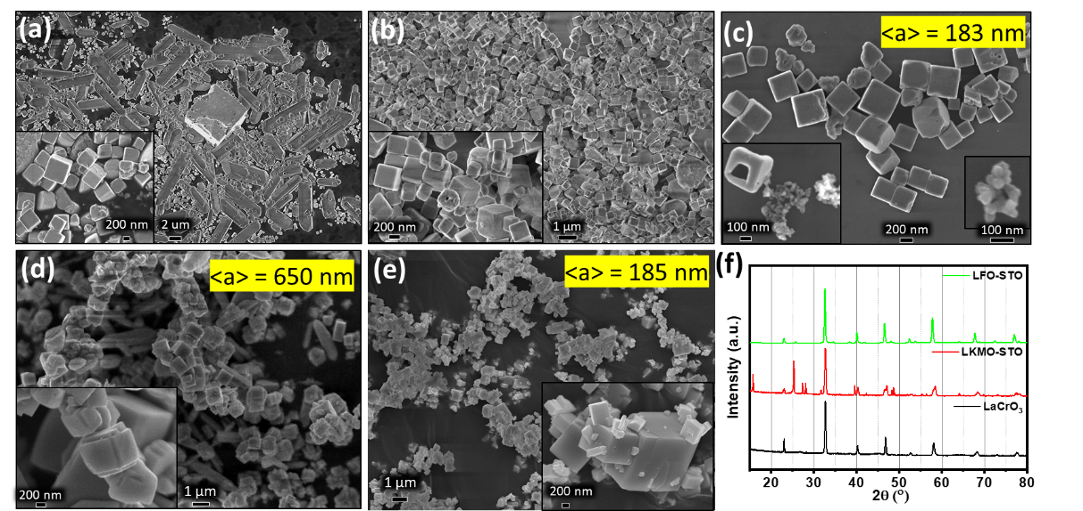

**Figure 2.16** SEM image of (a) as-synthesized LaCrO3 submicron cubes by secondary nucleation by adding pre-synthesized microcubes of the same, inset showing even smaller cubes of LCrO, (b & c) density-gradient separated LaCrO3 submicron cubes synthesized hydrothermally, (d) LaKMnO3 synthesized by using the STO nanoparticles (e) LFO submicron cubes synthesized by using the STO nanoparticles; inset showing the lower magnification of the same, and (g) XRD patterns of LaCrO3, LKMO-STO, and LFO-STO submicron cubes

**Figure 2.2**(**f)** shows SEM images of LKMO synthesized when in the presence of pre-synthesized cubes. The small LKMO cubes around 1 micron in size can be clearly seen from the image. The image also shows the formation of small cubes on top of the big cubes suggesting the secondary nucleation process. The overall reaction time has come down to 2 days (to complete the 80%). On the other hand, hydrothermal condition using SrTiO3 nanoparticles (inset in **Figure 2.16**(**c)**) as seeds (average size of 170 nm) yielded LKMO smaller cubes (Fig. **Figure 2.16**(**d)**) with an average size of 650 nm. Similarly, LaFeO3 submicron cubes (**Figure 2.16**(**f)**) with an average size of 180 nm were synthesized using STO nanoparticles as the precursor seeds. In the case of LaCrO3, hydrothermal conditions using pre-synthesized LaCrO3 as a precursor have yielded small LaCrO3 cubes (**Figure 2.16**(**b)**) with sizes ranging from 80 nm - 450 nm. The above observation clearly demonstrates the importance of secondary/heterogeneous nucleation in the synthesis of small cubes.

In the case of secondary or heterogeneous nucleation, the decrease in overall reaction time and the observation of small cubes could be explained as follows. The kinetic barrier for nucleation decreases in the presence of seeds, resulting in a faster nucleation process, and nucleation occurs at multiple locations. As a result, the consumption of dissolved La in the solution is greater for both nucleation and growth, resulting in a rapid undersaturation of the reaction solution. The dissolution of La(OH)3 rods into solution increases due to the common ion effect (Le Chatelier's principle). The freshly dissolved La in the solution is distributed among all the formed nuclei, lowering the average increment of size of cubes but a large number of nuclei; thus, small cubes are observed at the end of the reaction. In the meantime, newly formed cubes can serve as new nucleation centres. As a result, the entire process is supported by faster kinetics, which reduces the overall reaction time as previously discussed.

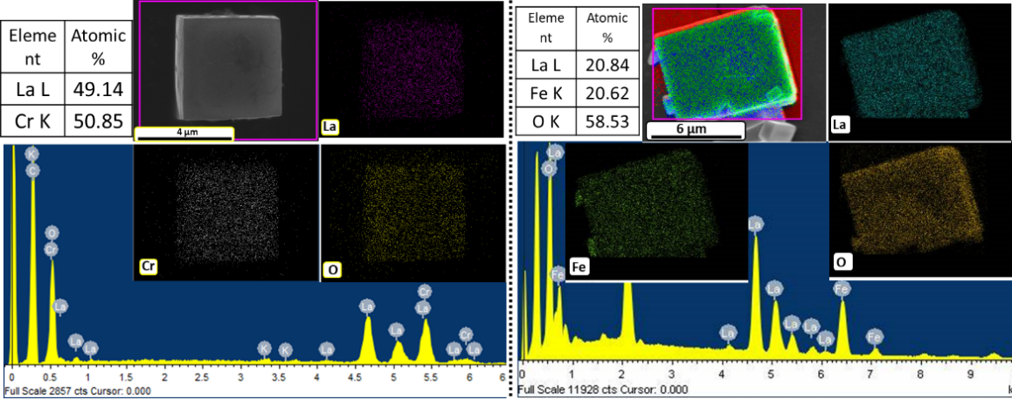

**Figure 2.17** EDS and mapping of density-separated (a) LaCrO3 and (b) LaFeO3 microcubes indicating the elemental composition and distribution

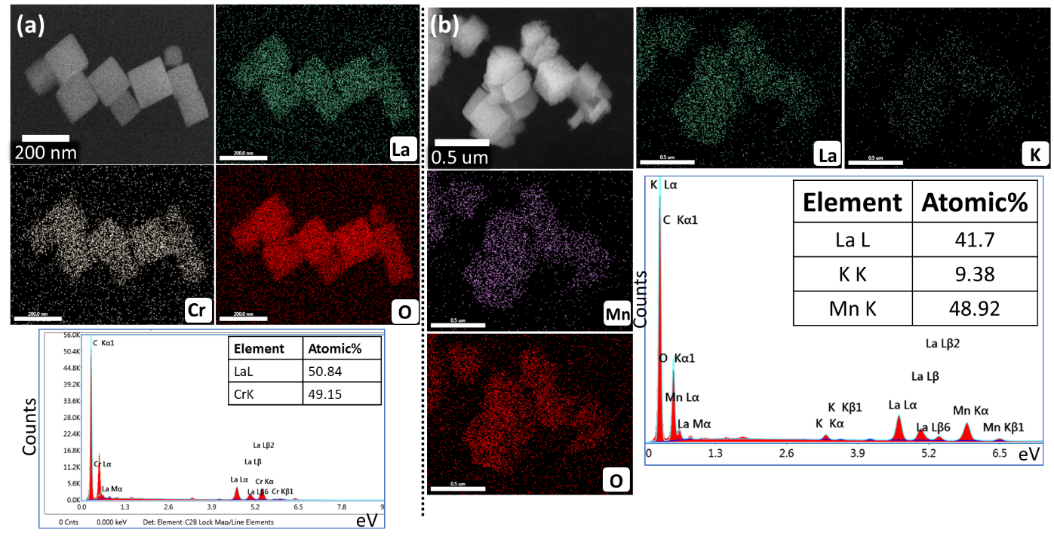

**Figure 2.18** EDS spectrum and mapping of density-separated (a) LaCrO3 and (b) LaKMnO3 submicron cubes indicating the elemental composition and distribution

## Magnetic properties measurement:

We have measured the magnetic properties of the LKMO cubes sample, which are synthesized at different KOH concentrations. **Figure 2.19** displays the magnetization-temperature (M-T) curves, zero fields cooled (ZFC), and field cooled (FC) measured for the LKMO sample synthesized at 12 м and at 18 м KOH concentration under 300 Oe field. The inset of each, **Figure 2.19**, shows the dM/dT-T curve, determined from the M-T curves, whose minimum gives the Curie temperature Tc (ferromagnetic to paramagnetic phase transition temperature). The red curve from **Figure 2.19**(**a)** shows the ZFC, and the black curve shows the FC of the 12 м LKMO sample with the Curie transition temperature around 277K. **Figure 2.19**(**c)** shows the ZFC and FC of the 18 м sample with the Curie transition temperature around 220K. **Figure 2.19**(**b)** and (**d)** show the field variations of magnetization (M-H) done at different temperatures between 2K to 300K for 12 м and 18 м, respectively. We can see from **Figure 2.19**(**d)** that the material has the saturation magnetization, Ms that is far from saturation.

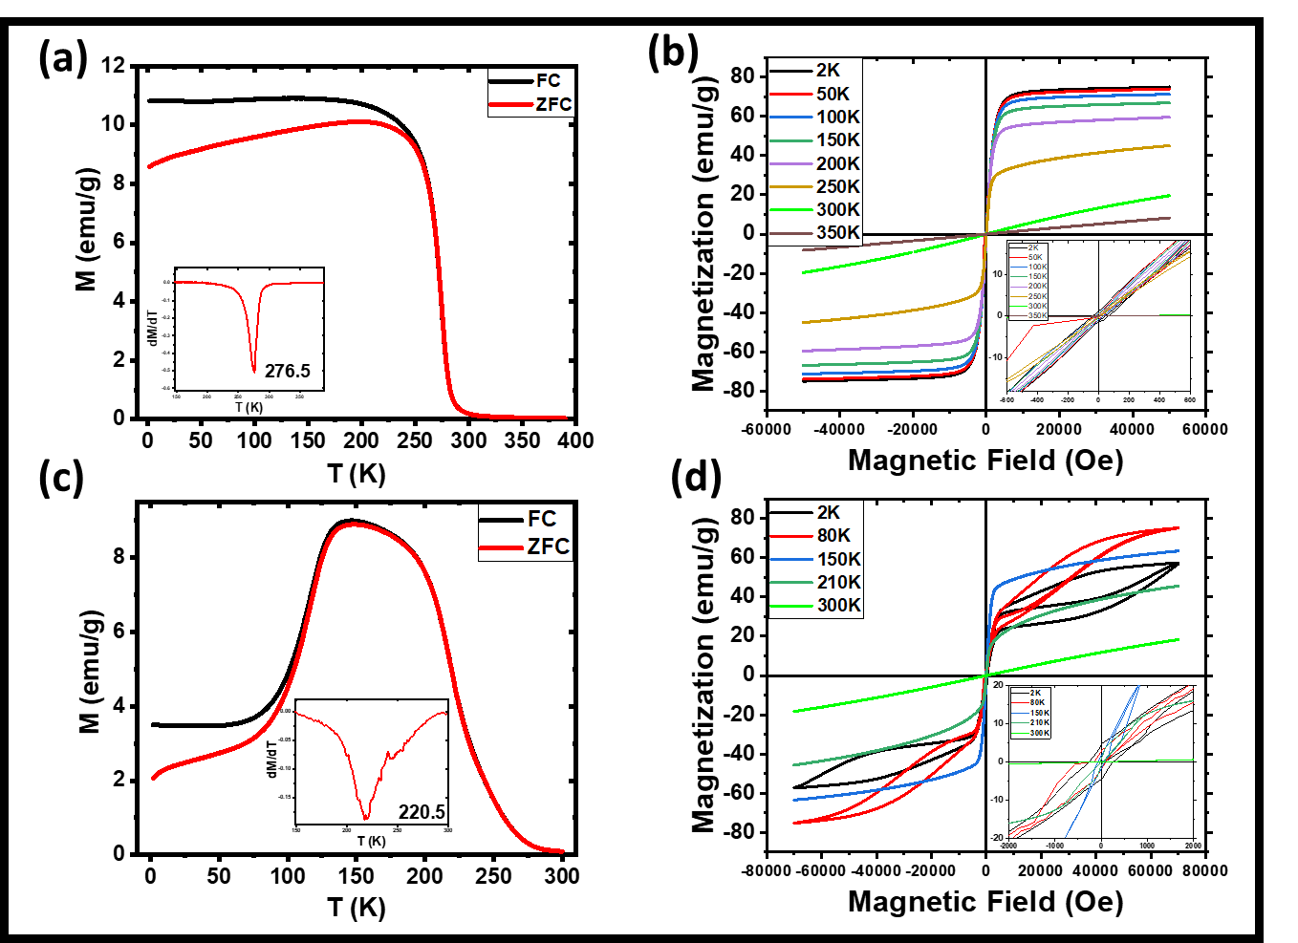

**Figure 2.19** Temperature-dependent magnetization of LKMO samples (a) 12 м KOH & (c) 18 м KOH obtained at 300 Oe. The inset shows the first-order derivative of the respective zero-field cooling magnetization with respect to temperature. (b) & (d) are the field-dependent magnetization of LKMO samples synthesized at 12 м and 18 м KOH, respectively, at different temperatures varying from 2K to 300K.

This shows that these materials exhibited a paramagnetic behaviour at and above ambient temperatures and experienced no magnetic saturation up to 50 KOe. However, an anomaly was observed in the hysteresis loops at the high magnetic field range indicative of a metamagnetic transition(137) where it was observed that the application of a critical magnetic field melted the charge-ordered, CO state and induced an irreversible ferromagnetic, FM ordering; thereby showing a steep increase in the magnetic moment. This metamagnetic transition was related to the field-induced melting of the strain-induced at the phase boundary between canted anti-ferromagnetic cAFM and FM clusters. It was reversible upon retracing the same magnetization path on subsequent sweeping of the field. The 12 м and 18 м samples show the coercivity, Hc 263 Oe and 40 Oe respectively at 2K shown in the inset of **Figure 2.19**(**b)** and (**d)**. 12 м case seems to have better exchange integral, ij suitable for double exchange of unpaired 3d eg electron along Mn3+-O2--Mn4+ leading to ferromagnetic phase and higher Tc. In contrast, 18 м case shows superexchange along Mn4+-O2--Mn4+ leading to canted antiferromagnetic phase (hysteresis loop at low-temperature under high field as shown in **Figure 2.19**(**d)**). One plausible explanation could be the variation of K substitution. In the 12 м cases, 22% K substitution was observed, whereas this has increased to 28% in the 18 м cases. By controlling the reaction parameters, the K quantity of the LKMO material and thus the magnetic properties can be altered.

## Phase transformation:

Rietveld refinement was carried out to understand the crystallographic or structural information of the LKMO microcube samples. **Figure 2.20**(**a)** below depicts the refinement of an 18 м-LKMO XRD pattern indicating Pnma space group with a=5.43 Å, b=7.72 Å, and c=5.45Å lattice parameters. While the 12 м-LKMO (**Figure 2.20**(**b)**) shows to be of I4/mmm space group which is hexagonal (higher in symmetry than orthorhombic). To investigate the effect of potassium, we synthesized pure LaMnO3 (LMO) using Molten Salt Synthesis (MSS) method, as described in the auxiliary section.

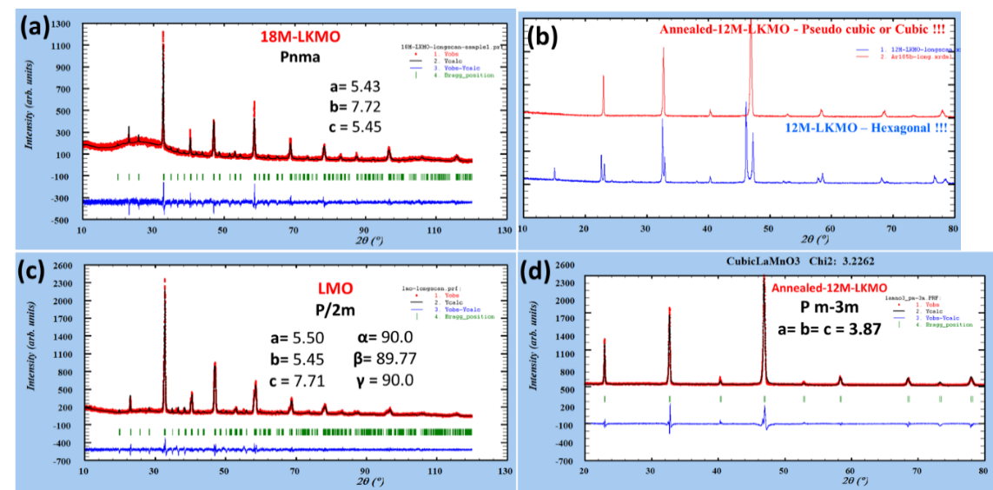

**Figure 2.20** Rietveld refinement of (a) 18 м-LKMO, (b) 12 м-LKMO\*, (c) LMO, and (d) annealed 12 м-LKMO; indicating the observed (Yobs), calculated (Ycal), and difference (Yobs-Ycal). (\*Neutron diffraction (ND) will provide accurate refinement of both as-prepared and annealed 12 м LKMO.)

As shown in **Figure 2.20**(**c),** we refined the XRD pattern of LMO, which indicates a P/2m space group, i.e., monoclinic. This indicates that potassium substitution improves the crystal symmetry significantly. We then annealed the hydrothermally synthesized 12 м and 18 м LKMO microcube samples at 900 °C temperature from 12 to 24 hrs to better understand the stability of the K as well as to verify structural transformation and magnetic property enhancement. The SEM images (**Figure 2.21**) show no morphological changes, whereas the XRD results are exciting. The phase of 18 м-LKMO is relatively unchanged, whereas 12 м-LKMO has evolved into higher symmetry. The lattice parameters are shown in **Figure 2.20**(**d)**.

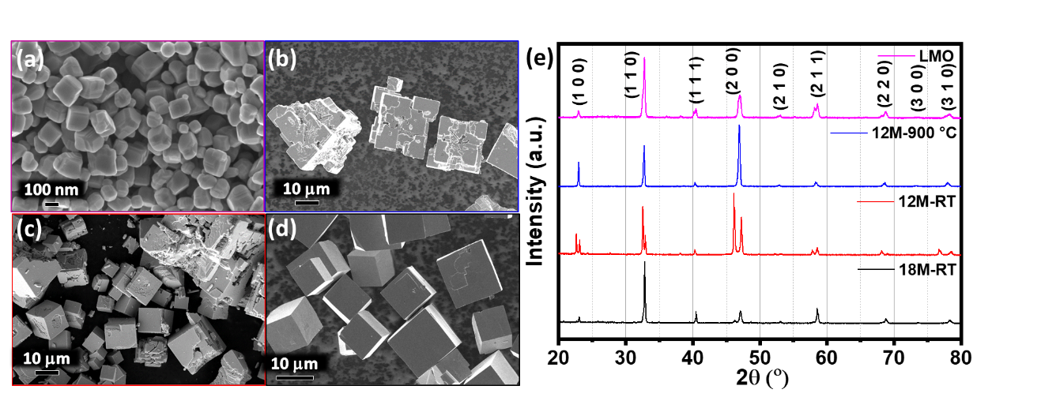

**Figure 2.21** SEM micrographs of (a) MSS-synthesized LMO nanoparticles, (b) 900 °C annealed 12 м-LKMO microcubes, (c) as-synthesized 12 м-LKMO microcubes, (d) as-synthesized 18 м-LKMO microcubes, and (e) XRD patterns of LMO, 18 м, 12 м, and annealed 12 м LKMO.

This annealed 12 м system goes to a much higher symmetry pseudo-cubic Pm3m with lattice parameter 3.87 Å. The position of K appeared to be off in both the as-synthesized and annealed 12 м LKMO microcubes. Neutron diffraction can provide us with more accurate structural parameters for the same. When the magnetic M-T measurement (**Figure 2.23**) was performed on annealed 12 м, we discovered a significant increase in curie temperature to 330.8 K from 276.8 K (**Figure 2.19**).

The unaltered presence of K (27.34% in 18 м and 21.74% in 12 м) from the EDS spectrum after annealing the sample to and above 850 °C to 1000 °C for 12hrs to 24hrs (**Figure 2.22**), indicates high potential application in the solid-oxide fuel cells (SOFCs), magnetocaloric (MCE), and thermochromic applications.

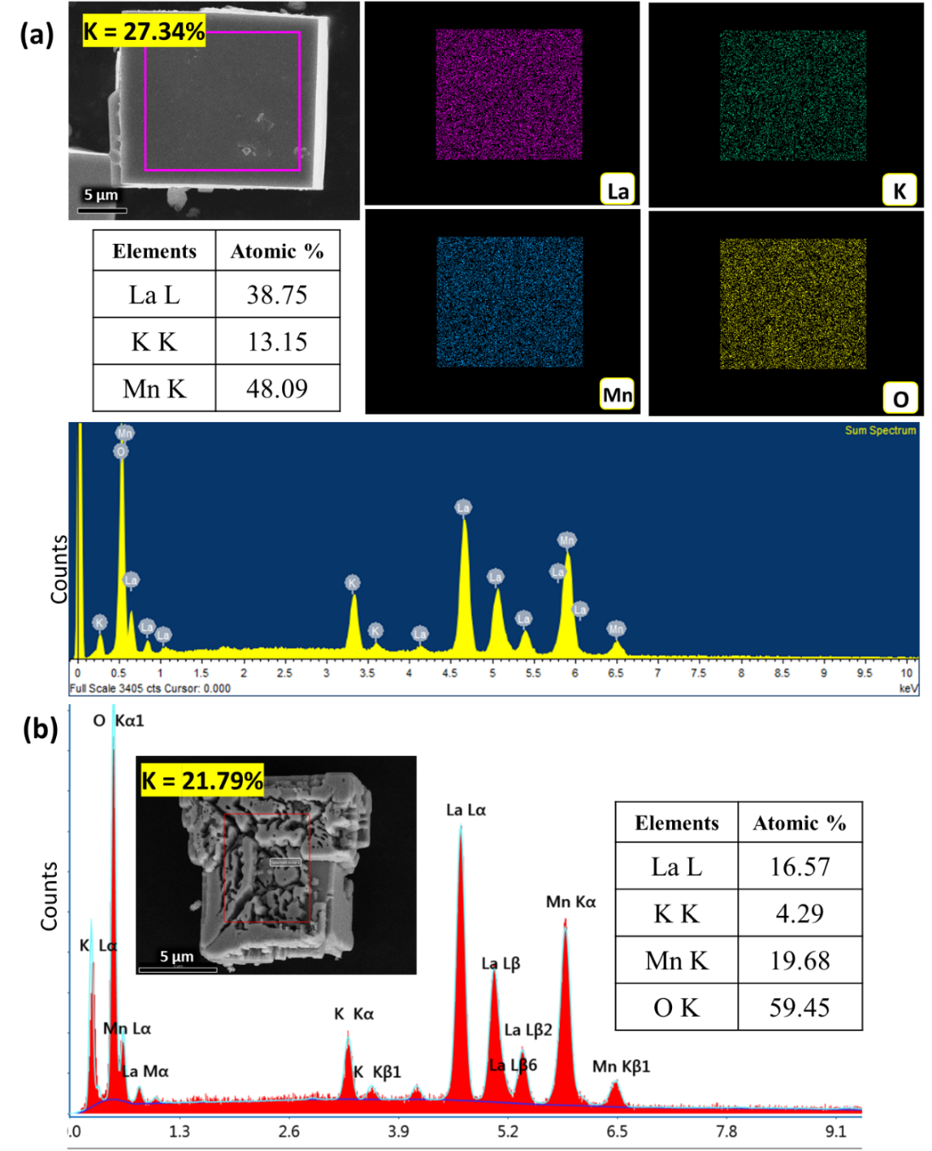

**Figure 2.22** EDS elemental quantification of (a) 18 м and (b) 12 м LKMO microcubes after annealed at 900 °C.

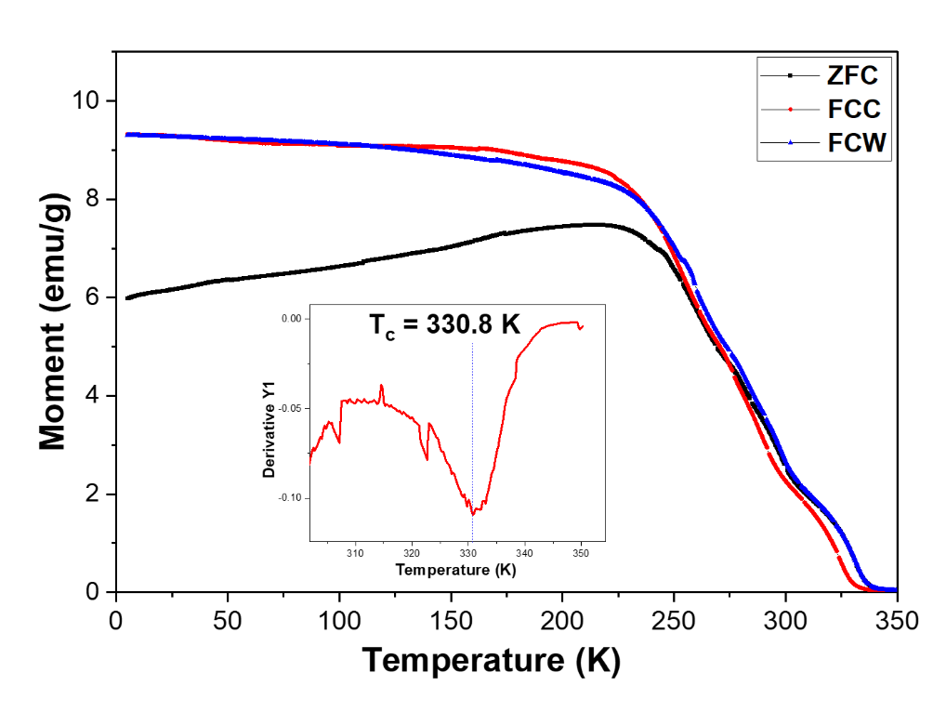

**Figure 2.23** Magnetization-Temperature curves (ZFC, FCC, FCW) of annealed 12 м LKMO microcube sample, with the first-derivative of ZFC indicating the Tc shown in the inset.

## LKMO synthesis as a generic growth strategy:

As discussed in the previous sections of this work, LKMOmicrocubes were synthesized through a low-temperature, hydrothermal solution-phase synthetic approach; and successfully optimized to produce not only the desired morphology and phase but also an appreciable yield; by tailoring various reaction parameters. However, the efficiency of this synthesis would cease to be as helpful and significant if it were not generic, viz., applicable to other Lanthanum-containing systems as well. In order to prove this, an attempt to synthesize other Lanthanum-containing systems was tried, employing Chromium (Cr) and Iron (Fe) in place of Manganese (Mn). In the literature, people have synthesized LaCrO3(51,111) and LaFeO3(138,139) by a hydrothermal method where 5 to 14 days takes for the reaction completion. These LaCrO3 and LaFeO3 microcubes were synthesized using a similar procedure as that for LaKMnO3, with a high KOH concentration of 9 м and 12 м, respectively, precursor concentration of 5 mM, and a typical reaction time of 5 to 7 days for 90 % completion. **Figure 2.15a** and **b** show the SEM images, **Figure 2.15c** XRD profiles, and & **Figure 2.17a** and **Figure 2.17b** shows the EDS mapping of these samples. The LaFeO3 microcubes were of the size range of 5 – 10 µm, while that of the LaCrO3 was around 1 – 2 µm. A noteworthy fact was that; in the combined presence of La and Cr, the former tended to become La2O3 in the solution phase, thus causing the LaCrO phase to retard; which made it mandatory to use Cr slightly in higher quantities than La(51). This also meant that the structural morphology could show some changes in comparison with the usual reported ones synthesized at markedly lower KOH concentrations of 3 – 6 M. Such as the LKMO microcubes, the latter showed a very good magnetic momentum; as is visible from **Figure 2.24a**. An interesting fact was that in contrast to the originally reported products(54,78,111), the ones synthesized in this work showed both Tc and Tn (as is depicted in **Figure 2.24a**). The possible reason for this phenomenon is not currently within the scope of this work.

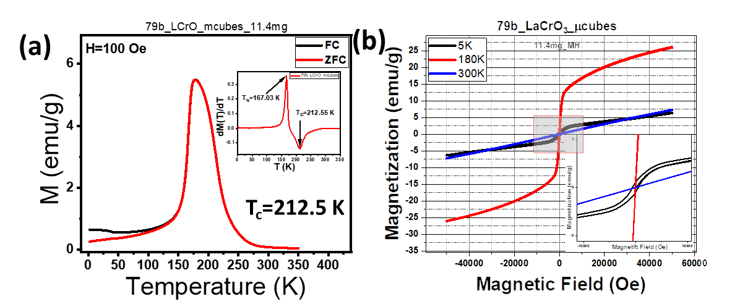

**Figure 2.24** (a) MT and (b) MH studies of LaCrO3 microcubes at 100 Oe field and 5K, 180K and 300K temperatures, respectively.

## Effect of doping:

Tuning the percentage of the A-site dopants was demonstrated to change the magnetic and electrical resistivity phenomenally of the material(140), where the highest ferromagnetic (FM) phase was shown to be possible with 33% Calcium doping in LCMO; deviation from which percentage caused the material to show a decrease in ferromagnetism and quantitatively undergo various phase changes such as AFM, canted AFM, charge-ordered and so on. This study provided the basis for understanding the importance of the percentage of K-substitution at the A-site in LMO and determining how crucially this parameter played a role in deciding the magnetic phase of the resultant LMO. With this knowledge, an attempt to synthesize LKMOs with varying amounts of K substitution was tried; by varying the potassium source in the synthesis, i.e., the KOH concentration. It was observed that in a typical synthesis, while 1 – 5 mM precursors with 12 – 21 м KOH formed LKMO microcubes containing 13 – 20 % potassium, concentrations of precursors above 5 mM and KOH below 12 м lead to microcubes with a distinctly lower potassium substitution. This could be due to the capability of a monovalent cation to drive the oxidation of two Mn ions from the (+3) oxidation state to the (+4) one within the same time as would be taken by its divalent counterpart; which would ultimately result in a quicker achievement of the spin locking between the adjacent Zener pairs and initiate the double exchange transfer integral to go below unity. Thus, ultimately, it could be successfully demonstrated in this work that the highest possible ferromagnetic phase of LMO could be achieved just by a meagre amount of K-substitution. **Figure 2.19** shows the inverse dependence of Tc on the degree of K-substitution. This evidently shows that the materials exhibit metallicity and ferromagnetism below this temperature (Tc) and insulation above it, the very property which makes them an ideal CMR material. It, however remains to understand further the different kinds of magnetic and electrical transitions that could be achieved by varying the degree of K-substitution.

## LKMO microcube growth

Several systematic studies were carried out by varying the reaction parameters such as temperature, precursor concentration, KOH concentration, reaction time, and pre-synthesis stirring time in order to understand the growth pattern of these LKMO microcubes. On average, large cubes of a size of around 15 µm were formed, which were characterized accordingly by a series of analytical techniques. All these investigations assisted in realizing the importance of the kinetically stable intermediates formed in the due course of the reaction.

As discussed in the previous section, hydrothermal synthesis is usually governed by the classical theory of nucleation and growth. Individual ions undergo homogeneous nucleation before reaching their activation energies, subsequently after which they grow into bigger particles with time. However, the growth mechanism of the LKMO microcubes in this current work has been estimated to follow a deviated path from the classical growth mechanism, which to the best of our knowledge, has not been reported yet.

A close look into the synthesis of LaMnO3 gave the knowledge that while the Lanthanum formed the kinetically more stable La(OH)3 nanorods, Manganese formed the potassium-substituted K0.5Mn2O4.3.(H2O)0.5 (Manganese oxide with intercalated water) sheets. It was estimated that the lanthanum precursor mediated La(OH)3 nanorods, under the constant hydrostatic environment, agglomerated together, excluding the manganese precursor molecules from their localized system. This led to the deposition and subsequent diffusion of the manganese into this agglomeration to further form the materials. Thus, the outer surface of the La-agglomerate acted as a primary nucleation site which oriented manganese diffusion in the direction of the cube formation. It is noteworthy that this very diffusion, which has been proven to date to be occurring only in solid-phase reactions at temperatures above 600 °C, could be achieved in this hydrothermal solution-phase synthesis protocol at a temperature as low as 265 °C. Further, this La-cluster seemed to undergo a structural reconstruction as the diffusion of the Mn ions occurred deeper and deeper into the core. Thus, the phase of the particles kept getting better with the size remaining constant; as the reaction proceeded with time, thus ultimately yielding the LKMO microcubes. Here, a remarkable clause for consideration could be the use of higher reagent (precursor) concentrations in order to increase the rate of diffusion.

Another interesting parameter here was found to be the role of KOH in LKMO formation. KOH in this current protocol had been more active in terms of a mineralizer than an active reagent. Identified as a ‘double-edged sword,’ a higher concentration of KOH has been demonstrated to decrease the activation energy, which in turn increased the phase formation. However, the capping effect shown by the alkali on the active faces of the nuclei blocked further nucleation and growth of the material, subsequently decreasing the yield (as is shown in **Figure 2.6**). When this background was applied to the current work, it was understood that increasing the concentration of the precursors in the solution phase needed to be potentiated with a decreased KOH concentration as well in order to obtain a high-yielding synthesis of LKMO.

Interestingly, growth of LKMO cubes of sizes varying from 0.6 – 1.0 µm was observed when pre-synthesized LKMO cubes of smaller sizes were used as a nucleation seed, proving the fact that the heterogeneous nucleation that had occurred followed the classical theory of nucleation and growth (**Figure 2.2**(**f)**). This could be because the growth rate of the material was so rapid that the formed nuclei hit the saturation limit of growth of the LKMO in usual cases; but once there was the availability of a pre-synthesized LKMO seed, the surface energy became so low, allowing smaller particles to easily settle on the surface and nucleate; further yielding larger microcubes.

Once the preliminary techniques such as SEM, EDS and XRD were employed to throw light on the morphology, crystallinity, phase, size, and chemical composition of the materials, a few characterizations were performed to further gain insight into their spectral, magnetic, and electrical properties.

## Conclusion

In summary, La1-xKxMnO3 (LKMO) microcubes of the size range 6 – 30 µm have been successfully synthesized through a low-temperature solution-phase hydrothermal synthesis; and characterized to exhibit various phenomenal electrical, magnetic and electrochemical properties (discussed in [**Chapter 4**](#_Applications:_study_of)). It was found that the yield and morphology of the LKMO microcubes were largely dependent on the reaction parameters such as KOH concentration, time, temperature, precursor concentration, and precursor ratio. The highest yield and accurate cubic morphology of the LKMO were obtained by a hydrothermal synthesis at 265 °C involving a precursor concentration of 5 mM, a ratio of 1, KOH concentration of 18 м, within a period of 7-14 days. Moreover, a mechanism for the formation of these LKMO microcubes has been proposed, and their stoichiometry; calculated. These materials, owing to their efficient exchange interaction between Mn+3 and Mn+4 demonstrated by the presence of Curie and Neel temperature, allow these materials to exhibit exceptional capability in magnetoresistance, supercapacitance, and oxygen reduction ability. A controlled synthesis of high-symmetry (pseudo-cubic) phase of manganite (A12 м-LKMO) was achieved. Furthermore, the synthetic hydrothermal strategy described in this chapter is a scale-up efficient one; and generic, which could be easily extended to the synthesis of other lanthanum-based systems as well.

# Dynamic hydrothermal synthesis: tailoring nucleation and growth

**Dynamic hydrothermal synthesis: tailoring nucleation and growth**

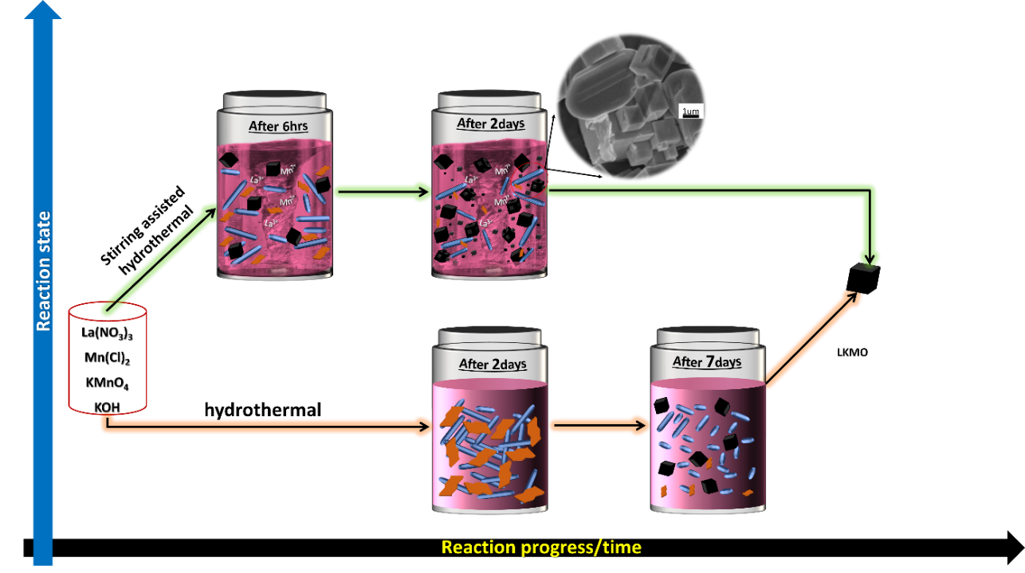

This chapter describes the effect of stirring to overcome the limitations of static hydrothermal synthesis of the same LPOs.

## Abstract

LPOs are extremely durable. They require a large amount of activation energy to synthesise. The major limitations of their synthesis via static hydrothermal are the unavailability of active reagents due to reagent trapping in the form of respective by-products. Because the byproducts dissolve slowly, the reaction can take up to 10 to 15 days. To enhance the reaction kinetics, stirring assisted hydrothermal, also known as dynamic hydrothermal (DH), method was performed. Hydrothermal synthesis is typically performed in an oven (below 200 °C) or furnace (above 200 °C), where stirring is not possible. As a result, a stirring-assisted reactor must be custom-built to perform reactions at low temperatures, specifically 250-300 °C. The idea behind this is that these products are mostly diffusion-limited, so to increase this, we need to create extra turbulence in the reaction environment, which results in an improvement of the reaction conditions such that the product that takes 1-2 weeks now takes 1-2 days. Based on the observations, an internal mechanism (shear jamming) of product formation has been hypothesised. We also got truncated cubes, nanorods, and hollow cubes of the same (LKMO) materials, also some double perovskites.

## Introduction

Previously, the effect of stirring was studied in organic and some inorganic reactions. However, no conclusive evidence exists to show how stirring affects the rate of the reaction. The role of stirring in materials synthesis has not been explored earlier. It is unclear in the literature whether stirring aids in nucleation. There are few literature reports on the synthesis of materials using the dynamic hydrothermal method. Stirring ensures uniform mixing and better control over the final product (**Figure 3.1**). Vediappan K. et al. have studied the effect of stirrer rotation frequency on the synthesis of nano C-LiFePO4.141 The frequency of agitation dictated particle size distribution, particle agglomeration, self-assembly, morphology, and crystallinity of the products. According to their findings, the rotation frequency has an effect on the nucleation-growth kinetics. The existing material synthesis methods are divided into two broad categories: solid-state and solution-state (hydrothermal). The solid-state method produces small spherical primary particles, while the hydrothermal method produces primary particles of various shapes and sizes. The addition of stirring to these methods will improve control over the size and morphologies of the primary particles. These primary particles also influence the formation of secondary particles, which determines the material properties. Sallem F. et al. 2017’s report demonstrates how the mechanical stirring reduces the required reaction time and evolves the morphology of titanate nanotubes into nanoribbons and multiwall TNTs.142

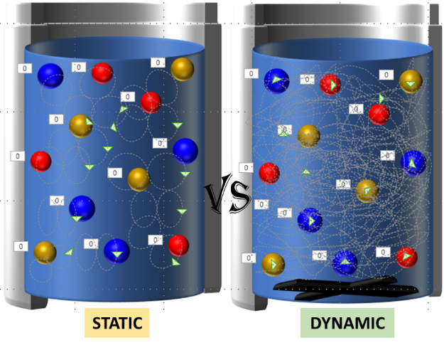

**Figure 3.1** Schematic representation; cross-sectional view of static vs dynamic hydrothermal autoclave where red, blue, and gold coloured spheres are reagent ions, magnetic bead is shown in black color. The grey lines indicate that the ionic movement is very much localized for static case. Whereas it is comprehensive for dynamic case.

This demonstrates that the stirring increased the contact area between the particles and the unreacted surrounding solution, thereby increasing the kinetics (**Figure 3.1**). This same group investigated the effect of stirring type, stirring rate, and stirring time variation on the morphology of the resulting titanate nanotubes. Papa A. et al. investigated the effect of stirring mode on the yield and the crystallinity of the P25 nanotubes.143 According to Gao J. et al. (2015), continuous stirring in the dynamic hydrothermal method promotes surface recrystallization and the formation of well-dispersed hollow BaTiO3 nanoparticles.144 According to them, stirring appears to be a vital parameter that is rarely discussed in the literature.

Based on this understanding of the literature, the stirring assisted hydrothermal or dynamic hydrothermal synthesis method could open up new possibilities. Among many modern approaches, the addition of sonication or microwave treatment in conjunction with the classical static hydrothermal (SH) suffers from a lack of control over the morphology. These add-ons are extremely energetic and are only available on small scales. Long reaction times, harsh alkaline conditions, and low nucleation efficiencies characterise solution phase chemistry. As a result, the addition of stirring to the SH is the most significant advance that this field can anticipate. Theoretically, stirring can accelerate nucleation, but this has only been demonstrated in bulk systems such as polystyrene beads or a colloidal system. However, we are demonstrating for the first time in a complex LPO. It is proposed that shear-induced jamming can improve the nucleation process; otherwise, it is a very high energy penalty step/process, particularly when lanthanides are involved.

So, in this chapter, we study the stirring assisted solution-based synthesis of various lanthanum-based transition metal perovskites at low temperatures. It was explored how stirring can enhance nucleation and growth compared to traditional hydrothermal synthesis. We chose our LKMO material synthesis as a model for this purpose. We achieved 90% completion with micron-sized LKMO crystals in two days, whereas this normally takes weeks via SH due to the slow dissolution of byproducts (La(OH)3). Stirring (shear) appears to influence not only the rate of dissolution but also how La(OH)3 dissolves, i.e. which planes dissolve first or rapidly. Without stirring, dissolution of these rods occurs in the [0 0 1] direction, resulting in rod shortening. Stirring appears to have little effect on length, but it does change diameter, implying that dissolution occurs via the (110) plane.

The same DH method was used to obtain LaCrO3 and LaFeO3 perovskites in significantly shorter duration. Along with the above-mentioned normal perovskites, we were also succeeded in synthesizing La1-xKxMnBO6 (B = Cr, Fe, and Ni) like double perovskites. We demonstrated the synthesis of {1 1 1} truncated LKMO microcubes and hollow microcubes, demonstrating the influence of stirring on the morphology of the material. Stirring has a significant impact on dimensionality, allowing us to obtain nanorods of LKMO perovskite using the DH method. Stirring-assisted synthesis, we believe, opens up a wide range of possibilities for creating variety of complex systems at low temperatures and exerting control over their nucleation and morphologies, and thus the resulting properties.

## Existing issues

The static hydrothermal method has no control over any other parameters besides the external temperature. This includes the inability to improve the reaction's dynamics. The science of the dynamic hydrothermal method is poorly understood.

## Objectives & Action plan

1. Obtain perovskite phases of lanthanum chromite, manganite, and ferrite.
2. Understand the influence of stirring on nucleation by observing the resulting phase and morphology.
3. Obtain double perovskite phases of manganite with other transition metals.
4. Tune the morphology to obtain single-crystal nanorods of these materials.
5. To accomplish this, we must optimise the mineralizer (KOH) concentration.
6. The concentration and ratio of the precursor must be optimized.
7. Reaction time, temperature, and knowledge of stirring and sonication times are required.
8. Use these nanorods to fabricate two and four probe devices and characterize their electrical properties.

## Materials and Methods

### Materials

#### Reagents

All the metal salts involved, viz. La(NO3)3.6H2O, MnCl2.4H2O, Cr(NO3)3.9H2O, Fe(NO3)3.6H2O, Co(NO3)2.6H2O, and Ni(NO3)2.6H2O were purchased from Merck (AR 99%) and employed as such in the experiments performed. Potassium salts KMnO4 and K2Cr2O7 were purchased from Merck (AR 99%) and used as such. KOH was purchased from Merck (AR 99%) and used as such. For the post-reaction workup, ethanol (Emparta, Merck, ACS) and Milli-Q water were used. No further purification was carried out for any chemical. Hygroscopic materials (La(NO3)3.6H2O) and pyrophoric chemicals (KMnO4) were carefully handled while weighing, ensuring minimum exposure to the atmosphere. All the hydrothermal reactions referred to in this work were performed in a 25 ml Teflon autoclave container.

#### Equipment

**Figure 3.2** is showing a custom-made dynamic hydrothermal reactor. It contains;

1. Heating chamber (aluminium block) with surrounding glass wool
2. Heating controlling unit (PID, heating indicator)
3. Two electric heating rods (10 mm diameter, 65 mm length)
4. Thermocouple (J-type (for low temperature accuracy))
5. Magnetic stirrer
6. Rotation controller
7. A couple of switches (main and heating)

We used one of the 25ml capacity autoclave as mold to make the base at the centre in an aluminium block. At the back side two holes for the heating rods and one hole for thermocouple made. The entire unit is based and surrounded with glass wool for insulation. Single step PID controller with heating indicator is used to set the program and observe the operation. The heating chamber is situation on top of the heating controller unit in between the magnetic stirrer is present. On the left side of the heating controller a knob to control the stirring rate is present. A Teflon coated magnetic bead stirs the reaction mixture from inside.

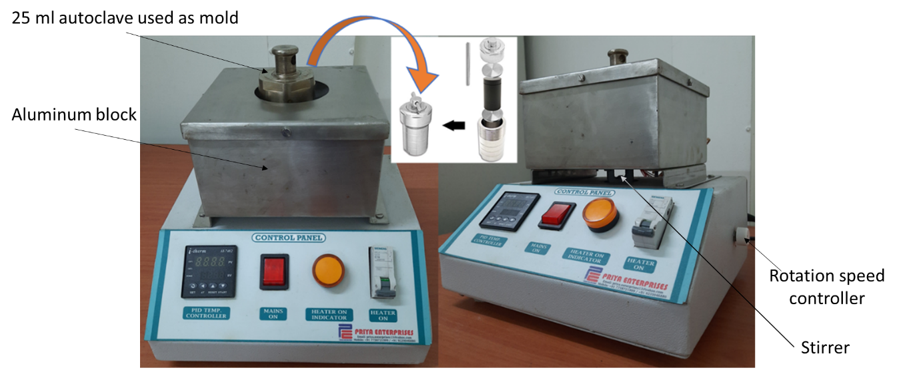

**Figure 3.2** The setup for the dynamic hydrothermal synthesis of LKMO microcubes

### Synthesis

#### Preparation of LKMO microcubes, truncated microcubes and nanorods

In [**Chapter 2**](#_STATIC_HYDROTHERMAL_SYNTHESIS:), the best optimised K18R11P5T7 procedure for the synthesis of LKMO microcube sample was chosen. In a typical synthesis, La(NO3)3.6H2O, MnCl2.H2O, and KMnO4 are taken into a beaker containing 2-5 ml of Milli Q water in a molar ratio of 1:0.7:0.3 (5 millimoles). These reagents are dissolved in water by stirring until the formation of a homogenous solution. The above solution is transferred into a 25 ml Teflon-based autoclave. Subsequently, KOH is added into the reaction mixture such that the resultant final concentration of KOH becomes 18 м and is allowed to undergo stirring for 10-20 mins. The dynamic hydrothermal reaction is performed at 800 to 1100 rpm by heating the autoclave at 265 °C under autogenous pressure for different periods of time ranging from 6 hours to 2 days. After completion of the reaction, the supernatant is decanted, and the resultant solid precipitate is washed thoroughly with MilliQ water and ethanol until the pH is found neutral. The product is dried 70 °C for 12h.

High-indexed {111} truncated microcubes of the LKMO phase were obtained by adjusting the precursor concentration to 2.5 mM while keeping the other reaction parameters constant. Nanorods of the LKMO phase were obtained by adjusting the KOH concentration to 12 м while keeping the other reaction parameters constant.

#### Preparation of LaCrO3 and LaFeO3 microcubes

To synthesis of LCrO and LFO in DH the procedures optimized in [**Chapter 2**](#_STATIC_HYDROTHERMAL_SYNTHESIS:) for the respective phases (Section **2.5.2.3** and **2.5.2.4**) were chosen. The prepared mixtures were hydrothermally treated at 265 °C for 2-3 days under 800rpm stirring. After completion of the reaction, the supernatant is decanted, and the resultant solid precipitate is washed thoroughly with MilliQ water and ethanol until the pH is found neutral. The product is dried at 70 °C for 12h. The reaction yields pure phase of LCrO and LFO microcubes.

#### Synthesis of La2-xKxMnBO6 (B = Cr, Fe, and Ni) double-perovskite microcubes

Double-perovskites with the general formula La1-xKxMnBO6 (B = Cr, Fe, and Ni) were synthesised in a single direct step. A 25ml Teflon container was taken with an 80 percent filling capacity. Into this La(NO3)3.6H2O salt with MnCl2.4H2O:KMnO4 (0.7:0.3) salt and (Cr(NO3)3.9H2O, or Fe(NO3)3.6H2O, or Ni(NO3)2.6H2O) were added in a molar ratio La:Mn:B to be 2:1:1. Then 2 to 3 ml MilliQ was added and thoroughly mixed the precursor salts for 15-20 minutes, until a homogeneous solution was obtained. Finally, the calculated amount of KOH was added to achieve the necessary 18 м solution. This allowed for 10 more mints to be stirred before being hydrothermally treated at 265 °C for 2-3 days at 800rpm stirring. After the reaction is finished, the supernatant is decanted, and the solid precipitate is thoroughly washed with MilliQ water and ethanol until the pH is neutral. The product is dried for 12 hours at 70 °C.

#### Synthesis of hollow cubes of LMKO

Purely washed 30 to 50 mg of pre-synthesized LKMO microcubes were placed in a 25 ml Teflon container with 2 to 3 ml MilliQ and sonicated for 10 to 15 minutes to ensure good dispersion. Then, with constant stirring, NaOH was added until the final concentration reached 18 м. This was allowed to stir for one whole night and then hydrothermally treated at 265 °C 800 rpm for one 1day. After decanting the clear upper solution, the final compound appeared brown to black. SEM and EDS were used to characterise this.

## Results and Discussion

The synthesis of high activation energy demanding LPO like robust materials poses risk financially and facility wise. Generally, hydrothermal synthesis is known to be the solo existing solution-based technique where one can achieve the required energetics as well as the flexibility to tune the features of the product. Combination of temperature with internal pressure is the key to it. But to synthesize LKMO in SH, 270 °C temperature with 80% filling factor wasn’t sufficient. When 18 м KOH was used in combination with above temperature and pressure then only we could get LKMO phase as seen in the previous [**Chapter 2**](#_CHAPTER-2). Because, KOH is a mineralizer and it decreases the huge activation energy required to obtain LPOs. But Still, the reaction was taking more than 5 to 7 days of time.

Apart from the temperature and mineralizer concentration none other parameters could exert any control over the reaction thermodynamics in case of SH method. The understanding of nucleation mechanism and thus the limiting step (dissolution of the byproducts) demands accommodation of an external flexible reaction parameter. Among the existing sonication or microwave assisted modern hydrothermal, which brings tremendous amount of uncontrolled energy, agitation/stirring could be the cheapest, easiest and more controlled parameter. Fusion of stirring with SH can be called as dynamic hydrothermal (DH). Popularly top assisted external stirring reactors are known but these are very costly and regular maintenance is required because of vacuum locks. When it comes to the regular hydrothermal reaction it is done in the oven (below 200 °C) or furnace (above 200 °C) where one cannot do stirring. Thus, we have designed our own dynamic hydrothermal reactor which is shown in the **Figure 3.2** with the help of Priya enterprises. With this one can conduct DH to do reactions at low temperatures, especially at 250-300 °C. The synthesis conditions that one can achieve are ranging up to 300 °C temperature and upto1500rpm stirring. As per the gained understating LKMO is mainly diffusion-limited, so to enhance we need to create extra turbulence in the reaction environment. Also, to understand the effect of shear during the reaction synthesis of LKMO phase is used as model example.

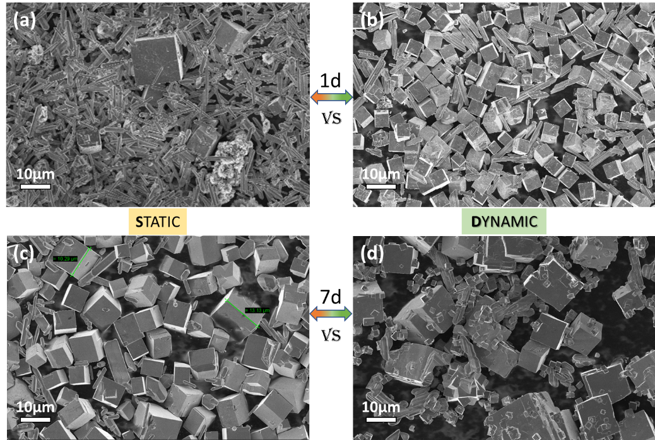

**Figure 3.3** Comparison of SEM micrographs of LKMO microcubes obtained by static and dynamic hydrothermal at 1 and 7 days.

Under the same conditions of precursors (5 mM), KOH (18 м), ratio (1:1), and temperature (265 °C), shear (850 rpm) is applied to understand how it affects the formation of the LKMO phase. This delivered assorted results. First of all, the kinetics have increased so vastly that within 6 hours of time LKMO microcubes forms (which took minimum 1 day to observe without stirring the reaction) (Check the [**TOC**](#_CHAPTER-3) of this chapter). and the reaction which usually takes 1 to 2 weeks is completing in 1 to 2 days. From the above **Figure 3.3** we can say high yield at lesser time and size reduction of LKMO is easily possible by DH.

Except the uniformity of the reagents people really didn’t explore much about the effect of stirring on the product formation. Several observations are made under shear-induced conditions. Under stirring, there is formation of grooves on La(OH)3 rods, which (might) suggest the dissolution of La(OH)3 is high (**Figure 3.4**(**b)**). In without stirring reaction conditions, the size of La(OH)3 rods is reduced (dissolving 001 planes first), while under stirring, 110 planes of La(OH)3 rods are dissolved. This could be due to the formation of micro/nano wavy patterns in the solution during the shear. As the relative motion of solution with respect to La(OH), 3 ribbons are different, which could affect La(OH)3 ribbons such that where La(OH)3 ribbons faces/interacts with the crest portions of sheared produced waves, dissolve fast.

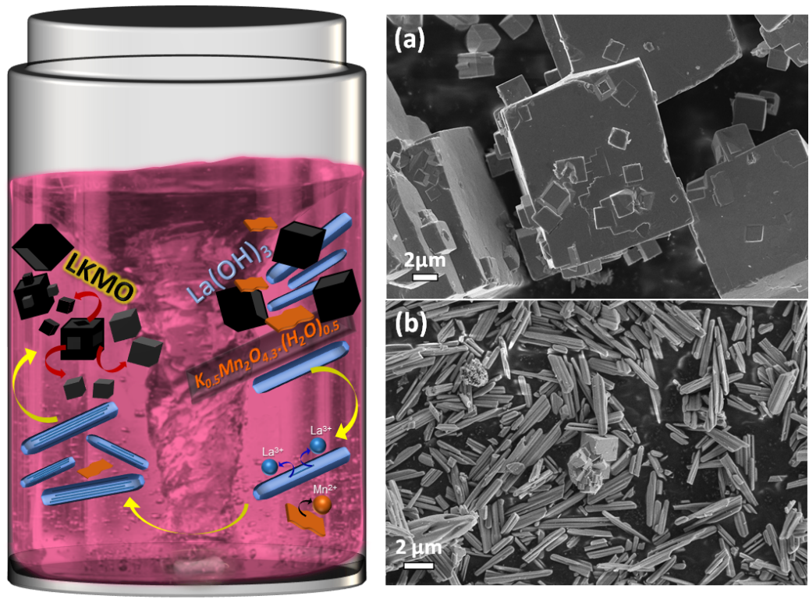

**Figure 3.4** Schematic representation of formation of LKMO in DH; SEM micrograph showing formation of (a) smaller cubes from bigger cubes, (b) dissolution of La(OH)3 rods forming groves.

In the initial times (6 hrs) uniform sized cubes (≈ <7> microns) (single-step nucleation) formed and after a prolonged time size distribution from 300 nm to10 microns observed (**Figure 3.4**(**a)**). This could be due to, under stirring conditions, small cubes are formed on top of big cubes which are sheared off from the big cubes during the reaction. This is quite possible because stirring breaks the gold nanorods into particles.145 This reduces the probability of multi-step nucleation (secondary nucleation) rather enhances the occurrence of heterogeneous nucleation. In other words, reaction shifts from multi-step nucleation to heterogeneous nucleation, which is energetically more favourable. Big cubes have rough surfaces which could serve as nucleation sites for hetero-generous nucleation. SEM images show marks in big cubes after removing small cubes from them.

As per Fletcher et. al. a crystal formation passes through four stages.146 These stages are shown in **Figure 3.5** left hand side. The transition of these stages there occur two rate limiting steps. First one is the diffusion process which happens at the beginning where the dissolved ions starts to aggregate into clusters. The second one is the organization of prenucleating clusters and embryos which is the formation of well-defined lattice. Teng et. al. published different internal ionic arrangements during the crystal nucleation. Here the stability of each arrangement is defined by the ratio of surface energy gain to the solution chemical potential. Once an arrangement crosses the critical nucleus size then it becomes stable and then growth commences (**Figure 3.5**).

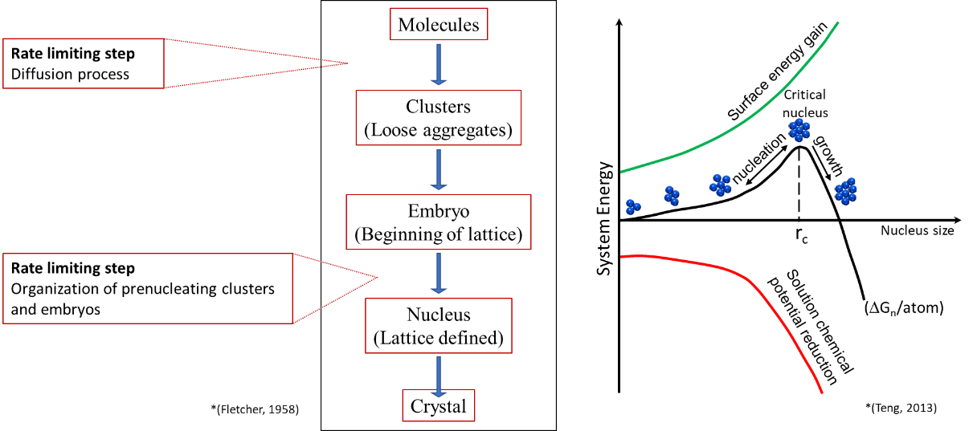

**Figure 3.5** (Left side) Different stages of crystal formation146 and Internal organisation of ions in crystal nucleation147 (right side)

La3+ is known to form the hydrodynamic sphere with the hydroxide and the water. The entire diameter of which is of the order of some nanometres (**Figure 3.6**). This is true when La dissolves into the solution. In case of SH there is enough Mnx+ ion concentration and poor La3+ ion concentration in the solution, at the prenucleation stage.

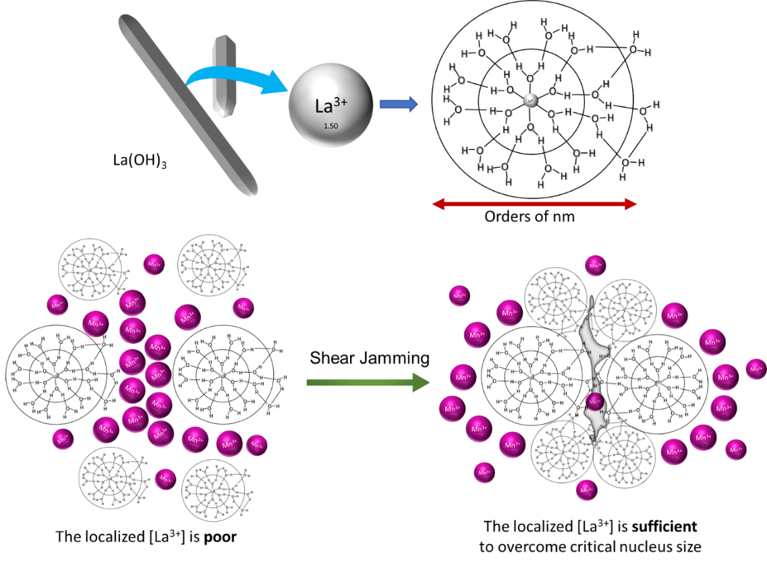

**Figure 3.6** Schematic representation of the shear jamming situation proposed in DH.

The reaction kinetics can be improved by increasing the temperature or also can be increased by adding the extra precursor. But even then, locally La3+ ion concentration is low due to the formation of La(OH)3 rods (discussed in **section 2.7**). In this case, two La3+ ions with its hydrodynamic spheres are physically separated by the Mn ions and the probability of having these two near is very less. So, whenever there is a nucleation, it happens locally and the nuclei size is extremely small. It might not cross the critical nuclei size thus it dissolves back as ions to the solution.

In DH method the stirring can instigate a situation called shear jamming. This concept of particle shear induced jamming is a consequence of dynamical structural transition.148,149 If it is happening for the 100nm particles still it can happen for 1 to 2 nm particle. There is no logic/reason why it can’t happen in LKMO case. So, now if this kind of jamming materializes at some places, might not be everywhere; wherever it happens the amount of La3+ ions becomes high at that place (as shown in **Figure 3.6**). If this happens the formed nuclei can quickly cross the critical nuclei size after which it won’t dissolve back. This nucleus is extremely energetic thus it rapidly consumes the rest of the available La and Mn ions in the immediately vicinity and grows bigger. Because of this situation there won’t be any further saturation to allow subsequent nuclei to form. For second nucleation once again, shear jamming has to facilitate.

This is the proposal for the phenomena taking place at the atomic scale as per our observation, which explains the improvement of the reaction rate of the synthesis of LKMO microcubes. The same DH method used to synthesize LaCrO3 and LaFeO3 LPOs. **Figure 3.7** represents the morphology and phase of the same. Here also DH shown superior results compared to SH. The obtained XRD patterns indicate formation of pure phase without any secondary or byproducts in both the cases. Thus, it clarifies that the stirring brings complete homogeneity of solution also enhances the reaction rate as within 2 days both the reactions reached their completion. These usually takes 5 to 7 days in case of SH method.

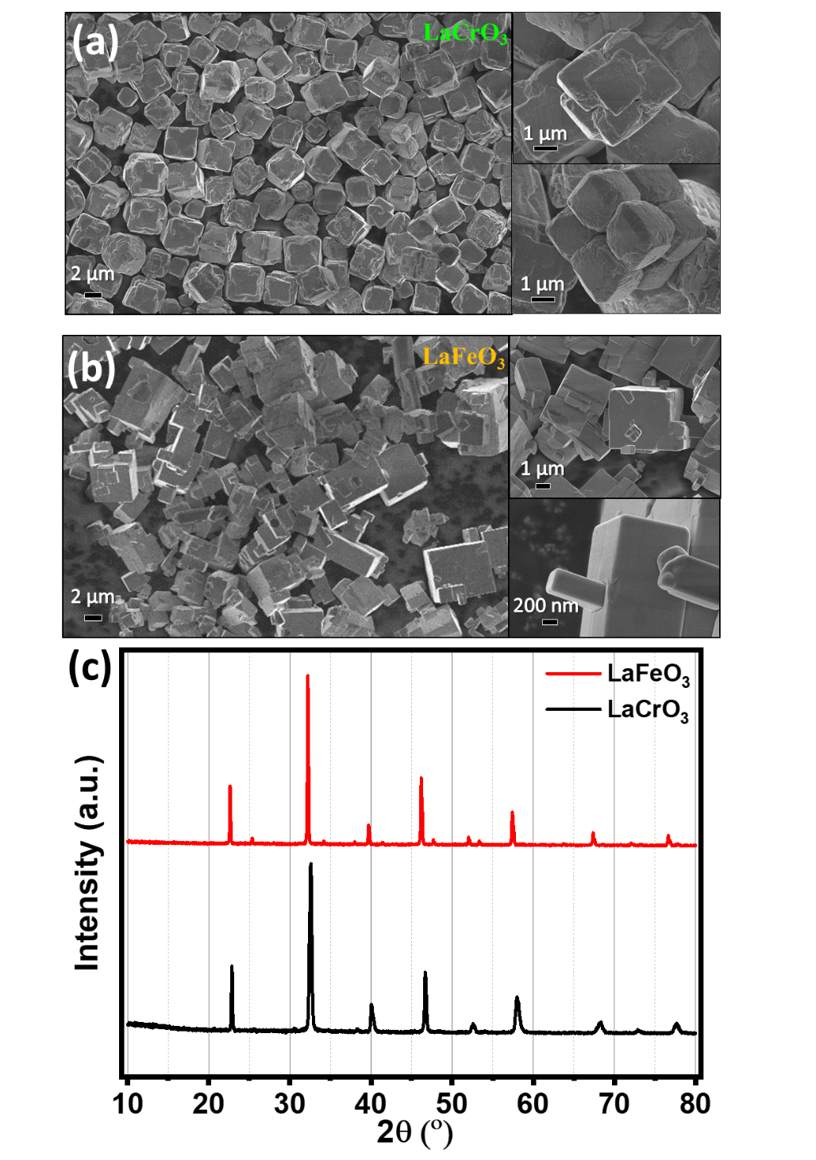



**Figure 3.7** SEM images of (a) LaCrO3 and (b) LaFeO3 sample synthesized by dynamic hydrothermal method and (c) corresponding XRD patterns.

**Hollow cubes**

The synthesized LKMO microcubes, when subjected to concentrated NaOH or KOH, resulted in internal corrosion/dissolution leading to hollow cubes. This explains the LKMO cubes has the tendency to dissolve back and form the respective byproducts. This formation of hollow cubes or dissolution of the LKMO microcubes shows DH is better than SH. Because, in the case of SH the precursor concentration is not uniformly distributed and thus there will be a place where the formed cubes will dissolve back where as in DH case we have more uniformity and thus the cubes stay stable.

By looking at the SEM images (**Figure 3.8**), the extent of the corrosive nature of the base seems very deep. Compared to the surface, edges and corners of the cubes are more prone to corrosion. Thus, these works as the active centres through which the base starts to dissolve the Mn and La from the cube and corrodes inside. The EDS spectrum and mapping shows that the perovskite phase at the shell level still maintained.

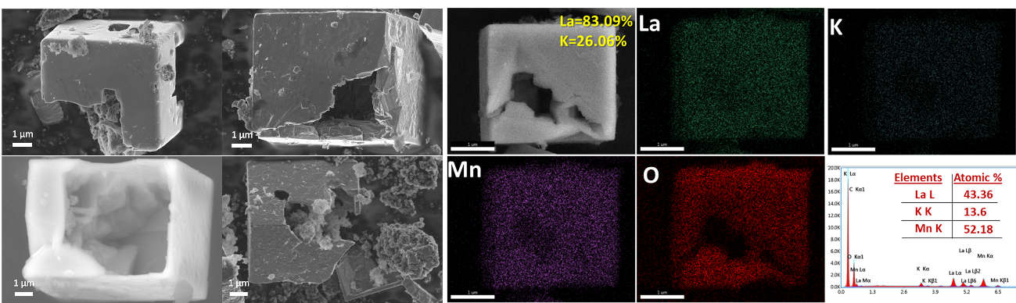

**Figure 3.8** SEM micrographs and EDS spectrum-mapping of LKMO hollow cubes.

**Facilitate in catalysis**

Catalysis is very specific to the surface of the catalyst material. The atomic arrangements in each facet are exclusive thus different facets hold specific energetics and thus catalytic activity. When LKMO is prepared in DH at reduced precursor concentration (< 2.5 mM) resulted high-index {1 1 1} faceted/truncated microcubes (**Figure 3.9**). This shows the capability to alter the morphology thus expose different facets of LPOs which was quite challenging to achieve in SH method.

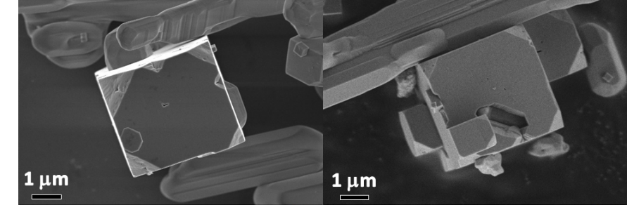

**Figure 3.9** SEM images of high-index {111} truncated LKMO microcubes obtained by DH method.

Catalytic activity in LPO systems usually dictated by the B-site atom. The covalency of Mn-O bonds plays significant role in designing catalyst. A-site substitution of K can modify the valence state of the B-site Mn and thus the filling of the d sates involved. As upper edge of the valency band and lower edge of the conduction band are defined by the oxygen 2p states and transition metal 3d states. Thus, the electronic properties of Mn-O bonds define the activity and stability of the catalyst. Having established DH as a better alternative to the more conventional SH method we further explored its potential in synthesis a series of La2-xKxMnBO6 (B = Cr, Fe, and Ni) double perovskites. Because of the presence of second transition metal with different 3d state filling can work in conjunction with the Mn resulting enhanced catalytic activity. If we look at the SEM images in **Figure 3.10a** of La2-xKxMnNiO6 (LKMNO) we see truncated microcubes similar to the above truncated LKMO microcubes. Elemental distribution and composition can be found from the **Figure 3.10c** and **d** EDS mapping and spectrum. The relatively equal atomic percentage presence of both the Mn and Ni can be clearly seen here indicating the double perovskite. Here Mn brings the potential of oxygen reduction while Ni is known for oxygen evolution thus making the LKMNO to be a bifunctional electrocatalyst.

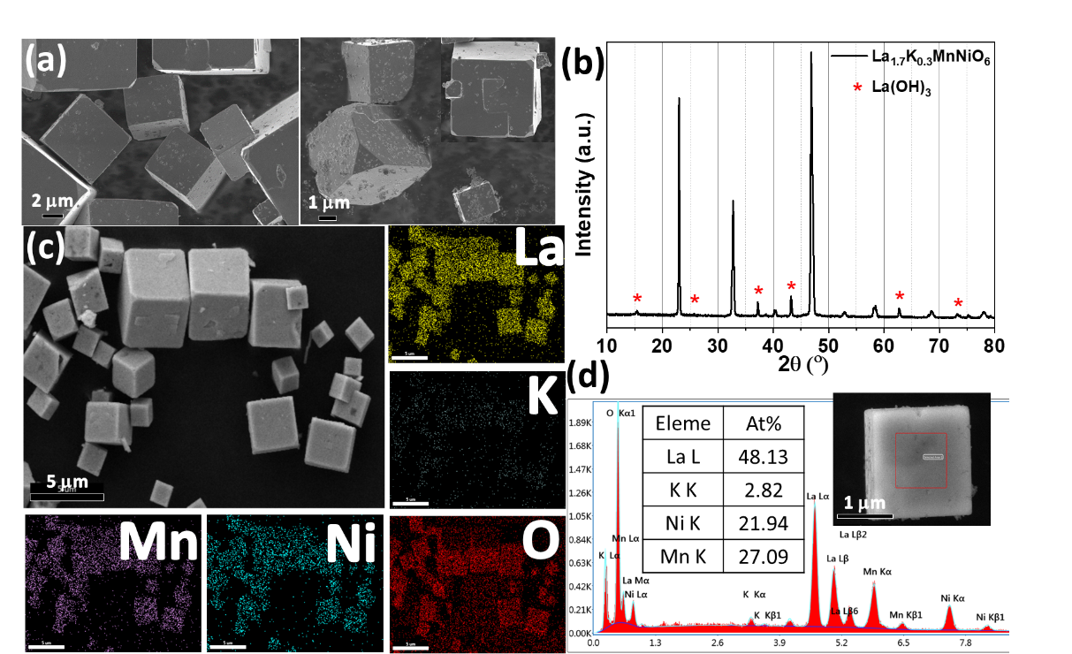

**Figure 3.10** (a) SEM micrographs indicating the {111} faceted LKMNO microcubes, (b) XRD pattern, (c) EDS mapping, and (d)EDS spectrum of LKMNO.

Similarly, one can obtain La2-xKxMnCrO6 and La2-xKxMnFeO6 double perovskites as shown in below **Figure 3.11**(**a** and **b).** Both the cases uniform distribution of both the transition metals on the cubes can be seen.

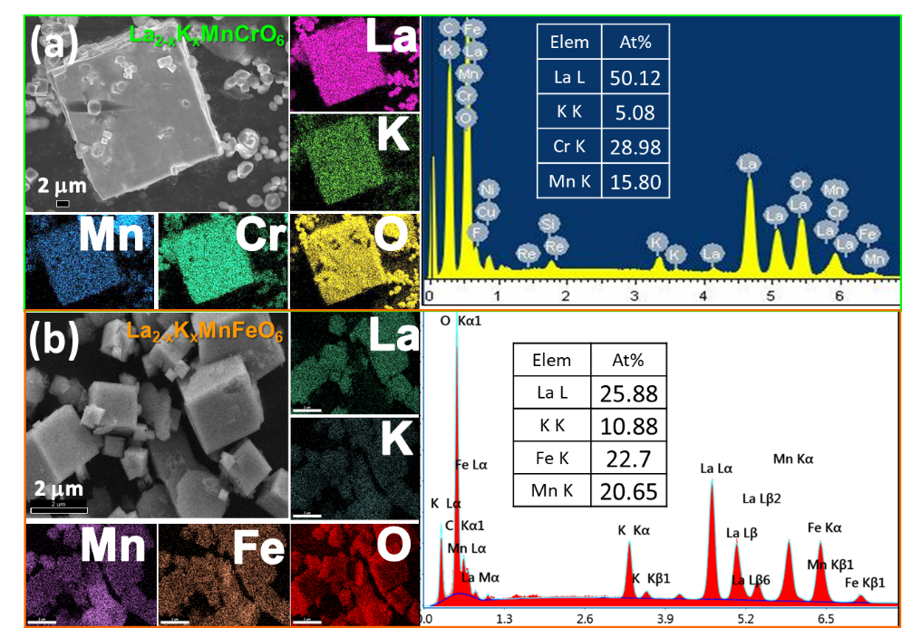

**Figure 3.11** EDS mapping of (a) LKMCrO and (b) LKMFO double perovskites.

**Electrical characterization of LKMO nanorods**

The reaction environment can bring serious changes to the resulting product morphologies. Lowering KOH (12 м) concentration can bring one-dimensional structures compared instead of cubes when crushed LKMO microcubes used as seeds in DH. The careful observation to the electron microscope images indicates the growth of these nanorods is screw dislocation assisted growth which is one of the prevalent growth mechanisms (**Figure 3.12**). In this process microns of length LKMO nanorods obtained within 2 days of time. By closely looking at the SEM images in **Figure 3.12** infers every nanorod is growing from a core and they themselves start to protrude new nanorods. This might be because of the presence of topological defects which are acting as active centres.

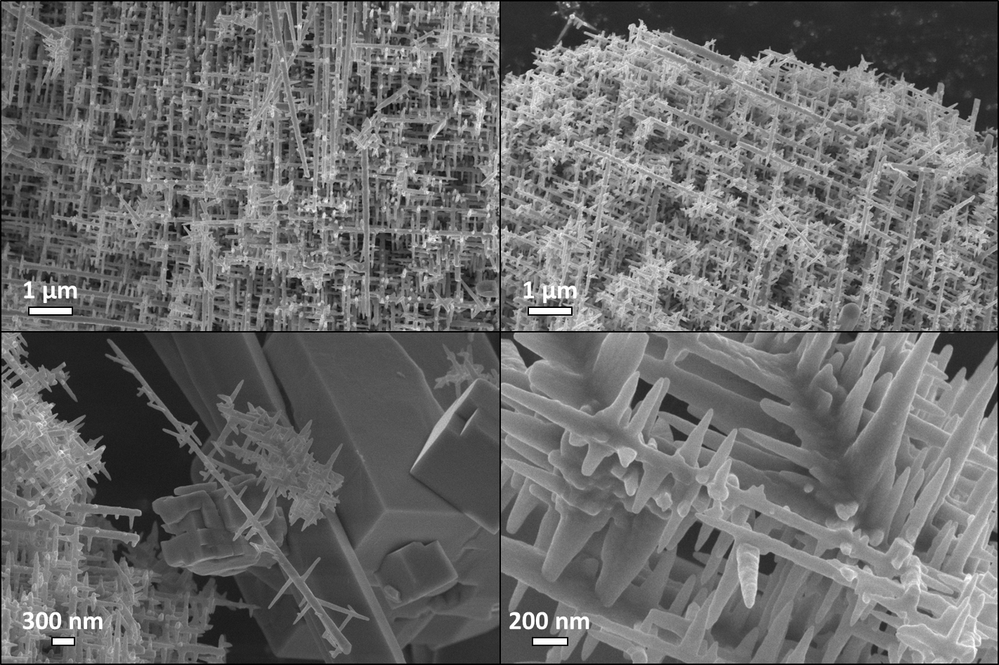

**Figure 3.12** SEM micrographs of LKMO nanorods obtained in DH at 12 м KOH.

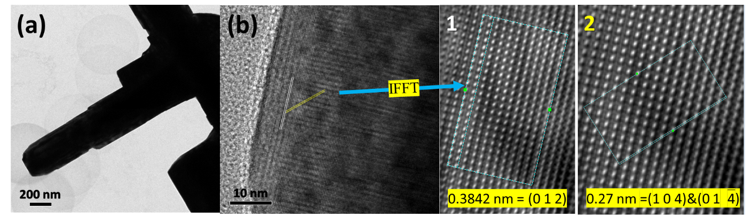

**Figure 3.13** (a) TEM image of LKMO nanorod, (b) HRTEM image showing the lattice fringes where 1 and 2 are IFFT images showing the lattice d-spacing and corresponding hkl plane.

A detailed TEM characterization has been carried out to understand the composition and structure of these nanorods. The TEM image in **Figure 3.13a** depicts the screw dislocation assisted growth of these nanorods. Analysis of the HRTEM image in **Figure 3.13b** indicates the surface of these nanorods oriented in [0 1 2] direction. This is clearly measured from the Inverse Fast Fourier Transformation (IFFT) using the Digital Micrograph software. In (1) this the spacing between two bright spots measured (as shown in **Figure 3.13b(1)**) to be 0.38 nm. This is corresponding with the (0 1 2) plane of LKMO phase. The **Figure 3.13b(2)** measures another d-spacing of 0.27 nm which corresponds with the (0 14) plane of LKMO phase. The Selected Area Electron Diffraction (SAED) analysis in **Figure 3.14a** also shows presence of (0 1 2) and (0 14) along with (0 0 6) and (0 2). More importantly the SAED pattern along with the HRTEM image proves that the LKMO nanorod is single crystalline in nature and it doesn’t have any observable internal defects. In addition to the main intense Bragg reflections, which are indexed to a rhombohedral perovskite structure, there are superlattice reflections.

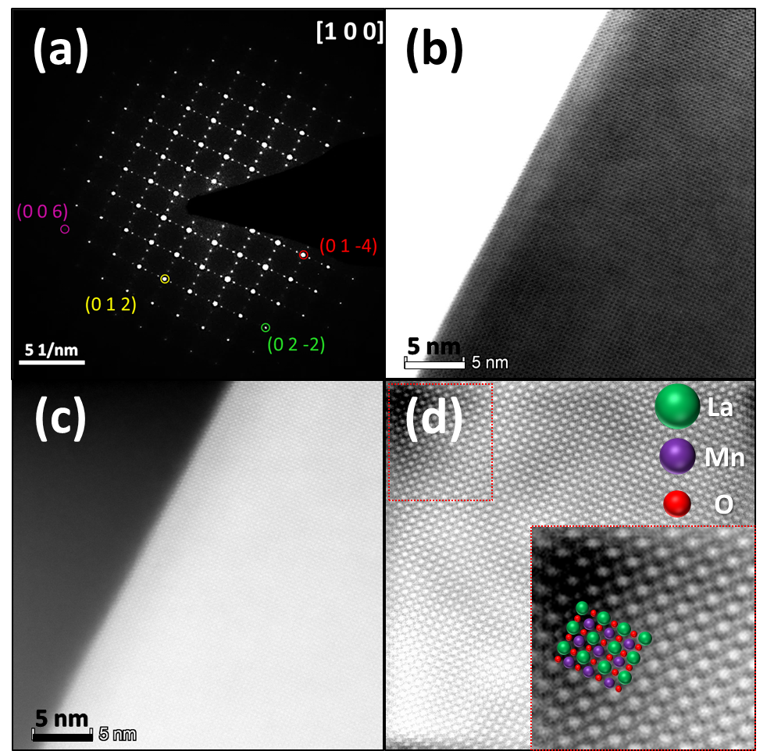

**Figure 3.14** (a) Indexed SAED along [1 0 0] zone axis, (b) STEM-BF, (c) STEM-HAADF image of LKMO nanorod, and (d) IFFT of bright field STEM image showing a model overlay of the La and Mn columns of the LKMO nanorod in the magnified red rectangle.

The HAADF-STEM imaging differentiates high atomic number element with brighter contrast because of larger electron scattering angle due to higher electrostatic interactions amongst the nucleus and electron beam. **Figure 3.14**(**a)** and (**b)** show high-resolution STEM images in both BF and DF, respectively, confirming good uniformity of La1-xKxMnO3 at the atomic scale. The dark spots in **Figure 3.14**(**b)** preferably represents the heavy element La column. For a better representation IFFT was collected from the BF-STEM (**Figure 3.14**(**c)**) as shown in **Figure 3.14**(**d).** Here the bigger spots correspond to La-atomic columns. smaller spots correspond to Mn-atomic columns and in between them oxygen atomic-column present, as represented in the model in the inset of **Figure 3.14**(**d)**. Here green atoms represent La, purple represents Mn, and red is O. There was no clear Z-contrast to distinguish K atomic columns.

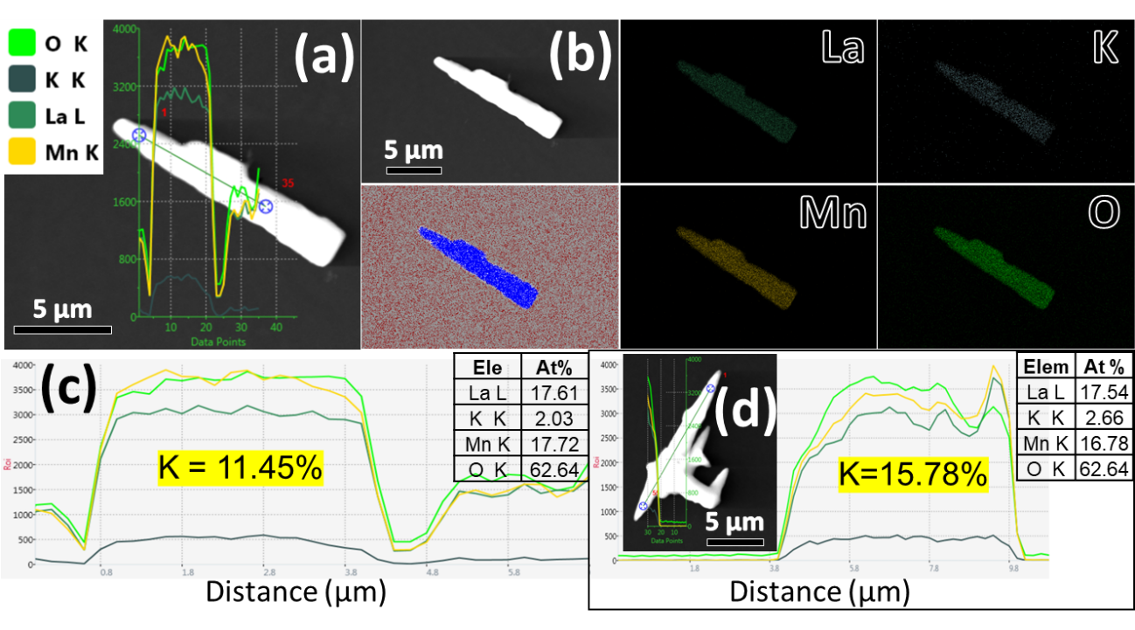

**Figure 3.15** (a) STEM image, (b) EDS mapping, (c) Line mapping along the length of LKMO nanorod, and (d) Second line mapping case of LKMO nanorod for K%.

Further, the elemental identification and location are examined from the chemical mapping using EDS in STEM (**Figure 3.15(a)** and (**d)**) which is a powerful technique at atomic resolution. The EDS spectrum indicates the K in the LKMO nanorods is averaged around ≈ 13% (**Figure 3.15**(**c)** and (**d)**). **Figure 3.15(b)** displays homogeneous distribution of La, K, Mn, and O elements throughout the nanorod. Thus, these LKMO nanorods could show better electrical properties.

**Fabrication of two probe devices from LKMO nanorods**

To measure the electrical properties of the LKMO single nanorod devices electron beam lithography was used to fabricate the two probe devices on the single LKMO nanorods. At first, Si/SiO2 substrates of 1 by 1cm were taken and washed thoroughly with acetone-iPa-MilliQ. Then, first-level marker lithography was done on these substrate chips. These were then spin-coated with the IPA dispersed LKMO nanorods sample. This process was optimized to isolate individual LKMO nanorods. Then the location of the LKMO rods was marked. Then based on their location, the second-level mask was written using KLayout and Clewin 4 softwares. To find out the suitable metal contact KPFM was used to calculate the work function which came to be 4.7 eV. Based on this we choose adhesive 2 nm Cr layer on top of the Si/SiO2, on top of which 80 nm Pt and 100 nm Au was sputter coated. As EL9 and PMMA e-resists were used the metal deposited device was left in acetone for lift-off over the night. The obtained device was etched at it’s back to remove the SiO2 using mild HF-buffer. This allows to apply the gate bias to the formed device.

Two probe measurements were done on these devices by using the instrument called Proxima. Here we have studied the 2-terminal IV, IDVD, and IDVG. We obtained the current, carrier concentration, carrier mobility ($μ$), carrier type information.

$μ=\frac{g_{m}*L*ln⁡(\frac{2t}{r})}{2πε_{0}ε{*V}_{sd}}$… … … … … … … … … … … 5

From the above Eq. (5)150 and **Figure 3.16**, gm is transconductance, Vsd is source-drain voltage, L (383 nm) is the channel length of the nanorod FET, t (100 nm) thickness of the silicon oxide layer, r (86 nm) the nanorod radius and ɛ (3.9) the dielectric constant of silicon.

IV characteristics obtained from the LKMO nanorod SEM micrograph are shown in **Figure 3.16 (a** & **b)**. The device has a channel length of 383 nm, and 173 nm is the diameter at the middle of the channel. Despite being thick, the device exhibited inverse-‘S’ such as IV characteristics which are typical of silicon nanowires. Previous studies explained this behavior using either quantum mechanical effects152,153 or the non-linearity of the metal silicon contacts154. Ponomareva et al. have theoretically studied the electronic properties of silicon nanowires. They have found that unsaturated bonds at the silicon nanowire surface play a key role in determining the electrical characteristics of a silicon nanowire.154

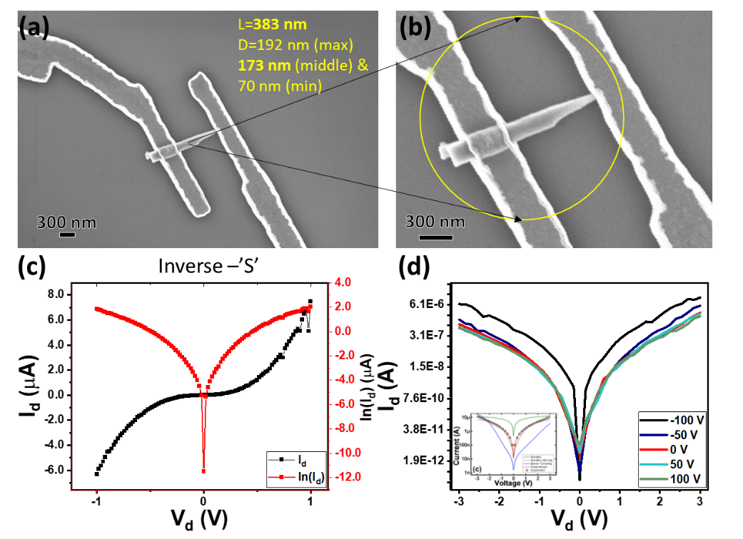

**Figure 3.16** (a) SEM image of two probe IV devices of LKMO single nanorod, (b) enlarged representatively, (c) 2-terminal IV or drain current and absolute values, and (d) variation of drain current w.r.t. the drain voltage, inset showing comparison of theoretical and experimental fitting for Schottky model shown by S. Acharya. (2018).151

The electric transport characteristics of LKMO nanorods were carried out as shown in **Figure 3.16(c** & **d)**. By looking at which the LKMO nanorods are showing p-type behavior. Because in a typical semiconductor such as silicon transistors, the pMOSFETs show conduction in negative gate bias whereas stays off in the positive gate bias.

… … … … … … … … … … … 6

B is a constant,

E is electric field,

$ϕ_{t}$ is zero field ionization energy,

$k_{B}$ is the Boltzmann constant,

T is absolute temperature,

e is the electronic charge,

$ε_{0}$ is the permittivity of the free space,

K is the optical dielectric constant

From the literature, the electrical transport properties of La(Fe, Ga)O3 perovskite oxide nanowires study shows the possible conduction mechanism.155 Similar to this, our LKMO rods also show inverse-S such as IV characteristics and a slight trend of increase in current with negative gate bias. Thus, we assume that the carrier transport in our nanorod follows the bulk-limited conduction mechanism where electron jumps from trap sites to conduction band that is known as Poole-Frenkel conduction Eq. (6) instead of interface-limited Schottky emission.

## Conclusion

We have improved the kinetics of synthesis of these LPOs by introducing the stirring. We decreased the overall reaction time from 7 days to 2 days. Proposed shear jamming taking place in the reaction under stirring conditions. This phenomenon has been shown to reflect the groves on the La(OH)3 rods and enhanced kinetics of LKMO formation. We have obtained nanorods, high-index {1 1 1} faceted microcubes, and hollow cubes of the LKMO sample. These can be used as selective catalysts pertaining to their specific facets’ exposure. The DH method can be used to obtain bifunctional catalysts like double perovskites. We fabricated the single rod devices of LKMO nanorods and studied their electrical properties. The results indicate that the nanorod is of p-type material and shows the Poole-Frenkel conduction mechanism, which is due to the cation vacancies, which probably originates due to potassium (cation) doping. In future, one can try to synthesize the nanorods of other materials such as cobaltite, nickelate and aluminate by this method.

# Applications: study of electrocatalytic and organocatalytic activity of LKMO microcubes

**Applications: study of electrocatalytic and organocatalytic activity of LKMO microcubes**

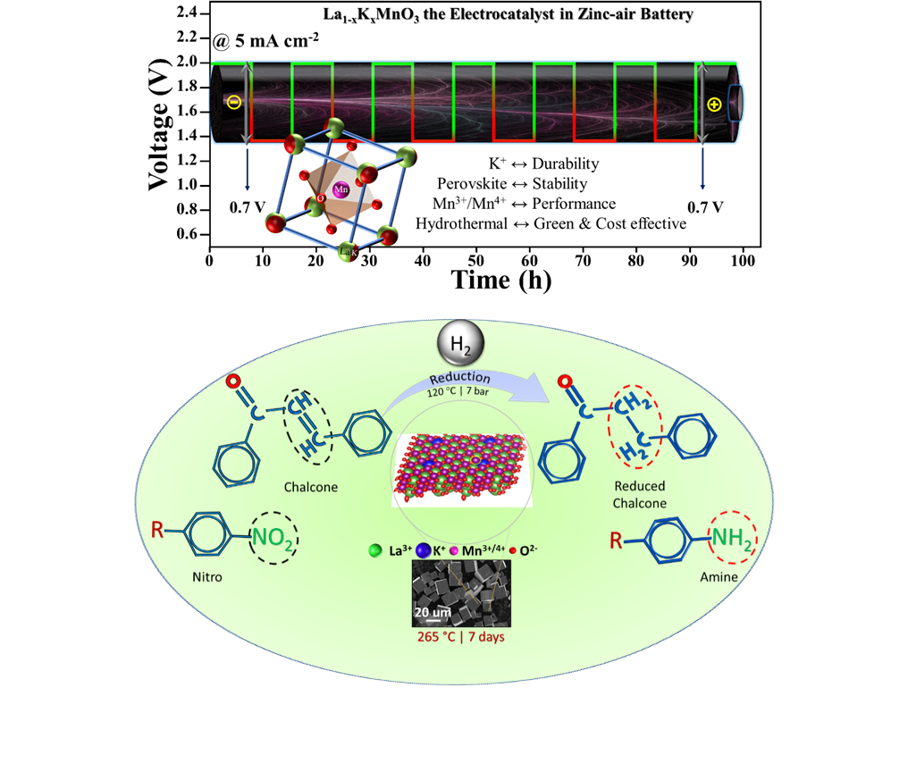

## Part-1: Importance of K Substitution in LaMnO3 to Achieve Highly Active and Exceptionally Stable Bifunctional Electrocatalyst Towards Oxygen Reduction and Oxygen Evolution Reactions

## Abstract

Efficient, low-cost, and long-lasting electrocatalysts that accelerate sluggish oxygen evolution reaction (OER) and oxygen reduction reaction (ORR) kinetics are highly desired for a variety of applications, including metal-air batteries and fuel cells, but they are uncommon. Such bifunctional catalysts primarily suffer either from low-catalytic activity or degradation during prolonged cycling. Here, we have used the low-temperature hydrothermally synthesized (as described in **Chapter 2, Section 2.5.2**) potassium substituted LaMnO3 microcubes as a perovskite oxide-based electrocatalyst. In an alkaline environment, the catalyst performs admirably, with improved kinetics and activity for ORR (half-wave onset potential of 0.78 V) and OER (onset potential at 10 mA cm-2 current density is of 1.66 V). Furthermore, as a two-electrode, this catalyst renders the potential for use as an electrode in zinc-air batteries with unprecedented stability (no visible sign of degradation even after 1000 cycles of charge-discharge).

## Introduction

Rechargeable zinc-air batteries have drawn much attentiveness in energy conversion and storage applications due to their high theoretical energy densities, eco-friendliness, low cost, and safety.156 The output performance of zinc-air battery enormously relies on the reaction rates of anodic oxygen evolution reaction (OER) and cathodic oxygen reduction reaction (ORR). However, slower kinetics and complicated multi-electron transfer processes of OER and ORR have posed many scientific challenges due to their resulting higher overpotentials.157–160 To date, the conventional electrocatalysts to boost OER or ORR rates are based on precious metals like Pt, Ru, and Ir. However, their utilization in practical applications is critically hindered by poor durability, scarce resource, and prohibitive cost.161,162 Thus, the precious metals are being replaced with alternatives with comparable electrocatalytic activity to reduce the cost. Therefore, developing high-performance and stable electrocatalysts is highly desirable yet remarkably challenging for OER and ORR of zinc-air battery.

Transition metal oxides have been proposed as alternative materials for replacing precious metals. Most high-performing bifunctional electrodes based on metal oxides such as Co3O4 and MnO2 suffer from low conductivity. Thus, adding conducting carbon-based materials is a usual practice. However, carbon gets oxidized during electrochemical cycles and destroys the conductive carbon network.163–165 The resulting carbonaceous precipitates clog pores of the electrodes and increase impedance, thus reducing performance and cell failure.166,167 In this regard, perovskite oxides have been considered promising efficient bifunctional electrocatalyst candidates due to their high intrinsic activity, chemical and structural stability, and compositional flexibility.168–171 In particular, LaMnO3 (LMO) has shown better catalytic activity and stability compared to many non-noble transition metal-based electrocatalysts, as reported by Hayashi M. et.al.172,173 Yabuuchi, N. et al. reported the unusual catalytic activity of LMO due to the presence of ideal d-orbital occupancy and optimum Mn-O bond.174 Doping +2 cations in perovskite oxides, LaxA1-xMO3 (M=Co, Ni, Mn; A=Ca, Sr, Ba), are valuable for improving the conductivity, thus eliminating the addition of external conducting agents.174–176 However, +2 cation substitution often terminates the surface with the AO layer due to charge neutrality and buries the catalytic MO layer inside the crystal.177 Thus, the catalyst is not able to perform to its full potential. On the other hand, substitution with +1 cation can solve this problem,178 but such studies have not been performed yet. Further, incorporating +1 cations inside perovskite shows synthetic challenges via high temperate solid-state synthesis131 (due to the significant evaporation rate of alkali metals during the reaction), and alternative low-temperature solution-based synthesis is yet to be explored. Thus, establishing low temperature solution-based synthesis, which can offer better control over nucleation and morphology will open plethora of opportunities to study and design the robust electrocatalysts.

Herein, we successfully synthesized catalytically active potassium substituted LaMnO3 perovskite oxide microcubes via a low-temperature, energy-efficient solution-phase hydrothermal method. The K+ substitution increases the average A-site ionic radii, thus decreasing the crystal structure towards a higher symmetry.72 Further, the K+ substitution also improves exchange interaction between the manganese ions and the effective transfer integral of the, eg electrons.179,180 The electrocatalytic activity and durability of designed electrocatalysts are examined by electrochemical studies in a three-electrode system and half-cell testing studies in zinc−air battery.

## Materials and Methods

### Materials

The 20 wt% Pt/C catalysts were procured from Johnson Matthey (UK), and Nafion (5 wt%) solution was purchased from DuPont. **Section 2.5.1**. lists the materials required for the synthesis of the LKMO catalyst.

### Synthesis of LKMO microcubes:

As discussed in [**Chapter** **2**](#_Preparation_of_LKMO), the LKMO microcubes were synthesized by taking (**Figure 4.1**) La(NO3)3.6H2O, MnCl2.H2O, and KMnO4 into a 25 ml Teflon container in a molar ratio of 1:0.7:0.3 (of 5 mmol equivalents). These reagents are dissolved in 4 ml of Milli-Q water by stirring until the formation of a homogenous solution. Subsequently, KOH is added into the reaction mixture such that the resultant final concentration of the solution becomes 18 м and is allowed to undergo stirring for 24 hours. The hydrothermal reaction is performed by heating the autoclave at 265 °C under autogenous pressure for a period of 7 days. After completing the reaction, the supernatant is decanted, and the resultant solid precipitate is washed thoroughly with Milli-Q water and ethanol until the pH is found neutral. The product is dried at 70 °C for 12 hrs. The reaction produces LKMO microcubes as a major product and La(OH)3 rods as a minor byproduct. La(OH)3 rods can be separated from the denser product in the workup process as described in the **section** **2.5.2.2.2**.

LaMnO3 (LMO) and La0.5Sr0.5MnO3 (LSMO) microcubes have been synthesized using the same above low-temperature hydrothermal method, which is similar to the approach adopted in the literature.106,109,181 For detailed information **section 4.8.2** and **4.8.3** can be referred.

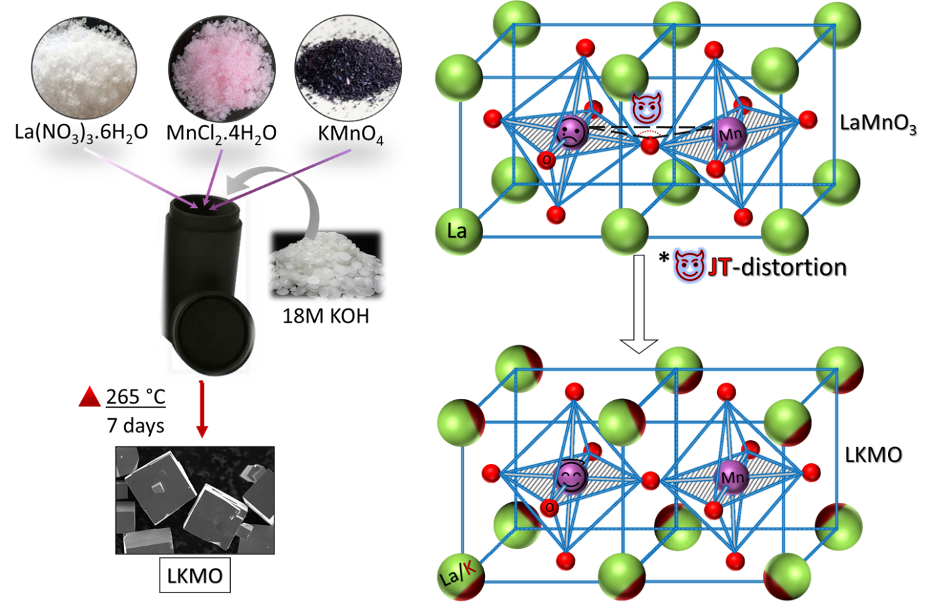

**Figure 4.1** Left side depicts the hydrothermal synthesis of LKMO microcubes, and the right side shows the drop in JT-distortion with potassium substitution

### Electrochemical characterization:

The electrochemical studies were carried out using a three-electrode electrochemical cell setup in 0.1 м KOH solution for the synthesized electrocatalysts using a bipotentiostat. The catalyst coated glassy carbon was used as a working electrode after polishing with alumina powder of 0.5 microns. A graphite rod was used as a counter electrode. The catalyst of 3 mg was mixed and sonicated well with 120 µl of water, 80 µl of IPA, and 30 µl of Nafion (5 wt%) solutions to obtain the slurry. The requisite quantity of slurry was drop casted onto the working electrode. The silver-silver chloride (Ag/AgCl) electrode filled with 3 м KCL was used as a reference electrode, and all the potential values mentioned in the chapter were converted to RHE values. The linear sweep voltammetry studies were performed to evaluate the electrocatalytic ORR and OER activity of the synthesized electrocatalysts in 0.1 м KOH with oxygen saturated solution at a scan rate of 5 mV s-1. The ORR was performed between the sweep potential of 0.2 V to 1.2 V vs RHE and 1 V to 2 V vs RHE for OER. The ORR and OER studies were compared at 1600 rpm. The ORR kinetics was investigated using the Koutecky-Levich plots with the following equation:

$$\frac{1}{I}= \frac{1}{I_{k}}+\frac{1}{I_{d}}= \frac{1}{nFAkC^{0}}-\frac{1}{0.62nFAD_{O_{2}}^{2/3}v^{\frac{-1}{6}}C^{0}w^{\frac{1}{2}} }…………………………….(1)$$

$$I_{k}=\frac{I*I_{d}}{I_{d}-I}……………………………………………………………………………(2)$$

A is geometric electrode area (cm2), k is the reaction rate constant, C0 is O2 saturated concentration in 0.1 м KOH solution, $D_{o_{2}}$ is the oxygen diffusion coefficient, ω is the rotation rate (radian s-1), ν is solvents kinetic viscosity, n is the involved number of electrons in the reaction, Id is the diffusion current density, F is Faraday constant, Ik is the kinetic current density, and I is measured current density.

### Zinc-air battery fabrication and testing:

A zinc-air battery of 2.5 cm2 active area was fabricated by using an acrylic cell setup consisting of zinc anode, air cathode with 8 м ZnO + 6 м KOH as electrolyte. The zinc electrode was developed by electro-deposition of zinc on the stainless-steel mesh of 4 cm2 of electrode surface area. The 12 mg cm-2 of catalyst loading was maintained on the air electrode of the battery. The performance and cycle life of the battery was tested using a battery cycler (Arbin instrument LBT21084). The charge-discharge cycles of the battery with 360 s per cycle period were performed by maintaining the airflow rate of 40 ml min-1 at the cathode during discharge, and the voltage polarization were observed over the life cycle test.

## Electrochemical measurements

Electrochemical characterizations were carried out to assess the catalytic activity of synthesized LMO, LSMO, LKMO, and commercial Pt/C and IrO2 catalysts. The cyclic voltammograms in N2 purged solution show the pure capacitive behaviour for the LKMO catalyst. The prominent ORR peak was observed at 0.8 V in the O2 purged 0.1 м KOH solution (**Figure 4.2**). The LSVs were further recorded for the different catalysts at 1600 rpm to analyse the ORR kinetics, as shown in **Figure 4.3**. The ORR onset potential for LMO, LSMO, LKMO, and Pt/C was found to be 0.75 V, 0.83 V, 0.86 V, and 0.93 V, and their corresponding half-wave potentials were found to be 0.58 V, 0.72 V, 0.78 V, and 0.85 V, respectively.



**Figure 4.2** Cyclic voltammogram of LKMO at N2 and O2 saturated 0.1 м KOH electrolyte.

The synthesized LKMO catalyst showed a higher limiting current density and higher positive shift in the onset potential for ORR compared to many previously reported perovskites in alkaline medium. Tafel slopes from LSV curves studied the kinetics of ORR catalytic activity. The LKMO electrocatalyst exhibited a lower Tafel slope of 84 mV dec-1 than LSMO (97 mV dec-1), LMO (121 mV dec-1), and is very close to Pt/C (59 mV dec-1) (**Figure 4.3**(**b)**). The lower the Tafel slope value indicates the faster reaction kinetics and higher intrinsic ORR activity.

D:\LKMO_Manuscript\ORR_OER_Final.tif

**Figure 4.3** (a) ORR polarization curves of LMO, LSMO, LKMO, and Pt/C (20% ) catalyst in 0.1 м KOH oxygen saturated at 1600rpm (b) Tafel slope plots for ORR (c) OER polarization curves of LMO, LSMO, LKMO and IrO2 at 1600rpm. (d) Tafel slopes plots for OER.

The OER activities of synthesized catalysts were evaluated by LSV at 1600 rpm and compared to the state-of-art noble electrocatalysts (IrO2), as shown in **Figure 4.3**(**c)**. The obtained potential at a current density of 10 mA cm-2 was found to be 1.79 V, 1.72 V, 1.66 V, and 1.59 V for LMO, LSMO, LKMO, and IrO2, respectively. The earlier onset potential and smaller overpotential indicate the higher OER catalytic activity of synthesized LKMO electrocatalysts. The measured catalytic kinetics for OER shows that the LKMO catalyst had a lower Tafel slope of 98 mV dec-1 than LSMO (119 mV dec-1), LMO (136 mV dec-1) and is comparable to IrO2 (74 mV dec-1) as shown in **Figure 4.3**(**d)**. The LKMO catalyst exhibited a better or comparable performance to many reported perovskite and transition metals-based OER electrocatalysts (Table 4.1).

D:\LKMO_Manuscript\Total_Final.tif

**Figure 4.4** (a) LSV curve in the range of potential from 0.2 to 2 V, ∆E( Ej = 10– E1/2) is a measure of OER and ORR bifunctionality. (b) Bifunctionality measurement from LSV for OER and ORR potential to achieve a current density of 10 mA cm-2 and 3 mA cm-2, respectively. (c) Polarization curves for charge-discharge of zinc-air battery. (d) Power density curve for LKMO, LSMO, LMO, and Pt/C (20% ) as electrocatalyst at air electrode of zinc-air battery.

The bi-functionality of synthesized electrocatalysts was evaluated by measuring the difference in the OER and ORR (∆E = Ej=10, OER - E1/2, ORR) potentials at the air cathode of zinc-air battery (**Figure 4.4**(**a)**). The lower value of ∆E identified the higher bifunctional activity of the catalyst as potential characteristics of zinc-air battery electrocatalysts. The obtained ∆E value for the LMO, LSMO, LKMO, Pt/C, and IrO2 was 1.21±0.03 V, 1.0±0.03 V, 0.89±0.02 V, 1.09±0.03 V, and 1.19±0.02 V, respectively.

The OER and ORR performance of synthesized electrocatalysts are compared with the state-of-art and other recently reported bifunctional electrocatalysts (Table 4.1), further confirming the excellent OER and ORR activity of the LKMO catalyst. The obtained overpotentials for the developed electrocatalysts for OER (@10 mA cm-2) and ORR (from onset potentials) were calculated for LMO, LSMO, LKMO, Pt/C and IrO2 to be (0.39 V, 0.48 V), (0.35 V, 0.40 V), (0.33 V, 0.37 V), (0.43 V, 0.30 V) and (0.26 V, 0.59 V), respectively (**Figure 4.4**(**b)**).

**Figure 4.4**(**c** and **d)** show the voltage profiles and power density curves of zinc-air battery during charge-discharge utilizing LMO, LSMO, LKMO, and Pt/C as electrocatalysts. The LKMO cathode exhibited a maximum current density of ≈200 mA cm-2 at 2.5 V, which is higher than LMO (≈120 mA cm-2), LSMO (≈160 mA cm-2), and Pt/C (≈188 mA cm-2) during the charging process. Similarly, the catalyst LKMO achieved a high discharge current density of ≈190 mA cm-2 at 0.5 V compared to LMO (≈90 mA cm-2) LSMO (≈120 mA cm-2) and it is very close to Pt/C (≈200 mA cm-2). The maximum peak power density for LMO, LSMO, and LKMO was found to be ≈45 mW cm-2, ≈58 mW cm-2 and ≈98 mW cm-2, respectively and it is comparable to benchmark Pt/C (104 mW cm-2). It is evident that the synthesized catalyst (LKMO) has higher performance compared to reported values.182–184

**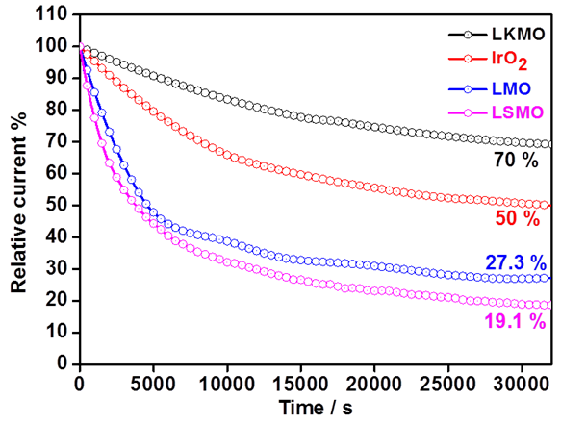**

**Figure 4.5** Chronoamperometric response of LMO, LSMO, LKMO, and IrO2 at 1.5 V vs. RHE

The superior performance of LKMO as an electrocatalyst compared to the existing LMO and LSMO can be attributed to the charge of the dopant, monovalent K than divalent Sr. +2 cation substitution often terminates the surface with the AO layer due to charge neutrality and buries the catalytic MO layer inside the crystal.

The stability of synthesized electrocatalysts was assessed by chronoamperometric measurements, as shown in **Figure 4.5**. The catalyst LMO, LSMO, LKMO, and IrO2 maintain 27.3 %, 19.1 %, 70 %, and 50 %, respectively, of its initial current density after continuous operation for 8 h at 1.5 V vs RHE. The higher stability of the catalyst can be ascribed to the size of the potassium (1.64 Å), which is slightly higher than the divalent cations, thus stabilizing the Goldsmith tolerance factor, which defines the overall perovskite structure stability. Also, the higher concentration of Mn4+ decreases the Jahn-Teller distortion associated with the Mn3+ ions.72

**Table 4.1.** The onset potentials of different catalysts are tabulated here.

|  |  |  |  |  |  |  |  |  |  |
| --- | --- | --- | --- | --- | --- | --- | --- | --- | --- |
| **Catalyst** | **ORR** | | | | **OER** | | | **∆E** | **Ref** |
| **E onset (V)** | **E1/2 (V)** | **Tafel (mV dec-1)** | **E onset (V)** | | **E@10**  **mAcm-2** | **Tafel (mV dec-1)** |  |  |
| **LKMO** | **0.86 ±0.02** | **0.78 ±0.04** | **84** | **1.56 ±0.04** | | **1.66 ±0.05** | **98** | **0.89 ±0.02** | **This Work** |
| **LSMO** | **0.83 ±0.03** | **0.72 ±0.06** | **97** | **1.58 ±0.06** | | **1.72 ±0.05** | **119** | **1.0 ±0.03** | **This Work** |
| **LMO** | **0.75 ±0.03** | **0.58 ±0.05** | **121** | **1.62 ±0.04** | | **1.79 ±0.05** | **136** | **1.21 ±0.03** | **This Work** |
| LSCM-80 | 0.89 | 0.71 | 83 |  | | 1.78 | 133 | 1.07 | 185 |
| BSCF-80 | 0.78 | 0.64 |  |  | | 1.62 | 68.6 | 0.99 | 186 |
| La1.5Sr0.5Ni0.5Mn0.5Ni0.5Ru0.5O6/C |  | 0.73 |  |  | | 1.66 |  | 0.92 | 187 |
| LaMn0.7Co0.3O3 | 0.88 | 0.73 | 110 |  | | 1.82 | 151 | 1.09 | 188 |
| LaNi0.85Mg0.15O3 | 0.82 | 0.69 | 105 |  | | 1.68 | 95 | 0.99 | 189 |
| Ba0.5Sr0.5Co0.8Fe0.2O3−δ |  |  |  |  | | 1.74 | 94 |  | 190 |
| LaMnO3 | 0.78 | 0.62 | 110.2 |  | | >2 | 154 | >1.3 | 191 |
| PrBa0.85Ca0.15MnFeO5+δ/CB |  | 0.77 |  |  | | 1.64 |  | 0.87 | 192 |
| LaNiO3 NR/rGO |  | 0.62 |  |  | | 1.70 |  | 1.07 | 193 |
| Nd1.5Ba1.5CoFeMnO9−d |  | 0.69 |  |  | | 1.58 |  | 0.89 | 194 |
| La1.7Sr0.3Co0.5Ni0.5O4+δ | 0.69 | 0.56 |  |  | | 1.82 | 125 |  | 195 |
| **IrO2** |  |  |  | **1.49 ±0.04** | | **1.59 ±0.05** | **74** | **1.19 ±0.02** | **This Work** |
| **Pt/C** | **0.93 ±0.01** | **0.85 ±0.02** | **59** | **1.66 ±0.05** | | **1.94 ±0.06** | **173** | **1.09 ±0.03** | **This Work** |

A zinc-air battery typically consists of an anode (Zinc-plate), a cathode (air), a separator in between them and the electrolyte, as shown in **Figure 4.6**. As an electrolyte, 6 м KOH and additives like Zn(Ac)2 or ZnO are mixed into a mixture to facilitate the reversible conversion of zinc anode in zinc-air batteries. Electrodeposited zinc on SS mesh or plate forms anode,192 and catalyst coated on SS mesh forms the cathode of Zn-air battery. The air electrode was developed by coating the electrocatalyst on SS mesh with a highly hydrophobic PTFE for oxygen permeability and to avoid air blockage by an aqueous electrolyte.196 The electrochemical reactions of zinc-air battery are as follows

$$Zn+ \frac{1}{2}O_{2} →ZnO…………………………………………………………… (3)$$

During discharge, the Zn electrode forms the Zn(OH4)2- by reacting with OH- ions as intermediate, further decomposing to ZnO.

$$2Zn+OH^{-}→2ZnO+2H_{2}O+4e^{-}………………………………………(4)$$

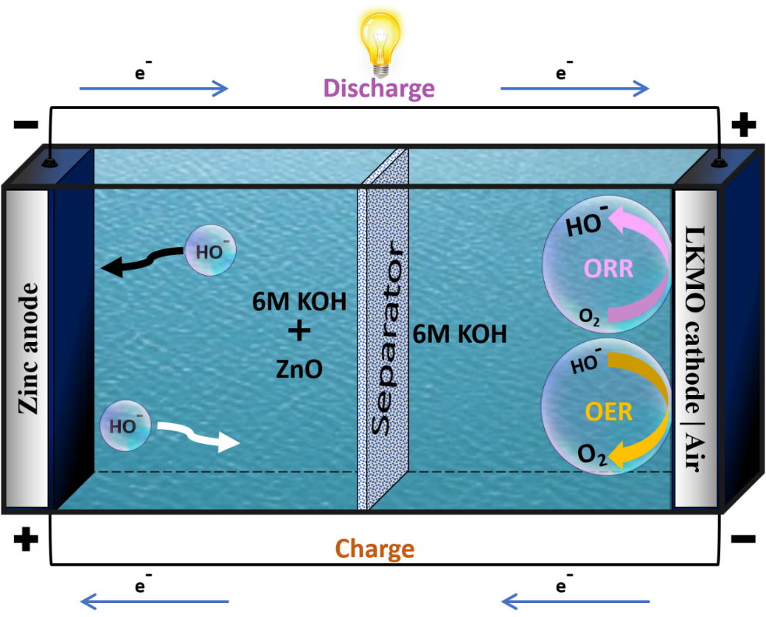

**Figure 4.6** Schematic illustration of the working of the Zinc-air battery.

The utilization of bifunctional electrocatalyst in the rechargeable zinc-air battery is highly desirable. The use of LKMO electrocatalysts in the assembled rechargeable zinc-air battery exhibited a high open circuit potential of ≈1.42 V, indicating its good catalytic activity.

D:\LKMO_Manuscript\CD_Full.tifD:\LKMO_Manuscript\CD_Pol.tif

**Figure 4.7** (a) Charge-discharge curve for zinc-air battery with LKMO electrocatalyst. (b) Specific discharge capacity of the battery at 15 mA cm-2 current density with LKMO catalyst (c) Cycling of battery with LKMO at 5 mA cm-2  (d) Discharging of battery with various current densities starting from 5 mA cm-2 to 100 mA cm-2. (e) Charging of battery with different current densities starting from 5 mA cm-2 to 100 mA cm-2.

**Table 4.2**. The stability of different perovskite catalysts is listed here.

|  |  |  |  |  |  |  |
| --- | --- | --- | --- | --- | --- | --- |
| **Electro-catalyst** | **Mass loading**  **(mg/cm)** | **Anode**  **Electrolyte** | **Voltage polarization** | **Charge-Discharge condition** | **Stability** | **Reference** |
| LaNiO3/N-CNT | 0.72 | Zn plate  6M KOH | ~1.2 V at a current density of 20 mA cm−2 | 600s per cycle period with a current density of ~17.6 mA cm−2 | 75 cycles; Voltage increased from 0.1 to 0.2 V at the end of the cycling | 197 |
| CoO/N-CNT + NiFe LDH | 1.0/5.0 | Zn foil,  0.2M Zn(AC)2 + 6 м KOH | ~0.69 V at 10 mA cm−2 of current density | 200s per cycle period with a current density of ~10 mA cm−2 | 60cycles; negligible change in the voltage at the end of cycling | 198 |
| LaNiO3/rGO | - | Zn plate  6 м KOH | ∼0.98 V at a current density of 25 mA cm−2 | 3600 s per cycle period with a current density of ~25 mA cm−2 | 97 cycles; negligible change in the voltage at the end of cycling | 193 |
| La0.7(Ba0.5Sr0.5)0.3Co0.8Fe0.2O3−δ/C | - | Zn plate  6M KOH | - | - | 100 cycles; negligible change in the voltage | 170 |
| BaTiO3−δ/C | - | - | - | - | 5000 s; stable  Charge-discharge  Cycles | 199 |
| NiCo2S4/N-CNT | 1.0 | Zn foil  0.2 ZnCl2 +  6 м KOH | ~0.63 V at 10 mA cm−2 of current density | 400 s per cycle period at ~10 mA cm−2 of current density | 150 cycles; very less increase in the potential (o.o6 V) at the end of cycles | 200 |
| Co3O4-doped Co/CoFe | - | 0.2 м ZnCl2 + 6M KOH | 0.9 V at a current density of 5 mA cm−2 | 1300 s per cycle period with ~5 mA cm−2 of current density | 180 cycles; very stable during cycling | 197 |
| N-Co/CNF-300-10 | - | Zn foil,  0.2 м Zn(AC)2 + 6 м KOH | 0.77 V at a current density of 10 mA cm−2 | 15 min per cycle period with ~10 mA cm−2 of current density | 100 cycles; voltage increased to 0.12 V at the end of cycles | 201 |
| Mn-S-C | 12 | Zinc electrodeposited SS mesh  ZnO + 6 м KOH | 0.75 V at a current density of 10 mA cm−2 | 200 s per cycle period with a current density of ~10 mA cm−2 | 100 cycles; negligible voltage change at the end of cycles | 202 |
| **LKMO** | **12** | **Zinc electro-deposited SS mesh**  **ZnO + 6 м KOH** | **0.7 V at 5 mA cm−2 of current density** | **360 s per cycle period with ~5 mA cm−2 of current density** | **1000 cycles; 100 hrs, no change in the voltage at the end of cycles** | **This work** |

**Figure 4.7**(**a)** display the charge-discharge curve by utilizing LKMO as electrocatalysts in the air electrode of the zinc-air battery. The specific capacity of the battery was measured at a current density of 15 mA cm-2, and it was found to be 742 mA. h. gZn-1 as shown in **Figure 4.7**(**b)**. The cycling performance of zinc-air battery with LKMO as electrocatalyst is shown in **Figure 4.7**(**c)** at 5 mA cm-2 of charge and discharge current density. The voltage polarization was proposed for the 1000 cycles of charge-discharge with LKMO catalyst. The voltages at initial cycles were found to be ~1.3 V and ~2 V for discharge and charge, respectively, and the corresponding voltaic efficiency was found to be 65% for the initial cycles of charge-discharge. However, the voltage gap for 1000 cycles of continuous charge-discharge remained the same. The LKMO electrocatalysts in zinc-air battery shows the excellent performance with no change in voltage polarization of charge-discharge and lowest change in round trip peak overpotential. **Figure 4.7**(**c** & **d)** shows the various discharge and charge of zinc-air battery with different current densities using LKMO electrocatalysts starting from 5 mA cm-2 to 100 mA cm-2. The performance of battery with synthesized LKMO catalysts was compared as shown in **Table 4.2** with the reported metal-based electrocatalysts.



**Figure 4.8** SEM micrographs **(a)** before, **(b)** after cycling, **(c)** XRD pattern of the catalyst before and after cycling, and **(d)** EDS spectrum-quantification of LKMO after cycling.

XRD, FESEM, and EDS studies were further carried out to investigate the morphology, structural stability, and composition of the cycled LKMO catalyst. SEM micrographs in **Figure** 4.9**(a** and **b)** indicate no significant change in the morphology of the used LKMO catalyst compared to the pristine one. The XRD patterns of pristine and cycled electrodes are shown in **Figure** 4.9**(c)** demonstrating no change in the peak shape and intensity of the cycled LKMO compared to the pristine one. It can be found from the EDS (**Figure** 4.9**(d)**) the presence of La and Mn in the post LKMO was consistent with that of the electrode before cycling. The excess K is due to cycling in the 6 м KOH electrolyte. The presence of F can be attributed to the Nafion (binder). These results confirm the structure, stability, and composition of the catalyst prepared.

## Conclusion:

In summary, we have synthesized potassium substituted LaMnO3 microcubes via the hydrothermal method at low temperatures. The electrochemical and full cell performance of LaSrMnO3, LaMnO3, and LaKMnO3 were evaluated. Owing to the presence of potassium in the perovskite structure, the improvement in the catalytic activity and excellent stability for OER and ORR compared to many reported perovskites and transitional metal-based electrocatalysts was observed. Potassium substitution helps form more Mn3+-Mn4+ Zener pairs and creates abundant oxygen vacancies. The superior stability over 1000 charge-discharge cycles and lower round-trip peak potential was achieved by utilizing LKMO as electrocatalysts in the zinc-air battery. The robust structure and chemical inertness of synthesized LKMO electrocatalysts has attributed excellent catalytic activity compared to LMO and LSMO perovskite-based catalysts. We believe this work will offer a new aspect to design electrocatalysts for large-scale applications in rechargeable zinc-air batteries.

## Part-2: Importance of K substitution in LaMnO3 towards high-performance selective reduction of α,β-unsaturated carbonyl compounds

## Abstract

Manganites based on lanthanum and their substituted analogs have attracted considerable interest due to their multifunctional properties, including colossal magnetoresistance, magnetocaloric effects, and catalytic oxidation. However, its application to significant heterogeneous catalytic hydrogenation reactions has not been thoroughly investigated. Primarily, these uses have focused mostly on precious metals and Raney nickel. This chapter is all about investigating the catalytic property of the synthesized micron-scale K substituted LaMnO3 (LKMO) under hydrothermal conditions. These findings are compared to those obtained with LaSrMnO3 (LSMO) and submicron LaMnO3, revealing that only LKMO exhibits enhanced catalytic activity against the selective reduction of α,β-unsaturated carbonyl compounds, and nitroarenes. LKMO demonstrated better catalytic conversion of 100% at 120 °C and 7 bar pressure, without any external activating agents. Systematic surface characterization demonstrates that LSMO covers microcubes with an inert SrO layer, while LKMO exposes catalytically active Mn sites on the surface. Due to its low cost, non-pyrophoric and catalytic properties, LKMO could be a possible substitute for precious metals in catalytic hydrogenation. These principles could also be extended to other types of heterogeneous catalysis, and catalytic activity could be further improved by developing synthesis techniques to make them on a nanometer scale.

## Introduction

Controlling the surface to expose catalytically active sites is vital for heterogeneous catalysis.203 Thus, synthesizing materials that could reveal active facets has gained interest over the last decade. In the pharmaceuticals and fine chemical industry, chemoselective hydrogenation of α,β-unsaturated carbonyl compounds are important but challenging.204–208 Chemoselective hydrogenation with traditional catalysts (Pt, Pd, Ru, Rh, Ir, or Raney-Ni) is extremely difficult.209–213 Additionally, conventional catalysts have a number of drawbacks, including the usage of expensive metals, high flammability, and a need for dry reaction conditions. Thus, it is highly beneficial to produce a cost-effective, easy-to-handle catalyst. Some studies have shown that supported nanoparticles based on 3d metals such as CoOx214, CoNi215 have shown some success in the temperature range of 110–130 °C and H2 pressure of 20-30 atm.

Lanthanum-based 3d metal perovskite oxides (LMOs) have been one of the most viable categories of materials for decades due to significant properties such as superconductivity82, colossal magnetoresistance83,84 and supercapacitor90,91. The catalytic activity of LMOs and their substitutional analogues are mainly concentrated on oxidative reactions as well as some NOx reductions.216–218 They have not been studied towards the reduction of α,β-unsaturated carbonyl compounds. In particular, Sr substituted LaMnO3 (LSMO) have been shown to be a suitable catalyst towards the oxidation of CO219, CH4220,221, and soot222. The improved activity is attributed to the high lattice oxygen mobility in substituted LMO.223 Compared to the divalent cations such as Sr2+ and Ca2+, the substitution of La3+ by monovalent cation such as K+ leads to the formation of more Zener pairs (Mn+3/Mn+4) and more stable LMO. This leads to better electronic structure yielding better thermal, magnetic and electrochemical performance.71 Especially in the case of K+, the size of it is very close to the La3+ makes it substitute easily and result in high Tc at lesser substitution.120 This chapter discusses a study of catalytic activity LKMO microcubes in the reduction of α,β-unsaturated molecules. We compare the catalytic activity of LKMO with other catalysts such as LaMnO3 and LaSrMnO3. We argue better performance of LKMO compared to LSMO (with a similar Mn4+ to Mn3+ ratio) could be assigned to the availability of more Mn sites on the surface of the LKMO. The structural stability of perovskites is superiors compared to many other classes of materials, which makes them suitable/ideal for catalytic applications. However, a perovskite metal oxide is not known to show high catalytic hydrogenation performance. Designing such materials would greatly help for the future of catalytic hydrogenation with high stability.

## Materials and Methods

### Materials and characterization

The hydrothermally synthesized and purified 18 м LKMO microcubes, as discussed in [**Chapter** **2**](#_Preparation_of_LKMO), are used. Purification of organic compounds were performed by column chromatography using silica gel (60-120 and 100-200 mesh) and thin layer chromatography was performed on Merck pre-coated silica gel 60-F254 plates. 1H and 13C NMR studies were conducted on a Jeol Spectrospin spectrometer at 400 MHz and 100 MHz, 500 MHz and 100 MHz respectively. Chemical shifts were reported in ppm relative to the residual CDCl3; coupling constants (*J*) were reported in Hertz. Components present in the synthesized materials were characterized through Powder X-ray Diffraction (PXRD) using a Panalytical Empyrean diffractometer system with CuKα (λ=1.5418 Å) with large beta-filter Nickel to filter the Kβ lines. Samples for the XRD analysis were prepared by packing onto the depression of a glass slide. Morphology of the materials was studied through Field Emission Scanning Electron Microscopy (FESEM, *Carl Zeiss*). Elemental composition and distribution in the materials were studied by Energy Dispersive Spectroscopy (EDS) mapping. The sample for SEM and EDS analysis was prepared by taking less than 1 mg of the powder product, crushing mildly to ensure the absence of lumps and sticking it to carbon tape on the SEM sample-stub, and analyzed without coating. XPS spectra were recorded on a Kratos AXIS 165 with a dual anode (Mg and Al) apparatus using the Mg Kα anode.

### Synthesis of LSMO microcubes:

The La0.5Sr0.5MnO3 (LSMO) microcubes have been synthesized using the low-temperature hydrothermal method, which is similar to the approach adopted in the literature.106,108,118 In a typical synthesis, La(NO3)3.6H2O, Sr(NO3)2.4H2O, MnCl2.H2O and KMnO4 are taken into a beaker containing 2-5 ml of Milli-Q water in a molar ratio of 1:1:1.3:0.7. These reagents are dissolved in water by stirring until the formation of a homogenous solution. The above solution is transferred into a 25 ml Teflon based autoclave with a filling capacity of 80%. Subsequently, 10 ml aqueous KOH is added into the reaction mixture such that the resultant final concentration of KOH to 12 м and allowed to undergo stirring for 20-24 hours. The hydrothermal reaction is performed by heating the autoclave at 265 °C under autogenous pressure for a different period of times ranging from 32 hours. After completing the reaction, the supernatant is decanted, and the resultant solid precipitate is washed thoroughly with Milli-Q water and ethanol until the pH was found neutral. The product is dried at 70 °C for 12 hrs.

### Synthesis of LMO sub-microcubes:

The LaMnO3 (LMO) microcubes have been synthesized using the molten salt synthesis technique as explained in auxiliary section.224 In a typical synthesis, equal amount of La(NO3)3.6H2O and MnCl2.H2O are taken into a mortar. Equal ratio of NaCl-KCl in a quantity ten times more than the precursor salts added further. This mixture was grinded thoroughly and then transferred into a beaker containing 2-5 ml of Milli-Q water. These reagents are dissolved in water by stirring until the formation of a homogenous solution. The above solution is slowly heated at 70 °C under stirring to evaporate all the water. The final mixture was transferred into an alumina boat and treated at 850 °C for 12 to 24 hrs. After completing the reaction, the resulted black powder was collected into a centrifuge tube and washed thoroughly with Milli-Q water and ethanol until all the excess flux material is separated. The product is dried at 70 °C for 12 hrs.

## Physical characterization

Hydrothermal treatment of 5 equimolar La(NO3)3.6H2O and MnCl2.H2O precursor salts in the presence of KMnO4 and an alkali-mineralizer 18 м KOH at 265 °C for 7 days yielded LKMO microcubes.

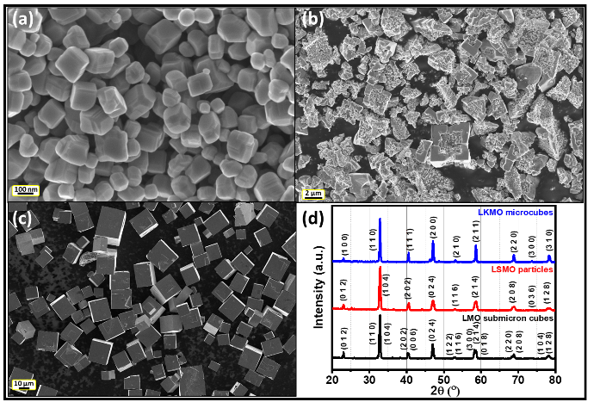

**Figure 4.9** SEM images of (a) LMO submicron cubes synthesized by molten salt, (b) LKMO particles synthesized hydrothermally, (c) LSMO microcubes synthesized hydrothermally, and (d) powder XRD pattern of all the three systems.

**Figure 4.9a** depicts a FESEM micrograph of the LMO submicron cubes obtained by the molten salt method as described in the literature.224 The submicron cubes range in size from 30 to 156 nm, with an average of 88 nm. In **Figure 4.9b**, depicts a FEG-SEM micrograph of LSMO particles prepared by hydrothermal treatment. The typical sizes vary between 1-10 µm. The SEM images reveal the porous nature of LSMO. In **Figure 4.9c**, we show a FEG-SEM image of LKMO micron size cubes prepared by basic (18 м KOH) hydrothermal treatment of La(NO3)3.6H2O with MnCl2.4H2O and KMnO4 at 265 °C for 7 days. The typical sizes range from 4.5 to 27.5 µm, with an average size of 12.7 µm. The XRD patterns (**Figure 4.9d**) of the LMO, LSMO, and LKMO could be indexed to the ICSD collection code 082224. SEM and powder XRD analysis of the as-prepared samples of LKMO reveals the formation of crystalline LKMO and La(OH)3 phases. SEM and XRD patterns recorded after the density-based separation techniques indicated the absence of La(OH)3 phase (**Figure 4.9b**, **1c,** and **1d**).

**Figure 4.10** shows the EDS elemental mapping and EDS spectrum of the LKMO microcubes after removal of the La(OH)3 rods by density-based separation. The SEM micrograph entirely accords to the images of the EDS mapping of La, K, Mn, and O atoms. All the atoms are homogeneously dispersed on the microcubes. The semi-quantitative EDS analysis on microcubes shows the ratio of La:K:Mn as 0.74:0.27:1.0.

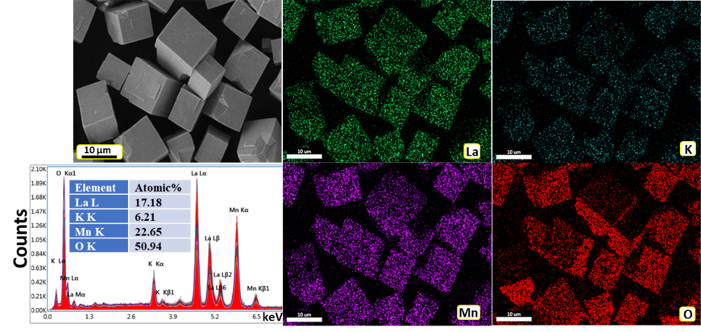

**Figure 4.10** EDS elemental mapping and EDS spectrum of the LKMO microcubes after removal of the La(OH)3 nanorods by density-based separation.

****

**Figure 4.11** EDS elemental mapping and EDS spectrum of the LMO submicron-cubes. The SEM micrograph entirely accords to the images of the EDS mapping of La, Mn and O atoms. All the atoms are homogeneously dispersed on the microcubes.

****

**Figure 4.12** EDS elemental mapping and EDS spectrum of the LSMO particles.The SEM micrograph entirely accords to the images of the EDS mapping of La, Sr, Mn and O atoms.

EDS mapping and spectra are collected on several LKMO cubes (more than 25), and the composition ratio among different cubes varies only marginally. The EDS mapping and spectra collected on LSMO are shown in **Figure 4.12**. EDS analysis on LSMO cubes shows the ratio of La:Sr:Mn as 0.53:0.48:1.0. This can be averaged to La0.5Sr0.5- Similarly, EDS analysis on LMO shows a La:Mn ratio of 1:1 (**Figure 4.11**).

### General procedure for hydrogenation

In a stainless steel reactor with 100 mL capacity was charged with α,β-unsaturated carbonyl compound (0.5 mmol), Catalyst (30 mg) and toluene (6 mL), reactor was evacuated to remove the air and purged with hydrogen (3 times at 5 atm) and finally pressurized with 7 atm of H2. Then the reaction kept for stirring at 120 °C for 12 h and progress of the reaction monitored by TLC. After the reaction was complete, autoclave was cooled to room temperature and the hydrogen was released carefully. The crude reaction mixture was purified by chromatography on silica (eluent: hexane/ethyl acetate = 10:1) to afford desired saturated carbonyl compounds.

## Catalytic activity

Catalysis is a surface phenomenon, and perovskites are known to show different compositions in bulk and at the surface. This variation becomes more prominent with doping. When divalent cations such as Sr2+ are introduced inside the LMO, SrO generally terminates the outer layer due to the electrostatic charge balance.177 SrO can further convert to SrCO3 in aerobic conditions. However, the SrO layer is not catalytically active towards hydrogenation. To understand the surface composition, we have analysed LMO, LSMO, and LKMO using XPS. Survey scans of the samples are shown in **Figure 4.13**. The patterns were charge corrected with amorphous carbon at 284.7 eV for all the samples. Peaks were fitted with mixture of Gauss and Lorentz function with 0.3 blend. In the case of 2p (Mn) and 3d (Sr) spectrum peak area ratios (1:2 for p and 2:3 for d-subshell) were considered for fitting the components as per their spin-orbit splitting j values. The high-resolution Mn 2p spectra are shown in **Figure 4.13**. It has contributions from Mn3+ and Mn4+ but accurate quantification is challenging due to close overlap among the multiplets of the 2p3/2 for both the oxidation states.228,229 By looking at the binding energy of Mn 2p3/2 the oxidation state of Mn in all the samples is in between +3 and +4. The Mn 2p3/2 peak is centred at 640 eV for all the samples (**Figure 4.13**) with FWHM of 2 eV in LMO. The binding energy of Mn 2p3/2 shifts to higher binding energy in the case of doped samples (K and Sr), and its FWHM increases compared to LMO due to the contribution of Mn4+ in doped samples.

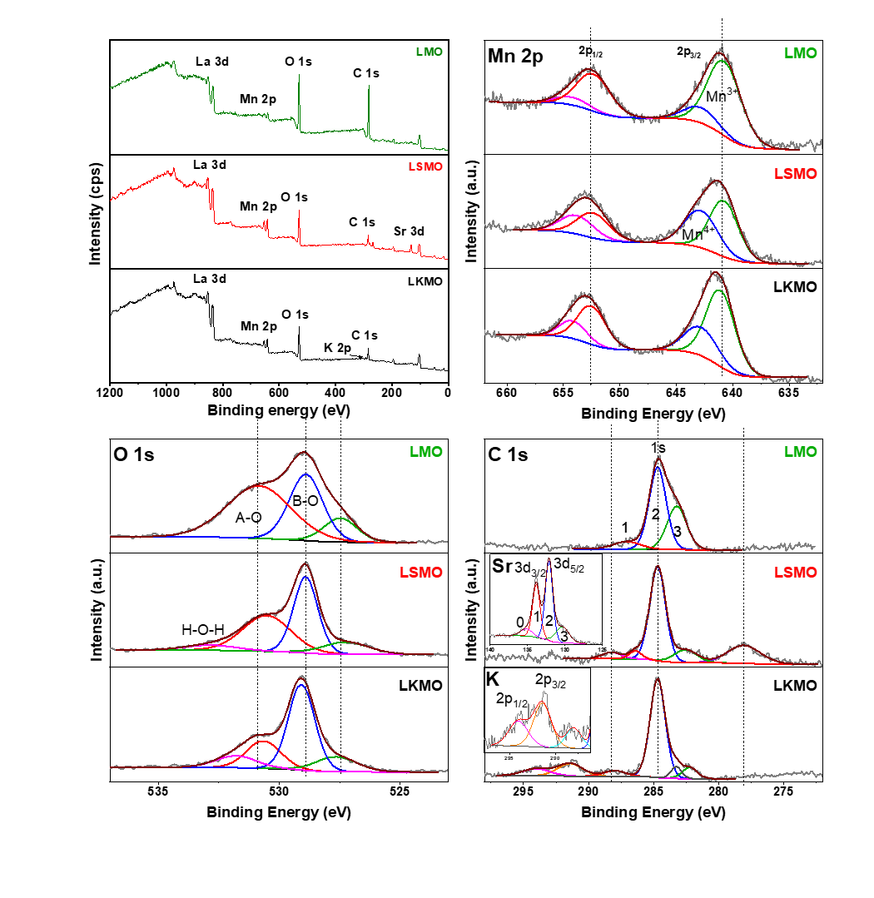

**Figure 4.13** XPS survey scan of LMO, LSMO, and LKMO samples and their high-resolution scans for the peaks Mn 2p, O 1s, and C 1s; insets show K 2p (LKMO) and Sr 3d (LSMO)).

The O 1s peak generally has three contributions(**Figure 4.13**). The lowest binding energy component in each sample is correspond to the perovskite bulk or oxygen bonded to the core Mn (B-O). The highest binding energy of smaller area percent comes due to moisture. The peak around 530 eV are less straightforward. Some literature assigned it to SrO precipitates at the surface of LSMO while this can be originated from surface SrCO3, Sr(OH)2 also the oxygen bonded with A-site cations (perovskite terminating with A-O layer).230 From the O 1s spectrum; compared to LSMO, LKMO shows less dopant concentration at the surface and exposes more Mn at the surface, which is catalytically more active.

The formation of SrCO3 can be clearly seen from the **Figure 4.13** Sr 3d spectrum in the inset. In case of LSMO in addition to the lattice Sr 3d (peak 1 and 2) additional Sr (peak 0) present. This was deconvoluted keeping equal FWHM values for the Sr 3d 3/2 and 5/2 components with 1.7 eV peak separation. Also, the corresponding C1s spectrum shows peak around 288.5 eV attributing to the carbon atoms of carbonate species. Thus LKMO can commence its catalytic activity for longer cycles without any degradation in activity promising to be superior catalyst than LSMO.

**Table 4.3** Binding energy (B.E.) and relative concentration of Mn3+, Mn4+, and oxygen species from the deconvolution of Mn 2p and O 1s XPS peaks of LMO, LSMO, LKMO.

|  |  |  |  |  |  |  |  |  |
| --- | --- | --- | --- | --- | --- | --- | --- | --- |
| Sample/Element | Mn | | | | O | | | |
| **LKMO** | 3+ | 4+ | 3+ | 4+ |  | B-O | A-O | H-O-H |
| Line | 2p3/2 | 2p3/2 | 2p1/2 | 2p1/2 | 1s | 1s | 1s | 1s |
| B.E. (eV) | 641.02 | 642.75 | 652.46 | 654.11 | 527.61 | 529.06 | 530.62 | 531.78 |
| Area (%) | 46.54 | 20.13 | 23.27 | 10.06 | 14.10 | 52.60 | 21.91 | 11.39 |
| **LSMO** |  |  |  |  |  |  |  |  |
| B.E. (eV) | 640.72 | 642.76 | 652.29 | 653.77 | 527.24 | 528.90 | 530.52 | 532.86 |
| Area (%) | 37.57 | 29.10 | 18.78 | 14.55 | 12.73 | 42.03 | 39.15 | 6.08 |
| **LMO** |  |  |  |  |  |  |  |  |
| B.E. (eV) | 640.69 | 642.79 | 652.29 | 654.18 | 527.47 | 528.89 | 530.83 |  |
| Area (%) | 55.29 | 11.37 | 27.65 | 5.69 | 12.50 | 34.69 | 52.81 |  |

**Table 4.4** Optimization of LKMO for hydrogenation of α,β-unsaturated carbonyl compounds.a



|  |  |  |
| --- | --- | --- |
| S.No | Catalyst | Yield (Conversion%)b |
| 1 | LMO submicron cubes | 4.2 |
| 2 | L0.77K0.23MnO3 microcubes | 100 |
| 3 | La0.5Sr0.5MnO3 particles | 58.8 |

a Reaction conditions: Temperature (120 °C), Time (12 h), α,β-unsaturated carbonyl compound (0.5 mmol), Catalyst (30 mg) and Toluene (5 mL); b GC-MS yields

Next, to understand the catalytic activity of the prepared catalysts, a model hydrogenation reaction was performed on α,β-unsaturated carbonyl compound as shown in **Table 4.4**. The initial studies were performed with simple LMO and were found to be less active. Further doping of divalent Sr2+ and monovalent K+ subsequently enhanced the catalytic activity towards the hydrogenation of α,β-unsaturated carbonyl compound. These experimental findings are clearly correlating with our understanding, as discussed earlier of these systems (see **Table 4.4**).

Further, after optimizing the reaction conditions for the hydrogenation of α,β-unsaturated carbonyl compounds, we have examined the substrate scope of the LKMO with functionalized α,β-unsaturated carbonyl compounds. From **Table 4.5**, it is clear that the catalyst has functional group tolerance towards halo, carbonyl, and benzyl groups (**1d** and **1e**). Along with the functional group tolerance, the catalyst has shown good to an excellent conversation with all substrates in **Table 4.5**. Next, to understand the wide scope of the catalyst, we have extended the hydrogenation method for the reduction of nitroarenes (**Table 4.6**). The *ortho* and *para*-substituted nitroarenes were converted to corresponding anilines (**2a** and **2b**) with excellent yields. p-Chloro nitrobenzene also could be converted to the corresponding aniline without any dehalogenation side product (**2c**).

**Table 4.5** Substrate scope of the LKMO for hydrogenation of α,β-unsaturated carbonyl compounds.



Reaction conditions: α,β-unsaturated carbonyl compound (0.5 mmol), Catalyst (30 mg), Toluene (5 mL).

**Table 4.6** Catalytic hydrogenation of nitroarenes to corresponding amines.



Reaction conditions: Nitroarenes (0.5 mmol), Catalyst (30 mg), Toluene (5 mL).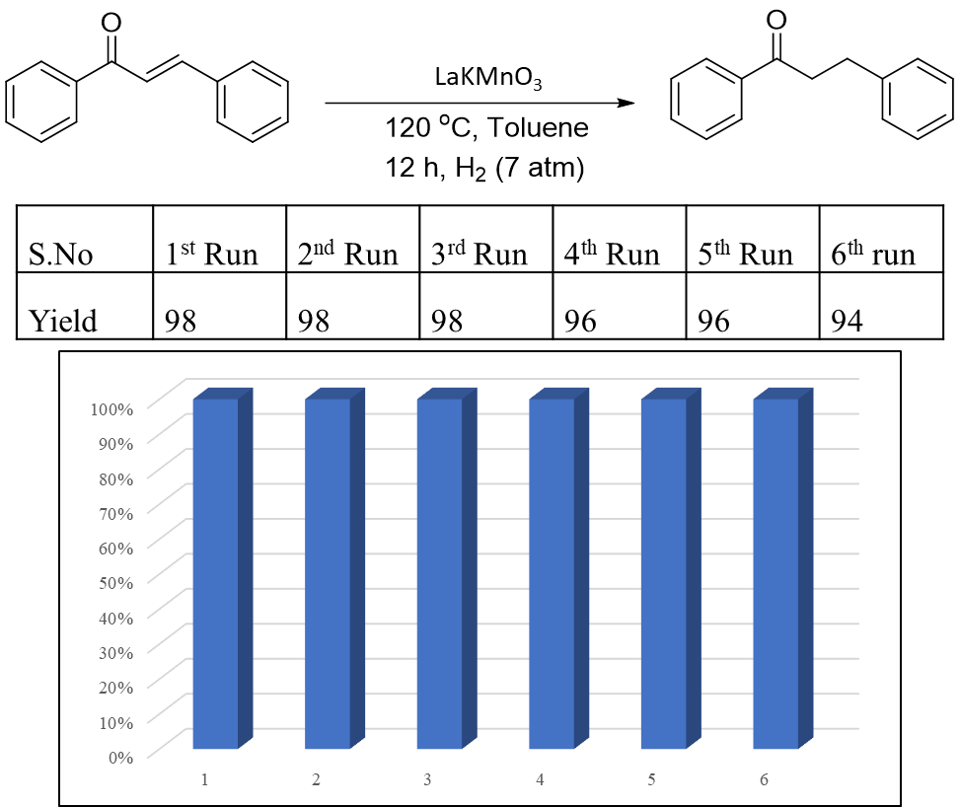

**Figure 4.14** Plot describing the recyclability of the LKMO catalyst.

4-nitrobenzoic acid and 6-nitroquinoline (bicyclic heteroaromatic compound) also could be converted to the corresponding amines in excellent yields. To understand the catalyst stability and recyclability for the hydrogenation process, the catalyst has been reused up to five successive runs without any appreciable loss in its catalytic activity (**Figure 4.14**).

## Conclusion

Finally, we demonstrated the catalytic activity of LKMO in the reduction of chalcones and nitroarenes. This hydrothermally synthesised LKMO could be a viable candidate to replace noble metals in catalysis. These LKMO microcubes have a remarkable activity of 98 percent conversion in the reduction of,-unsaturated compounds, which is far superior to existing materials. Despite having a smaller surface area, the micron size cubes have shown a high level of activity. We anticipate that this will lead to a better understanding of the fundamental principle underlying the formation/synthesis/crystallization mechanism of trimetallic-complex systems. Leading the research to investigate the synthesis and catalysis of other ternary systems with various morphologies for activity and selectivity.

# Doping with chemically hard elements to improve photocatalytic properties of ZnO nanostructures

**Doping with chemically hard elements to improve photocatalytic properties of ZnO nanostructures**

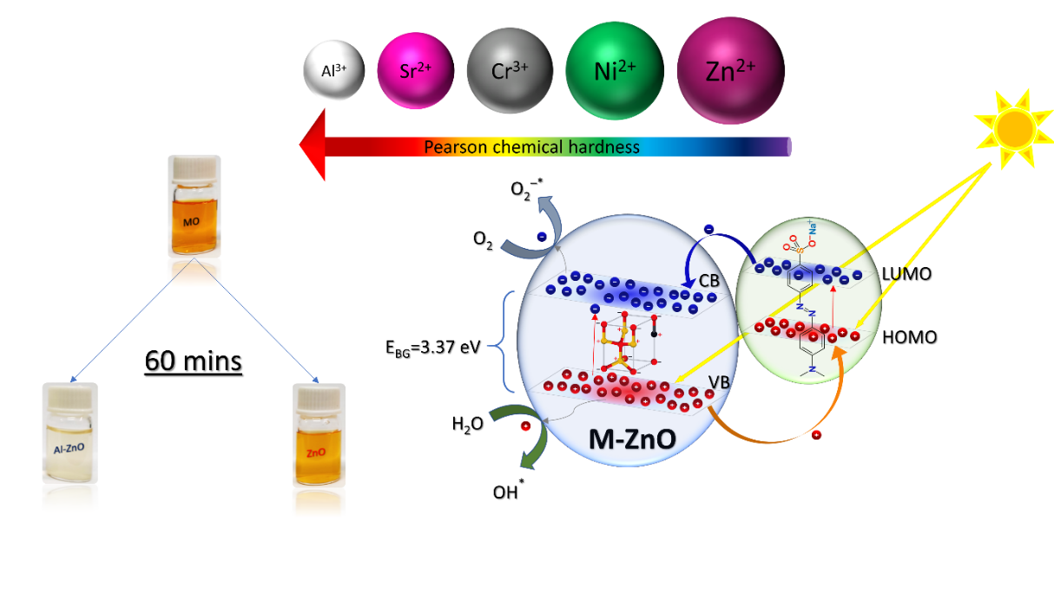

## Abstract

Here we report improved photocatalytic activity of ZnO nanostructures through judicious choice of the dopant, particularly by choosing the dopant with high chemical hardness. We have doped ZnO nanostructures with divalent (Ni2+ and Sr2+) and trivalent (Cr3+ and Al3+) using hydrothermal conditions. The photocatalytic activity of undoped and doped ZnO nanostructures was tested towards the degradation of methyl orange (MO), methylene blue (MB), and congo red (CR). The Al-ZnO exhibited a 91.25% removal rate compared to 40.88% for pure ZnO in MO degradation under ultra-violet (UV) radiation. The trend of photocatalytic activity of different photocatalysts (Al-ZnO > Sr-ZnO > Cr-ZnO > Ni-ZnO > ZnO) is similar to the trend of Pearson hardness values of Al3+ > Sr2+ > Cr3+ > Ni2+ > Zn2+. These reactions also reveal that the dopant type affects the morphology of the ZnO nanostructures in given reaction conditions. We propose the polarity-induced mechanism to understand the changes in the morphology due to different dopants.

## Introduction

Photocatalytic degradation of dyes using semiconductor nanoparticles is an efficient and cost-effective strategy to degrade environmentally concerning organic pollutants.231–240 However, strategies to improve the photocatalytic properties of existing catalytic need to be developed. Tuning the catalyst to improve photocatalytic activity is important for air purification and wastewater treatment. The widely investigated photocatalysts for these purposes are TiO2 and ZnO due to their non-toxic nature, abundant availability, high reactivity. However, they absorb light in the near UV region, only <5% of our solar spectrum.241–243 Several strategies have been adopted so far for improving the photocatalytic activity, including doping with other elements such as Al 244,245, Eu246, Mg247,248, Mn249,250, Fe251, Ce252,253, Y254, Sr255,256, La257, Ta258, Cu259, Nd260, Bi261, Hf262, Sn263, Sm264, Pd265, Se266, Ag267, and co-doping such as Co-Ni268. Dopants tune the properties of photocatalyst in several ways; some metals decrease the band gap254 and thus accommodate the visible part of the solar spectrum to be absorbed. Some dopants introduce trap states into the crystal that helps to trap the excited electrons-holes and diffuse them to the surface.246,269,270 Some dopants also tune the size and morphology of the photocatalyst, making it into a thin flakes-such as structure where the bulk generated e- - h+ pairs are easily transported to the surface.263 Also, in some cases, the presence of dopants makes the surface of the photocatalyst rough and porous allowing more adsorption of the dyes and organic pollutants.250,267 However, judiciously choosing a dopant by looking into their chemical nature to improve the photocatalytic properties are less explored especially correlating between photocatalytic activity and dopant chemical hardness. As the adsorption of chemically hard species such as oxygen and water species on photocatalyst is involved in the dye degradation mechanism, systematic studying of the chemical hardness effect on the dye degradation process is crucial.

Two mechanisms have been put forward in the literature to explain the dye degradation, namely, a) photocatalytic dye degradation and b) dye-sensitization mechanism.231,233,235 In the earlier case, the dispersed photocatalyst absorbs the radiation and generates electrons and holes.233,235,271–275 These photogenerated charge carriers reduce and oxidize oxygen and water species that are adsorbed on the photocatalyst surface, resulting in active superoxide radical anion and hydroxide radicals, which react with the dye and degrade it (See **Scheme 1)**.245,248,253 In the dye-sensitization mechanism, the dye absorbs light in the visible region (around 465 nm in MO) and gets excited. The photoexcited dye transfers the electron from its lowest unoccupied molecular orbital (LUMO) to the photocatalyst’s conduction band (CB). At the same time, one unit of hole migrates from dye to catalyst as the fermi level of the MO is above that of the ZnO (photocatalyst). The remaining process in the mechanism follows similar steps as of the earlier mechanism. Under UV irradiation, ZnO-based photocatalysts follow photocatalytic dye degradation. In contrast, the dye-sensitization mechanism is applicable in visible light.

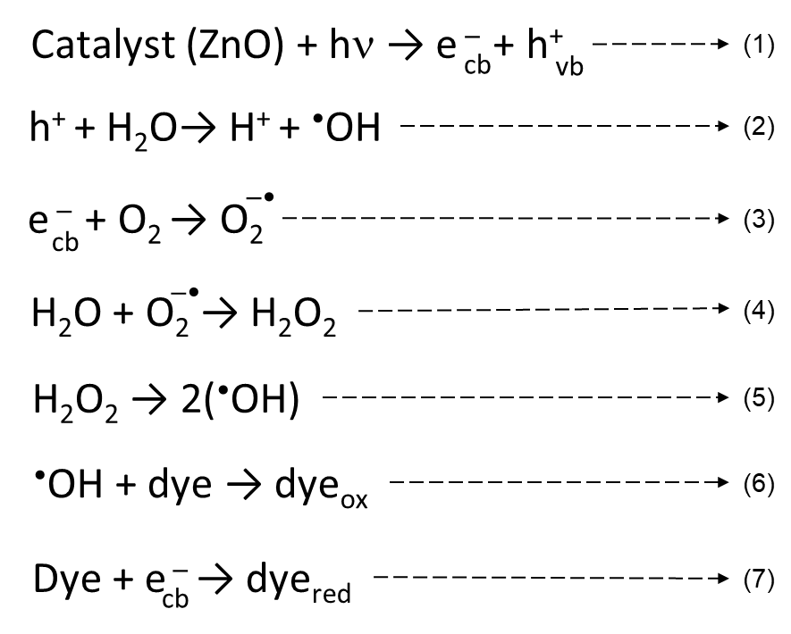

Scheme 1 Steps representing the dye degradation mechanism.

The dye sensitization mechanism also follows the similar above steps, except the dye gets excited by exposure to UV light, and the excited dye reacts with the catalyst (as shown in the below equations 8 & 9).

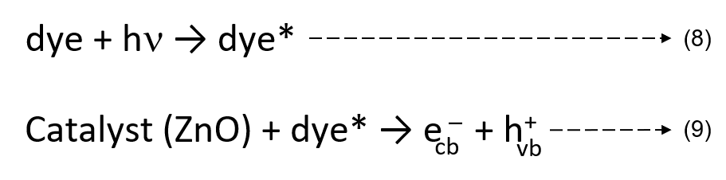

As ZnO follows the photocatalytic dye degradation mechanism, adsorption of oxygen and water species on photocatalyst is essential. This chemically hard oxygen and water can interact more with a photocatalyst if the photocatalyst contains more chemically hard dopants such as Al3+ or Sr2+. Here, we report doping of ZnO nanostructures with different divalent (Ni2+, Sr2+) and trivalent cations (Cr3+ and Al3+) in hydrothermal conditions. Even though ZnO nanostructures are doped with different cations in the literature,245,276–278, the correlation of dopant hardness on photocatalytic activity has not been studied earlier. We have also investigated the optical and morphological changes in the doped ZnO nanostructures. The mechanism of morphology change due to different types of cations is proposed. These doped nanostructures are further tested for photocatalytic activity under UV and artificial sunlight towards the most common organic dyes such as MO, MR, and CR (formulas given in **Figure 5.1**) used in the textile industry and major contaminants in wastewater.279,280

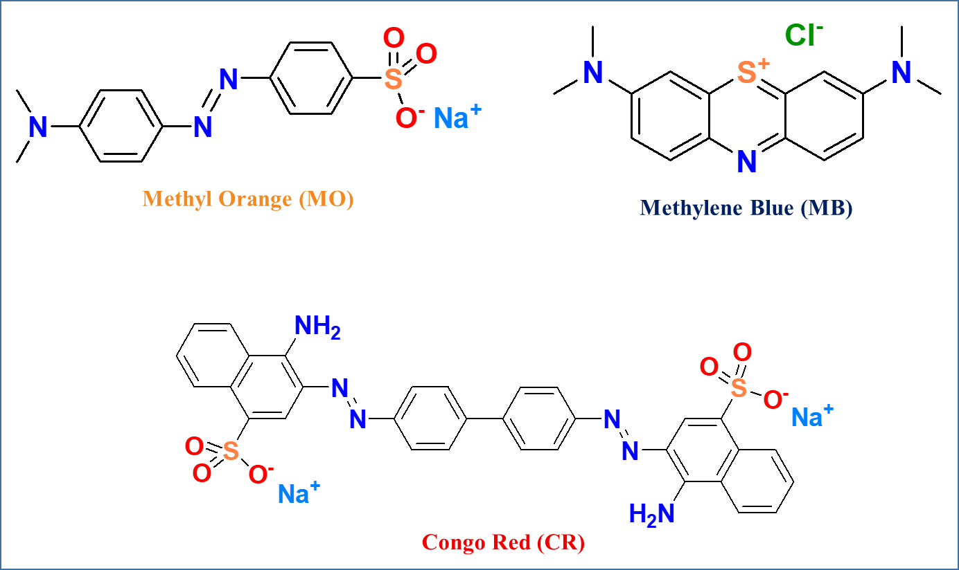

**Figure 5.1** The molecular structures of the dyes used for the photocatalytic activity of pure and doped ZnO nanostructures

## Existing issues

TiO2 and ZnO have commonly investigated photocatalysts for dye degradation due to their non-toxic nature, abundant availability, high reactivity. However, they absorb light in the near UV region, only <5% of our solar spectrum.

Consideration of dopant’s chemical nature to improve the photocatalytic properties are less explored especially correlating between photocatalytic activity and dopant chemical hardness.

## Objectives & Action plan

Hydrothermal synthesis of divalent (Ni2+ and Sr2+) and trivalent (Cr3+ and Al3+) doped ZnO nanostructures were studied.

Study the photocatalytic activity of undoped and doped ZnO nanostructures towards the degradation of methyl orange (MO), methylene blue (MB), and congo red (CR).

We compared their results to derive the trend of chemical hardness with respect to photocatalytic dye degradation.

## Materials and Methods

### Materials used

Zn(NO3)2.6H2O, Cr(NO3)3.9H2O, Al(NO3)3.9H2O, Ni(NO3)2.6H2O, Sr(NO3)2.9H2O, NaOH (Merck, South Africa), of analytical grades were used as received without any further treatment. Also, the methyl orange (MO), methylene blue (MB), and congo red (CR) were procured from Merck and used without any further treatment.

### Synthesis of ZnO nanoparticles

ZnO nanoparticles are synthesized by a hydrothermal method. In a typical synthesis of undoped ZnO nanoparticles, 1.25 mmol of Zn(NO3)2.6H2O (374.30 mg) and 0.5 g of NaOH were dissolved in 20 mL Milli-Q water. First, the above solution is transferred into a 25 mL Teflon container. Then, the Teflon container is sealed inside a stainless-steel autoclave and placed in a hot air oven at 180 °C for 18 h. After completing the reaction, the reactor was allowed to cool to room temperature, and then the precipitate was then separated and washed thoroughly with water and ethanol. The final compound was dried at 70 °C for overnight281.

To synthesize doped ZnO nanoparticles, 5 mol% of corresponding metal nitrates are used, keeping everything else similar as per the above procedure.

### Dye-degradation test

In a typical photocatalytic kinetic study, 3.0 mg of photocatalyst (ZnO, Ni-ZnO, Sr-ZnO, Cr-ZnO, and Al-ZnO) was added in 3.0 mL of 36.0 µmol/L aqueous solutions of MO. The formed suspension was well dispersed by sonication for 5 minutes and allowed to stir to mix catalyst and dye molecules. Then, the mixture of MO and catalyst was irradiated with 360 nm UV radiation inside a UV fluorescence cabinet of 220 volts and 50 Hz under constant stirring conditions. The distance of the quartz vessel from the UV lamp was 15 cm. Samples were collected in the regular interval of 10 minutes, and the change in the concentration of organic dye molecules was examined by recording the UV-Vis spectra in Cary 100 Bio UV-Vis spectrophotometer. Before measuring UV-Vis spectra, the collected samples were centrifuged at 5000 rpm for 2 minutes to separate the catalyst from the dye solution.234,282,283 We have also carried out a similar dye-degradation test with MB and CR dyes.

### Characterization

All the samples were characterized by powder x-ray diffraction (PANalytical Empyrean) with Cu-Kα radiation for phase identification. Field emission scanning electron microscopy (FESEM) of the Carl-Zeiss model (Zeiss ultra 55) was used for the morphology study. The absorption studies were conducted using (Cary 100 Bio UV-Vis spectrophotometer). Dopant concentration was characterized by an inductively coupled plasma atomic emission spectrometer (ICP-AES) using ARCOS, a simultaneous ICP spectrometer.

## Results and Discussion

Hydrothermal synthesis is employed in basic conditions to prepare pure as well as doped ZnO nanostructures. We have characterized as-prepared samples by scanning electron microscope (SEM) and powder X-ray diffraction (XRD). **Figure 5.2** shows powder XRD patterns of pure ZnO and Sr2+, Cr3+, Ni2+, and Al3+ doped ZnO nanostructures. All reflections of pure and doped ZnO nanostructures are nearly identical and characteristic of the hexagonal wurtzite structure of ZnO with the space group of P63mc.



**Figure 5.2** XRD patterns of undoped as well as Sr2+, Cr3+, Al3+, and Ni2+ doped ZnO nanostructure

SEM images of undoped, as well as Sr2+ and Ni2+ doped ZnO, are shown in **Figure 5.3(a**, **b,** and **c)**, respectively, revealing nanorods morphologies and lengths in the range of 0.48-3.21, 0.43-3.49, and 0.15-1.06 microns and diameters in the range of 0.073-0.293, 0.093-0.528, and 0.025-0.109 microns. **Figure 5.3(d** and **e)** show SEM images of Cr3+ and Al3+ doped ZnO nanostructures with nanoparticle/small nanosheet morphologies having sizes in the range of 0.035-0.353 and 0.049-0.474 microns, respectively.

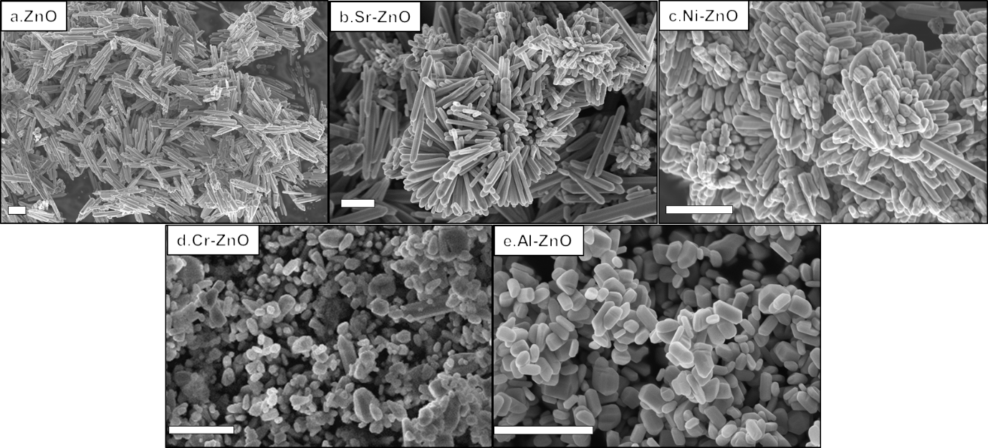

**Figure 5.3** FE-SEM images of undoped as well as Sr2+, Ni2+, Cr3+, and Al3+ doped ZnO nanostructures. The scale bars of the respective images indicate 1µm

SEM images of Al and Cr-doped ZnO nanostructures show less agglomeration behavior than undoped and Sr and Ni-doped ZnO nanostructures. Between Al and Cr-doped ZnO nanostructures, Al-doped ZnO shows a less agglomeration tendency. The Al-doped ZnO nanoparticles have also shown better dispersion properties in water than pristine, Sr, and Cr doped ZnO nanostructures, which show sedimentation after 12 h, whereas part of the Al-doped ZnO nanoparticles remains in the suspension. Fewer agglomeration properties of Al-doped ZnO nanostructures could be attributed to surface charges in n-type Al-doped ZnO nanostructures.284 The charge carriers would remain at the surface of the nanoparticles eliciting mutual repulsion. Similar experiments of Re-doped MoS2 have shown fewer agglomeration properties, leading to a notable effect on their rheological properties.285 Inductive coupled plasma-atomic emission spectroscopy (ICP-AES) estimates the dopant concentration in ZnO nanostructures. The ICP-AES data reveals 4.65 and 4.16 at % doping of Sr and Ni in ZnO nanorods. In contrast, the amount of incorporation of trivalent dopants in ZnO nanostructures is minor (0.34 at.% of Al3+ and 0.36 at.% of Cr3+).



**Figure 5.4** (a) Schematic of wurtzite structure, (b) schematic of polarity-cloud dispersion by doping (increasing intensity of the red color indicates an increase in polarity)

As presented above, pristine ZnO and Sr and Ni-doped ZnO form nanorods. On the contrary, ZnO crystallizes into small nanosheets in the presence of 3+ dopants. Several methods have been reported to change the morphology of ZnO nanostructures, including pH and capping agents, etc.286,287

**Table 5.1** Some of the relevant photocatalytic dye degradation of doped-ZnO nanostructures reported in the literature

|  |  |  |  |  |  |  |  |
| --- | --- | --- | --- | --- | --- | --- | --- |
| **SL No.** | **System** | **Dye** | **Morphology** | **Size** | **Optical region** | **Rate**  **(min-1)** | **Ref.** |
| 1 | Al-ZnO | MO | Films | 1.95-2.24 µm thickness | UV | 0.0117 | 244 |
| 2 | Eu-ZnO | MO | NPs | 5.67 nm | UV | 0.01514 | 246 |
| 3 | Mg-ZnO | RhB | NPs | 30-110 nm | UV | 0.0126 | 247 |
| 4 | Mn-ZnO | MB | NPs | 6-7 nm | Vis | 0.0197 | 249 |
| 5 | Fe-ZnO | 2-chlorophenol | NPs | 16-14 nm | UV | 0.0263 | 251 |
| 6 | Ce-ZnO | MB | Nanorods | 900nm-3 µm in L, 70-85 nm in D | UV | 0.044 | 252 |
| 7 | Sr-ZnO | MB | NPs | 20-60 nm | Vis | 0.1 | 256 |
| 8 | Mn,Co-ZnO | MO | NPs | 50-70 nm | UV | 0.0139, 0.0087 | 288 |
| 9 | Ce-ZnO | MB | Bottle-such as | ~1 µm in D | UV | 0.04 | 253 |
| 10 | La-ZnO | Monocrotophos  MCP | NPs | 100-500 nm | UV | 0.1 | 257 |
| 11 | Nd-ZnO | MO | Powders | 100-200 nm | UV | 0.15 | 260 |
| 12 | Bi-ZnO | MO | irregular villus-such as | 0.5 µm | UV | 0.01 | 261 |
| 13 | Mg-ZnO | MO | NPs | 60-70 nm | UV | 0.02 | 248 |
| 14 | Hf-ZnO | MB | NPs | 17-14 nm | Vis | 0.015 | 262 |
| 15 | Ni-Co-ZnO | RhB | NPs | 16-30 nm | Vis | 0.001 | 268 |
| 16 | Sm-ZnO | Phenol | Nanorod | 43–103 nm | Vis | 0.004 | 264 |
| 17 | Pd-ZnO | MO | NPs | 25-33 nm | Vis | 0.01 | 265 |
| 18 | Se-ZnO | Trypan blue | NPs | 9.5 nm | UV | 0.0046 | 266 |

\*NPs is nanoparticles, \*L: Length, and \*D: Diameter

However, in the present case, the type of dopant seems to affect the morphology while keeping the rest of the same reaction conditions. Therefore, we propose the following mechanism for morphology change in trivalent doped ZnO nanostructures. ZnO crystallizes in Wurtzite structure, having polar *c*-axis and non-polar *ab*-plane (see **Figure 5.4(a**)). In the growth stage (in the solution-based nucleation and growth mechanism), the newly formed Zn(OH)42- nuclei predominantly attach to the c-axis of the already existing ZnO cluster in the solution because of the high polarity along this direction. This is one of the main reasons for ZnO to form nanorod morphology, even without using any surfactants.289

In **Figure 5.4(b**), we show a schematic relative polarity index around the wurtzite structure. Here, the intensity of the red color represents the magnitude of polarity. As the schematic indicates, ZnO has a polar *c*-axis (indicated with red color) and a non-polar *ab*-plane. When Zn2+ is replaced with a 2+ cation, there is no change in polarity in the structure. On the contrary, when Zn2+ is replaced with a 3+ cation (such as Al3+ and Cr3+), polarity is also induced in the *ab*-plane. Thus, newly formed Zn(OH)42- nuclei can approach already existing ZnO clusters in the solution from any direction, leading to the formation of more isotropic morphology. Hence, the formation of small nanosheets or spherical nanoparticles is formed in the case of trivalent doping. Choice of counter ion of metal precursors can also affect the morphology of ZnO nanostructures.232 In this case, all the metal precursors are nitrates; thus, the possibility of a counter ion effect can be eliminated. Another possibility could be that 3+ dopant chemical species can adsorb on the polar (001) plane of ZnO and inhibit adsorption of Zn(OH)42- on the (001) plane and slow down the growth of ZnO in this direction. As the percentage of dopant is significantly less, we believe the contribution of this effect is minimal.



**Figure 5.5** Absorption spectra of the pure and doped ZnO nanostructures

**Figure 5.5** shows UV-Vis absorption spectra of pristine and doped ZnO nanostructures. The calculated molar absorption coefficients of these nanostructures are 2.7, 16.9, 61.9, 154, 171 M-1cm-1 for ZnO, Sr2+, Cr3+, Ni2+, and Al3+-doped ZnO nanostructures, respectively. The higher absorption coefficient of Al3+-doped ZnO nanostructures could be associated with the higher dispersion ability of these nanostructures in water, as described earlier. In addition, the small size of Ni-ZnO nanostructures also shows a high absorption coefficient with an excitonic-such as peak (**Figure 5.5**).

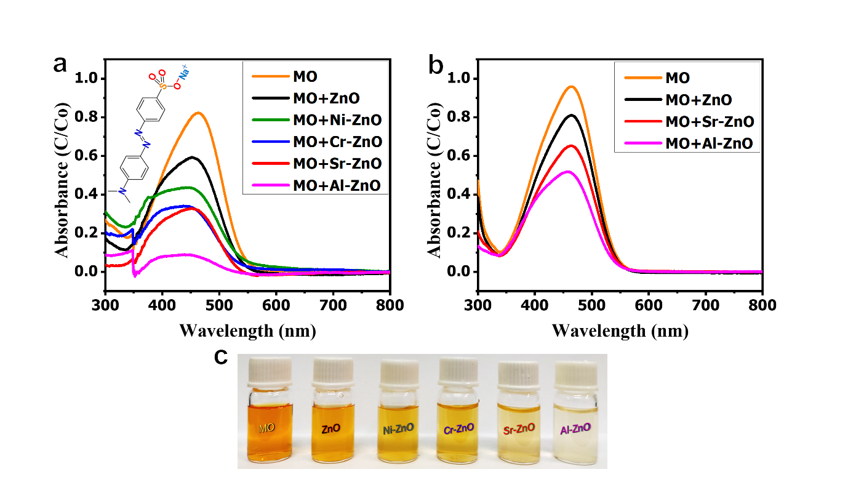

**Figure 5.6** Changes in absorption spectra of MO with and without photocatalyst after 60 minutes (a) under UV-light irradiation and (b) under visible-light irradiation. (c) Optical images of MO-degradation with and without photocatalyst under UV-light

Higher absorption coefficient and dispersibility are important properties for a photocatalyst to degrade the dyes in the solution. Photocatalytic activities of pristine ZnO and doped ZnO nanostructures were studied in the case of MO by utilizing the changes in the electronic absorption spectra of the dye. In **Figure 5.6(a)**, we present the typical changes in absorbance of MO on irradiation with and without a photocatalyst. The change in the concentration (C*/*C0) of MO with reaction time has been examined and presented in **Figure 5.7**.



**Figure 5.7** The change of normalized concentration with the exposure time for the photocatalytic degradation of MO with and without catalyst (a) under UV-light irradiation and (b) under visible-light irradiation

We observe that the degradation rate varies as Al-ZnO > Sr-ZnO > Cr-ZnO > Ni-ZnO > ZnO. The value of the rate constant, ka from the slope of ln(C0/C) vs time for ZnO, Ni-ZnO, Cr-ZnO, Sr-ZnO, Al-ZnO are 0.0091, 0.0143, 0.0187, 0.0227, 0.0396 min-1, respectively. The rate constant values obtained here are comparable to the literature values.290,291 In **Figure 5.6(c)**, we present photographs showing color variation of dye solutions after 60 min under UV light. The photographs exhibit the trend and show better efficiency of Al-ZnO nanostructures. In **Figure 5.6(b)**, we present typical changes in the absorbance of MO on irradiation of artificial sunlight for 60 min with ZnO, Sr-ZnO, and Al-ZnO nanostructures. We observe a similar degradation trend that varies as Al-ZnO > Sr-ZnO > ZnO. However, photocatalyst under UV light is slightly better than under artificial sun. This could be due to bandgap excitation of photocatalysts (~3.37 eV) under UV-light that generate more electrons and holes, which are further responsible for dye degradation.



**Figure 5.8** (a) Absorption plots of MO dye degradation at different time intervals under UV light, in the presence and absence of photocatalyst. (b) Optical images of MO dye degradation at (0 mins, 30 mins, and 60 mins) under UV light, in the presence and absence of photocatalyst

**Figure 5.8(a** and **b)** show absorption spectra and optical images of MO degradation using ZnO, Sr-ZnO, and Al-ZnO nanostructures at different time intervals. The MB and CR degradation studies have also shown similar photocatalytic activity trends, which can be seen from the absorption spectra (**Figure 5.9(a** and **b)**) and the optical images **Figure 5.9(c** and **d)**. These catalysts were very robust to be used for multiple cycles of dye degradation studies. After every cycle, a couple of ultrasonication cleaning followed by Milli-Q water washing removes the surface deposited dyes, and the activity was fully re-established. We have re-used all the catalysts for seven cycles without reduction in photocatalytic activity.



**Figure 5.9** (a) and (b) are the absorption spectrum of MB and CR with and without photocatalyst treated under UV-light for 60 mins, respectively. (c) and (d) are the optical images of MB and CR degradation with and without catalyst under UV-light with time, respectively

Dispersion of a photocatalyst in the water and absorption coefficient are important to improve the dye degradation process. Nevertheless, it is interesting to note that the catalytic activity trend does not match the absorption coefficient trend presented in **Figure 5.5**. For instance, Ni-ZnO and Cr-ZnO nanostructures show better absorption coefficients than Sr-ZnO, but the photocatalytic activity of Sr-ZnO is superior to Ni-ZnO and Cr-ZnO nanostructures. We propose that besides dispersibility and absorption coefficient, the adsorption capability of O2, H2O, and dye onto the photocatalyst is an important property so that electron transfer between photocatalyst and adsorbed molecules is efficient. As Sr2+ is harder than Ni2+ and Cr3+, it has a higher tendency to adsorb chemically hard molecules such as H2O and O2, subsequently dye degradation process.

The Pearson hardness values of Al > Sr > Cr > Ni > Zn.292 The trend is similar to the trend of photocatalytic activity of different photocatalysts (Al-ZnO > Sr-ZnO > Cr-ZnO > Ni-ZnO > ZnO). Isovalent doping (Sr2+ and Ni2+) has shown similar morphology and doping concentration in ZnO nanostructures. Similarly, aliovalent doping (Al3+ and Cr3+) has also shown similar morphology and doping concentrations in ZnO nanostructures. Thus, we believe that comparing the isovalent and aliovalent doped ZnO nanostructures is more reasonable. Even in this case, dye degradation trends are following the chemical hardness trend (Al-ZnO > Cr-ZnO > ZnO and Sr-ZnO > Ni-ZnO > ZnO).

## Conclusions

We have reported isovalent (Sr2+ and Ni2+) and aliovalent doping (Al3+ and Cr3+) in ZnO nanostructures using hydrothermal synthesis. The incorporation of isovalent ions is found to be high (~at 4%) compared to the aliovalent dopants (0.3-0.4 at%). Aliovalent doping also tunes the morphology of ZnO nanostructure from nanorods to nanoparticles. The polarity-induced morphology change mechanism is proposed in the case of aliovalent doping. The photocatalytic activity studies of undoped and doped ZnO nanostructures towards MO, MB, and CR demonstrate that catalytic activity is higher in the case of ZnO nanostructures doped with high chemicals hardness elements such as Al3+ and Sr2+. Further, Al-doped ZnO nanostructures show less agglomeration and high dispersion properties in the water, which is an asset for using these structures for making better composites. We believe the present study contributes to the development of various dye degradation systems and could help in designing materials with a more rational way of improving photocatalytic properties in the future.

# Conclusion and Future Scope

**Conclusion and Future Scope**

## Conclusion

Our experiments with low-temperature synthesis and morphology control of LPOs yielded promising results. We discovered the optimal conditions for synthesising LCrO, LKMO, and LFO phases in the SH method. We discovered that diffusion and byproduct dissolution limit the kinetics of the formation of these materials, particularly LKMO. The addition of precursor seeds was found to allow the limited-simultaneous available reagents to be distributed uniformly throughout the reaction volume, which as a result, regulated the rapid growth of primary nuclei leading to the formation of secondary nuclei and, ultimately, nanocubes or submicron cubes. The same phenomenon allowed for the rapid dissolution of by-products according to Le-Chatelier's principle, resulting in nearly 80 per cent reaction completion in just two days, which would otherwise have taken seven days. Variation in KOH concentration, particularly at 9 м, 12 м, and 18 м, had a significant impact on the surface morphology and yield of the LKMO system. The discussion of Tc being inversely proportional to K per cent demonstrated the significance of potassium substitution in the LMO system.

Another way to improve the kinetics of the system was found to be an incorporation of stirring into the synthesis, commonly known as the dynamic hydrothermal (DH) approach. Thanks to stirring, we could obtain LKMO cubes in less than 6 hours. Using a custom-made reactor to implement a new synthesis technique yielded. Exciting results in this class of materials were demonstrated using this DH method to obtain LKMO nanorods. We created hollow LKMO cubes by DH-treating pre-synthesized LKMO microcubes under NaOH conditions. The precursor concentration and KOH concentration variation resulted in 111-facet truncated LKMO cubes. Further, we also investigated the electrical properties of single rod two-probe devices made of LKMO nanorods. The profile fitting of XRD data from 12 м LKMO microcubes revealed that the phase is hexagonal (I4/mmm). This controlled method of synthesis of higher symmetry phases in oxide materials; a field that had received only a little attention to date; could be explored through this. The high-temperature continuous XRD measurement revealed a gradual shift in phase from hexagonal to pseudocubic.

The presence of potassium in the perovskite structure resulted in improved catalytic activity and superior stability for oxygen reduction and evolution reactions when compared to many previously reported perovskites and transition metal-based electrocatalysts. Because of Mn3+-Mn4+ Zener pairs and abundant oxygen vacancies, the zinc-air battery with LKMO catalyst demonstrated lower round-trip peak potential and excellent stability over 1000 charge-discharge cycles of continuous operation. When compared to LMO and LSMO perovskite-based catalysts, the robust structure and chemical inertness of synthesised LKMO electrocatalysts exhibited excellent catalytic activity. Apart from electrochemical activity, LKMO microcubes were demonstrated to be a promising candidate for replacing noble metals in organic catalysis. This remarkable catalytic efficiency was witnessed in the reduction of α,β,-unsaturated compounds and nitroarenes where a conversion rate of 98% was obtained, which is significantly higher than that of existing materials.

Finally, isovalent (Sr2+ and Ni2+) and aliovalent doped (Al3+ and Cr3+) ZnO nanostructures were hydrothermally synthesized for photocatalytic degradation of MO, MB, and CR organic dyes under UV. We found that doping ZnO nanostructures with high chemical hardness elements like Al3+ and Sr2+ improved their photocatalytic activity. Aliovalent doping also influenced the morphology of ZnO nanostructures, ranging from nanorods to nanoparticles. Further, the mechanism of polarity-induced morphology change has also been proposed subsequently.

## Future scope

This thesis covers a wide range of topics, including the low-temperature hydrothermal synthesis of potassium substituted perovskite manganite LKMO, chromite LCrO, ferrite LFO. To briefly summarize, the key outcomes of this thesis included; (a) The effect of mineralizer (KOH) concentration on the stabilization of the critical phase in addition to time variation, (b) The importance of pre-synthesized microcubes and STO nanoparticles as templates in improving secondary nucleation through the dynamic hydrothermal approach substantiated by the proposal of the shear jamming concept, (c) Demonstration of electrical conductivity through the fabrication of two-probe LKMO nanorod devices, (d) Estimation of catalytic efficiency of hydrothermally synthesized oxides in zinc-air battery and pharmaceutically important processes, (e) Hydrothermal synthesis of ZnO nanoparticles doped with chemically hard elements and demonstration of photocatalytic activity in addition to the proposal of a polarity-induced morphology tuning mechanism.

Even though all these topics have been discussed in the previous sections, there are a few directions that have not been covered under the scope of this thesis and could be investigated in future:

In [**Chapter 2**](#_CHAPTER-2), the effect of KOH concentration variation on LKMO formation was investigated. The XRD refinement showed that the 12 м case led to a higher symmetry phase of LKMO than the 18 м case. The crystal structure information of this 12 м phase promises intriguing insights. This could explain how 12 м could stabilize high symmetry, and one can further understand the energetics of this system by doing DFT calculations. In the 12 м cases, the Rietveld refinement analysis of XRD could not provide an exact location of K. Thus, one could do neutron diffraction (ND) to precisely determine atomic positions and thus the crystal structure information. This high symmetry LKMO phase may have magnetocaloric activity, which can be investigated by performing M vs. H magnetic measurements in the VSM-PPMS facility. Because of their high crystallinity, these hydrothermally synthesized LKMO microcubes may exhibit improved magnetoresistance activity. Also, by measuring the I-V sweep for 12 м and 18 м cubes before and after annealing at 850 °C, one could investigate the effect of oxygen vacancies on the mechanism of change of electrical resistance of the LKMO. The multiferroic nature of LKMO may be investigated by measuring ferroelectric and dielectric properties using broadband dielectric spectroscopy (BDS). However, this may involve the need to compress the sample into a pellet; thus making it mandatory to have a good quantitative yield of the material.

Additionally, demonstrates that SH can achieve monovalent substitution of perovskites. This has been demonstrated successfully by the synthesis of K-substituted lanthanum manganite, LKMO. However, a similar monovalent substitution in other transition metal perovskites, such as LaCrO3 and LaFeO3, has not been investigated in this chapter. So, for future scientists who take over, this could be a very good future direction. As a result, the effect of monovalent substitution on crystal structure, electrical-magnetic properties, and catalytic activity could be investigated. This could be accomplished by further optimising the appropriate KOH environment required for individual phases, as KOH dictates individual phase stability.

Further, manganite, chromite, and ferrite perovskite oxide phases were successfully synthesised. It was also demonstrated that 9 M KOH is suitable for stabilising LaCrO3, while 18 м KOH is required for LaMnO3, and 12 м KOH is required for LaFeO3 phase. However, the low-temperature hydrothermal synthesis of LaTiO3, LaVO3, LaCoO3, and LaNiO3 systems was not addressed in this chapter. Obtaining these materials is critical because these have a variety of important functions such as titanate for transparent electrodes, vanadate for semiconductivity, and cobaltate and nickelate for catalytic activities. With the knowledge gained in this chapter, one could consider optimising the KOH concentration, the sequence of precursor addition, exposure to environmental oxygen, and mixing duration to achieve each of these phases in the SH method. In addition to the simple phases, achieving K-substituted systems will provide enhanced features, opening a new horizon of applications. LaKCoO3, for example, may very well have higher electrocatalytic activity. Also, the 12 м case of LKMO resulted in nanorods. However, the synthesis of nanorods of other LPO materials is not covered in this chapter. By adjusting the reaction parameters, particularly the KOH concentration, chromite and ferrite phase nanorods can be obtained. With the availability of this morphology, researchers will be able to investigate the transport properties of these oxide perovskite systems. In the same chapter, the use of seed materials reduced reaction time and energy. Thus, one can think in the same direction for the synthesis of new phases. The nanopowders of the required phase can be obtained using the TMSS method, as described in the auxiliary section, and can be used as seeds in SH. This increases the likelihood of the new phases stabilising in the SH method. This will also result in higher crystallinity and yield.

In [**chapter 3**](#_Dynamic_hydrothermal_synthesis:), it was demonstrated how stirring enhanced the reaction kinetics of LKMO-like LPO synthesis. With this knowledge that constant stirring could affect nucleation and crystal growth, further investigations could be done on how the rate of stirring and the duration of stirring in intervals may make a difference in the morphology of the materials, thus affecting nucleation and growth. As a step ahead, since DH has been shown to improve reaction kinetics, this approach could be used to stabilise challenging phases like nickelate and cobaltate which may require long reaction hours. Perhaps using the TMSS method to obtain these phases and using them as seeds to support the reaction further can be considered. This could lead to the discovery of new morphologies, such as useful nanorods. Also, it is evident from this work that La(OH)3 rods, which are the by-products of the formation of lanthanum-based perovskites, have long and distinctly separated groves in DH. This was not explored further in this chapter. One could use them as a template to synthesize assembled nanoparticles.

Several perovskite oxides, including SrTiO3 (STO), have been discovered in the literature using the hydrothermal method. It is popular for a variety of reasons. The lower lattice mismatch with the other oxide perovskites is one of them. It is well known that STO creates functionally interesting interfaces with LPOs. These interfaces are known to exhibit novel properties and to be the source of several new features. Thus, one could consider synthesising STO on top of these LKMO nanorods to achieve a core/shell morphology. HRTEM can be used to characterise this and use it to study interface transport properties by fabricating two- and four-probe devices.

From [**Chapter 4**](#_Toc88146784), it is clear that the 18 м LKMO was a stable and bifunctional electrocatalyst. However, the electrocatalytic activity of the 12 м case has not been investigated. Thus, in a similar manner, one could investigate the electrocatalytic activity of these 12 м LKMO cubes as well as the nanorods obtained from the DH method. Because this phase has a lower K percent, it may be a better catalyst than the 18 м case. In addition, the bifunctional activity of a series of double perovskites synthesised using the DH method, which was not discussed in this chapter, can be investigated. To begin, the electrocatalytic activity of NiMn double perovskite in an electrolyser can be investigated. In the same [**Chapter 4**](#_Part-2:_Importance_of), LKMO was proven to be an excellent reduction catalyst. However, different facet specific activity in similar organic reduction can be investigated further, which has not been done in this chapter.

[**Chapter 5**](#_DOPING_WITH_CHEMICALLY) investigated the effect of dopant chemical hardness on the photocatalytic activity and morphology of wurtzite structured metal oxide nanoparticles. This method could be further extended to other hexagonally structured functional materials, such as GaN. This method allows one to synthesize important materials like GaN in specific morphologies with controlled shape and sizes.

In general, perovskite oxides are cost-effective and abundant. If synthesised in a controlled manner, they have the potential to replace noble metals in the field of catalysis. Understanding their formation mechanism reveals new information. Because solution-based synthesis of these materials has not been extensively studied, there is a large scope for future research.

# Appendix

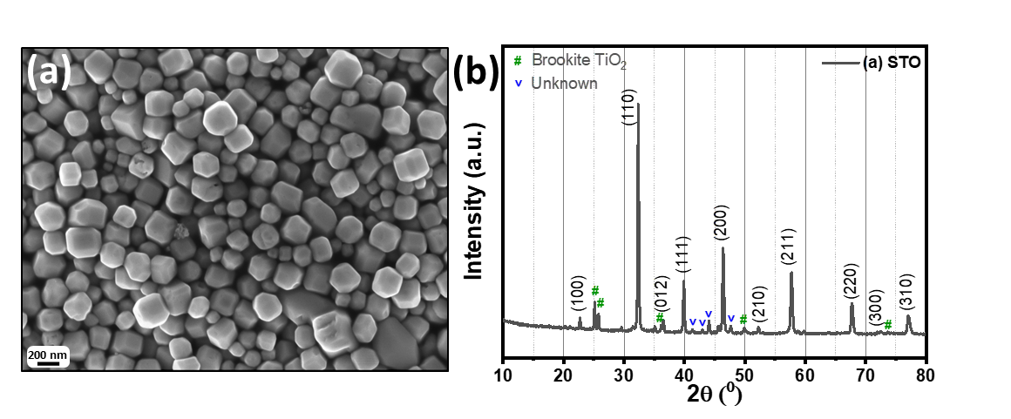

**Figure 0.1** (a) SEM image and (b) XRD pattern of SrTiO3 nanoparticles.

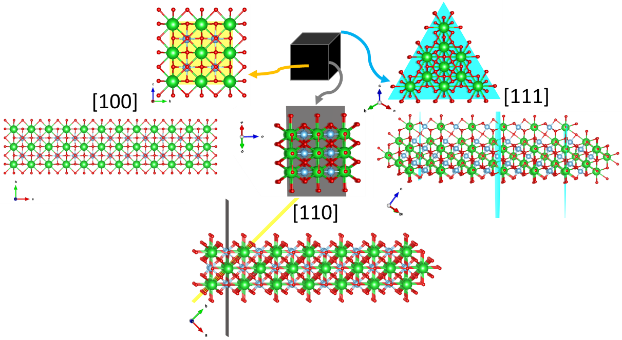

**Figure 0.2** Top and lateral view of atomic arrangement along face [1 0 0], edge [1 1 0], and corner [1 1 1] of LKMO (R3c-167) microcube.

### Spectral data:



**1,3-diphenylpropan-1-one (1a)**: Colorless liquid; 1H NMR (400 MHz, CDCl3): *δ* = 7.98 (d, *J* = 7.45 Hz, 2H), 7.57 (t, *J* = 7.39 Hz, 1H), 7.46 (t, *J* = 7.39 Hz, 2H), 7.32-7.20 (m, 5H), 3.31 (t, *J* = 8.01 Hz, 2H) and 3.08 (t, *J* = 8.01 Hz, 2H); 13C NMR (100 MHz, CDCl3): *δ* = 199.31, 141.40, 136.97, 133.15, 128.70, 128.63, 128.53, 128.14, 126.24, 40.54 and 30.23.



**1-phenyl-3-(p-tolyl)propan-1-one (1b)**: Colorless liquid; 1H NMR (400 MHz, CDCl3): *δ* = 7.96 (d, J = 7.49 Hz, 2H), 7.55 (t, J = 7.49 Hz, 1H), 7.45 (t, J = 7.67 Hz, 2H), 7.13 (q, J = 16 Hz, 8.15 Hz, 4H), 3.28 (t, J = 7.70 Hz, 2H), 3.30 (t, J = 7.70 Ha, 2H), 2.32 (s, 3H); 13C NMR (100 MHz, CDCl3): *δ* = 199.48, 138.32, 137.01, 135.76, 133.16, 129.33, 128.72, 128.42, 128.17, 40.75, 29.84, 21.13.



**3-(4-methoxyphenyl)-1-phenylpropan-1-one (1c)**: Colorless liquid; 1H NMR (400 MHz, CDCl3): *δ* = 7.95 (d, *J* = 7.5 Hz, 2H), 7.55 (t, *J* = 7.38 Hz, 1H), 7.45 (t, *J* = 7.72, 2H), 7.17 (d, *J* = 8.56 Hz, 2H), 6.84 (d, *J* = 8.56 Hz, 2H), 3.78 (s, 3H), 3.27 (t, *J* = 7.85 Hz, 2H), 3.01 (t, *J* = 7.85 Hz, 2H); 13C NMR (100 MHz, CDCl3): *δ* = 199.55, 158.10, 137.01, 133.44, 133.17, 129.48, 128.72, 128.17, 114.06, 55.40, 40.85, 29.40.



**1-(4-fluorophenyl)-3-(p-tolyl)propan-1-one (1d)**: Pale yellow color liquid; 1H NMR (400 MHz, CDCl3): *δ* = 7.98 (*J* = 8.88, 5.48, 2H), 7.16-7.09 (m, 6H), 3.25 (t, *J* = 8.09 Hz, 2H), 3.03 (t, J = 7.3 Hz, 2H), 2.33 (s, 3H); 13C NMR (100 MHz, CDCl3): *δ* = 197.83, 167.10, 164.57, 138.16, 135.82, 133.48, 133.46, 130.82, 130.73, 129.35, 128.40, 115.90, 115.68, 40.64, 29.82, 21.11.



**1-(4-(benzyloxy)phenyl)-3-(p-tolyl)propan-1-one (1e)**: Colourless solid; 1H NMR (400 MHz, CDCl3): *δ* = 7.94 (d, *J* = 8.5 Hz, 2H), 7.49-7.33 (m, 5H), 7.13 (q, *J* = 15.0 and 7.5 Hz, 4H), 7.00 (d, *J* = 8.5 Hz, 2H), 5.13 (s, 2H), 3..23 (t, *J* = 7.6 Hz, 2H), 3.02 (t, *J* = 7.5 Hz, 2H) and 2.32 (s, 3H); 13C NMR (100 MHz, CDCl3): *δ* = 198.06, 162.71, 138.48, 136.33, 135.70, 130.45, 129.31, 128.83, 128.42, 128.37, 127.60, 114.71, 70.27, 40.42, 30.04, 21.13.



***o*-Toluidine (2a)**: 1H NMR (400 MHz, CDCl3): *δ* = 7.23-7.11 (m, 2H), 6.55 (m, 1H), 6.78 (m, 1H), 3.69 (s, 2H, NH­2), 2.28 (s, 3H);13C NMR (100 MHz, CDCl3): *δ* = 144.72, 130.55, 127.09, 122.47, 118.71, 115.08, 17.5



***p*-Toluidine (2b)**: 1H NMR (400 MHz, CDCl3): *δ* = 7.00 (d, J = 8.02 Hz), 6.64 (d, J = 8.20 Hz), 3.55 (s, 2H, NH2), 2.27 (s, 3H); 13C NMR (100 MHz, CDCl3): *δ* = 143.81, 129.77, 127.82, 115.29, 20.47



**4-Aminobenzoic acid (2c)**: 1H NMR (400 MHz, CDCl3): *δ* = 11.95 (d, *J* = 8.76 Hz), 6.54 (d, *J* = 8.69 Hz), 5.86 (s, 2H, NH2); 13C NMR (100 MHz, CDCl3): *δ* = 167.97, 153.61, 131.70, 117.33, 113.25.



**4-Chloroaniline (2d)**: 1H NMR (400 MHz, CDCl3): *δ* = 7.12 (d, *J* = 8.71 Hz), 6.62 (d, *J* = 8.74), 3.68 (s, 2H, NH2); 13C NMR (100 MHz, CDCl3): *δ* = 144.97, 129.13, 123.17, 116.28



**Quinolin-6-amine (2e)**: 1H NMR (400 MHz, CDCl3): *δ* = 8.64 (s, 1H), 7.88 (m, 2H), 7.24 (m, 1H), 7.12 (m, 1H), 6.06 (m, 1H), 4.05 (s, 2H, NH2); 13C NMR (100 MHz, CDCl3): *δ* = 146.75, 144.76, 143.38, 133.80, 130.45, 129.82, 121.62, 121.41, 107.38.

**1H and 13C spectrums of hydrogenated αβ-unsaturated carbonyl compounds**:

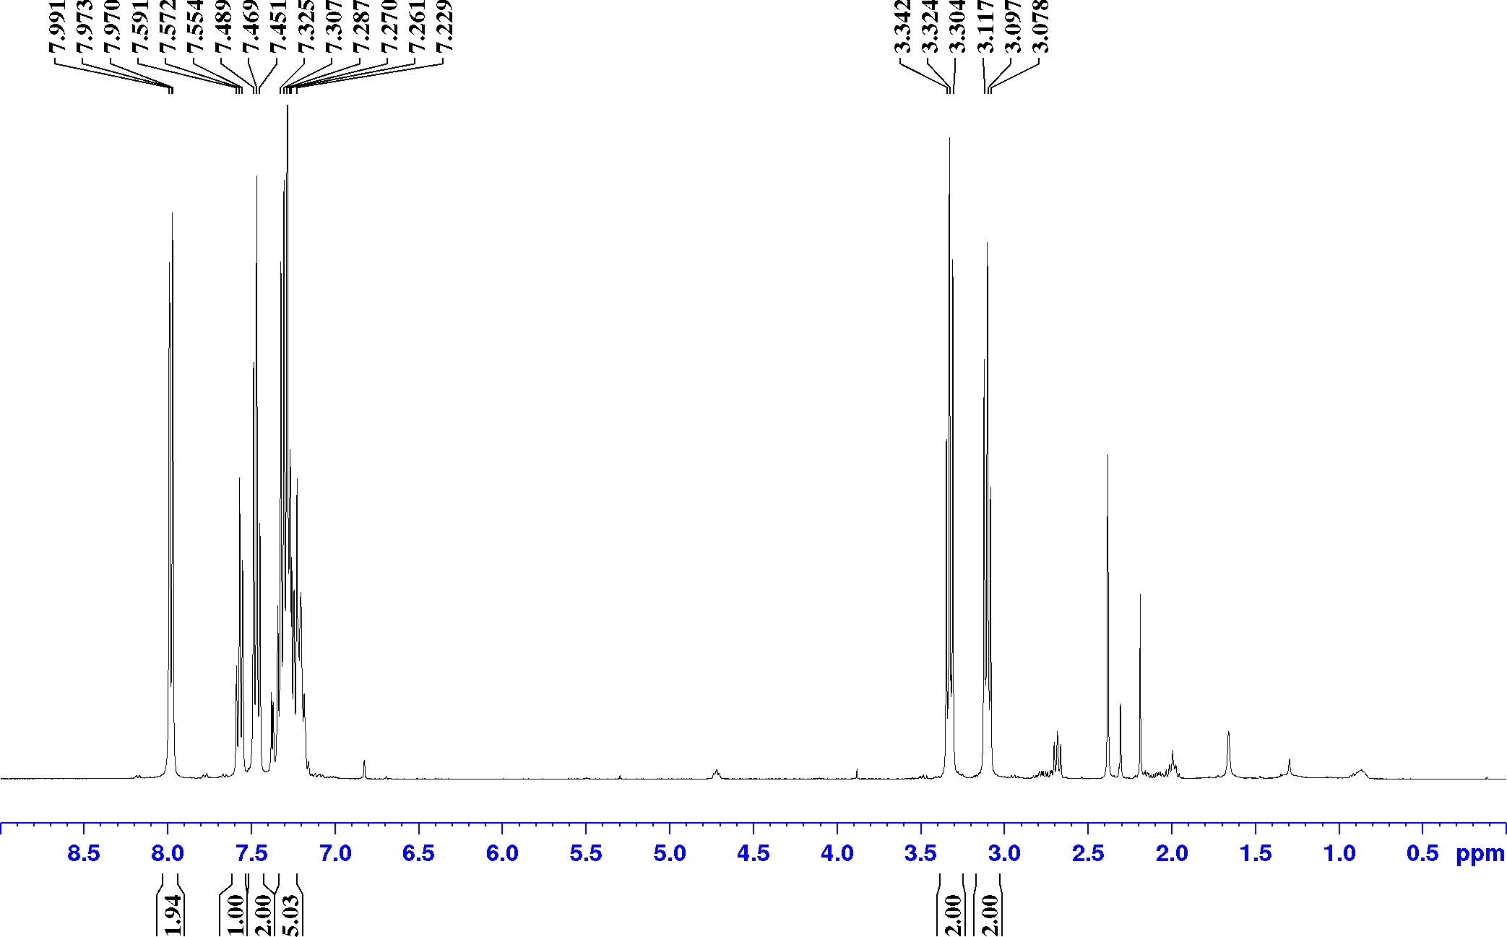



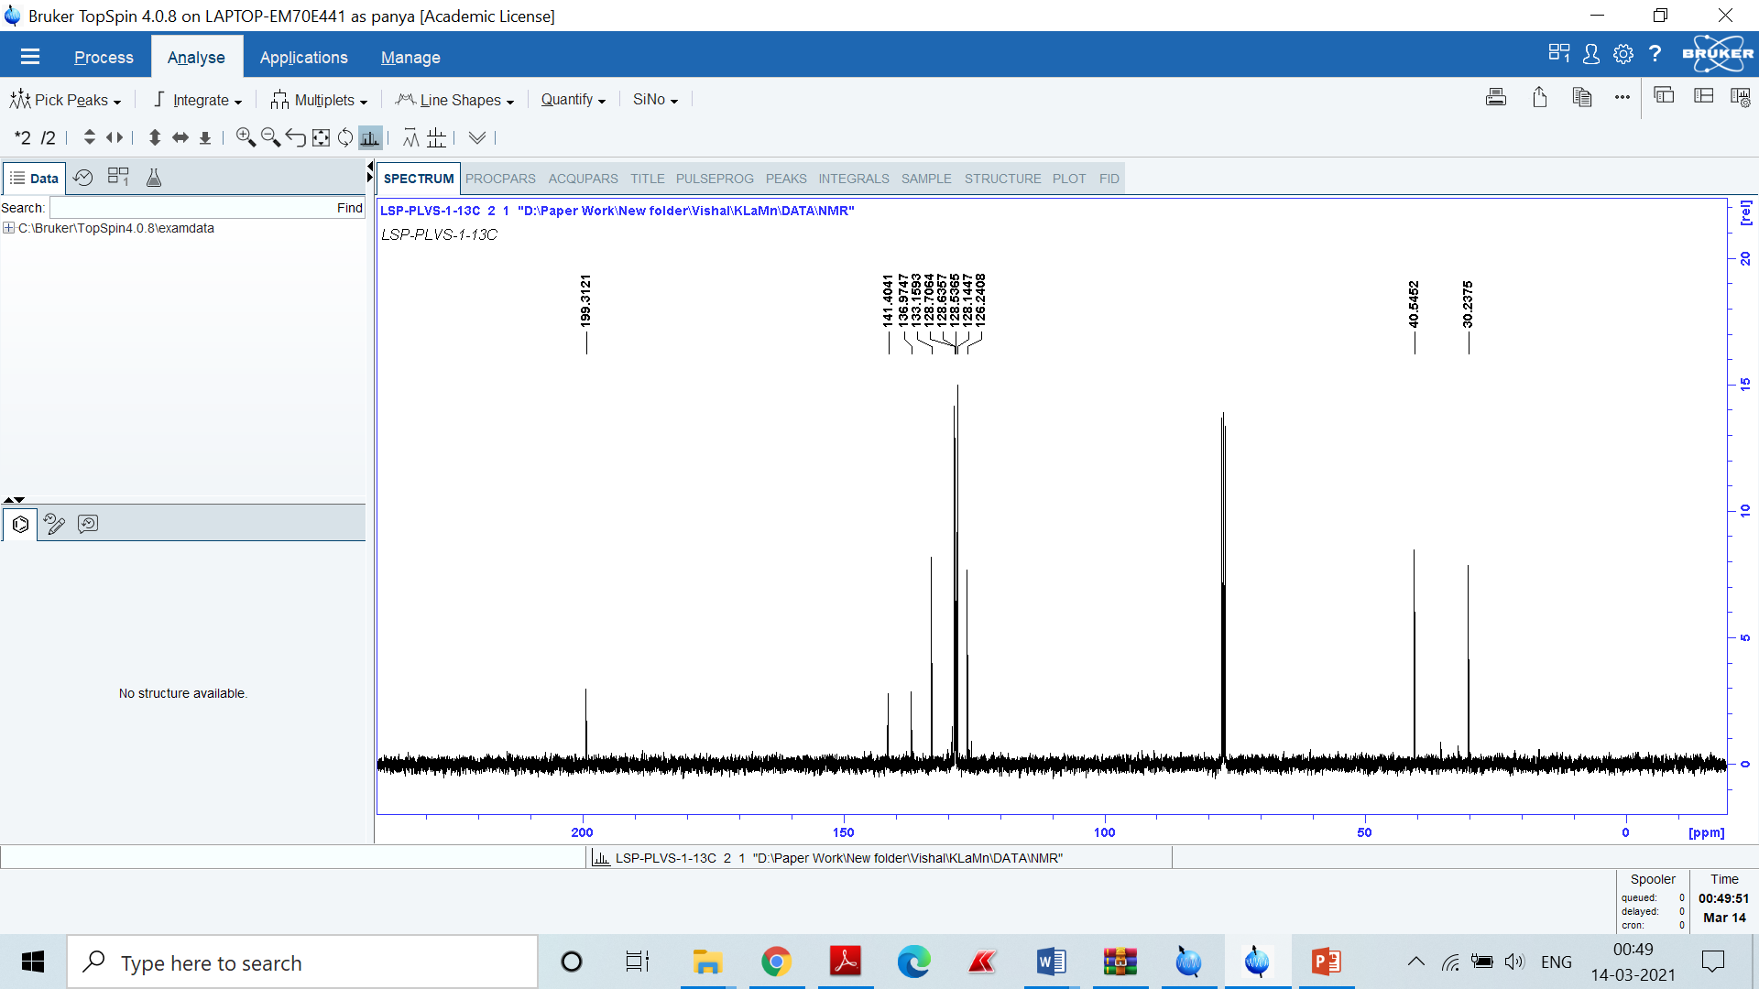

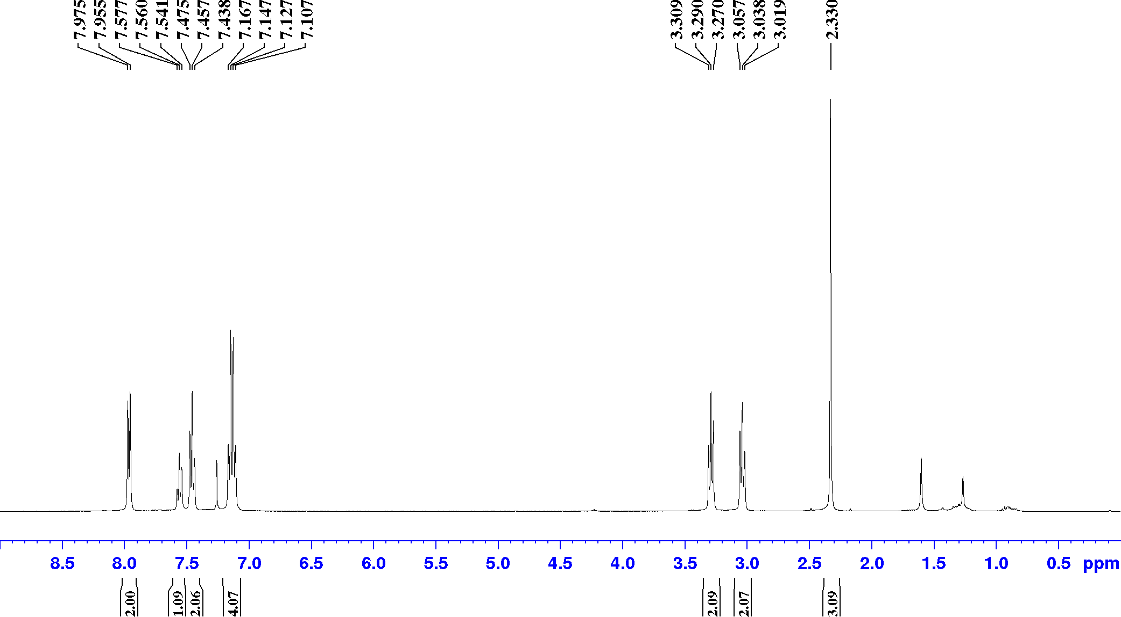

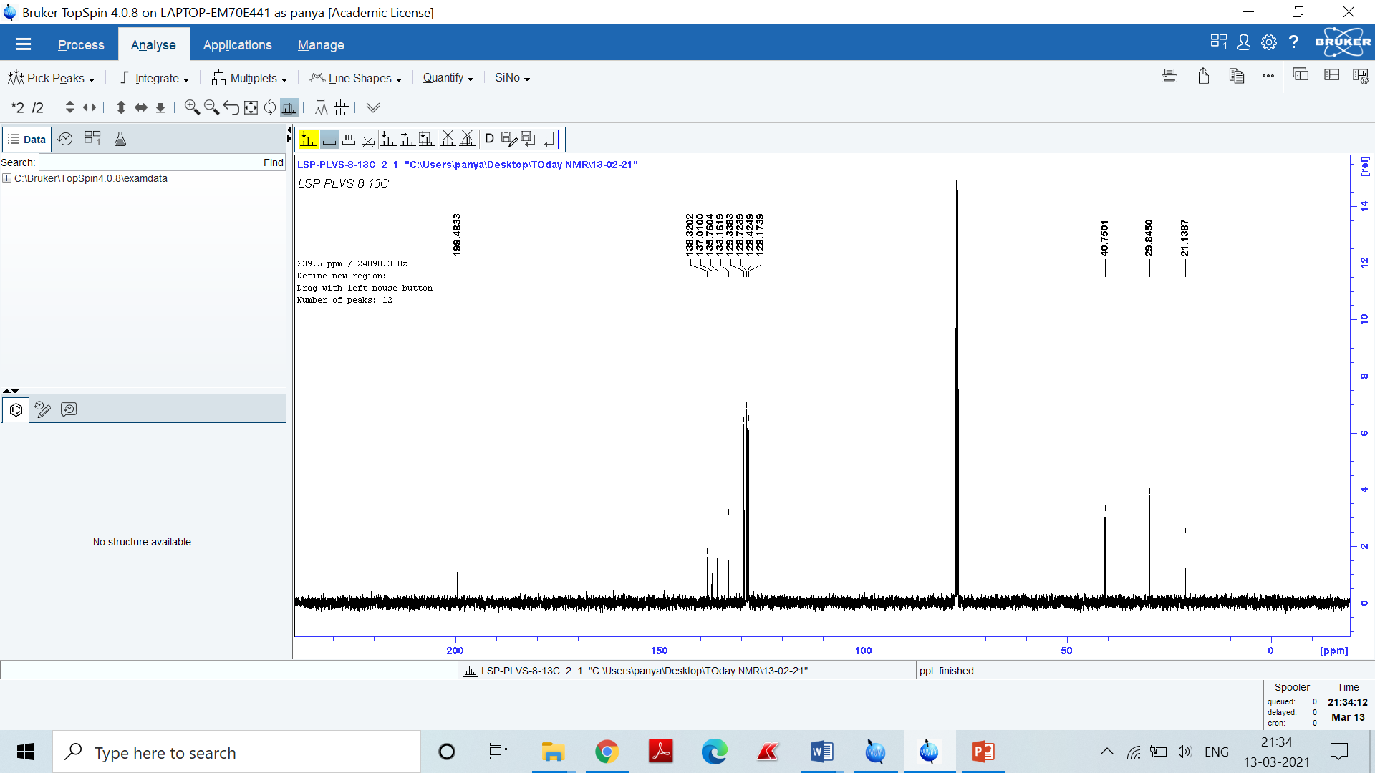

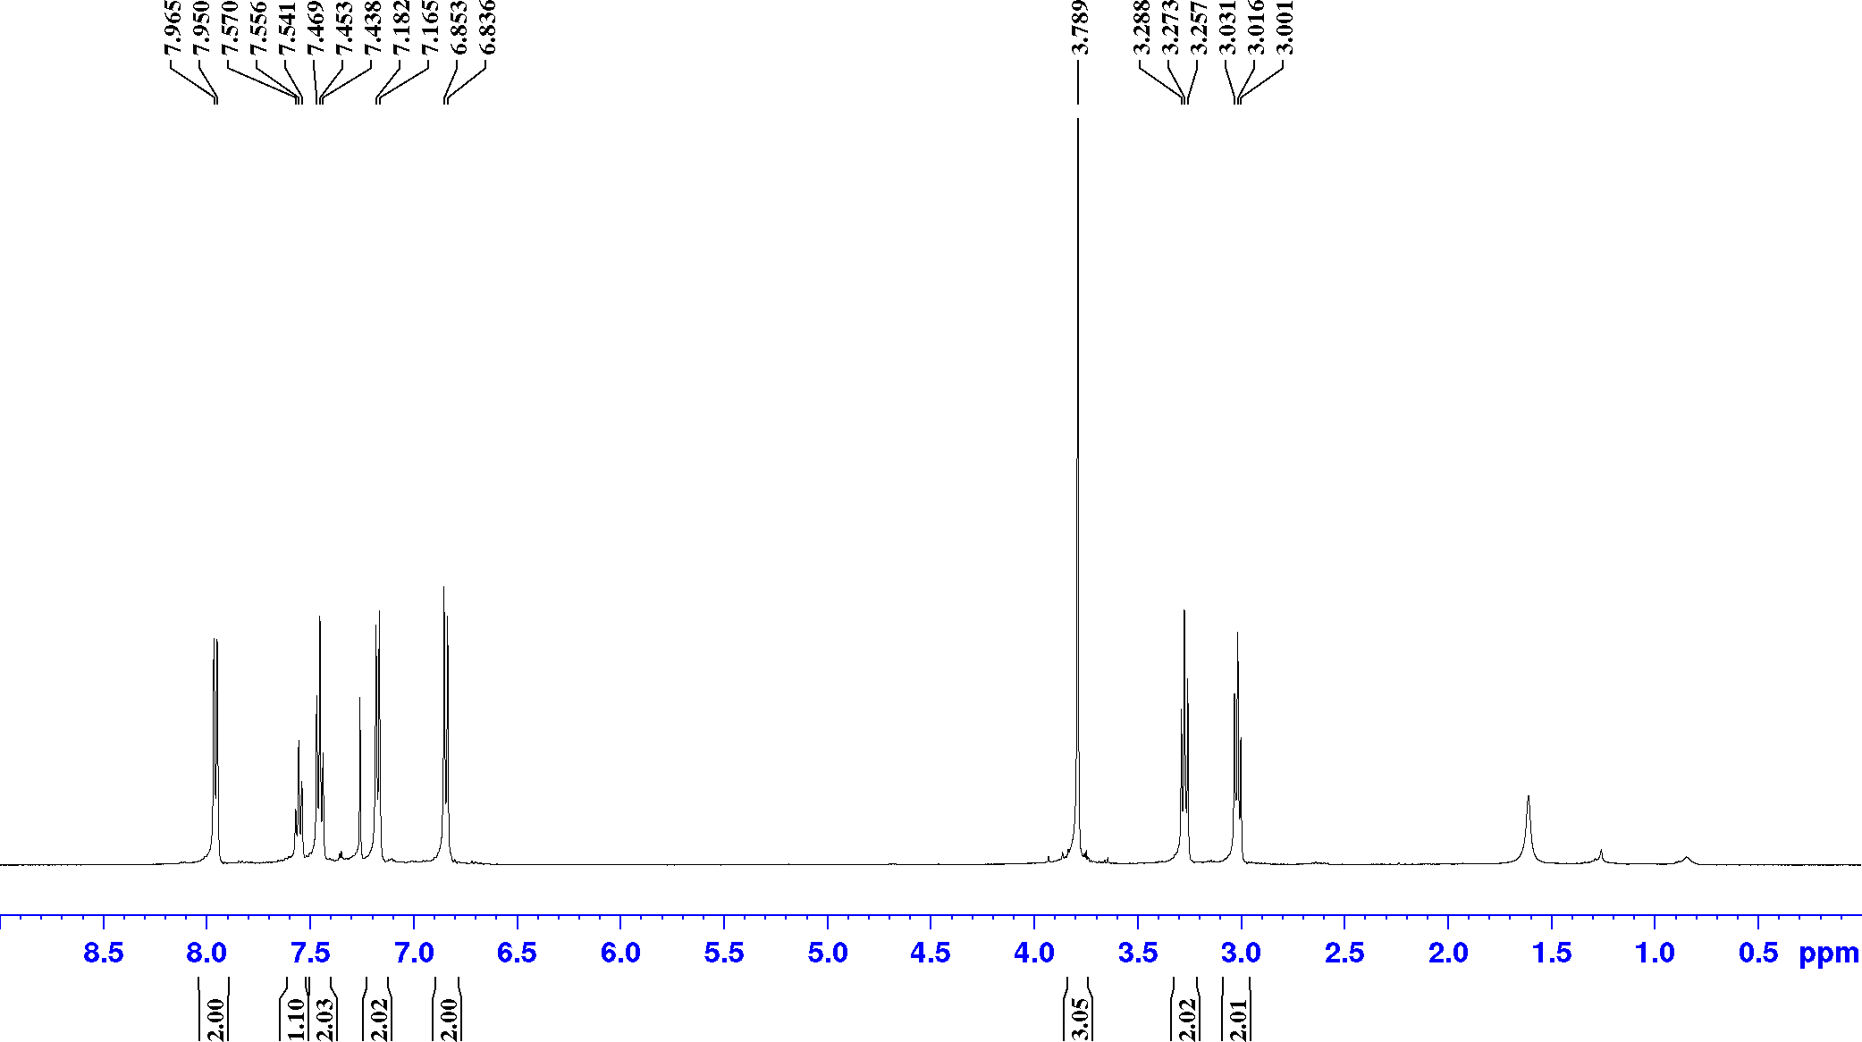

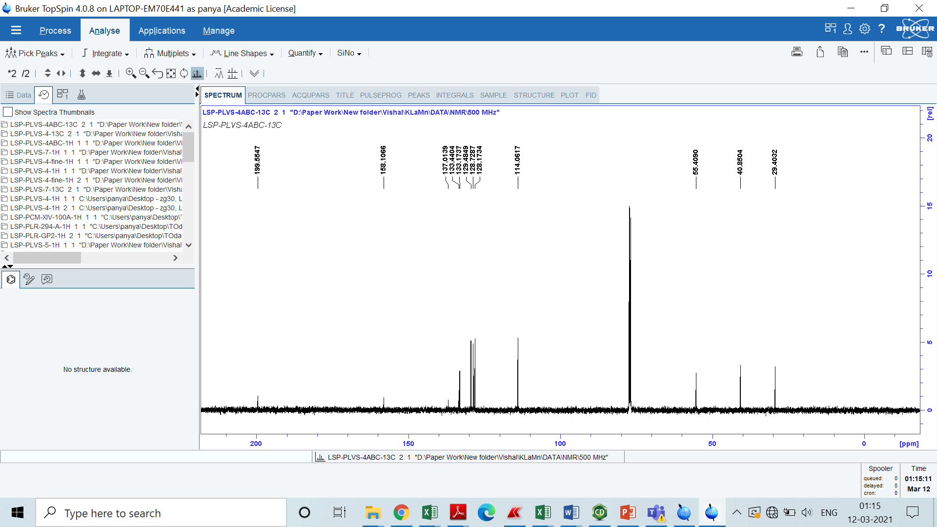

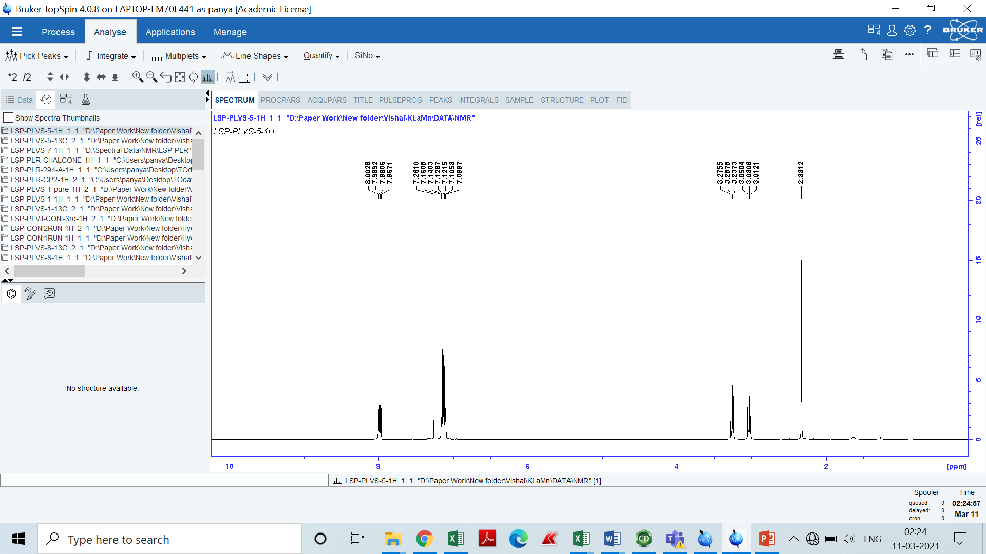

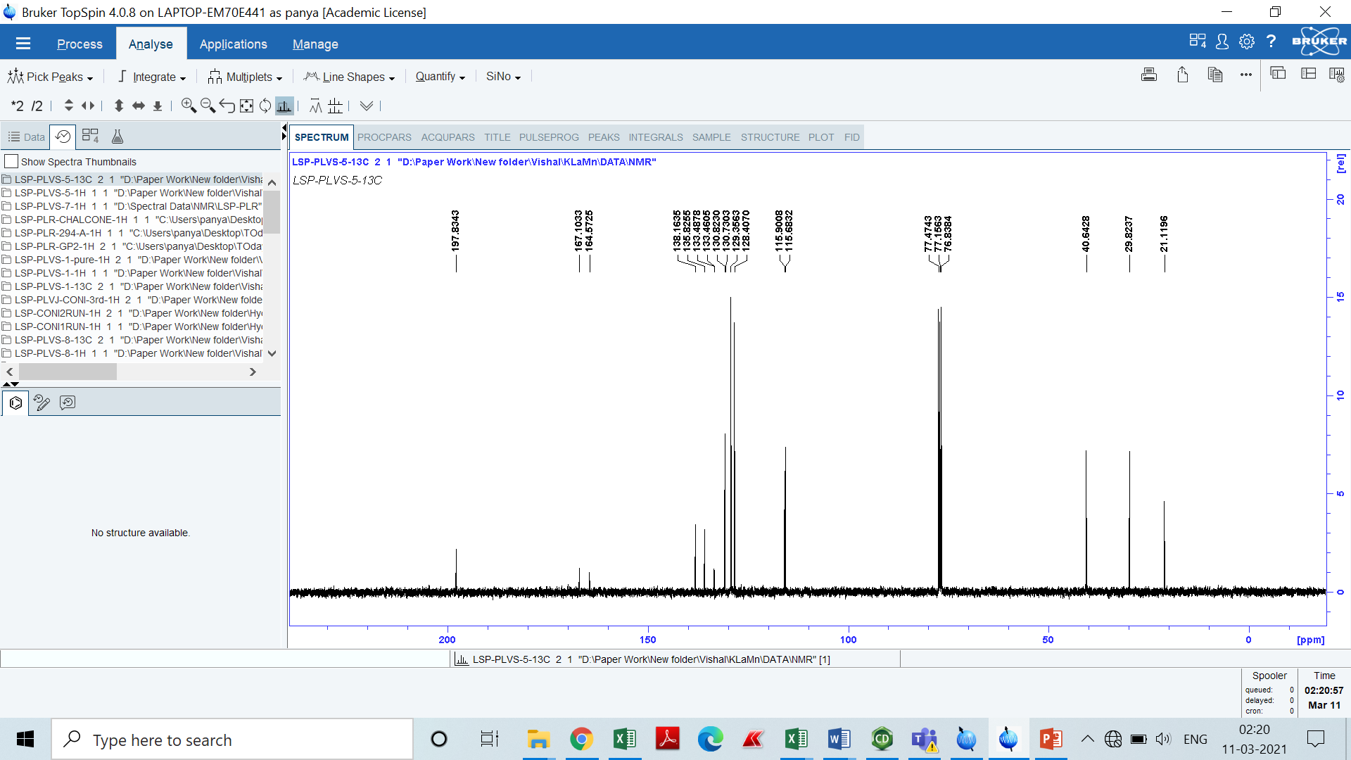

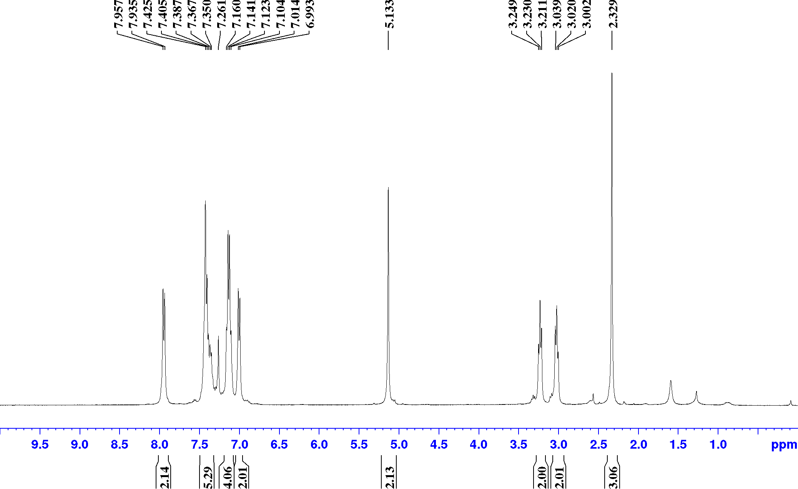

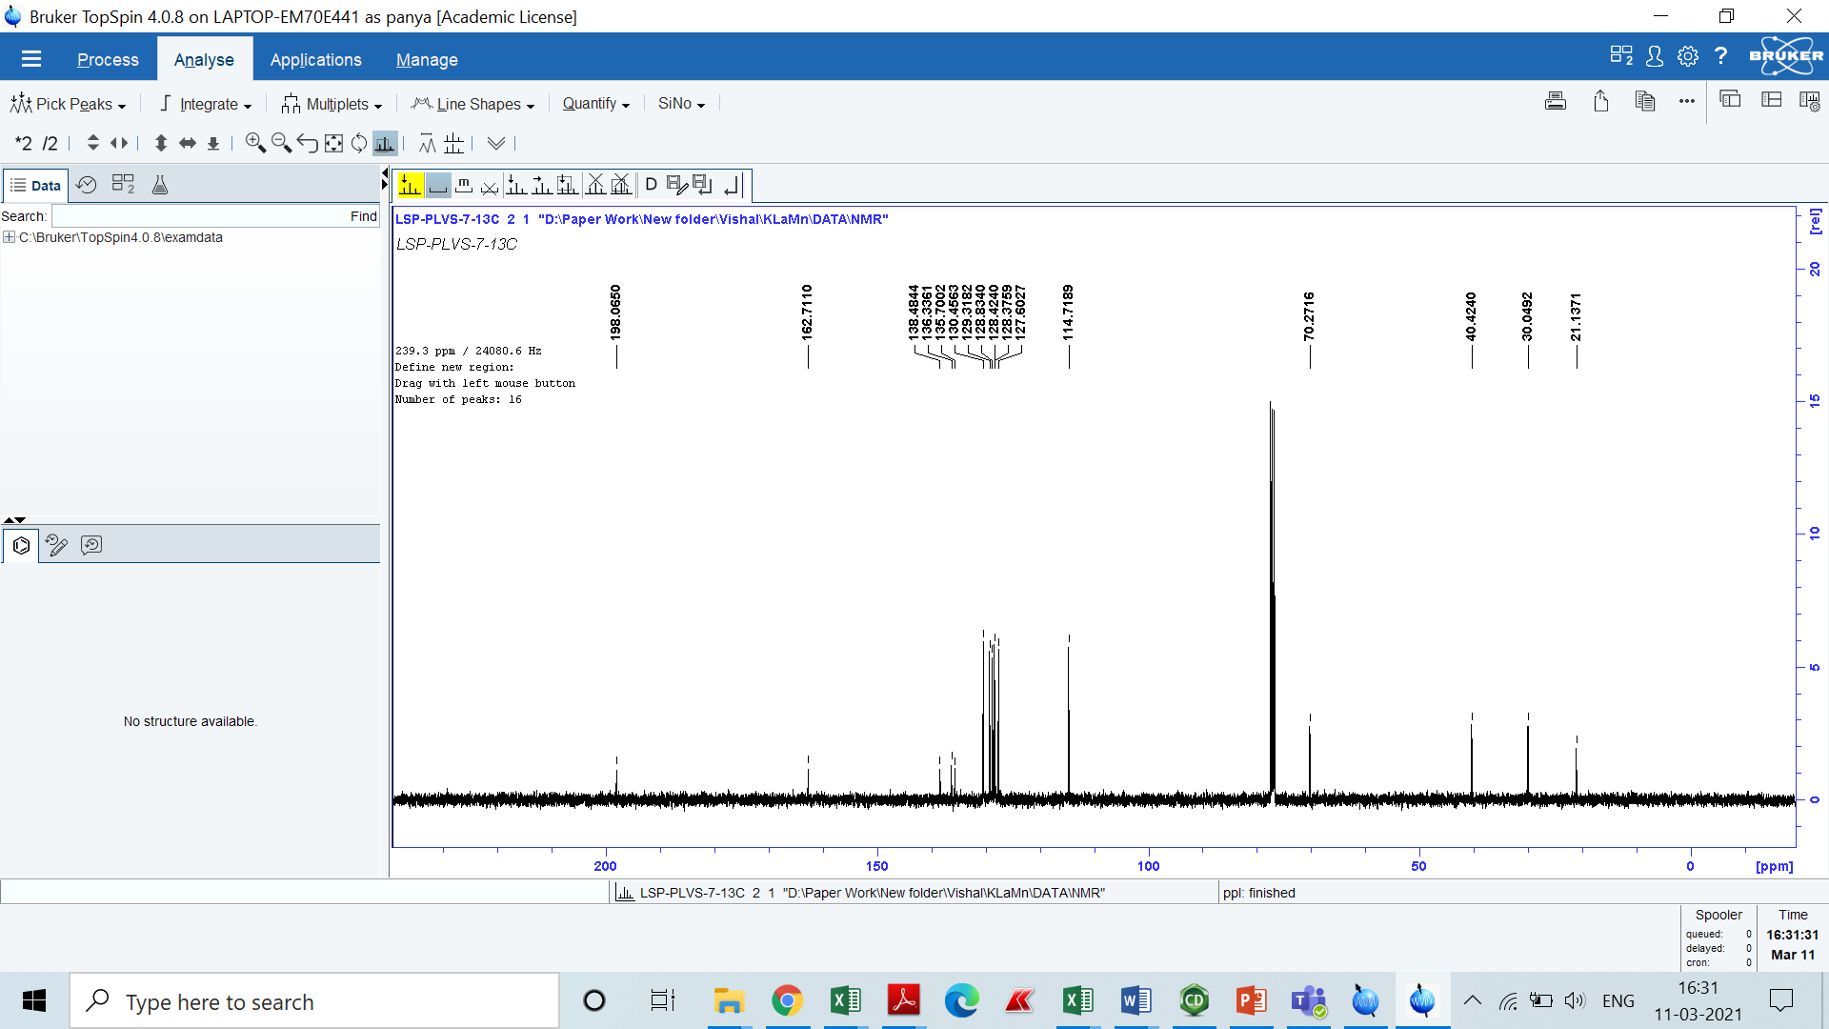

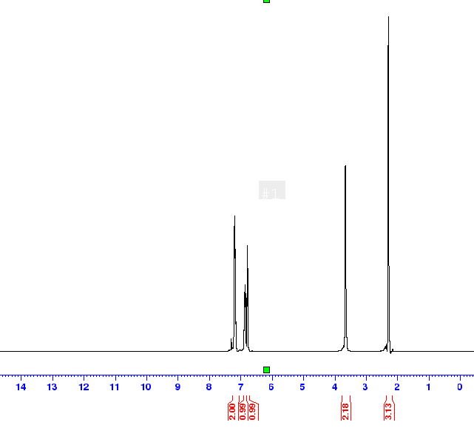

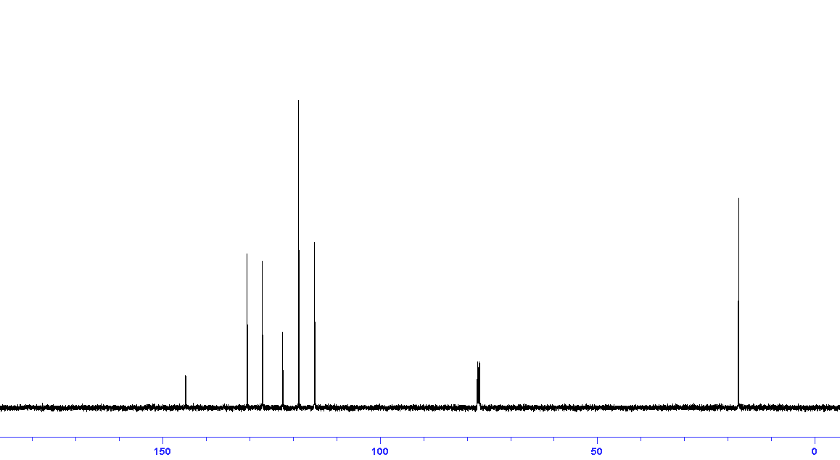

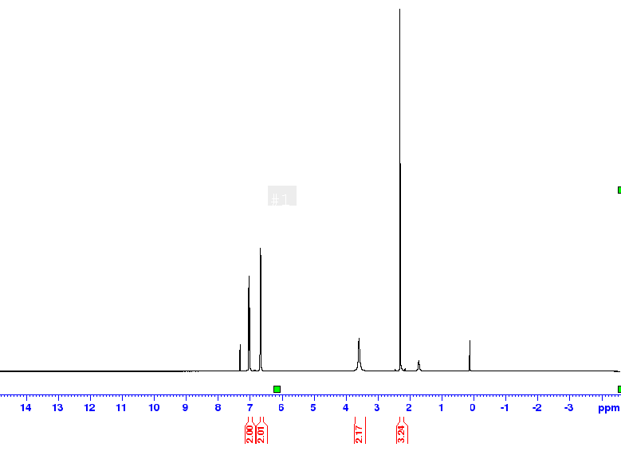

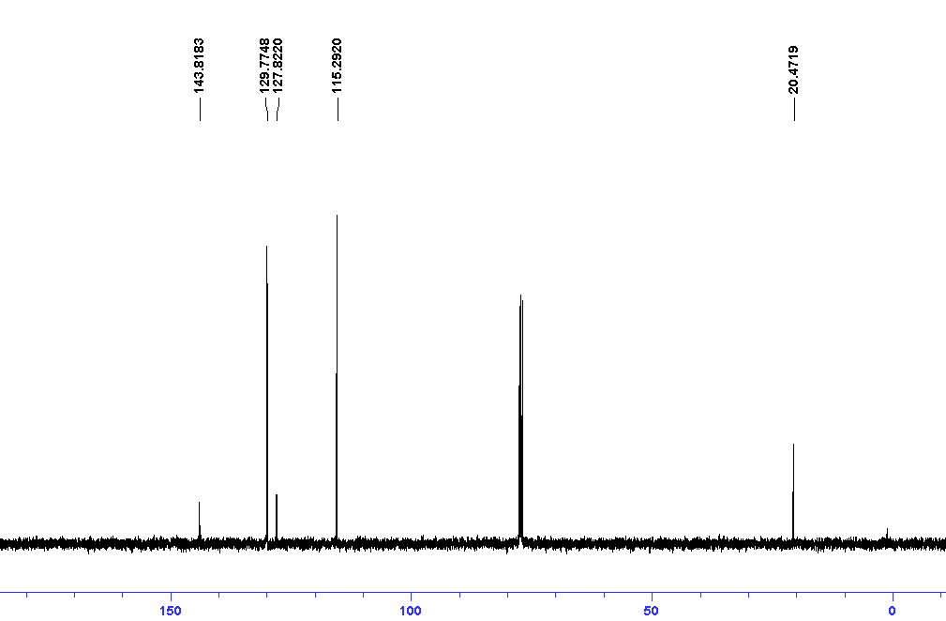

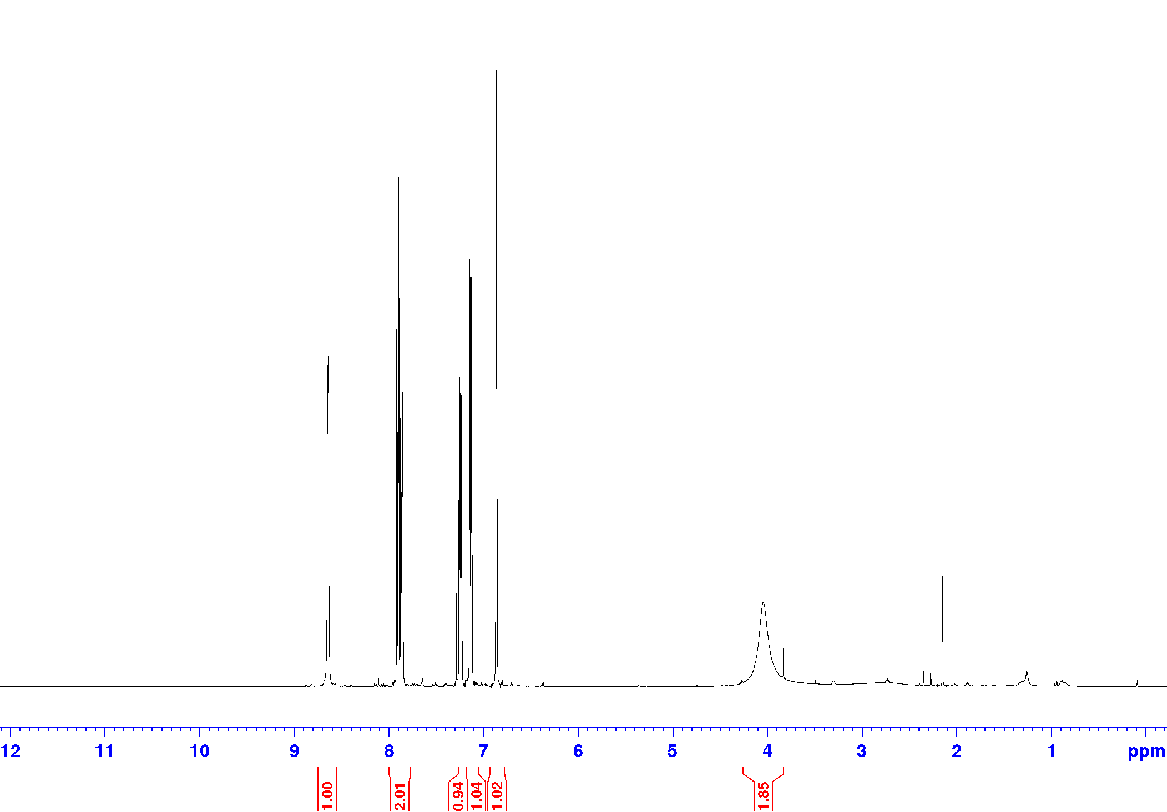

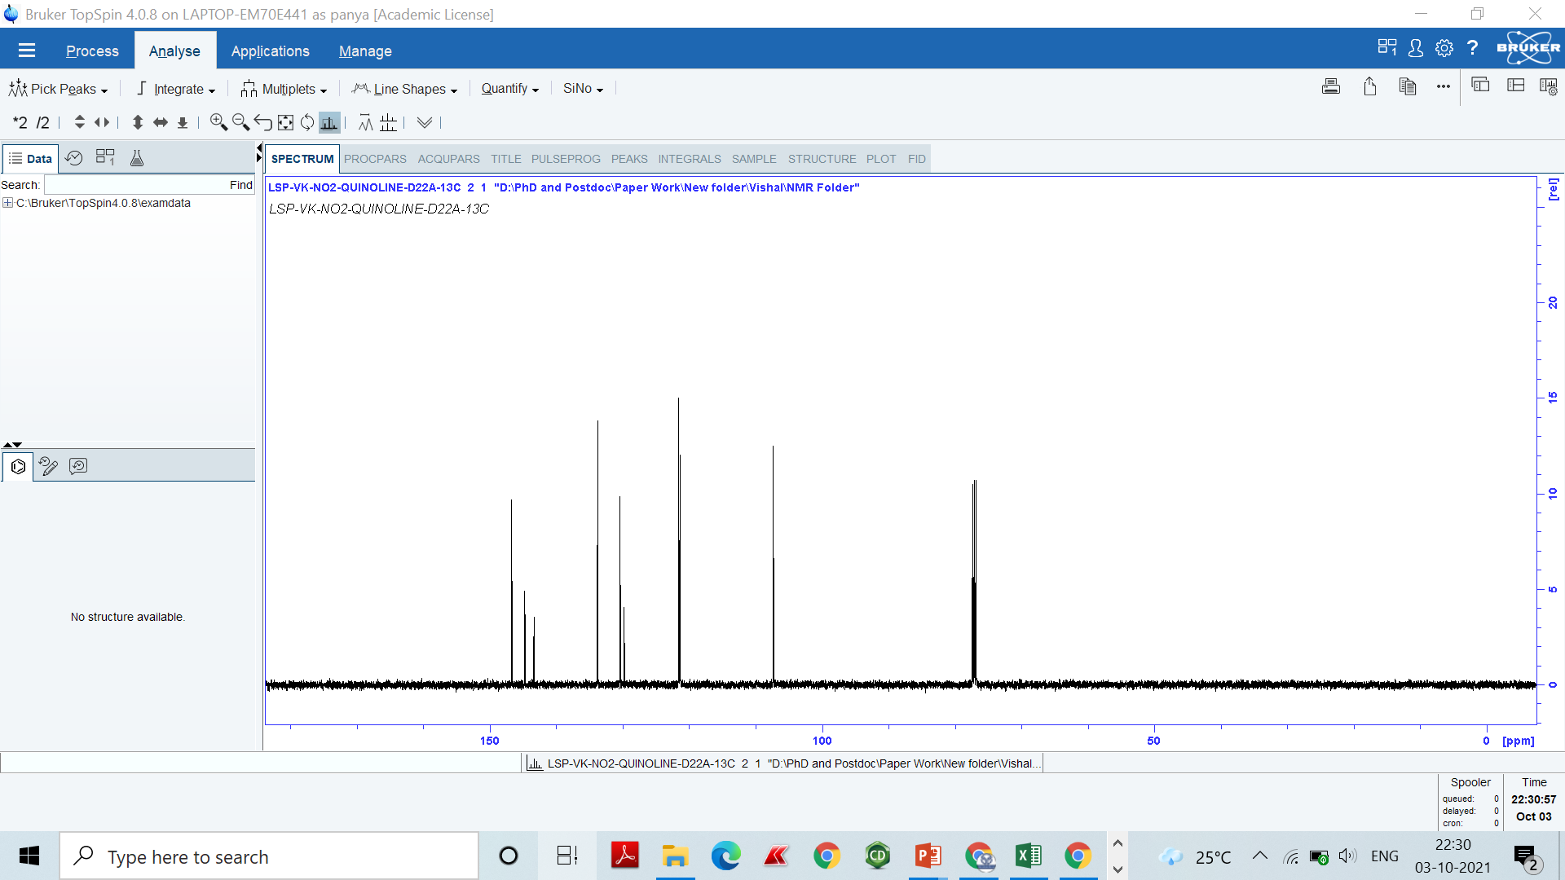

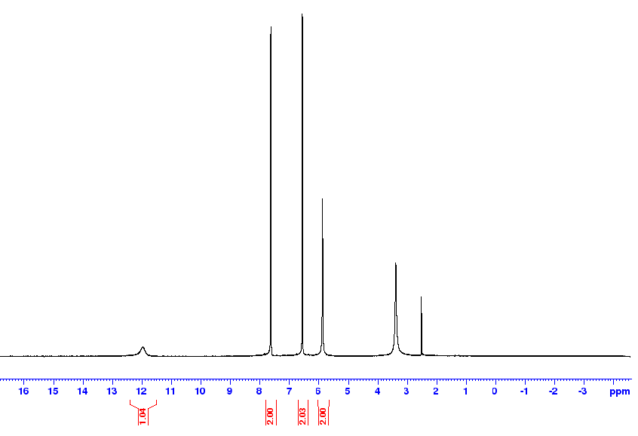

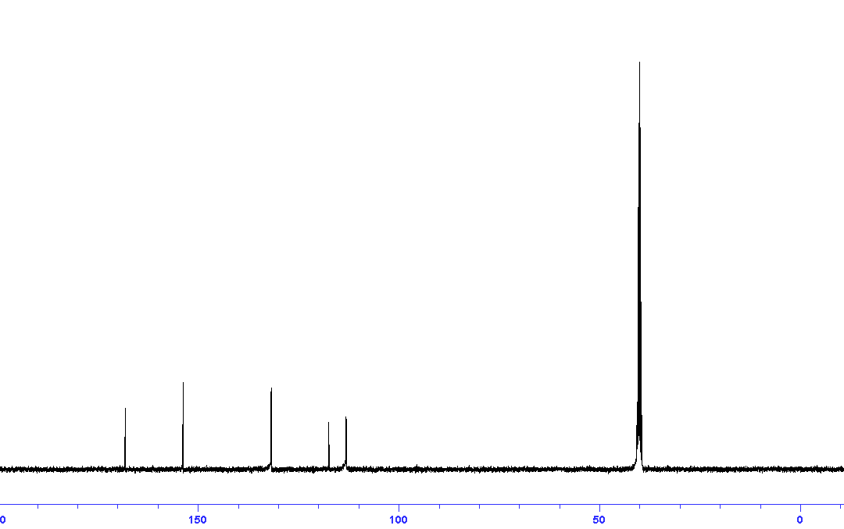

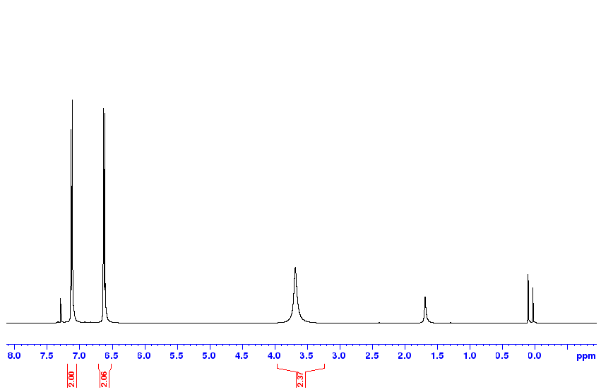

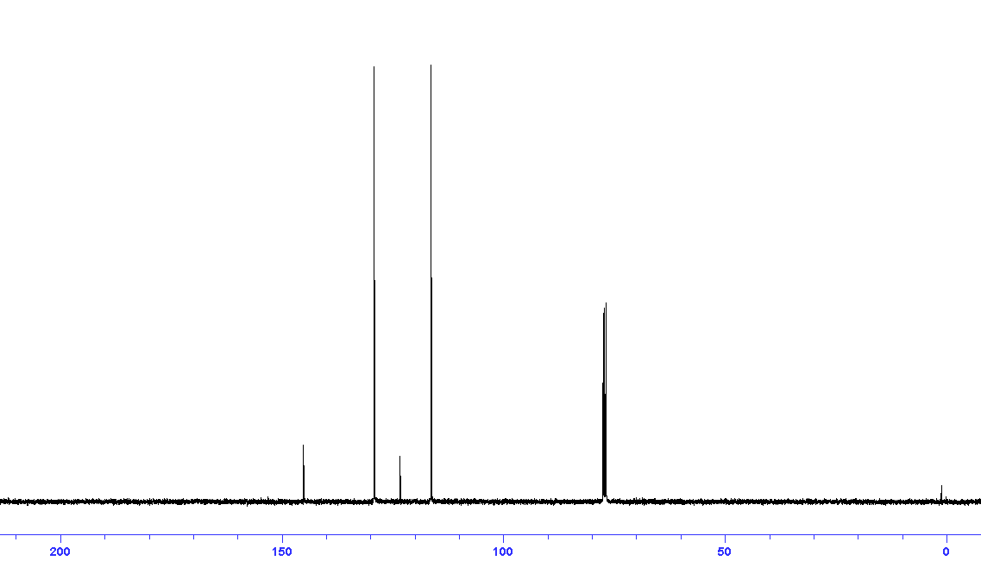

### Synthesis of perovskite oxides by TMSS method [:](https://www.ncbi.nlm.nih.gov/pmc/articles/PMC5953007/)-

There is no standard procedure to synthesize the lanthanum-based perovskite oxide nanorods in the literature. One can think of clubbing the seed addition to this dynamic hydrothermal, which leads to the formation of the nanorods the LPOs like that of LKMO. To synthesize the other materials in a similar reaction, we synthesized the precursor materials using the molten salt method (MSS). Compared to solid-state reactions, the TMSS method lowers the reaction temperature by allowing faster mass transport in the liquid environment of the molten salts through convection and diffusion.293 Thus, from understanding the growth mechanism, we can choose the TMSS method, which exactly or nearly provides similar ionic mobility and high energies. We used molten 1:1 NaCl+KCl eutectic mixture as the reaction medium. Due to short diffusion distance and high mobilities of reactant oxides in this medium reduces the temperature and time of the reaction.

In an as typical reaction, pre-synthesized La(OH)3 nanorods used as the starting material as a source of La. Adding few drops of the aqueous eutectic mixture along with the respective transition metal salt to it forms the reaction mixture. Till date, LMO, LFO, LCoO, LNO, & LAO synthesize by this method at 800 °C in 12hrs. As the used salts are very much soluble in water, thus the washing got easier. **Figure 0.3**, shows the SEM and XRD of these compounds.

The fundamental reaction mechanism is that in the molten salt medium, the more soluble reactants diffuse onto the surface of less soluble reagent and react with them to give the final product. If both fully dissolve then they diffuse to react and results in an irregular shape. Except LFO others are deviating from the one-dimensional shape, indicating that the La(OH)3 nanorods are partly getting soluble in this particular eutectic mixture. In future one can use these as seeds and try to obtain the phase as well as nanorods of other materials. 5 mM precursor concentration, 12 м KOH at 850 rpm in 2 days.

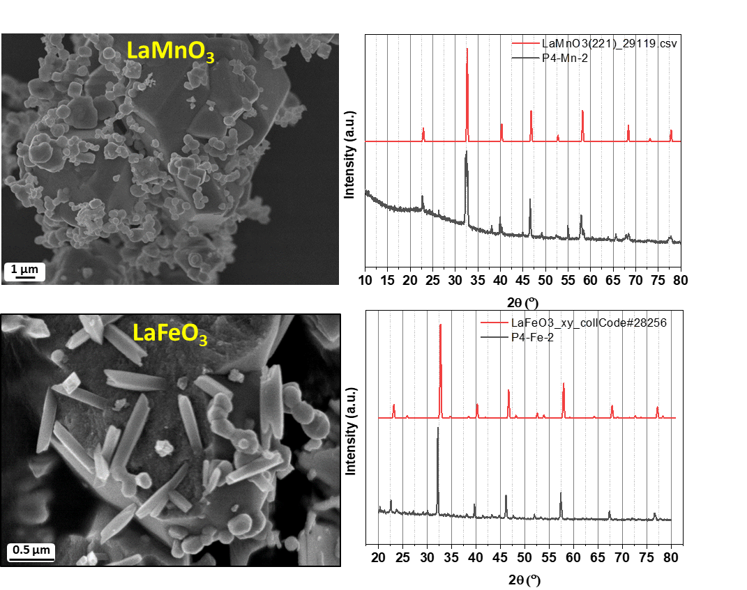

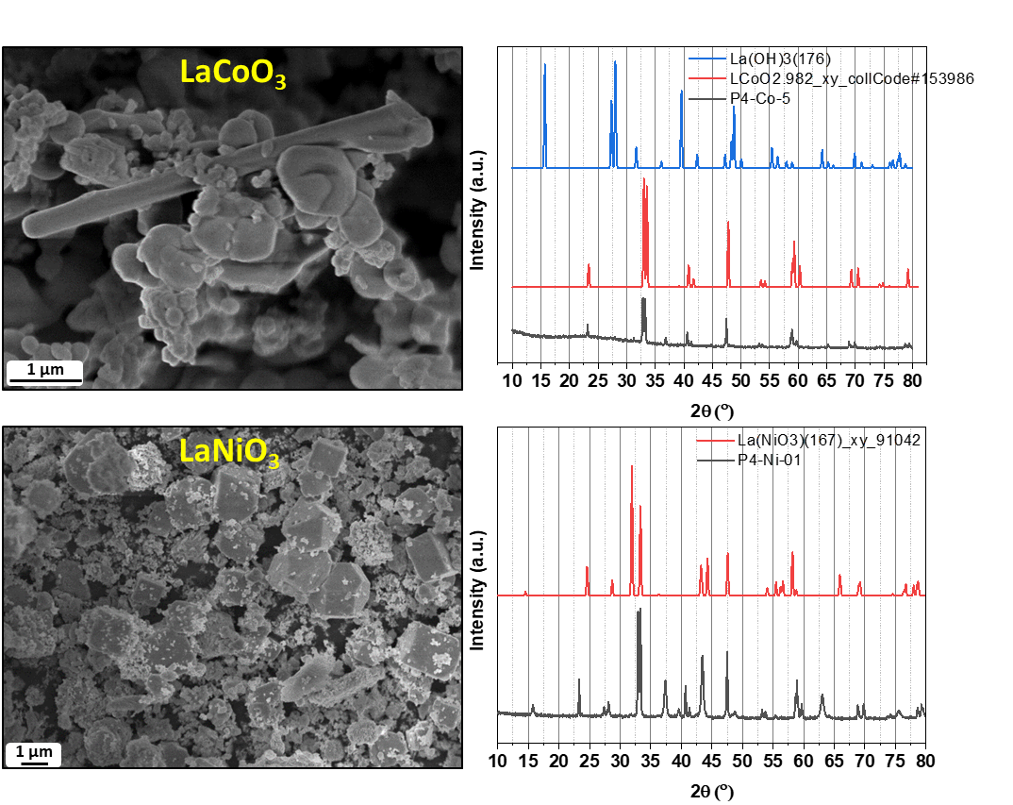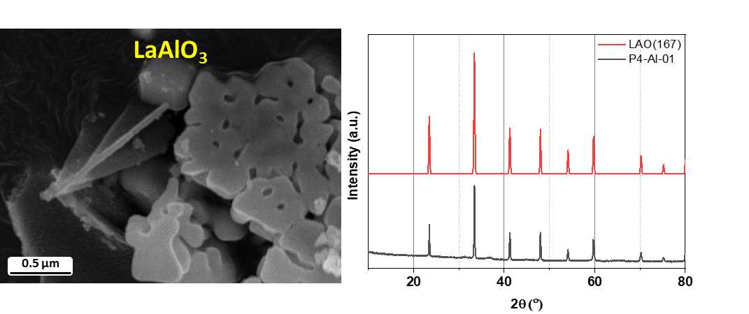

**Figure 0.3** XRD and SEM of LMO, LFO, LCoO, LNO, & LAO obtained from TMSS

# Bibliography

(1) HH., M. Characterisation of Mixed-Metal Oxides Prepared by Hydrothermal Synthesis, Coventry CV4 7AL, United Kingdom: The University of Warwick, 2013.

(2) Johnsson, M.; Lemmens, P. Crystallography and Chemistry of Perovskites. *Handb. Magn. Adv. Magn. Mater.* **2007**. https://doi.org/10.1002/9780470022184.HMM411.

(3) Kay, H. F.; Bailey, P. C. Structure and Properties of CaTiO3. *Acta Crystallogr.* **1957**, *10* (3), 219–226. https://doi.org/10.1107/S0365110X57000675.

(4) Sasaki, S.; Prewitt, C. T.; Bass, J. D.; Schulze, W. A. Orthorhombic Perovskite CaTiO3 and CdTiO3: Structure and Space Group. *Acta Crystallogr. Sect. C Cryst. Struct. Commun.* **1987**, *43* (9), 1668–1674. https://doi.org/10.1107/S0108270187090620.

(5) Verma, A. S.; Jindal, V. K. ChemInform Abstract: ABX3-Type Oxides and Halides: Their Structure and Physical Properties. *ChemInform* **2011**, *42* (21), no-no. https://doi.org/10.1002/chin.201121201.

(6) Goodenough, J. B.; Zhou, J.-S. Orbital Ordering in Orthorhombic Perovskites. *J. Mater. Chem.* **2007**, *17* (23), 2394. https://doi.org/10.1039/b701805c.

(7) Benedek, N. A.; Fennie, C. J. Why Are There so Few Perovskite Ferroelectrics? *J. Phys. Chem. C* **2013**, *117* (26), 13339–13349. https://doi.org/10.1021/JP402046T/SUPPL\_FILE/JP402046T\_SI\_001.PDF.

(8) Zubko, P.; Gariglio, S.; Gabay, M.; Ghosez, P.; Triscone, J.-M. Interface Physics in Complex Oxide Heterostructures. *Annu. Rev. Condens. Matter Phys.* **2011**, *2* (1), 141–165. https://doi.org/10.1146/annurev-conmatphys-062910-140445.

(9) Sergienko, I. A.; Şen, C.; Dagotto, E. Ferroelectricity in the Magnetic E-Phase of Orthorhombic Perovskites. *Phys. Rev. Lett.* **2006**, *97* (22), 227204. https://doi.org/10.1103/PHYSREVLETT.97.227204/FIGURES/2/MEDIUM.

(10) Goodenough, J. B.; Longo, M. Landolt-Börnstein - Group III Condensed Matter · Volume 4A: “Part A.” Springer-Verlag Berlin Heidelberg: Berlin 1970, p 126. https://doi.org/10.1007/10201420\_62.

(11) Pickett, W. E.; Singh, D. J. Electronic Structure and Half-Metallic Transport in the La1−xCaxMnO3 System. *Phys. Rev. B* **1996**, *53* (3), 1146–1160. https://doi.org/10.1103/PhysRevB.53.1146.

(12) Goodenough, J. B.; Longo, J. M.; Hellwege, K. H. *Crystallographic and Magnetic Properties of Perovskite and Perovskite-Related Compounds (Ed), Landolt-Bornstein Tabellen, New Series III 4a, Springer-Verlag, Berlin, 126. - References - Scientific Research Publishing*; 1970.

(13) Wiebe, C. R.; Greedan, J. E.; Kyriakou, P. P.; Luke, G. M.; Gardner, J. S.; Fukaya, A.; Gat-Malureanu, I. M.; Russo, P. L.; Savici, A. T.; Uemura, Y. J. Frustration-Driven Spin Freezing in the S=1/2 Fcc Perovskite Sr2MgReO6. *Phys. Rev. B* **2003**, *68* (13), 134410. https://doi.org/10.1103/PhysRevB.68.134410.

(14) Cava, R. J.; Batlogg, B.; Krajewski, J. J.; Farrow, R.; Rupp, L. W.; White, A. E.; Short, K.; Peck, W. F.; Kometani, T. Superconductivity near 30 K without Copper: The Ba0.6K0.4BiO3 Perovskite. *Nature* **1988**, *332* (6167), 814–816. https://doi.org/10.1038/332814a0.

(15) Vasala, S.; Karppinen, M. A2B′B″O6 Perovskites: A Review. *Prog. Solid State Chem.* **2015**, *43* (1–2), 1–36. https://doi.org/10.1016/j.progsolidstchem.2014.08.001.

(16) Souza, E. C. C. de; Muccillo, R. Properties and Applications of Perovskite Proton Conductors. *Mater. Res.* **2010**, *13* (3), 385–394. https://doi.org/10.1590/S1516-14392010000300018.

(17) Skinner, S. J. Recent Advances in Perovskite-Type Materials for SOFC Cathodes. *Fuel Cells Bull.* **2001**, *4* (33), 6–12. https://doi.org/10.1016/S1464-2859(01)80254-6.

(18) Skinner, S. J. Recent Advances in Perovskite-Type Materials for Solid Oxide Fuel Cell Cathodes. *Int. J. Inorg. Mater.* **2001**, *3* (2), 113–121. https://doi.org/10.1016/S1466-6049(01)00004-6.

(19) Peña, M. A.; Fierro, J. L. G. Chemical Structures and Performance of Perovskite Oxides. *Chem. Rev.* **2001**, *101* (7), 1981–2018. https://doi.org/10.1021/cr980129f.

(20) Bonanos, N. Perovskite Solid Electrolytes: Structure, Transport Properties and Fuel Cell Applications. *Solid State Ionics* **1995**, *79* (C), 161–170. https://doi.org/10.1016/0167-2738(95)00056-C.

(21) ANDERSON, H. Review of P-Type Doped Perovskite Materials for SOFC and Other Applications. *Solid State Ionics* **1992**, *52* (1–3), 33–41. https://doi.org/10.1016/0167-2738(92)90089-8.

(22) Bangert, U.; Falke, U.; Weidenkaff, A. Ultra-High Resolution EEL Studies of Domains in Perovskite. *J. Phys. Conf. Ser.* **2006**, *26* (1), 17–20. https://doi.org/10.1088/1742-6596/26/1/004.

(23) Mandal, T. K.; Gopalakrishnan, J. From Rocksalt to Perovskite: A Metathesis Route for the Synthesis of Perovskite Oxides of Current Interest. *J. Mater. Chem.* **2004**, *14* (8), 1273. https://doi.org/10.1039/b315263d.

(24) zur Loye, H.-C.; Zhao, Q.; Bugaris, D. E.; Chance, W. M. 2H-Perovskite Related Oxides: Synthesis, Structures, and Predictions. *CrystEngComm* **2012**, *14* (1), 23–39. https://doi.org/10.1039/C1CE05788J.

(25) Prado-Gonjal, J.; Schmidt, R.; Moran, E. ChemInform Abstract: Microwave-Assisted Synthesis and Characterization of Perovskite Oxides. *ChemInform* **2014**, *45* (24), no-no. https://doi.org/10.1002/chin.201424225.

(26) Parkin, I. P. Solid State Metathesis Reaction for Metal Borides, Silicides, Pnictides and Chalcogenides: Ionic or Elemental Pathways. *Chem. Soc. Rev.* **1996**, *25* (3), 199. https://doi.org/10.1039/cs9962500199.

(27) Whittingham, M. S. Hydrothermal Synthesis of Transition Metal Oxides under Mild Conditions. *Curr. Opin. Solid State Mater. Sci.* **1996**, *1* (2), 227–232. https://doi.org/10.1016/S1359-0286(96)80089-1.

(28) Delahaye, T.; Al-Zein, A.; Berger, M.-H.; Bril, X.; Hochepied, J.-F. Hydrothermal Synthesis of Ferroelectric Mixed Potassium Niobate-Lead Titanate Nanoparticles. *J. Am. Ceram. Soc.* **2014**, *97* (5), 1456–1464. https://doi.org/10.1111/jace.12778.

(29) Ebbinghaus, S. G.; Abicht, H.-P.; Dronskowski, R.; Müller, T.; Reller, A.; Weidenkaff, A. Perovskite-Related Oxynitrides – Recent Developments in Synthesis, Characterisation and Investigations of Physical Properties. *Prog. Solid State Chem.* **2009**, *37* (2–3), 173–205. https://doi.org/10.1016/j.progsolidstchem.2009.11.003.

(30) Segal, D. Related Chemical Themes in the Synthesis of Advanced Ceramic Materials. *Mater. Sci. Eng. A* **1989**, *109* (C), 261–264. https://doi.org/10.1016/0921-5093(89)90597-2.

(31) Muthurajan, H.; Kumar, H. H.; Samuel, V.; Gupta, U. N.; Ravi, V. Novel Hydroxide Precursors to Prepare NaNbO3 and KNbO3. *Ceram. Int.* **2008**, *34* (3), 671–673. https://doi.org/10.1016/J.CERAMINT.2006.12.014.

(32) Pribošič, I.; Makovec, D.; Drofenik, M. Chemical Synthesis of KNbO3 and KNbO3–BaTiO3 Ceramics. *J. Eur. Ceram. Soc.* **2005**, *25* (12), 2713–2717. https://doi.org/10.1016/J.JEURCERAMSOC.2005.03.128.

(33) Bhattacharyya, K.; Tyagi, A. K. A Novel Soft-Chemical Method for the Synthesis of Nanocrystalline MNbO3 (M = Na, K). *J. Alloys Compd.* **2009**, *470* (1–2), 580–583. https://doi.org/10.1016/J.JALLCOM.2008.03.024.

(34) Liu, M.; Xue, D.; Zhang, S.; Zhu, H.; Wang, J.; Kitamura, K. Chemical Synthesis of Stoichiometric Lithium Niobate Powders. *Mater. Lett.* **2005**, *59* (8–9), 1095–1097. https://doi.org/10.1016/J.MATLET.2004.12.015.

(35) Lu, C. H.; Lo, S. Y.; Wang, Y. L. Glycothermal Preparation of Potassium Niobate Ceramic Particles under Supercritical Conditions. *Mater. Lett.* **2002**, *55* (1–2), 121–125. https://doi.org/10.1016/S0167-577X(01)00633-4.

(36) Byrappa, K. Hydrothermal Processing. *Kirk-Othmer Encycl. Chem. Technol.* **2005**. https://doi.org/10.1002/0471238961.0825041804012319.A01.PUB2.

(37) Byrappa, K.; Yoshimura, M. *Handbook of Hydrothermal Technology, Technology for Crystal Growth and Materials Processing*; 2001.

(38) Suchanek, W. L.; Riman, R. E. Hydrothermal Synthesis of Advanced Ceramic Powders. *Adv. Sci. Technol.* **2006**, *45*, 184–193. https://doi.org/10.4028/www.scientific.net/AST.45.184.

(39) Lencka, M. M.; Riman, R. E. Intelligent Synthesis of Smart Ceramic Materials. *Encycl. Smart Mater.* **2002**. https://doi.org/10.1002/0471216275.ESM047.

(40) Byrappa, K.; Adschiri, T. Hydrothermal Technology for Nanotechnology. *Prog. Cryst. Growth Charact. Mater.* **2007**, *53* (2), 117–166. https://doi.org/10.1016/J.PCRYSGROW.2007.04.001.

(41) Tencka, M. M.; Riman, R. E. Thermodynamic Modeling of Hydrothermal Synthesis of Ceramic Powders. *Chem. Mater* **1993**, *5*, 61–70.

(42) Lencka, M. M.; Riman, R. E. Thermodynamics of the Hydrothermal Synthesis of Calcium Titanate with Reference to Other Alkaline-Earth Titanates. *Chem. Mater.* **2002**, *7* (1), 18–25. https://doi.org/10.1021/CM00049A006.

(43) Lencka, M. M.; Riman, R. E. Hydrothermal Synthesis of Perovskite Materials: Thermodynamic Modeling and Experimental Verification. *https://doi.org/10.1080/00150199408244737* **2011**, *151* (1), 159–164. https://doi.org/10.1080/00150199408244737.

(44) Lencka, M. M.; Nielsen, E.; Anderko, A.; Riman, R. E. Hydrothermal Synthesis of Carbonate-Free Strontium Zirconate:  Thermodynamic Modeling and Experimental Verification. *Chem. Mater.* **1997**, *9* (5), 1116–1125. https://doi.org/10.1021/CM960444N.

(45) Łencka, M. M.; Riman, R. E. Synthesis of Lead Titanate: Thermodynamic Modeling and Experimental Verification. *J. Am. Ceram. Soc.* **1993**, *76* (10), 2649–2659. https://doi.org/10.1111/J.1151-2916.1993.TB03994.X.

(46) Cho, S. B.; Noh, J. S.; Lencka, M. M.; Riman, R. E. Low Temperature Hydrothermal Synthesis and Formation Mechanisms of Lead Titanate (PbTiO3) Particles Using Tetramethylammonium Hydroxide: Thermodynamic Modelling and Experimental Verification. *J. Eur. Ceram. Soc.* **2003**, *23* (13), 2323–2335. https://doi.org/10.1016/S0955-2219(03)00085-2.

(47) Gelabert, M. C.; Laudise, R. A.; Riman, R. E. Phase Stability, Solubility and Hydrothermal Crystal Growth of PbTiO3. *J. Cryst. Growth* **1999**, *197* (1–2), 195–203. https://doi.org/10.1016/S0022-0248(98)00914-2.

(48) Eckert, J. O.; Hung-Houston, C. C.; Gersten, B. L.; Lencka, M. M.; Riman, R. E. Kinetics and Mechanisms of Hydrothermal Synthesis of Barium Titanate. *J. Am. Ceram. Soc.* **1996**, *79* (11), 2929–2939. https://doi.org/10.1111/J.1151-2916.1996.TB08728.X.

(49) Gersten, B. L.; Lencka, M. M.; Riman, R. E. Low-Temperature Hydrothermal Synthesis of Phase-Pure (Ba,Sr)TiO3 Perovskite Using EDTA. *J. Am. Ceram. Soc.* **2004**, *87* (11), 2025–2032. https://doi.org/10.1111/J.1151-2916.2004.TB06355.X.

(50) Lencka, M. M.; Anderko, A.; Riman, R. E. Hydrothermal Precipitation of Lead Zirconate Titanate Solid Solutions: Thermodynamic Modeling and Experimental Synthesis. *J. Am. Ceram. Soc.* **1995**, *78* (10), 2609–2618. https://doi.org/10.1111/J.1151-2916.1995.TB08030.X.

(51) Zheng, W.; Pang, W.; Meng, G.; Peng, D. Hydrothermal Synthesis and Characterization of LaCrO3. *J. Mater. Chem.* **1999**, *9* (11), 2833–2836. https://doi.org/10.1039/a904399c.

(52) Choi, B. H.; Park, S. A.; Park, B. K.; Chun, H. H.; Kim, Y. T. Controlled Synthesis of La1−xSrxCrO3 Nanoparticles by Hydrothermal Method with Nonionic Surfactant and Their ORR Activity in Alkaline Medium. *Mater. Res. Bull.* **2013**, *48* (10), 3651–3656. https://doi.org/10.1016/J.MATERRESBULL.2013.04.084.

(53) Rendón-Angeles, J. C.; Yanagisawa, K.; Matamoros-Veloza, Z.; Pech-Canul, M. I.; Mendez-Nonell, J.; Torre, S. D. D. La. Hydrothermal Synthesis of Perovskite Strontium Doped Lanthanum Chromite Fine Powders and Its Sintering. *J. Alloys Compd.* **2010**, *504* (1), 251–256. https://doi.org/10.1016/J.JALLCOM.2010.05.103.

(54) Wang, S.; Huang, K.; Zheng, B.; Zhang, J.; Feng, S. Mild Hydrothermal Synthesis and Physical Property of Perovskite Sr Doped LaCrO3. *Mater. Lett.* **2013**, *101*, 86–89. https://doi.org/10.1016/j.matlet.2013.03.083.

(55) Sardar, K.; Lees, M. R.; Kashtiban, R. J.; Sloan, J.; Walton, R. I. Direct Hydrothermal Synthesis and Physical Properties of Rare-Earth and Yttrium Orthochromite Perovskites. *Chem. Mater.* **2011**, *23* (1), 48–56. https://doi.org/10.1021/cm102925z.

(56) Zhu, D.; Zhu, H.; Zhang, Y. Hydrothermal Synthesis of La0.5Ba0.5MnO3 Nanowires. *Appl. Phys. Lett.* **2002**, *80* (9), 1634. https://doi.org/10.1063/1.1455690.

(57) Zhang, T.; Jin, C. G.; Qian, T.; Lu, X. L.; Bai, J. M.; Li, X. G. Hydrothermal Synthesis of Single-Crystalline La0.5Ca0.5MnO3 Nanowires at Low Temperature. *J. Mater. Chem.* **2004**, *14* (18), 2787. https://doi.org/10.1039/b405288a.

(58) Bernard, C.; Dauzet, G.; Mathieu, F.; Durand, B.; Puech-Costes, E. Optimization of the Hydrothermal Synthesis of La0.7Sr0.3MnO3 + δ Using an Original Optimal Experimental Design. *Mater. Lett.* **2005**, *59* (21), 2615–2620. https://doi.org/10.1016/J.MATLET.2005.02.063.

(59) Makovec, D.; Goršak, T.; Zupan, K.; Lisjak, D. Hydrothermal Synthesis of La1−XSrXMnO3 Dendrites. *J. Cryst. Growth* **2013**, *375*, 78–83. https://doi.org/10.1016/J.JCRYSGRO.2013.04.019.

(60) Spooren, J.; Walton, R. I.; Millange, F. A Study of the Manganites La0.5M0.5MnO3(M = Ca, Sr, Ba) Prepared by Hydrothermal Synthesis. *J. Mater. Chem.* **2005**, *15* (15), 1542. https://doi.org/10.1039/b417003b.

(61) Sun, W. A.; Li, J. Q.; Ao, W. Q.; Tang, J. N.; Gong, X. Z. Hydrothermal Synthesis and Magnetocaloric Effect of La0.7Ca0.2Sr0.1MnO3. *Powder Technol.* **2006**, *166* (2), 77–80. https://doi.org/10.1016/J.POWTEC.2006.05.015.

(62) Li, J. Q.; Sun, W. A.; Ao, W. Q.; Tang, J. N. Hydrothermal Synthesis and Magnetocaloric Effect of La0.5Ca0.3Sr0.2MnO3. *J. Magn. Magn. Mater.* **2006**, *302* (2), 463–466. https://doi.org/10.1016/J.JMMM.2005.10.007.

(63) Ifrah, S.; Kaddouri, A.; Gelin, P.; Leonard, D. Conventional Hydrothermal Process versus Microwave-Assisted Hydrothermal Synthesis of La1−xAgxMnO3+δ (x = 0, 0.2) Perovskites Used in Methane Combustion. *Comptes Rendus Chim.* **2007**, *10* (12), 1216–1226. https://doi.org/10.1016/J.CRCI.2007.08.002.

(64) Zhou, Z.; Guo, L.; Ye, F. Hydrothermal Synthesis, Magnetism and Resistivity of Orthorhombic Perovskite Manganates Y1−xCaxMnO3 (x = 0, 0.07, 0.55, 0.65). *J. Alloys Compd.* **2013**, *571*, 123–131. https://doi.org/10.1016/J.JALLCOM.2013.03.220.

(65) Spooren, J.; Walton, R. I. Hydrothermal Synthesis of the Perovskite Manganites Pr0.5Sr0.5MnO3 and Nd0.5Sr0.5MnO3 and Alkali-Earth Manganese Oxides CaMn2O4, 4H-SrMnO3, and 2H-BaMnO3. *J. Solid State Chem.* **2005**, *178* (5), 1683–1691. https://doi.org/10.1016/J.JSSC.2005.03.006.

(66) Wang, Y.; Lu, X.; Chen, Y.; Chi, F.; Feng, S.; Liu, X. Hydrothermal Synthesis of Two Perovskite Rare-Earth Manganites, HoMnO3 and DyMnO3. *J. Solid State Chem.* **2005**, *178* (4), 1317–1320. https://doi.org/10.1016/J.JSSC.2004.12.039.

(67) Chen, Y.; Yuan, H.; Tian, G.; Zhang, G.; Feng, S. Hydrothermal Synthesis and Magnetic Properties of RMn2O5 (R=La, Pr, Nd, Tb, Bi) and LaMn2O5+δ. *J. Solid State Chem.* **2007**, *180* (4), 1340–1346. https://doi.org/10.1016/J.JSSC.2007.02.005.

(68) Chen, Y.; Yuan, H.; Li, G.; Tian, G.; Feng, S. Crystal Growth and Magnetic Property of Orthorhombic RMnO3 (R=Sm–Ho) Perovskites by Mild Hydrothermal Synthesis. *J. Cryst. Growth* **2007**, *305* (1), 242–248. https://doi.org/10.1016/J.JCRYSGRO.2007.03.052.

(69) Zener, C. Interaction between the D-Shells in the Transition Metals. II. Ferromagnetic Compounds of Manganese with Perovskite Structure. *Phys. Rev.* **1951**, *82* (3), 403–405. https://doi.org/10.1103/PhysRev.82.403.

(70) Mahendiran, R.; Tiwary, S. K.; Raychaudhuri, A. K.; Ramakrishnan, T. V; Mahesh, R.; Rangavittal, N.; Rao, C. N. R. *Structure, Electron-Transport Properties, and Giant Magnetoresistance of Hole-Doped LaMnO 3 Systems*; 1996.

(71) Shivakumara, C.; Bellakki, M. B. Synthesis, Structural and Ferromagnetic Properties of La1−xKxMnO3 (0·0 ≤ x ≤ 0·25) Phases by Solution Combustion Method. *Bull. Mater. Sci.* **2009**, *32* (4), 443–449. https://doi.org/10.1007/s12034-009-0065-1.

(72) Joseph, S.; Saban, K. V. Monovalent Doping Effects on the Structural, Magnetic and Magnetotransport Properties of La0.833R0.167MnO3 (R = Li+, Na+, Ag+, K+). *Ceram. Int.* **2019**, *45* (5), 6425–6439. https://doi.org/10.1016/j.ceramint.2018.12.130.

(73) Shivakumara, C.; Subbanna, G. N.; Lalla, N. P.; Hegde, M. S. Na Substitution for La- and Mn-Sites in LaMnO3 from Alkali Halide Fluxes: Low Temperature Synthesis, Structure and Properties. *Mater. Res. Bull.* **2004**, *39* (1), 71–81. https://doi.org/10.1016/j.materresbull.2003.09.027.

(74) Shivakumara, C.; Hegde, M. S.; Subbanna, G. N. Low Temperature Synthesis of Ferromagnetic (LaK)MnO3 from KCl, KBr and KI Fluxes. *Solid State Sci.* **2001**, *3* (1–2), 43–48. https://doi.org/10.1016/S1293-2558(00)01116-X.

(75) Huang, K.; Yuan, L.; Feng, S. Crystal Facet Tailoring Arts in Perovskite Oxides. *Inorg. Chem. Front.* **2015**, *2* (11), 965–981. https://doi.org/10.1039/C5QI00168D.

(76) Rao, C. N. R. *Trends in Chemistry of Materials*; Co-Published with Indian Institute of Science (IISc), Bangalore, India, 2008. https://doi.org/10.1142/6975.

(77) Ng-Lee, Y.; Sapiña, F.; Martinez-Tamayo, E.; Folgado, J.-V.; Ibañez, R.; Beltrán, D.; Lloret, F.; Segura, A. Low-Temperature Synthesis, Structure and Magnetoresistance of Submicrometric La1−xKxMnO3+δ Perovskites. *J. Mater. Chem.* **1997**, *7* (9), 1905–1909. https://doi.org/10.1039/a607090f.

(78) Fabian, F. A.; Pedra, P. P.; Filho, J. L. S.; Duque, J. G. S.; Meneses, C. T. Synthesis and Characterization of La(Cr,Fe,Mn)O3 Nanoparticles Obtained by Co-Precipitation Method. *J. Magn. Magn. Mater.* **2015**, *379*, 80–83. https://doi.org/10.1016/j.jmmm.2014.12.004.

(79) Sooryanarayana, K.; Shivakumara, C.; Row, T. N. G.; Hedge, M. S. Crystal Structure of Sodium Doped Lanthanum Orthomanganite. *Eur. J. Solid State Inorg. Chem.* **1998**, *35* (3), 273–280. https://doi.org/10.1016/S0992-4361(98)80008-8.

(80) Özbay, N.; Şahin, R. Z. Y. Preparation and Characterization of LaMnO3 and LaNiO3 Perovskite Type Oxides by the Hydrothermal Synthesis Method. In *AIP Conference Proceedings*; 2017; Vol. 1809, p 020040. https://doi.org/10.1063/1.4975455.

(81) BYRAPPA, K. Novel Hydrothermal Solution Routes of Advanced High Melting Nanomaterials Processing. *J. Ceram. Soc. Japan* **2009**, *117* (1363), 236–244. https://doi.org/10.2109/jcersj2.117.236.

(82) Zhai, H.-Y.; Ma, J. X.; Gillaspie, D. T.; Zhang, X. G.; Ward, T. Z.; Plummer, E. W.; Shen, J. Giant Discrete Steps in Metal-Insulator Transition in Perovskite Manganite Wires. *Phys. Rev. Lett.* **2006**, *97* (16), 167201. https://doi.org/10.1103/PhysRevLett.97.167201.

(83) Baldini, M.; Muramatsu, T.; Sherafati, M.; Mao, H.; Malavasi, L.; Postorino, P.; Satpathy, S.; Struzhkin, V. V. Origin of Colossal Magnetoresistance in LaMnO3 Manganite. *Proc. Natl. Acad. Sci.* **2015**, *112* (35), 10869–10872. https://doi.org/10.1073/pnas.1424866112.

(84) Raveau, B.; Maignan, A.; Martin, C.; Hervieu, M. Colossal Magnetoresistance Manganite Perovskites: Relations between Crystal Chemistry and Properties. *Chem. Mater.* **1998**, *10* (10), 2641–2652. https://doi.org/10.1021/cm9801791.

(85) Zhu, H.; Zhang, P.; Dai, S. Recent Advances of Lanthanum-Based Perovskite Oxides for Catalysis. *ACS Catal.* **2015**, *5* (11), 6370–6385. https://doi.org/10.1021/acscatal.5b01667.

(86) Shaterian, M.; Enhessari, M.; Rabbani, D.; Asghari, M.; Salavati-Niasari, M. Synthesis, Characterization and Photocatalytic Activity of LaMnO3 Nanoparticles. *Appl. Surf. Sci.* **2014**, *318*, 213–217. https://doi.org/10.1016/j.apsusc.2014.03.087.

(87) Zhang, C.; Hua, W.; Wang, C.; Guo, Y.; Guo, Y.; Lu, G.; Baylet, A.; Giroir-Fendler, A. The Effect of A-Site Substitution by Sr, Mg and Ce on the Catalytic Performance of LaMnO3 Catalysts for the Oxidation of Vinyl Chloride Emission. *Appl. Catal. B Environ.* **2013**, *134*–*135* (135), 310–315. https://doi.org/10.1016/j.apcatb.2013.01.031.

(88) Voorhoeve, R. J. H.; Remeika, J. P.; Trimble, L. E.; Cooper, A. S.; Disalvo, F. J.; Gallagher, P. K. Perovskite-like La1−xKxMnO3 and Related Compounds: Solid State Chemistry and the Catalysis of the Reduction of NO by CO and H2. *J. Solid State Chem.* **1975**, *14* (4), 395–406. https://doi.org/10.1016/0022-4596(75)90061-4.

(89) Arandiyan, H. R.; Parvari, M. STUDIES ON MIXED METAL OXIDES SOLID SOLUTIONS AS HETEROGENEOUS CATALYSTS. *Brazilian J. Chem. Eng.* **2009**, *26* (01), 63–74.

(90) Elsiddig, Z. A.; Xu, H.; Wang, D.; Zhang, W.; Guo, X.; Zhang, Y.; Sun, Z.; Chen, J. Modulating Mn4+ Ions and Oxygen Vacancies in Nonstoichiometric LaMnO3 Perovskite by a Facile Sol-Gel Method as High-Performance Supercapacitor Electrodes. *Electrochim. Acta* **2017**, *253*, 422–429. https://doi.org/10.1016/j.electacta.2017.09.076.

(91) Mo, H.; Nan, H.; Lang, X.; Liu, S.; Qiao, L.; Hu, X.; Tian, H. Influence of Calcium Doping on Performance of LaMnO3 Supercapacitors. *Ceram. Int.* **2018**, *44* (8), 9733–9741. https://doi.org/10.1016/j.ceramint.2018.02.205.

(92) Bidrawn, F.; Kim, G.; Aramrueang, N.; Vohs, J. M.; Gorte, R. J. Dopants to Enhance SOFC Cathodes Based on Sr-Doped LaFeO3 and LaMnO3. *J. Power Sources* **2010**, *195* (3), 720–728. https://doi.org/10.1016/j.jpowsour.2009.08.034.

(93) Minh, N. Q. Ceramic Fuel Cells. *J. Am. Ceram. Soc.* **1993**, *76* (3), 563–588. https://doi.org/10.1111/j.1151-2916.1993.tb03645.x.

(94) Rao, C. N. R. Charge, Spin, and Orbital Ordering in the Perovskite Manganates, Ln 1- X A x MnO 3 (Ln = Rare Earth, A = Ca or Sr). *J. Phys. Chem. B* **2000**, *104* (25), 5877–5889. https://doi.org/10.1021/jp0004866.

(95) Royer, S.; Duprez, D.; Can, F.; Courtois, X.; Batiot-Dupeyrat, C.; Laassiri, S.; Alamdari, H. Perovskites as Substitutes of Noble Metals for Heterogeneous Catalysis: Dream or Reality. *Chem. Rev.* **2014**, *114* (20), 10292–10368. https://doi.org/10.1021/cr500032a.

(96) Wang, Y.; Chi, Z.; Chen, C.; Su, C.; Liu, D.; Liu, Y.; Duan, X.; Wang, S. Facet- and Defect-Dependent Activity of Perovskites in Catalytic Evolution of Sulfate Radicals. *Appl. Catal. B Environ.* **2020**, *272*, 118972. https://doi.org/10.1016/j.apcatb.2020.118972.

(97) Shivakumara, C.; Subbanna, G. N.; Lalla, N. P.; Hegde, M. S. Na Substitution for La- and Mn-Sites in LaMnO3 from Alkali Halide Fluxes: Low Temperature Synthesis, Structure and Properties. *Mater. Res. Bull.* **2004**, *39* (1), 71–81. https://doi.org/10.1016/j.materresbull.2003.09.027.

(98) Mugavero, S. J.; Smith, M. D.; zur Loye, H. C. Hydroxide Flux Synthesis and Crystal Structure of the Ordered Palladate, LuNaPd6O8. *J. Solid State Chem.* **2006**, *179* (11), 3586–3589. https://doi.org/10.1016/j.jssc.2006.07.025.

(99) Bharathy, M.; Fox, A. H.; Mugavero, S. J.; zur Loye, H.-C. Crystal Growth of Inter-Lanthanide LaLn′O3 (Ln′=Y, Ho–Lu) Perovskites from Hydroxide Fluxes. *Solid State Sci.* **2009**, *11* (3), 651–654. https://doi.org/10.1016/j.solidstatesciences.2008.10.005.

(100) Mugavero, S. J.; Smith, M. D.; Zur Loye, H. C. Crystal Growth and Structural Characterization of the New Ordered Palladates LnKPdO3 (Ln = La, Pr, Nd, Sm-Gd) and the Isostructural, Partially Cu-Substituted Palladate PrK(Cu0.14Pd0.86)O 3. *Inorg. Chem.* **2007**, *46* (8), 3116–3122. https://doi.org/10.1021/ic062066m.

(101) Marks, L. D.; Peng, L. Nanoparticle Shape, Thermodynamics and Kinetics. *J. Phys. Condens. Matter* **2016**, *28* (5), 053001. https://doi.org/10.1088/0953-8984/28/5/053001.

(102) Walton, R. I. Perovskite Oxides Prepared by Hydrothermal and Solvothermal Synthesis: A Review of Crystallisation, Chemistry, and Compositions. *Chem. – A Eur. J.* **2020**, *26* (42), 9041–9069. https://doi.org/10.1002/chem.202000707.

(103) Rendón-Angeles, J. C.; Matamoros-Veloza, Z.; Montoya-Cisneros, K. L.; López Cuevas, J.; Yanagisawa, K. Synthesis of Perovskite Oxides by Hydrothermal Processing – From Thermodynamic Modelling to Practical Processing Approaches. In *Perovskite Materials - Synthesis, Characterisation, Properties, and Applications*; InTech, 2016. https://doi.org/10.5772/61568.

(104) Urban, J. J.; Ouyang, L.; Jo, M.-H.; Wang, D. S.; Park, H. Synthesis of Single-Crystalline La 1 - x Ba x MnO 3 Nanocubes with Adjustable Doping Levels. *Nano Lett.* **2004**, *4* (8), 1547–1550. https://doi.org/10.1021/nl049266k.

(105) Spooren, J.; Rumplecker, A.; Millange, F.; Walton, R. I. Subcritical Hydrothermal Synthesis of Perovskite Manganites: A Direct and Rapid Route to Complex Transition-Metal Oxides. *Chem. Mater.* **2003**, *15* (7), 1401–1403. https://doi.org/10.1021/cm0213366.

(106) Datta, S.; Ghatak, A.; Ghosh, B. Manganite (La1-xAxMnO3; A = Sr, Ca) Nanowires with Adaptable Stoichiometry Grown by Hydrothermal Method: Understanding of Growth Mechanism Using Spatially Resolved Techniques. *J. Mater. Sci.* **2016**, *51* (21), 9679–9695. https://doi.org/10.1007/s10853-016-0201-4.

(107) Datta, S.; Ghosh, B. Critical Behavior near the Ferromagnetic – Paramagnetic Phase Transition in La0.7Sr0.3MnO3+d Nanowires Synthesized by Hydrothermal Method; 2015; p 050045. https://doi.org/10.1063/1.4917686.

(108) Datta, S.; Chandra, S.; Samanta, S.; Das, K.; Srikanth, H.; Ghosh, B. Growth and Physical Property Study of Single Nanowire (Diameter ~45 Nm) of Half Doped Manganite. *J. Nanomater.* **2013**, *2013* (December 2012), 1–6. https://doi.org/10.1155/2013/162315.

(109) Deng, J.; Zhang, Y.; Dai, H.; Zhang, L.; He, H.; Au, C. T. Effect of Hydrothermal Treatment Temperature on the Catalytic Performance of Single-Crystalline La0.5Sr0.5MnO3−δ Microcubes for the Combustion of Toluene. *Catal. Today* **2008**, *139* (1–2), 82–87. https://doi.org/10.1016/j.cattod.2008.08.010.

(110) Hou, C.; Feng, W.; Yuan, L.; Huang, K.; Feng, S. Crystal Facet Control of LaFeO3, LaCrO3, and La0.75Sr0.25MnO3. *CrystEngComm* **2014**, *16* (14), 2874. https://doi.org/10.1039/c3ce42554a.

(111) Wang, S.; Huang, K.; Hou, C.; Yuan, L.; Wu, X.; Lu, D. Low Temperature Hydrothermal Synthesis, Structure and Magnetic Properties of RECrO 3 (RE = La, Pr, Nd, Sm). *Dalt. Trans.* **2015**, *44* (39), 17201–17208. https://doi.org/10.1039/C5DT02342D.

(112) Zhou, Z.; Guo, L.; Yang, H.; Liu, Q.; Ye, F. Hydrothermal Synthesis and Magnetic Properties of Multiferroic Rare-Earth Orthoferrites. *J. Alloys Compd.* **2014**, *583*, 21–31. https://doi.org/10.1016/j.jallcom.2013.08.129.

(113) Wang, S.; Wu, X.; Wang, T.; Zhang, J.; Zhang, C.; Yuan, L.; Cui, X.; Lu, D. Mild Hydrothermal Crystallization of Heavy Rare-Earth Chromite RECrO 3 (RE = Er, Tm, Yb, Lu) Perovskites and Magnetic Properties. *Inorg. Chem.* **2019**, *58* (4), 2315–2329. https://doi.org/10.1021/acs.inorgchem.8b02596.

(114) Lamer, V. K.; Dinegar, R. H. Theory, Production and Mechanism of Formation of Monodispersed Hydrosols. *J. Am. Chem. Soc.* **1950**, *72* (11), 4847–4854. https://doi.org/10.1021/ja01167a001.

(115) Mozaffari, S.; Li, W.; Dixit, M.; Seifert, S.; Lee, B.; Kovarik, L.; Mpourmpakis, G.; Karim, A. M. The Role of Nanoparticle Size and Ligand Coverage in Size Focusing of Colloidal Metal Nanoparticles. *Nanoscale Adv.* **2019**, *1* (10), 4052–4066. https://doi.org/10.1039/c9na00348g.

(116) Huang, K.; Feng, W.; Yuan, L.; Zhang, J.; Chu, X.; Hou, C.; Wu, X.; Feng, S. The Effect of NH 4 + on Shape Modulation of La 1−x Sr x MnO 3 Crystals in a Hydrothermal Environment. *CrystEngComm* **2014**, *16* (42), 9842–9846. https://doi.org/10.1039/C4CE01332H.

(117) Ramirez, A. P. Colossal Magnetoresistance. *J. Phys. Condens. Matter* **1997**, *9* (39), 8171–8199. https://doi.org/10.1088/0953-8984/9/39/005.

(118) Zhu, D.; Zhu, H.; Zhang, Y. H. Hydrothermal Synthesis of Single-Crystal La 0.5 Sr 0.5 MnO 3 Nanowire under Mild Conditions. *J. Phys. Condens. Matter* **2002**, *14* (27), L519–L524. https://doi.org/10.1088/0953-8984/14/27/102.

(119) Sulaeman, U.; Yin, S.; Sato, T. Solvothermal Synthesis of Designed Nonstoichiometric Strontium Titanate for Efficient Visible-Light Photocatalysis. *Appl. Phys. Lett.* **2010**, *97* (10), 103102. https://doi.org/10.1063/1.3486466.

(120) Aliev, A. M.; Gamzatov, A. G.; Batdalov, A. B.; Mankevich, A. S.; Korsakov, I. E. Structure and Magnetocaloric Properties of La1−xKxMnO3 Manganites. *Phys. B Condens. Matter* **2011**, *406* (4), 885–889. https://doi.org/10.1016/j.physb.2010.12.021.

(121) Thomas, L.; Guérin, D.; Quinard, B.; Jacquet, E.; Mattana, R.; Seneor, P.; Vuillaume, D.; Mélin, T.; Lenfant, S. Conductance Switching at the Nanoscale of Diarylethene Derivative Self-Assembled Monolayers on La0.7Sr0.3MnO3. *Nanoscale* **2020**, *12* (15), 8268–8276. https://doi.org/10.1039/C9NR09928J.

(122) NIST X-ray Photoelectron Spectroscopy Database, NIST Standard Reference Database Number 20 (National Institute of Standards and Technology, Gaithersburg MD, 20899) http://dx.doi.org/10.18434/T4T88K. https://doi.org/10.18434/T4T88K.

(123) Lam, D. J.; Veal, B. W.; Ellis, D. E. Electronic Structure of Lanthanum Perovskites with 3d Transition Elements. *Phys. Rev. B* **1980**, *22* (12), 5730–5739. https://doi.org/10.1103/PhysRevB.22.5730.

(124) Dudric, R.; Vladescu, A.; Rednic, V.; Neumann, M.; Deac, I. G.; Tetean, R. XPS Study on La0.67Ca0.33Mn1−xCoxO3 Compounds. *J. Mol. Struct.* **2014**, *1073* (C), 66–70. https://doi.org/10.1016/j.molstruc.2014.04.065.

(125) Sharma, J.; Gora, T.; Rimstidt, J. D.; Staley, R. X-Ray Photoelectron Spectra of the Alkali Azides. *Chem. Phys. Lett.* **1972**, *15* (2), 232–235. https://doi.org/10.1016/0009-2614(72)80156-8.

(126) Gao, H.; Yan, S.; Wang, J.; Huang, Y. A.; Wang, P.; Li, Z.; Zou, Z. Towards Efficient Solar Hydrogen Production by Intercalated Carbon Nitride Photocatalyst. *Phys. Chem. Chem. Phys.* **2013**, *15* (41), 18077–18084. https://doi.org/10.1039/C3CP53774A.

(127) Fujiwara, M.; Matsushita, T.; Ikeda, S. Evaluation of Mn3s X-Ray Photoelectron Spectroscopy for Characterization of Manganese Complexes. *J. Electron Spectros. Relat. Phenomena* **1995**, *74* (3), 201–206. https://doi.org/10.1016/0368-2048(94)02375-1.

(128) Beyreuther, E.; Grafström, S.; Eng, L. M.; Thiele, C.; Dörr, K. XPS Investigation of Mn Valence in Lanthanum Manganite Thin Films under Variation of Oxygen Content. *Phys. Rev. B* **2006**, *73* (15), 155425. https://doi.org/10.1103/PhysRevB.73.155425.

(129) Borca, C. N.; Canulescu, S.; Loviat, F.; Lippert, T.; Grolimund, D.; Döbeli, M.; Wambach, J.; Wokaun, A. Analysis of the Electronic Configuration of the Pulsed Laser Deposited La0.7Ca0.3MnO3 Thin Films. *Appl. Surf. Sci.* **2007**, *254* (4), 1352–1355. https://doi.org/10.1016/J.APSUSC.2007.09.049.

(130) Choi, J.; Zhang, J.; Liou, S.-H.; Dowben, P. A.; Plummer, E. W. Surfaces of the Perovskite Manganites La1-xCaxMnO3. *Phys. Rev. B* **1999**, *59* (20), 13453–13459. https://doi.org/10.1103/PhysRevB.59.13453.

(131) Shivakumara, C.; Hegde, M. S.; Subbanna, G. N. Low Temperature Synthesis of Ferromagnetic (LaK)MnO3 from KCl, KBr and KI Fluxes. *Solid State Sci.* **2001**, *3* (1–2), 43–48. https://doi.org/10.1016/S1293-2558(00)01116-X.

(132) Watzky, M. A.; Finney, E. E.; Finke, R. G. Transition-Metal Nanocluster Size vs Formation Time and the Catalytically Effective Nucleus Number: A Mechanism-Based Treatment. *J. Am. Chem. Soc.* **2008**, *130* (36), 11959–11969. https://doi.org/10.1021/ja8017412.

(133) Yin, X.; Shi, M.; Wu, J.; Pan, Y. T.; Gray, D. L.; Bertke, J. A.; Yang, H. Quantitative Analysis of Different Formation Modes of Platinum Nanocrystals Controlled by Ligand Chemistry. *Nano Lett.* **2017**, *17* (10), 6146–6150. https://doi.org/10.1021/acs.nanolett.7b02751.

(134) Yang, T. H.; Peng, H. C.; Zhou, S.; Lee, C. T.; Bao, S.; Lee, Y. H.; Wu, J. M.; Xia, Y. Toward a Quantitative Understanding of the Reduction Pathways of a Salt Precursor in the Synthesis of Metal Nanocrystals. *Nano Lett.* **2017**, *17* (1), 334–340. https://doi.org/10.1021/acs.nanolett.6b04151.

(135) Laxson, W. W.; Finke, R. G. Nucleation Is Second Order: An Apparent Kinetically Effective Nucleus of Two for Ir(0)n Nanoparticle Formation from [(1,5-COD)IrI·P2W15Nb3O62]8- plus Hydrogen. *J. Am. Chem. Soc.* **2014**, *136* (50), 17601–17615. https://doi.org/10.1021/ja510263s.

(136) Yuan, L.; Huang, K.; Hou, C.; Feng, W.; Wang, S.; Zhou, C.; Feng, S. Hydrothermal Synthesis and Magnetic Properties of REFe0.5Cr0.5O3 (RE = La, Tb, Ho, Er, Yb, Lu and Y) Perovskite. *New J. Chem.* **2014**, *38* (3), 1168. https://doi.org/10.1039/c3nj01046e.

(137) Elovaara, T.; Huhtinen, H.; Majumdar, S.; Paturi, P. Irreversible Metamagnetic Transition and Magnetic Memory in Small-Bandwidth Manganite Pr 1−x Ca x MnO 3 (x = 0.0-0.5). *J. Phys. Condens. Matter* **2012**, *24*, 216002–216012. https://doi.org/10.1088/0953-8984/24/21/216002.

(138) Zheng, W.; Liu, R.; Peng, D.; Meng, G. Hydrothermal Synthesis of LaFeO3 under Carbonate-Containing Medium. *Mater. Lett.* **2000**, *43* (1–2), 19–22. https://doi.org/10.1016/S0167-577X(99)00223-2.

(139) Gómez-Cuaspud, J. A.; Vera-López, E.; Carda-Castelló, J. B.; Barrachina-Albert, E. One-Step Hydrothermal Synthesis of LaFeO3 Perovskite for Methane Steam Reforming. *React. Kinet. Mech. Catal.* **2017**, *120* (1), 167–179. https://doi.org/10.1007/s11144-016-1092-8.

(140) Yin, Y. W.; Burton, J. D.; Kim, Y. M.; Borisevich, A. Y.; Pennycook, S. J.; Yang, S. M.; Noh, T. W.; Gruverman, A.; Li, X. G.; Tsymbal, E. Y.; Li, Q. Enhanced Tunnelling Electroresistance Effect Due to a Ferroelectrically Induced Phase Transition at a Magnetic Complex Oxide Interface. *Nat. Mater.* **2013**, *12* (5), 397–402. https://doi.org/10.1038/nmat3564.

(141) Vediappan, K.; Guerfi, A.; Gariépy, V.; Demopoulos, G. P.; Hovington, P.; Trottier, J.; Mauger, A.; Julien, C. M.; Zaghib, K. Stirring Effect in Hydrothermal Synthesis of Nano C-LiFePO4. *J. Power Sources* **2014**, *266*, 99–106. https://doi.org/10.1016/j.jpowsour.2014.05.005.

(142) Sallem, F.; Chassagnon, R.; Megriche, A.; El Maaoui, M.; Millot, N. Effect of Mechanical Stirring and Temperature on Dynamic Hydrothermal Synthesis of Titanate Nanotubes. *J. Alloys Compd.* **2017**, *722*, 785–796. https://doi.org/10.1016/j.jallcom.2017.06.172.

(143) Papa, A.-L.; Millot, N.; Saviot, L.; Chassagnon, R.; Heintz, O. Effect of Reaction Parameters on Composition and Morphology of Titanate Nanomaterials. *J. Phys. Chem. C* **2009**, *113* (29), 12682–12689. https://doi.org/10.1021/jp903195h.

(144) Gao, J.; Shi, H.; Yang, J.; Li, T.; Zhang, R.; Chen, D. Influencing Factor Investigation on Dynamic Hydrothermal Growth of Gapped Hollow BaTiO3 Nanospheres. *Nanoscale Res. Lett.* **2015**, *10* (1), 329. https://doi.org/10.1186/s11671-015-1033-x.

(145) García, M. A.; Bouzas, V.; Carmona, N. Influence of Stirring in the Synthesis of Gold Nanorods. *Mater. Chem. Phys.* **2011**, *127* (3), 446–450. https://doi.org/10.1016/j.matchemphys.2011.02.026.

(146) Fletcher, N. H. Size Effect in Heterogeneous Nucleation. *J. Chem. Phys.* **1958**, *29* (3), 572–576. https://doi.org/10.1063/1.1744540.

(147) Teng, H. H. How Ions and Molecules Organize to Form Crystals. *Elements* **2013**, *9* (3), 189–194. https://doi.org/10.2113/gselements.9.3.189.

(148) Bertrand, E.; Bibette, J.; Schmitt, V. From Shear Thickening to Shear-Induced Jamming. *Phys. Rev. E* **2002**, *66* (6), 060401. https://doi.org/10.1103/PhysRevE.66.060401.

(149) Kaganyuk, M.; Mohraz, A. Shear-Induced Deformation and Interfacial Jamming of Solid-Stabilized Droplets. *Soft Matter* **2020**, *16* (18), 4431–4443. https://doi.org/10.1039/D0SM00374C.

(150) Park, W. Il; Kim, J. S.; Yi, G. C.; Bae, M. H.; Lee, H. J. Fabrication and Electrical Characteristics of High-Performance ZnO Nanorod Field-Effect Transistors. *Appl. Phys. Lett.* **2004**, *85* (21), 5052–5054. https://doi.org/10.1063/1.1821648.

(151) Acharya, sanchar. Charge-Carrier Transport in VLS (Vapour-Liquid-Solid) Grown Silicon Nanowires, Indian Institute of Technology Bombay, Mumbai, 2019.

(152) Ma, D. D. D.; Lee, C. S.; Au, F. C. K.; Tong, S. Y.; Lee, S. T. Small-Diameter Silicon Nanowire Surfaces. *Science* **2003**, *299* (5614), 1874–1877. https://doi.org/10.1126/SCIENCE.1080313/SUPPL\_FILE/PAP.PDF.

(153) Ponomareva, I.; Menon, M.; Richter, E.; Andriotis, A. N. Structural Stability, Electronic Properties, and Quantum Conductivity of Small-Diameter Silicon Nanowires. *Phys. Rev. B* **2006**, *74* (12), 125311. https://doi.org/10.1103/PhysRevB.74.125311.

(154) Samanta, S.; Das, K.; Raychaudhuri, A. K. Junction Effect on Transport Properties of a Single Si Nanowire Metal-Semiconductor-Metal Device. *IEEE Trans. Nanotechnol.* **2013**, *12* (6), 1089–1093. https://doi.org/10.1109/TNANO.2013.2279838.

(155) Moon, T.; Lee, W.-Y.; Choi, C.-J.; Yoon, J.-W. Electric Transport through Perovskite La(Fe,Ga)O 3 Nanowires Formed by Electrospinning. *Appl. Phys. Lett.* **2014**, *105* (15), 153103. https://doi.org/10.1063/1.4897992.

(156) Liu, T.; Leskes, M.; Yu, W.; Moore, A. J.; Zhou, L.; Bayley, P. M.; Kim, G.; Grey, C. P. Cycling Li-O₂ Batteries via LiOH Formation and Decomposition. *Science* **2015**, *350* (6260), 530–533. https://doi.org/10.1126/science.aac7730.

(157) Lin, X.; Sun, Z.; Tang, C.; Hong, Y.; Xu, P.; Cui, X.; Yuan, R.; Zhou, Z.; Zheng, M.; Dong, Q. Highly Reversible O2 Conversions by Coupling LiO2 Intermediate through a Dual-Site Catalyst in Li-O2 Batteries. *Adv. Energy Mater.* **2020**, *10* (38), 2001592. https://doi.org/10.1002/aenm.202001592.

(158) Wang, P.; Zhao, D.; Hui, X.; Qian, Z.; Zhang, P.; Ren, Y.; Lin, Y.; Zhang, Z.; Yin, L. Bifunctional Catalytic Activity Guided by Rich Crystal Defects in Ti3C2 MXene Quantum Dot Clusters for Li–O2 Batteries. *Adv. Energy Mater.* **2021**, *11* (32), 2003069. https://doi.org/10.1002/aenm.202003069.

(159) Seitz, L. C.; Dickens, C. F.; Nishio, K.; Hikita, Y.; Montoya, J.; Doyle, A.; Kirk, C.; Vojvodic, A.; Hwang, H. Y.; Norskov, J. K.; Jaramillo, T. F. A Highly Active and Stable IrOx /SrIrO3 Catalyst for the Oxygen Evolution Reaction. *Science* **2016**, *353* (6303), 1011–1014. https://doi.org/10.1126/science.aaf5050.

(160) Sun, W.; Wang, F.; Zhang, B.; Zhang, M.; Küpers, V.; Ji, X.; Theile, C.; Bieker, P.; Xu, K.; Wang, C.; Winter, M. A Rechargeable Zinc-Air Battery Based on Zinc Peroxide Chemistry. *Science* **2021**, *371* (6524), 46–51. https://doi.org/10.1126/science.abb9554.

(161) Su, Y.; Yao, Z.; Zhang, F.; Wang, H.; Mics, Z.; Cánovas, E.; Bonn, M.; Zhuang, X.; Feng, X. Sulfur-Enriched Conjugated Polymer Nanosheet Derived Sulfur and Nitrogen Co-Doped Porous Carbon Nanosheets as Electrocatalysts for Oxygen Reduction Reaction and Zinc–Air Battery. *Adv. Funct. Mater.* **2016**, *26* (32), 5893–5902. https://doi.org/10.1002/adfm.201602158.

(162) Park, J.; Park, M.; Nam, G.; Lee, J. S.; Cho, J. All-Solid-State Cable-Type Flexible Zinc-Air Battery. *Adv. Mater.* **2015**, *27* (8), 1396–1401. https://doi.org/10.1002/adma.201404639.

(163) Karajagi, I.; K., R.; Ghosh, P. C.; Sarkar, A.; Rajalakshmi, N. Nickel Integrated Carbon Electrodes for Improved Stability. *J. Electrochem. Soc.* **2020**, *167* (13), 130510. https://doi.org/10.1149/1945-7111/abb7df.

(164) Ng, J. W. D.; Tang, M.; Jaramillo, T. F. A Carbon-Free, Precious-Metal-Free, High-Performance O2 Electrode for Regenerative Fuel Cells and Metal-Air Batteries. *Energy Environ. Sci.* **2014**, *7* (6), 2017–2024. https://doi.org/10.1039/c3ee44059a.

(165) Velraj, S.; Zhu, J. H. Cycle Life Limit of Carbon-Based Electrodes for Rechargeable Metal-Air Battery Application. *J. Electroanal. Chem.* **2015**, *736*, 76–82. https://doi.org/10.1016/j.jelechem.2014.11.003.

(166) Wang, X.; Li, W.; Chen, Z.; Waje, M.; Yan, Y. Durability Investigation of Carbon Nanotube as Catalyst Support for Proton Exchange Membrane Fuel Cell. *J. Power Sources* **2006**, *158* (1), 154–159. https://doi.org/10.1016/j.jpowsour.2005.09.039.

(167) Gu, P.; Zheng, M.; Zhao, Q.; Xiao, X.; Xue, H.; Pang, H. Rechargeable Zinc-Air Batteries: A Promising Way to Green Energy. *J. Mater. Chem. A* **2017**, *5* (17), 7651–7666. https://doi.org/10.1039/c7ta01693j.

(168) Malkhandi, S.; Yang, B.; Manohar, A. K.; Manivannan, A.; Prakash, G. K. S.; Narayanan, S. R. Electrocatalytic Properties of Nanocrystalline Calcium-Doped Lanthanum Cobalt Oxide for Bifunctional Oxygen Electrodes. *J. Phys. Chem. Lett.* **2012**, *3* (8), 967–972. https://doi.org/10.1021/jz300181a.

(169) Hardin, W. G.; Slanac, D. A.; Wang, X.; Dai, S.; Johnston, K. P.; Stevenson, K. J. Highly Active, Nonprecious Metal Perovskite Electrocatalysts for Bifunctional Metal-Air Battery Electrodes. *J. Phys. Chem. Lett.* **2013**, *4* (8), 1254–1259. https://doi.org/10.1021/jz400595z.

(170) Jung, J. Il; Risch, M.; Park, S.; Kim, M. G.; Nam, G.; Jeong, H. Y.; Shao-Horn, Y.; Cho, J. Optimizing Nanoparticle Perovskite for Bifunctional Oxygen Electrocatalysis. *Energy Environ. Sci.* **2016**, *9* (1), 176–183. https://doi.org/10.1039/c5ee03124a.

(171) Bursell, M.; Pirjamali, M.; Kiros, Y. La0.6Ca0.4CoO3, La0.1Ca0.9MnO3 and LaNiO3 as Bifunctional Oxygen Electrodes. *Electrochim. Acta* **2002**, *47* (10), 1651–1660. https://doi.org/10.1016/S0013-4686(02)00002-6.

(172) Bidault, F.; Brett, D. J. L.; Middleton, P. H.; Brandon, N. P. Review of Gas Diffusion Cathodes for Alkaline Fuel Cells. *J. Power Sources* **2009**, *187* (1), 39–48. https://doi.org/10.1016/j.jpowsour.2008.10.106.

(173) Hayashi, M.; Uemura, H.; Shimanoe, K.; Miura, N.; Yamazoe, N. Reverse Micelle Assisted Dispersion of Lanthanum Manganite on Carbon Support for Oxygen Reduction Cathode. *J. Electrochem. Soc.* **2004**, *151* (1), A158. https://doi.org/10.1149/1.1633266.

(174) Suntivich, J.; Gasteiger, H. A.; Yabuuchi, N.; Nakanishi, H.; Goodenough, J. B.; Shao-Horn, Y. Design Principles for Oxygen-Reduction Activity on Perovskite Oxide Catalysts for Fuel Cells and Metal–Air Batteries. *Nat. Chem.* **2011**, *3* (7), 546–550. https://doi.org/10.1038/nchem.1069.

(175) Pavone, M.; Muñoz-García, A. B.; Ritzmann, A. M.; Carter, E. A. First-Principles Study of Lanthanum Strontium Manganite: Insights into Electronic Structure and Oxygen Vacancy Formation. *J. Phys. Chem. C* **2014**, *118* (25), 13346–13356. https://doi.org/10.1021/jp500352h.

(176) Adler, S. B. Factors Governing Oxygen Reduction in Solid Oxide Fuel Cell Cathodes. *Chem. Rev.* **2004**, *104* (10), 4791–4843. https://doi.org/10.1021/cr020724o.

(177) Koo, B.; Kim, K.; Kim, J. K.; Kwon, H.; Han, J. W.; Jung, W. C. Sr Segregation in Perovskite Oxides: Why It Happens and How It Exists. *Joule* **2018**, *2* (8), 1476–1499. https://doi.org/10.1016/j.joule.2018.07.016.

(178) Tsvetkov, N.; Lu, Q.; Sun, L.; Crumlin, E. J.; Yildiz, B. Improved Chemical and Electrochemical Stability of Perovskite Oxides with Less Reducible Cations at the Surface. *Nat. Mater.* **2016**, *15* (9), 1010–1016. https://doi.org/10.1038/nmat4659.

(179) Shivakumara, C.; Bellakki, M. B. Synthesis, Structural and Ferromagnetic Properties of La1−xKxMnO3 (0·0 ≤ x ≤ 0·25) Phases by Solution Combustion Method. *Bull. Mater. Sci.* **2009**, *32* (4), 443–449. https://doi.org/10.1007/s12034-009-0065-1.

(180) Rodríguez-Carvajal, J.; Hennion, M.; Moussa, F.; Moudden, A. H.; Pinsard, L.; Revcolevschi, A. Neutron-Diffraction Study of the Jahn-Teller Transition in Stoichiometric LaMnO3. *Phys. Rev. B* **1998**, *57* (6), R3189–R3192. https://doi.org/10.1103/PhysRevB.57.R3189.

(181) Kim, C. H.; Qi, G.; Dahlberg, K.; Li, W. Strontium-Doped Perovskites Rival Platinum Catalysts for Treating NOx in Simulated Diesel Exhaust. *Science* **2010**, *327* (5973), 1624–1627. https://doi.org/10.1126/science.1184087.

(182) Zhang, S.; Cai, Y.; He, H.; Zhang, Y.; Liu, R.; Cao, H.; Wang, M.; Liu, J.; Zhang, G.; Li, Y.; Liu, H.; Li, B. Heteroatom Doped Graphdiyne as Efficient Metal-Free Electrocatalyst for Oxygen Reduction Reaction in Alkaline Medium. *J. Mater. Chem. A* **2016**, *4* (13), 4738–4744. https://doi.org/10.1039/C5TA10579J.

(183) Guan, J.; Zhang, Z.; Ji, J.; Dou, M.; Wang, F. Hydrothermal Synthesis of Highly Dispersed Co3O4 Nanoparticles on Biomass-Derived Nitrogen-Doped Hierarchically Porous Carbon Networks as an Efficient Bifunctional Electrocatalyst for Oxygen Reduction and Evolution Reactions. *ACS Appl. Mater. Interfaces* **2017**, *9* (36), 30662–30669. https://doi.org/10.1021/ACSAMI.7B08533.

(184) Li, T.; Lu, Y.; Zhao, S.; Gao, Z.-D.; Song, Y.-Y. Co3O4-Doped Co/CoFe Nanoparticles Encapsulated in Carbon Shells as Bifunctional Electrocatalysts for Rechargeable Zn–Air Batteries. *J. Mater. Chem. A* **2018**, *6* (8), 3730–3737. https://doi.org/10.1039/C7TA11171A.

(185) Wang, Q.; Xue, Y.; Sun, S.; Li, S.; Miao, H.; Liu, Z. La0.8Sr0.2Co1-xMnxO3 Perovskites as Efficient Bi-Functional Cathode Catalysts for Rechargeable Zinc-Air Batteries. *Electrochim. Acta* **2017**, *254*, 14–24. https://doi.org/10.1016/J.ELECTACTA.2017.09.034.

(186) Wu, X.; Miao, H.; Hu, R.; Chen, B.; Yin, M.; Zhang, H.; Xia, L.; Zhang, C.; Yuan, J. A-Site Deficient Perovskite Nanofibers Boost Oxygen Evolution Reaction for Zinc-Air Batteries. *Appl. Surf. Sci.* **2021**, *536*, 147806. https://doi.org/10.1016/J.APSUSC.2020.147806.

(187) Retuerto, M.; Calle-Vallejo, F.; Pascual, L.; Lumbeeck, G.; Fernandez-Diaz, M. T.; Croft, M.; Gopalakrishnan, J.; Peña, M. A.; Hadermann, J.; Greenblatt, M.; Rojas, S. La1.5Sr0.5NiMn0.5Ru0.5O6 Double Perovskite with Enhanced ORR/OER Bifunctional Catalytic Activity. *ACS Appl. Mater. Interfaces* **2019**, *11* (24), 21454–21464. https://doi.org/10.1021/ACSAMI.9B02077.

(188) Shinde, S. S.; Lee, C.-H.; Sami, A.; Kim, D.-H.; Lee, S.-U.; Lee, J.-H. Scalable 3-D Carbon Nitride Sponge as an Efficient Metal-Free Bifunctional Oxygen Electrocatalyst for Rechargeable Zn–Air Batteries. *ACS Nano* **2016**, *11* (1), 347–357. https://doi.org/10.1021/ACSNANO.6B05914.

(189) Bian, J.; Su, R.; Yao, Y.; Wang, J.; Zhou, J.; Li, F.; Wang, Z. L.; Sun, C. Mg Doped Perovskite LaNiO3 Nanofibers as an Efficient Bifunctional Catalyst for Rechargeable Zinc–Air Batteries. *ACS Appl. Energy Mater.* **2019**, *2* (1), 923–931. https://doi.org/10.1021/ACSAEM.8B02183.

(190) Zhu, Y.; Zhou, W.; Zhong, Y.; Bu, Y.; Chen, X.; Zhong, Q.; Liu, M.; Shao, Z. A Perovskite Nanorod as Bifunctional Electrocatalyst for Overall Water Splitting. *Adv. Energy Mater.* **2017**, *7* (8), 1602122. https://doi.org/10.1002/aenm.201602122.

(191) Liu, X.; Gong, H.; Wang, T.; Guo, H.; Song, L.; Xia, W.; Gao, B.; Jiang, Z.; Feng, L.; He, J. Cobalt-Doped Perovskite-Type Oxide LaMnO3 as Bifunctional Oxygen Catalysts for Hybrid Lithium–Oxygen Batteries. *Chem. – An Asian J.* **2018**, *13* (5), 528–535. https://doi.org/10.1002/ASIA.201701561.

(192) Hua, B.; Sun, Y.-F.; Li, M.; Yan, N.; Chen, J.; Zhang, Y.-Q.; Zeng, Y.; Amirkhiz, B. S.; Luo, J.-L. Stabilizing Double Perovskite for Effective Bifunctional Oxygen Electrocatalysis in Alkaline Conditions. *Chem. Mater.* **2017**, *29* (15), 6228–6237. https://doi.org/10.1021/ACS.CHEMMATER.7B01114.

(193) Hu, J.; Liu, Q.; Shi, Z.; Zhang, L.; Huang, H. LaNiO3-Nanorod/Graphene Composite as an Efficient Bi-Functional Catalyst for Zinc–Air Batteries. *RSC Adv.* **2016**, *6* (89), 86386–86394. https://doi.org/10.1039/C6RA16610E.

(194) Kim, N.-I.; Sa, Y. J.; Yoo, T. S.; Choi, S. R.; Afzal, R. A.; Choi, T.; Seo, Y.-S.; Lee, K.-S.; Hwang, J. Y.; Choi, W. S.; Joo, S. H.; Park, J.-Y. Oxygen-Deficient Triple Perovskites as Highly Active and Durable Bifunctional Electrocatalysts for Oxygen Electrode Reactions. *Sci. Adv.* **2018**, *4* (6), 1–10. https://doi.org/10.1126/sciadv.aap9360.

(195) Li, P.; Wei, B.; Lü, Z.; Wu, Y.; Zhang, Y.; Huang, X. La1.7Sr0.3Co0.5Ni0.5O4+δ Layered Perovskite as an Efficient Bifunctional Electrocatalyst for Rechargeable Zinc-Air Batteries. *Appl. Surf. Sci.* **2019**, *464*, 494–501. https://doi.org/10.1016/J.APSUSC.2018.09.113.

(196) Sapkota, P.; Kim, H. Zinc–Air Fuel Cell, a Potential Candidate for Alternative Energy. *J. Ind. Eng. Chem.* **2009**, *15* (4), 445–450. https://doi.org/10.1016/J.JIEC.2009.01.002.

(197) Chen, Z.; Yu, A.; Higgins, D.; Li, H.; Wang, H.; Chen, Z. Highly Active and Durable Core–Corona Structured Bifunctional Catalyst for Rechargeable Metal–Air Battery Application. *Nano Lett.* **2012**, *12* (4), 1946–1952. https://doi.org/10.1021/NL2044327.

(198) Li, Y.; Gong, M.; Liang, Y.; Feng, J.; Kim, J.-E.; Wang, H.; Hong, G.; Zhang, B.; Dai, H. Advanced Zinc-Air Batteries Based on High-Performance Hybrid Electrocatalysts. *Nat. Commun.* **2013**, *4* (1), 1805. https://doi.org/10.1038/ncomms2812.

(199) Chen, C. F.; King, G.; Dickerson, R. M.; Papin, P. A.; Gupta, S.; Kellogg, W. R.; Wu, G. Oxygen-Deficient BaTiO3-x Perovskite as an Efficient Bifunctional Oxygen Electrocatalyst. *Nano Energy* **2015**, *13*, 423–432. https://doi.org/10.1016/J.NANOEN.2015.03.005.

(200) Han, X.; Wu, X.; Zhong, C.; Deng, Y.; Zhao, N.; Hu, W. NiCo2S4 Nanocrystals Anchored on Nitrogen-Doped Carbon Nanotubes as a Highly Efficient Bifunctional Electrocatalyst for Rechargeable Zinc-Air Batteries. *Nano Energy* **2017**, *31*, 541–550. https://doi.org/10.1016/J.NANOEN.2016.12.008.

(201) Rao, P.; Cui, P.; Wei, Z.; Wang, M.; Ma, J.; Wang, Y.; Zhao, X. Integrated N-Co/Carbon Nanofiber Cathode for Highly Efficient Zinc–Air Batteries. *ACS Appl. Mater. Interfaces* **2019**, *11* (33), 29708–29717. https://doi.org/10.1021/ACSAMI.9B04648.

(202) K., I.; K., R.; Ghosh, P. C.; Sarkar, A.; N., R. Ion Immobilized Bifunctional Electrocatalyst for Oxygen Reduction and Evolution Reaction. *ACS Appl. Energy Mater.* **2019**, *2* (11), 7811–7822. https://doi.org/10.1021/ACSAEM.9B01217/SUPPL\_FILE/AE9B01217\_SI\_001.PDF.

(203) Zhou, K.; Li, Y. Catalysis Based on Nanocrystals with Well-Defined Facets. *Angew. Chemie Int. Ed.* **2012**, *51* (3), 602–613. https://doi.org/10.1002/anie.201102619.

(204) Adduci, L. L.; Bender, T. A.; Dabrowski, J. A.; Gagné, M. R. Chemoselective Conversion of Biologically Sourced Polyols into Chiral Synthons. *Nat. Chem.* **2015**, *7* (7), 576–581. https://doi.org/10.1038/nchem.2277.

(205) Li, C.; Zhao, X.; Wang, A.; Huber, G. W.; Zhang, T. Catalytic Transformation of Lignin for the Production of Chemicals and Fuels. *Chemical Reviews*. American Chemical Society November 11, 2015, pp 11559–11624. https://doi.org/10.1021/acs.chemrev.5b00155.

(206) Augustine, R. L.; Doyle, L. K.; Malhotra, S.; Posner, L. S.; O’Leary, S. T.; Roberto, S. A.; Tanielyan, S. K. Heterogeneous Catalysis in Organic Synthesis. In *Catalysis of Organic Reactions*; Routledge, 2018; pp 81–90. https://doi.org/10.1201/9781315138855-8.

(207) Picquet, M. *Organometallics as Catalysts in the Fine Chemical Industry*; 2013; Vol. 57. https://doi.org/10.1595/147106713X672320.

(208) Shultz, C. S.; Krska, S. W. Unlocking the Potential of Asymmetric Hydrogenation at Merck. *Accounts of Chemical Research*. American Chemical Society December 2007, pp 1320–1326. https://doi.org/10.1021/ar700141v.

(209) Yu Yao, Y. F. The Oxidation of Hydrocarbons and CO over Metal Oxides. IV. Perovskite-Type Oxides. *J. Catal.* **1975**, *36* (3), 266–275. https://doi.org/10.1016/0021-9517(75)90036-6.

(210) Hong, Y.-C.; Sun, K.-Q.; Zhang, G.-R.; Zhong, R.-Y.; Xu, B.-Q. Fully Dispersed Pt Entities on Nano-Au Dramatically Enhance the Activity of Gold for Chemoselective Hydrogenation Catalysis. *Chem. Commun.* **2011**, *47* (4), 1300–1302. https://doi.org/10.1039/C0CC03790G.

(211) Wei, Z.; Gong, Y.; Xiong, T.; Zhang, P.; Li, H.; Wang, Y. Highly Efficient and Chemoselective Hydrogenation of α,β-Unsaturated Carbonyls over Pd/N-Doped Hierarchically Porous Carbon. *Catal. Sci. Technol.* **2015**, *5* (1), 397–404. https://doi.org/10.1039/C4CY00946K.

(212) Queffélec, C.; Schlindwein, S. H.; Gudat, D.; Silvestre, V.; Rodriguez-Zubiri, M.; Fayon, F.; Bujoli, B.; Wang, Q.; Boukherroub, R.; Szunerits, S. Wilkinson-Type Immobilized Catalyst on Diamond Nanoparticles for Alkene Reduction. *ChemCatChem* **2017**, *9* (3), 432–439. https://doi.org/10.1002/cctc.201601424.

(213) Jagtap, S.; Kaji, Y.; Fukuoka, A.; Hara, K. High Density Monolayer of Diisocyanide on Gold Surface as a Platform of Supported Rh-Catalyst for Selective 1,4-Hydrogenation of α,β-Unsaturated Carbonyl Compounds. *Chem. Commun.* **2014**, *50* (39), 5046. https://doi.org/10.1039/c3cc48181f.

(214) Song, T.; Ma, Z.; Yang, Y. Chemoselective Hydrogenation of α,β-Unsaturated Carbonyls Catalyzed by Biomass-Derived Cobalt Nanoparticles in Water. *ChemCatChem* **2019**, *11* (4), 1313–1319. https://doi.org/10.1002/cctc.201801987.

(215) Ni, T.; Zhang, S.; Cao, F.; Ma, Y. NiCo Bimetallic Nanoparticles Encapsulated in Graphite-like Carbon Layers as Efficient and Robust Hydrogenation Catalysts. *Inorg. Chem. Front.* **2017**, *4* (12), 2005–2011. https://doi.org/10.1039/c7qi00492c.

(216) Voorhoeve, R. J. H.; Remeika, J. P.; Freeland, P. E.; Matthias, B. T. Rare-Earth Oxides of Manganese and Cobalt Rival Platinum for the Treatment of Carbon Monoxide in Auto Exhaust. *Science* **1972**, *177* (4046), 353–354. https://doi.org/10.1126/science.177.4046.353.

(217) Voorhoeve, R. J. H.; Remeika, J. P.; Johnson, D. W. Rare-Earth Manganites: Catalysts with Low Ammonia Yield in the Reduction of Nitrogen Oxides. *Science* **1973**, *180* (4081), 62–64. https://doi.org/10.1126/science.180.4081.62.

(218) Gallagher, P. K.; Johnson, D. W.; Schrey, F. Studies of Some Supported Perovskite Oxidation Catalysts. *Mater. Res. Bull.* **1974**, *9* (10), 1345–1352. https://doi.org/10.1016/0025-5408(74)90057-9.

(219) Guo, Y.; Zhang, Z.; Ren, Z.; Gao, H.; Gao, P. X. Synthesis, Characterization and CO Oxidation of TiO 2/(La,Sr) MnO 3 Composite Nanorod Array. In *Catalysis Today*; Elsevier, 2012; Vol. 184, pp 178–183. https://doi.org/10.1016/j.cattod.2011.10.027.

(220) Oliva, C.; Allieta, M.; Scavini, M.; Biffi, C.; Rossetti, I.; Forni, L. Electron Paramagnetic Resonance Analysis of La 1- XM XMnO 3+δ (M = Ce, Sr) Perovskite-like Nanostructured Catalysts. *Inorg. Chem.* **2012**, *51* (15), 8433–8440. https://doi.org/10.1021/ic300977e.

(221) Rossetti, I.; Buchneva, O.; Biffi, C.; Rizza, R. Effect of Sulphur Poisoning on Perovskite Catalysts Prepared by Flame-Pyrolysis. *Appl. Catal. B Environ.* **2009**, *89* (3–4), 383–390. https://doi.org/10.1016/j.apcatb.2008.12.017.

(222) FUJIMOTO, J.; MASUDA, K.; HANAKI, Y.; MUNAKATA, F. Particulate Matter Oxidation on Ruddlesden–Popper-Type, La1.8Sr1.2Mn2O7. *J. Ceram. Soc. Japan* **2011**, *119* (1385), 85–87. https://doi.org/10.2109/jcersj2.119.85.

(223) Ivanov, D. V.; Sadovskaya, E. M.; Pinaeva, L. G.; Isupova, L. A. Influence of Oxygen Mobility on Catalytic Activity of La-Sr-Mn-O Composites in the Reaction of High Temperature N2O Decomposition. *J. Catal.* **2009**, *267* (1), 5–13. https://doi.org/10.1016/j.jcat.2009.07.005.

(224) Vradman, L.; Friedland, E.; Zana, J.; Vidruk-Nehemya, R.; Herskowitz, M. Molten Salt Synthesis of LaCoO3 Perovskite. *J. Mater. Sci.* **2017**, *52* (19), 11383–11390. https://doi.org/10.1007/s10853-017-1332-y.

(225) Xia, W.; Pei, Z.; Leng, K.; Zhu, X. Research Progress in Rare Earth-Doped Perovskite Manganite Oxide Nanostructures. *Nanoscale Research Letters*. Springer January 13, 2020, pp 1–55. https://doi.org/10.1186/s11671-019-3243-0.

(226) Kimura, T. Molten Salt Synthesis of Ceramic Powders. In *Advances in Ceramics - Synthesis and Characterization, Processing and Specific Applications*; InTech, 2011. https://doi.org/10.5772/20472.

(227) Yang, J.; Li, R.; Zhou, J.; Li, X.; Zhang, Y.; Long, Y.; Li, Y. Synthesis of LaMO3 (M = Fe, Co, Ni) Using Nitrate or Nitrite Molten Salts. *J. Alloys Compd.* **2010**, *508* (2), 301–308. https://doi.org/10.1016/j.jallcom.2010.08.073.

(228) Celorrio, V.; Calvillo, L.; van den Bosch, C. A. M.; Granozzi, G.; Aguadero, A.; Russell, A. E.; Fermín, D. J. Mean Intrinsic Activity of Single Mn Sites at LaMnO 3 Nanoparticles Towards the Oxygen Reduction Reaction. *ChemElectroChem* **2018**, *5* (20), 3044–3051. https://doi.org/10.1002/celc.201800729.

(229) Wu, Q.-H.; Liu, M.; Jaegermann, W. X-Ray Photoelectron Spectroscopy of La0.5Sr0.5MnO3. *Mater. Lett.* **2005**, *59* (16), 1980–1983. https://doi.org/10.1016/j.matlet.2005.01.038.

(230) van der Heide, P. A. W. Systematic X-Ray Photoelectron Spectroscopic Study of La1?XSrx-Based Perovskite-Type Oxides. *Surf. Interface Anal.* **2002**, *33* (5), 414–425. https://doi.org/10.1002/sia.1227.

(231) Kabra, K.; Chaudhary, R.; Sawhney, R. L. Treatment of Hazardous Organic and Inorganic Compounds through Aqueous-Phase Photocatalysis: A Review. *Industrial and Engineering Chemistry Research*. November 24, 2004, pp 7683–7696. https://doi.org/10.1021/ie0498551.

(232) Catto, A. C.; Ferrer, M. M.; Lopes, O. F.; Mastelaro, V. R.; Andrés, J.; da Silva, L. F.; Longo, E.; Avansi, W. The Role of Counter-Ions in Crystal Morphology, Surface Structure and Photocatalytic Activity of ZnO Crystals Grown onto a Substrate. *Appl. Surf. Sci.* **2020**, *529*, 147057. https://doi.org/10.1016/j.apsusc.2020.147057.

(233) Shinde, D. R.; Tambade, P. S.; Chaskar, M. G.; Gadave, K. M. Photocatalytic Degradation of Dyes in Water by Analytical Reagent Grades ZnO, TiO&amp;Lt;Sub&amp;Gt;2&amp;Lt;/Sub&amp;Gt; and SnO&amp;Lt;Sub&amp;Gt;2&amp;Lt;/Sub&amp;Gt;: A Comparative Study. *Drink. Water Eng. Sci.* **2017**, *10* (2), 109–117. https://doi.org/10.5194/dwes-10-109-2017.

(234) Iqbal, K.; Iqbal, A.; Kirillov, A. M.; Shan, C.; Liu, W.; Tang, Y. A New Multicomponent CDs/Ag@Mg-Al-Ce-LDH Nanocatalyst for Highly Efficient Degradation of Organic Water Pollutants. *J. Mater. Chem. A* **2018**, *6* (10), 4515–4524. https://doi.org/10.1039/c8ta00258d.

(235) Anwer, H.; Mahmood, A.; Lee, J.; Kim, K.-H.; Park, J.-W.; Yip, A. C. K. Photocatalysts for Degradation of Dyes in Industrial Effluents: Opportunities and Challenges. *Nano Res.* **2019**, *12* (5), 955–972. https://doi.org/10.1007/s12274-019-2287-0.

(236) Zhang, Q.; Jiang, X.; Kirillov, A. M.; Zhang, Y.; Hu, M.; Liu, W.; Yang, L.; Fang, R.; Liu, W. Covalent Construction of Sustainable Hybrid UiO-66-NH2@Tb-CP Material for Selective Removal of Dyes and Detection of Metal Ions. *ACS Sustain. Chem. Eng.* **2019**, *7* (3), 3203–3212. https://doi.org/10.1021/acssuschemeng.8b05146.

(237) Singh, P.; Borthakur, A.; Mishra, P. K.; Tiwary, D. *Nano-Materials as Photocatalysts for Degradation of Environmental Pollutants*; Elsevier, 2020. https://doi.org/10.1016/C2018-0-03858-X.

(238) RA, E. Advances in Photo-Catalytic Materials for Environmental Applications. *Res. Rev. J. Mater. Sci.* **2016**, *04* (02), 26–50. https://doi.org/10.4172/2321-6212.1000145.

(239) Viswanathan, B. Photocatalytic Degradation of Dyes: An Overview. *Curr. Catal.* **2018**, *7* (2), 99–121. https://doi.org/10.2174/2211544707666171219161846.

(240) Chen, W.; Liu, Q.; Tian, S.; Zhao, X. Exposed Facet Dependent Stability of ZnO Micro/Nano Crystals as a Photocatalyst. *Appl. Surf. Sci.* **2019**, *470*, 807–816. https://doi.org/10.1016/J.APSUSC.2018.11.206.

(241) Selishchev, D. S.; Kolobov, N. S.; Pershin, A. A.; Kozlov, D. V. TiO2 Mediated Photocatalytic Oxidation of Volatile Organic Compounds: Formation of CO as a Harmful by-Product. *Appl. Catal. B Environ.* **2017**, *200*, 503–513. https://doi.org/10.1016/j.apcatb.2016.07.044.

(242) Chen, X.; Shen, S.; Guo, L.; Mao, S. S. Semiconductor-Based Photocatalytic Hydrogen Generation. *Chem. Rev.* **2010**, *110* (11), 6503–6570. https://doi.org/10.1021/cr1001645.

(243) Grabowska, E. Selected Perovskite Oxides: Characterization, Preparation and Photocatalytic Properties-A Review. *Applied Catalysis B: Environmental*. Elsevier B.V. June 5, 2016, pp 97–126. https://doi.org/10.1016/j.apcatb.2015.12.035.

(244) Bizarro, M.; Sánchez-Arzate, A.; Garduño-Wilches, I.; Alonso, J. C.; Ortiz, A. Synthesis and Characterization of ZnO and ZnO:Al by Spray Pyrolysis with High Photocatalytic Properties. *Catal. Today* **2011**, *166* (1), 129–134. https://doi.org/10.1016/j.cattod.2010.08.005.

(245) Zhang, X.; Chen, Y.; Zhang, S.; Qiu, C. High Photocatalytic Performance of High Concentration Al-Doped ZnO Nanoparticles. *Sep. Purif. Technol.* **2017**, *172*, 236–241. https://doi.org/10.1016/j.seppur.2016.08.016.

(246) Zong, Y.; Li, Z.; Wang, X.; Ma, J.; Men, Y. Synthesis and High Photocatalytic Activity of Eu-Doped ZnO Nanoparticles. *Ceram. Int.* **2014**, *40* (7), 10375–10382. https://doi.org/10.1016/j.ceramint.2014.02.123.

(247) Pradeev raj, K.; Sadaiyandi, K.; Kennedy, A.; Sagadevan, S.; Chowdhury, Z. Z.; Johan, M. R. Bin; Aziz, F. A.; Rafique, R. F.; Thamiz Selvi, R.; Rathina bala, R. Influence of Mg Doping on ZnO Nanoparticles for Enhanced Photocatalytic Evaluation and Antibacterial Analysis. *Nanoscale Res. Lett.* **2018**, *13* (1), 229. https://doi.org/10.1186/s11671-018-2643-x.

(248) Wang, Y.; Zhao, X.; Duan, L.; Wang, F.; Niu, H.; Guo, W.; Ali, A. Structure, Luminescence and Photocatalytic Activity of Mg-Doped ZnO Nanoparticles Prepared by Auto Combustion Method. *Mater. Sci. Semicond. Process.* **2015**, *29*, 372–379. https://doi.org/10.1016/j.mssp.2014.07.034.

(249) Mahmood, M. A.; Baruah, S.; Dutta, J. Enhanced Visible Light Photocatalysis by Manganese Doping or Rapid Crystallization with ZnO Nanoparticles. *Mater. Chem. Phys.* **2011**, *130* (1–2), 531–535. https://doi.org/10.1016/j.matchemphys.2011.07.018.

(250) Ullah, R.; Dutta, J. Photocatalytic Degradation of Organic Dyes with Manganese-Doped ZnO Nanoparticles. *J. Hazard. Mater.* **2008**, *156* (1–3), 194–200. https://doi.org/10.1016/j.jhazmat.2007.12.033.

(251) Ba-Abbad, M. M.; Kadhum, A. A. H.; Mohamad, A. B.; Takriff, M. S.; Sopian, K. Visible Light Photocatalytic Activity of Fe3+-Doped ZnO Nanoparticle Prepared via Sol-Gel Technique. *Chemosphere* **2013**, *91* (11), 1604–1611. https://doi.org/10.1016/j.chemosphere.2012.12.055.

(252) Faisal, M.; Ismail, A. A.; Ibrahim, A. A.; Bouzid, H.; Al-Sayari, S. A. Highly Efficient Photocatalyst Based on Ce Doped ZnO Nanorods: Controllable Synthesis and Enhanced Photocatalytic Activity. *Chem. Eng. J.* **2013**, *229*, 225–233. https://doi.org/10.1016/j.cej.2013.06.004.

(253) Rodríguez-Peña, M.; Flores-Carrasco, G.; Urbieta, A.; Rabanal, M. E.; Fernández, P. Growth and Characterisation of ZnO Micro/Nanostructures Doped with Cerium for Photocatalytic Degradation Applications. *J. Alloys Compd.* **2020**, *820*, 153146. https://doi.org/10.1016/j.jallcom.2019.153146.

(254) Sanoop, P. K.; Anas, S.; Ananthakumar, S.; Gunasekar, V.; Saravanan, R.; Ponnusami, V. Synthesis of Yttrium Doped Nanocrystalline ZnO and Its Photocatalytic Activity in Methylene Blue Degradation. *Arab. J. Chem.* **2016**, *9*, S1618–S1626. https://doi.org/10.1016/j.arabjc.2012.04.023.

(255) Yousefi, R.; Jamali-Sheini, F.; Cheraghizade, M.; Khosravi-Gandomani, S.; Sáaedi, A.; Huang, N. M.; Basirun, W. J.; Azarang, M. Enhanced Visible-Light Photocatalytic Activity of Strontium-Doped Zinc Oxide Nanoparticles. *Mater. Sci. Semicond. Process.* **2015**, *32*, 152–159. https://doi.org/10.1016/j.mssp.2015.01.013.

(256) Yarahmadi, M.; Maleki-Ghaleh, H.; Mehr, M. E.; Dargahi, Z.; Rasouli, F.; Siadati, M. H. Synthesis and Characterization of Sr-Doped ZnO Nanoparticles for Photocatalytic Applications. *J. Alloys Compd.* **2021**, *853*, 157000. https://doi.org/10.1016/j.jallcom.2020.157000.

(257) Anandan, S.; Vinu, A.; Sheeja Lovely, K. L. P.; Gokulakrishnan, N.; Srinivasu, P.; Mori, T.; Murugesan, V.; Sivamurugan, V.; Ariga, K. Photocatalytic Activity of La-Doped ZnO for the Degradation of Monocrotophos in Aqueous Suspension. *J. Mol. Catal. A Chem.* **2007**, *266* (1–2), 149–157. https://doi.org/10.1016/j.molcata.2006.11.008.

(258) Kong, J. Z.; Li, A. D.; Zhai, H. F.; Gong, Y. P.; Li, H.; Wu, D. Preparation, Characterization of the Ta-Doped ZnO Nanoparticles and Their Photocatalytic Activity under Visible-Light Illumination. *J. Solid State Chem.* **2009**, *182* (8), 2061–2067. https://doi.org/10.1016/j.jssc.2009.03.022.

(259) Jongnavakit, P.; Amornpitoksuk, P.; Suwanboon, S.; Ndiege, N. Preparation and Photocatalytic Activity of Cu-Doped ZnO Thin Films Prepared by the Sol–Gel Method. *Appl. Surf. Sci.* **2012**, *258* (20), 8192–8198. https://doi.org/10.1016/j.apsusc.2012.05.021.

(260) ZHAO, Z.; SONG, J.; ZHENG, J.; LIAN, J. Optical Properties and Photocatalytic Activity of Nd-Doped ZnO Powders. *Trans. Nonferrous Met. Soc. China* **2014**, *24* (5), 1434–1439. https://doi.org/10.1016/S1003-6326(14)63209-X.

(261) Zhong, J. B.; Li, J. Z.; Lu, Y.; He, X. Y.; Zeng, J.; Hu, W.; Shen, Y. C. Fabrication of Bi3+-Doped ZnO with Enhanced Photocatalytic Performance. *Appl. Surf. Sci.* **2012**, *258* (11), 4929–4933. https://doi.org/10.1016/j.apsusc.2012.01.121.

(262) Ahmad, M.; Ahmed, E.; Hong, Z. L.; Iqbal, Z.; Khalid, N. R.; Abbas, T.; Ahmad, I.; Elhissi, A. M.; Ahmed, W. Structural, Optical and Photocatalytic Properties of Hafnium Doped Zinc Oxide Nanophotocatalyst. *Ceram. Int.* **2013**, *39* (8), 8693–8700. https://doi.org/10.1016/j.ceramint.2013.04.051.

(263) Jia, X.; Fan, H.; Afzaal, M.; Wu, X.; O’Brien, P. Solid State Synthesis of Tin-Doped ZnO at Room Temperature: Characterization and Its Enhanced Gas Sensing and Photocatalytic Properties. *J. Hazard. Mater.* **2011**, *193*, 194–199. https://doi.org/10.1016/j.jhazmat.2011.07.049.

(264) Sin, J.-C.; Lam, S.-M.; Lee, K.-T.; Mohamed, A. R. Preparation and Photocatalytic Properties of Visible Light-Driven Samarium-Doped ZnO Nanorods. *Ceram. Int.* **2013**, *39* (5), 5833–5843. https://doi.org/10.1016/j.ceramint.2013.01.004.

(265) Zhong, J. B.; Li, J. Z.; He, X. Y.; Zeng, J.; Lu, Y.; Hu, W.; Lin, K. Improved Photocatalytic Performance of Pd-Doped ZnO. *Curr. Appl. Phys.* **2012**, *12* (3), 998–1001. https://doi.org/10.1016/j.cap.2012.01.003.

(266) Nenavathu, B. P.; Krishna Rao, A. V. R.; Goyal, A.; Kapoor, A.; Dutta, R. K. Synthesis, Characterization and Enhanced Photocatalytic Degradation Efficiency of Se Doped ZnO Nanoparticles Using Trypan Blue as a Model Dye. *Appl. Catal. A Gen.* **2013**, *459*, 106–113. https://doi.org/10.1016/j.apcata.2013.04.001.

(267) Wang, R.; Xin, J. H.; Yang, Y.; Liu, H.; Xu, L.; Hu, J. The Characteristics and Photocatalytic Activities of Silver Doped ZnO Nanocrystallites. *Appl. Surf. Sci.* **2004**, *227* (1–4), 312–317. https://doi.org/10.1016/j.apsusc.2003.12.012.

(268) Pascariu, P.; Tudose, I. V.; Suchea, M.; Koudoumas, E.; Fifere, N.; Airinei, A. Preparation and Characterization of Ni, Co Doped ZnO Nanoparticles for Photocatalytic Applications. *Appl. Surf. Sci.* **2018**, *448*, 481–488. https://doi.org/10.1016/j.apsusc.2018.04.124.

(269) Liu, L.; Chen, X. Titanium Dioxide Nanomaterials: Self-Structural Modifications. *Chem. Rev.* **2014**, *114* (19), 9890–9918. https://doi.org/10.1021/cr400624r.

(270) Zuo, F.; Bozhilov, K.; Dillon, R. J.; Wang, L.; Smith, P.; Zhao, X.; Bardeen, C.; Feng, P. Active Facets on Titanium(III)-Doped TiO2: An Effective Strategy to Improve the Visible-Light Photocatalytic Activity. *Angew. Chemie* **2012**, *124* (25), 6327–6330. https://doi.org/10.1002/ange.201202191.

(271) Ajmal, A.; Majeed, I.; Malik, R. N.; Idriss, H.; Nadeem, M. A. Principles and Mechanisms of Photocatalytic Dye Degradation on TiO 2 Based Photocatalysts: A Comparative Overview. *RSC Adv.* **2014**, *4* (70), 37003–37026. https://doi.org/10.1039/C4RA06658H.

(272) Wang, F.; Yang, H.; Zhang, Y. Enhanced Photocatalytic Performance of CuBi2O4 Particles Decorated with Ag Nanowires. *Mater. Sci. Semicond. Process.* **2018**, *73*, 58–66. https://doi.org/10.1016/j.mssp.2017.09.029.

(273) Zhang, X.; Wang, S.; Lin, L.; Tan, X.; Zeng, Y. Design of a Novel CuBi2O4/CdMoO4 Heterojunctions with Nano-Microsphere Structure: Synthesis and Photocatalytic Degradation Mechanism. *Colloids Surfaces A Physicochem. Eng. Asp.* **2021**, *614*, 126008. https://doi.org/10.1016/j.colsurfa.2020.126008.

(274) Huang, F.; Yan, A.; Zhao, H. Influences of Doping on Photocatalytic Properties of TiO2 Photocatalyst. In *Semiconductor Photocatalysis - Materials, Mechanisms and Applications*; InTech, 2016. https://doi.org/10.5772/63234.

(275) Ong, C. B.; Ng, L. Y.; Mohammad, A. W. A Review of ZnO Nanoparticles as Solar Photocatalysts: Synthesis, Mechanisms and Applications. *Renew. Sustain. Energy Rev.* **2018**, *81*, 536–551. https://doi.org/10.1016/j.rser.2017.08.020.

(276) Pal, U.; Santiago, P. Controlling the Morphology of ZnO Nanostructures in a Low-Temperature Hydrothermal Process. *J. Phys. Chem. B* **2005**, *109* (32), 15317–15321. https://doi.org/10.1021/jp052496i.

(277) Escobedo Morales, A.; Herrera Zaldivar, M.; Pal, U. Indium Doping in Nanostructured ZnO through Low-Temperature Hydrothermal Process. *Opt. Mater. (Amst).* **2006**, *29* (1), 100–104. https://doi.org/10.1016/j.optmat.2006.03.010.

(278) Li, D.; Liu, Z. T.; Leung, Y. H.; Djurišić, A. B.; Xie, M. H.; Chan, W. K. Transition Metal-Doped ZnO Nanorods Synthesized by Chemical Methods. *J. Phys. Chem. Solids* **2008**, *69* (2–3), 616–619. https://doi.org/10.1016/j.jpcs.2007.07.080.

(279) Iqbal, K.; Iqbal, A.; Kirillov, A. M.; Wang, B.; Liu, W.; Tang, Y. A New Ce-Doped MgAl-LDH@Au Nanocatalyst for Highly Efficient Reductive Degradation of Organic Contaminants. *J. Mater. Chem. A* **2017**, *5* (14), 6716–6724. https://doi.org/10.1039/C6TA10880F.

(280) Iqbal, K.; Iqbal, A.; Kirillov, A. M.; Liu, W.; Tang, Y. Hybrid Metal-Organic-Framework/Inorganic Nanocatalyst toward Highly Efficient Discoloration of Organic Dyes in Aqueous Medium. *Inorg. Chem.* **2018**, *57* (21), 13270–13278. https://doi.org/10.1021/acs.inorgchem.8b01826.

(281) U-thaipan, K.; Tedsree, K. Manipulation of Surface Morphology of Flower-like Ag/ZnO Nanorods to Enhance Photocatalytic Performance. *Adv. Nat. Sci. Nanosci. Nanotechnol.* **2018**, *9* (2), 025003. https://doi.org/10.1088/2043-6254/aabac5.

(282) Gopalakrishnan, K.; Joshi, H. M.; Kumar, P.; Panchakarla, L. S.; Rao, C. N. R. Selectivity in the Photocatalytic Properties of the Composites of TiO2 Nanoparticles with B- and N-Doped Graphenes. *Chem. Phys. Lett.* **2011**, *511* (4–6), 304–308. https://doi.org/10.1016/j.cplett.2011.06.033.

(283) Pung, S.-Y.; Lee, W.-P.; Aziz, A. Kinetic Study of Organic Dye Degradation Using ZnO Particles with Different Morphologies as a Photocatalyst. *Int. J. Inorg. Chem.* **2012**, *2012*, 1–9. https://doi.org/10.1155/2012/608183.

(284) Zhou, D.; Wang, P.; Roy, C. R.; Barnes, M. D.; Kittilstved, K. R. Direct Evidence of Surface Charges in N-Type Al-Doped ZnO. *J. Phys. Chem. C* **2018**, *122* (32), 18596–18602. https://doi.org/10.1021/acs.jpcc.8b04718.

(285) Rapoport, L.; Moshkovich, A.; Perfilyev, V.; Laikhtman, A.; Lapsker, I.; Yadgarov, L.; Rosentsveig, R.; Tenne, R. High Lubricity of Re-Doped Fullerene-like MoS 2 Nanoparticles. *Tribol. Lett.* **2012**, *45* (2), 257–264. https://doi.org/10.1007/s11249-011-9881-8.

(286) Wu, J.; Xue, D. Morphology-Tuned Growth of ZnO Microstructures. *Mater. Res. Bull.* **2010**, *45* (3), 300–304. https://doi.org/10.1016/j.materresbull.2009.12.011.

(287) Abdelmohsen, A. H.; Rouby, W. M. A. El; Ismail, N.; Farghali, A. A. Morphology Transition Engineering of ZnO Nanorods to Nanoplatelets Grafted Mo8O23-MoO2 by Polyoxometalates: Mechanism and Possible Applicability to Other Oxides. *Sci. Rep.* **2017**, *7* (1), 5946. https://doi.org/10.1038/s41598-017-05750-x.

(288) Saleh, R.; Djaja, N. F. Transition-Metal-Doped ZnO Nanoparticles: Synthesis, Characterization and Photocatalytic Activity under UV Light. *Spectrochim. Acta Part A Mol. Biomol. Spectrosc.* **2014**, *130*, 581–590. https://doi.org/10.1016/j.saa.2014.03.089.

(289) Panchakarla, L. S.; Shah, M. A.; Govindaraj, A.; Rao, C. N. R. A Simple Method to Prepare ZnO and Al(OH)3 Nanorods by the Reaction of the Metals with Liquid Water. *J. Solid State Chem.* **2007**, *180* (11), 3106–3110. https://doi.org/10.1016/j.jssc.2007.09.005.

(290) Chen, X.; Wu, Z.; Liu, D.; Gao, Z. Preparation of ZnO Photocatalyst for the Efficient and Rapid Photocatalytic Degradation of Azo Dyes. *Nanoscale Res. Lett.* **2017**, *12* (1), 143. https://doi.org/10.1186/s11671-017-1904-4.

(291) Chen, C.; Liu, J.; Liu, P.; Yu, B. Investigation of Photocatalytic Degradation of Methyl Orange by Using Nano-Sized ZnO Catalysts. *Adv. Chem. Eng. Sci.* **2011**, *01* (01), 9–14. https://doi.org/10.4236/aces.2011.11002.

(292) Pearson, R. G. Hard and Soft Acids and Bases. *J. Am. Chem. Soc.* **1963**, *85* (22), 3533–3539. https://doi.org/10.1021/ja00905a001.

(293) Li, L.; Deng, J.; Chen, J.; Xing, X. Topochemical Molten Salt Synthesis for Functional Perovskite Compounds. *Chem. Sci.* **2016**, *7* (2), 855–865. https://doi.org/10.1039/C5SC03521J.